**REQUEST FOR INFORMATION**

**CUSTOMER:**  Department for Work and Pensions (DWP)

**SCOPE:** Call Transcription and Analytics

**START DATE:** 26 July 2022

**DATE RESPONSE REQUIRED:** 11 August 2022

# OBJECTIVES OF THE MARKET ENGAGEMENT PROCESS

The DWP is issuing a market engagement notice via the government portal Contracts Finder to raise awareness in the wider market of a potential future procurement activity to procure a product or service, which will meet its requirements for a **Call Transcription and Analytics Service**.

This notice intends to facilitate an electronic market engagement exercise, so the DWP can examine the readiness, capacity and capability of interested commercial providers in the market. The aims and objectives for this exercise will be to:

* Brief suppliers interested in the future Call Transcription and Analytics procurement opportunity.
* Engage with suppliers to identify the service components presently available within the marketplace (as they understand it), and to help inform and progress the development of the Call Transcription and Analytics service requirements.
* Receive feedback from suppliers on what their proposed approach to key aspects of the Call Transcription and Analytics service requirements would be, which will help inform a detailed commercial and procurement strategy, (including scope, delivery, market/supplier capacity, and potential commercial approaches).

We therefore wish to invite interested organisations to complete a Request for Information (RFI) questionnaire to gather views and information concerning certain aspects of the service requirements prior to commencement of any formal competitive tendering process. Please note, no detailed discussions will be held relating to any commercially sensitive or confidential information during the market engagement process.

The approach for duration of future contract(s), any opportunities for splitting the Call Transcription and Analytics service requirements into separate procurement lots, and route to market for the future procurement is currently undecided. We reserve the right to use a pre-existing compliant digital services framework agreement (Crown Commercial Service or other public sector digital framework agreements) should that be identified to be the most suitable option during this process.

# MARKET ENGAGEMENT APPROACH

### **Stage 1 – Publication of market engagement notice and expressions of interest**

* This stage will involve the publication of a market engagement notice. The alert serves as an invitation to interested organisations to participate in the market engagement exercise.
* The RFI documents will be available for suppliers to review and complete via the Contracts Finder website: <https://www.contractsfinder.service.gov.uk>

### **Stage 2 – Submission of completed RFI questionnaire responses**

* Suppliers are asked to sign the embedded Mutual Non-Disclosure Agreement (NDA) which will govern the content of this RFI and any response.
* We request that all questionnaire responses are submitted to us by 11 August 2022. Whilst we are unable to guarantee we will incorporate all feedback into any subsequent future procurement exercise, we would state that there is greater potential for your suggestions to be considered in more depth, if you are able to submit a response in accordance with the deadline.

### **Stage 3 – Procurement scoping and feedback**

* We will collate and review the responses received. Responses will be used to develop and scope any commercial procurement strategy and inform the most suitable route to market.
* We will publish a summary of non-commercial generalised feedback in respect of the responses received and confirm the final route to market for any future procurement exercise via the Contracts Finder website.

# GENERAL GUIDANCE

Please note that the DWP is conducting the market engagement exercise in accordance with the EU principles of equal treatment, non-discrimination (in respect of suppliers based in other EU member states) and transparency.

It is the intention that no one organisation will be in receipt of information which will not be available to all. To that end, it is important to stress that the eventual Call Transcription and Analytics service requirements will not be designed to give direct or indirect advantage to any potential supplier. All information concerning the procurement will be disseminated to all interested parties at the same time.

In submitting a response to this questionnaire, participating organisations acknowledge:

* that the information provided within their responses could potentially be disclosed to stakeholders. Organisations are therefore invited to clearly identify any information within its response that it considers is ‘commercially sensitive’.
* All costs associated with the production of such a response to a RFI must be borne by the Supplier. DWP will not contribute in any way to meeting production costs of any response.

Suppliers are requested to confirm that they have not, and they will not:

* canvass responses from any DWP staff.
* attempt to fix or fix with any other person, the amount (including rates and prices to be quoted) of any future prospective tender.
* enter into any agreement or arrangement with any other person that a person shall refrain from submitting a response to this questionnaire, or any subsequent formal competitive tendering documents including Capability Assessments, Selection Questionnaire or Invitation to Tender (ITT).
* offer, give or agree to give any inducement or reward in respect of this prospective procurement.

**For the avoidance of doubt, the above provisions shall not restrict any organisation in respect of discussing responses with their professional advisers or prospective commercial partners.**

The market engagement notice, and any market engagement (RFI) documents issued pursuant to this exercise, are **not a formal call for competition**. Such documents have been produced solely for the purpose of conducting an early market engagement exercise to gather market intelligence and will not formally commence any procurement process or constitute any commitment by DWP to undertake any subsequent procurement exercise.

Potential bidders will not be prejudiced by any response or failure to respond to this market engagement alert notice or RFI Questionnaire. Potential bidders must also note that a response to this market engagement exercise does not guarantee an invitation to participate in any future procurement that DWP may conduct, as this will be advertised separately as a formal call for competition, nor that DWP will procure any such supply and/or services or accept any proposals offered.

DWP intends to conduct any subsequent formal procurement exercise of the required supplies and/or services by following the procedures laid down in the Public Contracts Regulations 2015 (PCR 2015) via a compliant route to market. In line with this legislation, market engagement will help identify that there is genuine competition in the marketplace prior to commencing the procurement exercise.

### **Instructions for submission of RFI questionnaire responses**

The DWP email contact for this market engagement is: [ED.NETWORK@DWP.GOV.UK](mailto:ED.NETWORK@DWP.GOV.UK)

If you are interested in participating in this market engagement opportunity, please send an email to us with the following subject title: “**Market Engagement for DWP Call Transcription - [***Supplier Name***]**” attaching your Mutual NDA response. This will also trigger the sharing of any Clarification Responses.

This RFI document is available to access via the Contracts Finder website and includes the RFI questionnaire. The deadline for completing and submitting the RFI questionnaire is: **11 August 2022**.

Unfortunately, we will not be able to consider any responses received after this deadline.

**Please note, information gathered during this process including any RFI responses, will not be scored or used to pre-select or prohibit suppliers from participating in any future formal procurement process. Any competitive tender opportunity will be advertised as per the Public Contracts Regulations (PCR 2015) guidelines through a compliant route to market. Any pricing information submitted by the potential bidder in good faith will be considered indicative only and it is recognised that it does not represent a commercial commitment in any way.**

# PROBLEM STATEMENT

### **Context**

The Department for Work and Pensions (DWP) are responsible for welfare, pensions, and child maintenance policy within the UK. As the UK’s biggest public service Department, it administers the State Pension and a range of working age and disability benefits to around 20 million citizens, primarily in the UK. The department is committed to doing everything it can to enhance the overall customer experience of our citizens.

Citizens contact the Department via free of charge Non-Geographic Numbers (NGNs) when wishing to create, validate or query their benefit claims. NGNs are answered by agents within the DWP Next Generation Contact Centre (NGCC) which is the largest contact centre across all UK Government Departments and is one of the largest in Europe. The current managed service solution for NGCC ensures that all business groups can connect with and support customers from circa 135 locations, while also offering specialist services such as debt recovery, card payments and support for customers with complex needs.

DWP records all NGCC contact centre calls. NGCC currently utilises a Genesys platform. NGCC uses Verint software as the solution for Voice Recording (VR), Speech Analytics (SA) and Call Quality Management (CQM). The recordings are then stored in the NGCC data centres for a 14-month period.

Speech Analytics transcribes the call recording and then searches for key words within the call transcripts. It is used for identifying trends in customer intent, themes, and particularly emotive topics which in turn enables targeted planning by the business and operational teams. Verint SA does not provide a ‘real time’ solution, but it does provide insight on a day-by-day basis, enabling the business to respond to trends and themes. Historically, due to a limited pool of licenses, only 15-20% of the call received have been transcribed.

DWP started to operate a transcription service in January 2021 with an objective to provide an alert to the business, triggered by key words within the transcripts.

This high-level process flow is represented below:

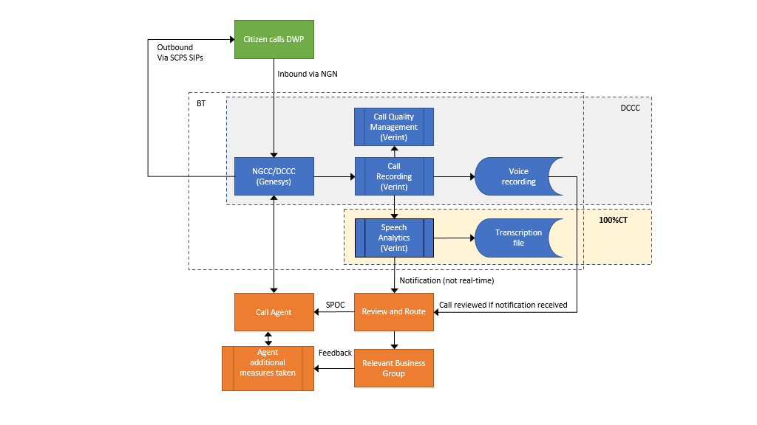

### **Future Approach**

The Department have identified a business need to enhance the currently limited call transcription service to have comprehensive coverage of all **inbound and outbound** calls. Increasing call transcription and analysis to all calls will provide the quantitative/qualitative management information, insights and reporting that senior leaders are seeking. The proposed approach aims to support:

1. Improving the quality of services delivered to operational groups, enabling operational targets and key performance indicators (KPI) to be met, including transcription accuracy of above 90% with service availability above 99.99%.
2. Exploring the reduction in cost of public services through innovation schemes and more effective spend on innovative technologies.
3. Continuing to meet regulatory requirements and accepted best practice for contact centres whilst also being capable of adapting to new policy and legislation.

# REQUIREMENT

Requirements were categorised into the following key themes:

1. Behavioural
2. Compliance
3. Emotion analysis
4. Good speech error rate
5. Real time alerts and reports
6. Watch terms

Stakeholders identified the following recurring themes during the requirement development:

1. Ability to train specifickey words, phrases and tones.
2. Capture of events meeting criteria and then alert for follow up
3. Integration with Interactive Voice Response (IVR)
4. Proactive Notifications / Alerts/Reports
5. New Trends/words
6. Word Clouds
7. Flexible expansion for volume peaks
8. API into Verint Call Recording Application
9. Integration with Chatbot

The solution therefore needs to:

1. Transcribe with an accuracy level exceeding the market average for transcription products.
2. Be a machine learning solution which can pick up key words, voice recognition and tone.
3. Provides word clouds whereby DWP can perform trend analysis upon identifying recurring words and can trigger notifications to identified users when new words/trends are identified.
4. API integration with:
   1. Verint Call Recording application/databases
   2. other technologies, e.g., webchat, video, textbox, etc.
5. Provided scalability in the event of additional volume due to unforeseen operational reasons.
6. Proactive MI reporting that can be utilised:
   1. to inform performance/behaviours of agents and citizens
   2. improve quality, efficiency, and customer service
   3. review technical effectiveness of the solution e.g., accuracy, reliability etc.
7. Be capable of operating alongside both the current NGCC and future DCCC platform (which includes an Azure subscription) to minimise dependencies on CCMP.

Please review the current draft requirement which are **embedded below**.

# VOLUMETRICS

DWP currently receives, on a rolling annual average (May 21 to April 22), 3.7M **inbound** calls a month, with 3.0M answered, and 30% transcribed.

Based on current volumes, the overall future volume including outbound calls, is expected to be made up of the following:

**Inbound:**

Annual calls answered = 33,894,215 + 2,425,976 = 36,320,191

Average inbound call duration = 10mins 40 secs

Total inbound ‘voice traffic’ = 387,192,396 mins

**Outbound**

Annual calls placed = 994,098

Average outbound call duration = 4mins 8 secs

Total outbound ‘voice traffic’ = 4,108,938 mins

**Total**

Annual ‘voice traffic’ in scope for this Service = **391,301,334 mins**

Equivalent to **1.254 million mins/day** (based on a 6-day week)

# REQUEST FOR INFORMATION

We would be interested in hearing from you in respect of the following questions:

|  |  |
| --- | --- |
| **Ref** | **Question** |
|  | **Product** |
| 1 | Please provide an overview of the service you can provide to meet our requirements, explaining how your core solution, and any add-on components, can achieve the required outcome. |
| 2 | Please explain any additional capabilities that you can offer that could further enhance the outcomes we are trying to achieve, e.g., automation, AI, machine-learning. |
| 3 | Please explain any challenges in achieving the attached requirements and any alternatives if you are unable to meet these. |
| 4 | Please provide a typical architecture design, including your preferred hosting environment and any required network connectivity. Please describe any capacity constraints that might exist. |
| 5 | If any components of the solution are based on open-source software, please detail which and explain how any associated risks are mitigated? |
| 6 | Please detail your future product roadmap, any planned major upgrades and their timing. |
| 7 | If requested, can you demonstrate your product within your environment as part of this RFI |
| 8 | Where are the solution boundaries between DWP and your services and what other dependencies do you have on DWP? |
| 9 | What components and activities would DWP be expected to supply and undertake to make your solution work? |
| 10 | Please describe how you would deploy the required solution with indicative timeframes. |
| 11 | Please provide case study references of similar engagements you have undertaken. |
|  | **Service** |
| 12 | Please describe your support model, for example 24x7 directly, or via a partner? Please explain from which geographic locations support is provided. |
| 13 | Please provide a summary of your service monitoring capabilities and, whether they are controlled within UK borders. If not, please state the location(s) where this will occur. |
| 14 | Please confirm your standard service levels relating to performance, quality, and incident management of the solution, and how this relates to a typical Service Credit model? |
|  | **Commercial** |
| 15 | Please confirm whether your company is registered on any Crown Commercial Services (CCS) Frameworks, and if so which one(s)? Please confirm that the contact details contained within the CCS e-Sourcing procurement tool are up to date: https://[Crown Commercial Service C&SM (bravosolution.co.uk](https://crowncommercialservice.bravosolution.co.uk/web/login.html) |
| 16 | Please detail how your pricing model operates for the solution components, covering consumption-based, licencing (perpetual/ subscription), ongoing support and maintenance, including any price bandings, minimum commitments, or discount structures applicable. |
| 17 | Given our estimated volumes and the pricing model detailed above, please provide indicative pricing for your solution, assuming a contract with a 2-year initial term with +1+1 extension years. If applicable, please provide your standard licence terms, noting that these would operate within the content of the identified CCS Framework(s) above. |
| 18 | Please provide indicative pricing for the implementation and transition of this solution, giving consideration of our current technology landscape. |
| 19 | Please provide indicative day rates for any additional professional services that may be required using the industry standard Skills for Information Age (SFIA) framework. |
|  | **Compliance** |
| 20 | **Accessibility** - Please explain how you will provide a solution that will comply with ‘The Public Sector Bodies (Websites and Mobile Applications) (No.2) Accessibility Regulations 2018’ given that DWP regards the ‘common standard’ for applications to be the “AA” in line with the Web Content Accessibility Guidelines (WCAG) v2.1. |
| 21 | **GDPR** - Please explain how you will assist the Department in obtaining and maintaining compliance to GDPR, explaining which location(s) data will be stored and/or processed as part of your solution. |
| 22 | **Social Value** - Please confirm you companies’ willingness to comply with the adoption of Social Value measures specific to Supply Chain Diversity and that any sub-contractor will be paid on 30 days as per Policy Note 07/20. further detailed here:  <https://www.gov.uk/government/publications/procurement-policy-note-0620-taking-account-of-social-value-in-the-award-of-central-government-contracts> |
| 23 | **Modern Slavery** - Please confirm your companies’ willingness to complete an annual Modern Slavery Assessment Tool submission. |
| 24 | **Carbon Reduction** - Please confirm that your organisation adheres to Policy Decision Notice 06/21 further detailed here:  <https://www.gov.uk/government/publications/procurement-policy-note-0621-taking-account-of-carbon-reduction-plans-in-the-procurement-of-major-government-contracts> |

# ATTACHMENTS

|  |  |
| --- | --- |
| Non-Disclosure Agreement |  |
| Call Transcription Requirements |  |

# OUR TIMETABLE

|  |  |
| --- | --- |
| DATE | ACTIVITY |
| 26 July 2022 | Publication of the Request for Information |
| 27 July 2022 | Clarification period starts |
| 04 August 2022 | Clarification period closes |
| 11 August 2022 | Target date for submission of a RFI Response |
| September 2022 | Confirm next steps to RFI Respondents |

# QUESTIONS AND CLARIFICATIONS

1. Suppliers may raise clarifications regarding any aspect of this RFI prior to the Clarification Deadline.
2. Clarifications should be submitted to the identified DWP contact.
3. To ensure that all Suppliers have equal access to information, anonymised responses to questions will be made available to every party that has signed the Mutual NDA on a regular basis.

# COMMON ABBREVIATIONS

|  |  |
| --- | --- |
| Abbreviation | Definition |
| ACS | Advanced Customer Support |
| CCMP | Contact Centre Modernisation Platform |
| DWP | Department for Work and Pensions |
| NDA | Non-Disclosure Agreement |
| NGCC | Next Generation Contact Centre |
| NGN | Non-Geographic Numbers |
| SA | Speech Analytics, a component of the Verint product suite |
| WCAG | Web Content Accessibility Guidelines |