**HDC202112 - Coldstream Marsh fencing - Appendix 1 Specification**

**Fleet Pond SSSI nature reserve**

**Stock proof fencing and scrub clearance**

**Overview:**  
Prepare groundworks including scrub and tree removal; remove and dispose of existing fence line; supply and install cattle stock proof metal fencing around Coldstream marsh on Fleet Pond and install 2 field gates, as per the specification.

Quotation to be split into the following sections:

1. Scrub and tree removal
2. Fencing removal and disposal across the Coldstream marsh area
3. Installation of approximately 870m of new fencing and access gates for Coldstream marsh

Preference will be given to contractors who can complete all the work specified, however considerations will be made for those who can only complete part of the specification (e.g. fencing work only).

Due to the wet nature of the marsh, contractors may choose to split the work across the season for more favorable conditions. Scrub clearing to take place **January 2022** with fence installation to follow **January – February 2022** (weather permitting).

**Access:**  
The site can be accessed through the site’s car park (off Cove Road) via lockable bollards, a 2.1m height barrier is in place which can be opened to allow access if required. Access to the marsh is along a non-hardcore path, entry onto the marsh is via a 15ft field gate. The western edge of the marsh fence line is inaccessible with 4x4 vehicles due to the wet nature of the marsh.

**Site map**  
Fencing to be installed around Coldstream marsh:

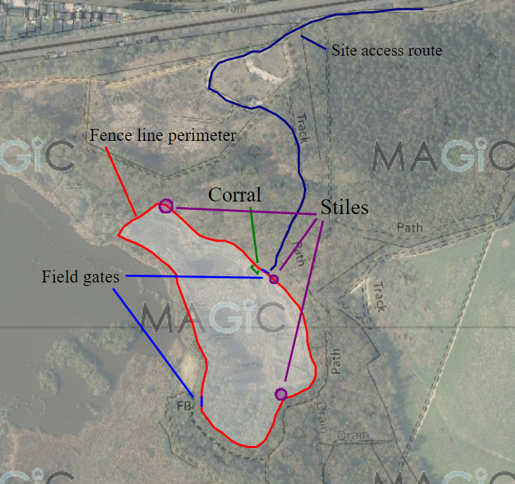

*Map to indicate the location of the current fence line. New fence to follow the original fence line (no planned deviations).*

**Metal fencing materials:**

Clipex steel fencing to match the following specification (or equivalent, to be agreed with Site Ranger as part of quotation): [Triple X 1000m Cattle & Railway Fence Kit | Triple X Fencing | McVeigh Parker](https://mcveighparker.com/triple-x-1000m-cattle-railway-fence-kit#description)

* Cattle/railway X fence livestock wire: XHT8-80-30, 80cm height
* Beefy intermediate posts: CLR2720, 2.0m length, in-ground depth 900mm (fence height 1.1m)
* Triple X steel standard end strainer, 2.4m length
* Triple X two way strainer, 2.4m length
* High tensile line wire

2 field gates based on the following: [Half Meshed Field Gate (mcveighparker.com)](https://mcveighparker.com/half-meshed-field-gate) to be installed following the instructions set by the supplier.

**Description of works:**

**Scrub clearance**

Clearance of trees (including overhanging tree branches) and scrub (mainly bramble) 1m either side of the fence line. Hand tools such as chainsaws and brush cutters will be used. Where possible, chip the brash into areas of scrub, where ground conditions are too wet to chip, brash can be stacked in pre-determined locations as agreed with the Site Ranger. All chord wood to be cut into 1.2m lengths (approximately) and stacked on site.

**Fencing**

Existing fence line, including all timber and metal, to be removed and disposed of by contractor in an appropriate and legal method off site (e.g. at licensed waste disposal site)

Fencing should notbe attached to, or strained against gate posts, trees, shrubs or other structures. Gaps between the end straining posts and other structures should be stock proofed with post and rail sections a minimum of 1.5m long either side of structures (i.e., access gates (x2), styles. *Note: any corrals requires 3m length post and rail - no corrals required for this specification*)

Posts to be driven to a depth of 900mm, giving an overall fence height of 1.1m

Fencing should be constructed in straight lines and be strained between strainer posts. Strainer posts should be used at each end of the fence and at least every 100m, along with at all changes of direction and sudden changes of gradient. Two struts per straining post should be used on changes of direction, in line with the fence. Anchors can be used where required for necessary minor directional changes in fence line.

Intermediate posts to be spaced 4.5m apart (based on centres) as per the Clipex steel fencing specification.

**Gates**

Contractor to follow manufacturer’s guidelines for installation of gates. Where no specification is provided, posts should be between 500mm and 700mm in the ground, hanging posts should be 1100mm.

**Corral and stiles**

Remove the corral and stiles from the site, these are not to be replaced as part of the new fence line.

**Remediation works**

The site should be ‘made good’, any ruts caused by machinery are to be graded/leveled out and seeded with grass mix if required (discuss with site ranger as part of remediation works). All man-made debris to be removed from site and disposed of responsibly by contractor, including old fencing, wire, etc.

Site ranger to view works with site foreman to view the work and ensure that the work has been completed to satisfaction. This is to take place ideally before any machinery and material are removed from site.

**Code of working**

All works to be carried out by contractor in line with Hart District Council’s Code of Conduct for contractors.