Primary Care Extended Access for Bedfordshire CCG

Coverage of the practice-registered populations of the five localities making up Bedfordshire Clinical Commissioning Group are as follows:
Locality | 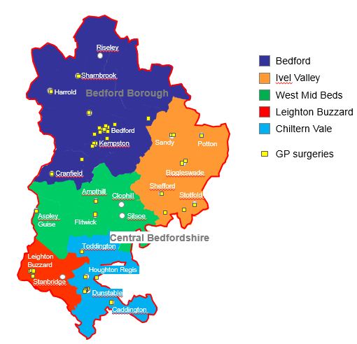
Bedford
Chiltern Vale
Ivel Valley
Leighton Buzzard
West Mid Beds
Further information on each locality is available at:
https://www.bedfordshireccg.nhs.uk/page/?id=3880

Indicative Funding per Locality / APMS Contract
Lot Ref | Indicative funding per Locality/Contract | Year 1 - 2018/19  PYE - Oct 18 | Year 2 - 2019/20  FYE | Year 3 - 2020/21  PYE - Oct 20 | Total - 2 years contract  Oct 18 - Oct 20
1 | Bedford | £572,186.97 | £1,027,880.79 | £513,940.39 | £2,114,008.16
2 | Chiltern Vale | £266,353.78 | £478,479.84 | £239,239.92 | £984,073.54
3 | Ivel Valley | £297,359.24 | £534,178.28 | £267,089.14 | £1,098,626.67
4 | Leighton Buzzard | £143,940.85 | £258,576.37 | £129,288.19 | £531,805.41
5 | West Mid Beds | £231,412.62 | £415,711.29 | £207,855.64 | £854,979.55
6 | BCCG Total | £1,511,253.46 | £2,714,826.58 | £1,357,413.29 | £5,583,493.33

