Luton Extended Access Supplier Information
NHS Luton Clinical Commissioning Group (LCCG) is contracting for Extended Access services provision to provide primary care appointments seven days a week as per the national extended access initiative. This initiative requires all patients to receive extended access primary medical care services from 18:30-20:00 during weekdays and at weekends (based on local demand), 365 days of the year.
The General Practice Forward View sets out a requirement for primary care services to be accessible 7 days a week. There is a national need to adopt an intelligent approach to introducing extended access through flexibilities in delivery of the Government's access commitment, enabling integration with out of hours provision, and ensuring there is the ability for extended access to boost overall capacity and reduce demand in normal working hours, both in primary care and as part of a wider system approach.
Luton CCG intends for this initiative to be delivered by Luton GP practices working collaboratively at scale for the registered population of all ‘27’ member practices. Luton CCG requires a minimum of 2 sites of delivery, the main site of delivery to be within the Town Centre Vicinity (1) as indicated in the map below with an additional second site (2) to be in the north of the town as per the indicative map below.
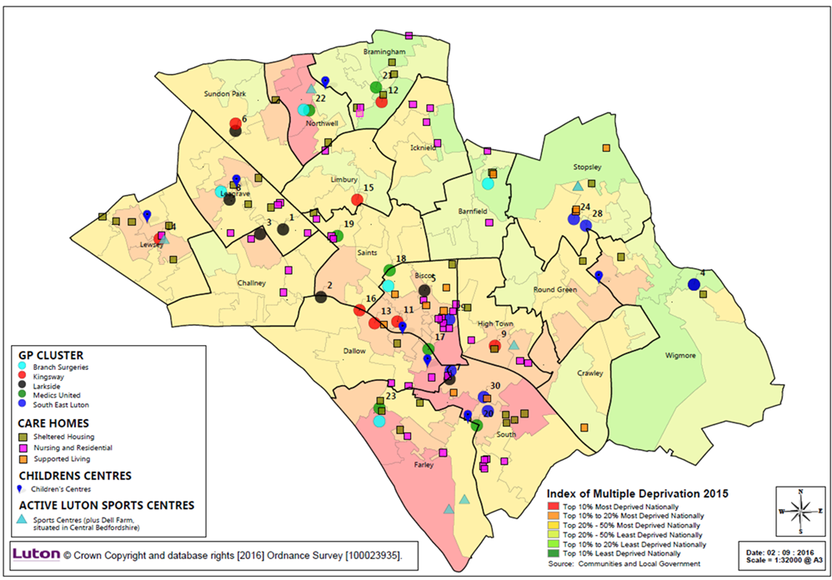
1
2
This ambition would see future provision, and associated funding, for the extended access initiative within scope of a lead APMS contract model, enabling “needs-based” delivery.
The contract length is likely to be 19 months with the option to potentially extend again for up to 24 months subject to satisfactory review and funding.

