A Partnership Opportunity

**Twenty One**

A Partnership Opportunity

Invitation for Expression of Interest

17th June 2021

*“Finally a brilliant arts venue to house ALL the vibrant communities and give them a platform,*

*Twenty One is the perfect place for events and a great new venue to get excited about. So much potential – everyone is talking about it!”*

Contents

1 Introduction 3

2 About Twenty One 4

3 The Future for Twenty One 6

5 Programme Highlights 7

6 The Opportunity 8

Expression of Interest 9

# Image may contain: one or more people, people on stage and indoorIntroduction

This partnership opportunity seeks to attract expressions of interest with a means to appoint a *Delivery Partner* to work with Southend-on-Sea Borough Council to facilitate cultural and community events and an associated catering offer at the seafront venue Twenty One, to ensure the venue maximises its potential for the local community as a creative venture and visitor attraction.

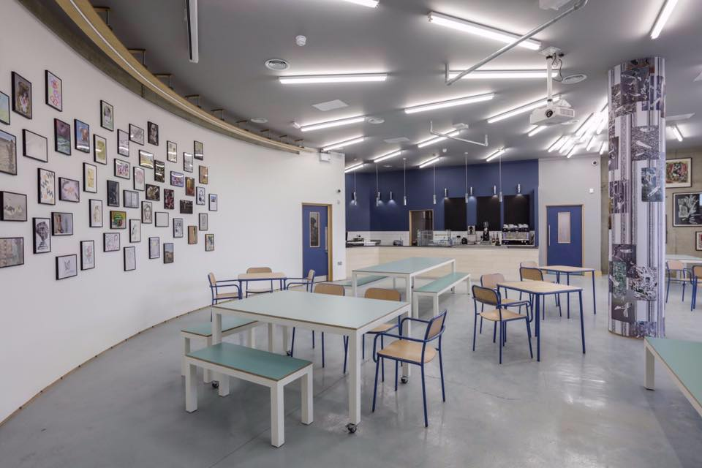This document details information about Twenty One, the vision Southend-on-Sea Borough Council has for its future, and the exciting opportunities the venue holds for a partnering organisation.

Twenty One is located on Western Esplanade, opposite the entrance to Southend Pier.

# About Twenty One

Twenty One is an unique cultural venue, for live art, events and exhibitions. It services the local community in providing a site to showcase the variety of art forms of the Southend scene, including comedy, poetry, performance, dance and music, as well as being a small venue on a national circuit. It includes a basic but high quality PA and speaker set up, projection and screening facilities, furniture, and basic ceiling track and stage lighting.

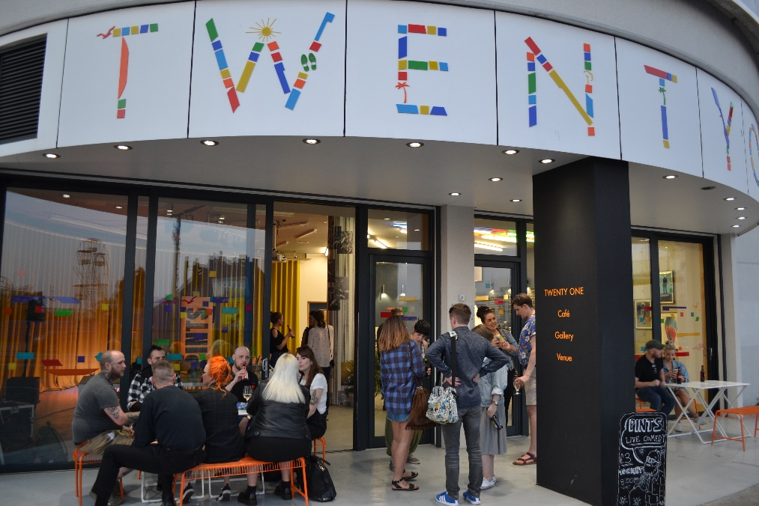

Acknowledging the devastating effect of the Covid-19 pandemic on the creative sector, in particular live venues, and the impact on mental health and wellbeing through lack of social gatherings, the venue is well placed to be a catalyst and enabler for the town’s recovery, supporting community activity, encouraging events hosted by local community groups and individuals, as well as bringing nationally recognised performers to Southend.

Twenty One can become a strong contributor to the night time economy, and Southend’s status as a purple flag destination, welcoming visitors and amplifying the diverse cultural offer of the town. The venue can be a year-round attraction at the heart of Southend town centre and seafront.

The venture embraces the thinking behind Southend 2050, a vision of the town held by local residents, businesses, employees and others, drawn together following extensive public engagement since 2018. Relevant outcomes of the consultation include:

* The variety and quality of our outstanding cultural and leisure offer has increased for our residents and visitors and we have become the region’s first choice coastal tourism destination
* A range of initiatives help communities come together to enhance their neighbourhood and environment.
* Southend is a place that is renowned for its creative industries, where new businesses thrive and where established employers and others invest for the long term.
* A group of people in a room

  Description automatically generated with medium confidenceWe have a fast-evolving, re-imagined and thriving town centre, with an inviting mix of shops, homes, culture and leisure opportunities.
* Even more Southenders agree that people from different backgrounds are valued and get on well together.
* Public services are routinely designed, and sometimes delivered, with their users to best meet their needs.
* There is a tangible sense of pride in the place and local people are actively, and knowledgeably, talking up Southend.
* Residents feel the benefits of social connection, in building and strengthening their local networks through common interests and volunteering
* We act as a Green City with outstanding examples of energy efficient and carbon neutral buildings, streets, transport and recycling

In addition, during 2020 significant engagement with the public regarding culture in Southend was undertaken to help inform the future offer. Some key themes from this feedback that can be delivered by activating Twenty One include:

* Frequent references to developing new cultural uses in vacant town centre spaces
* The importance of community led cultural activity
* An identified need for a more accessible and inclusive cultural offer

# The Future for Twenty One

Twenty One is owned by Southend-on-Sea Borough Council (SBC), with the creative offer prior to the pandemic delivered by Focal Point Gallery (FPG), an Arts Council National Portfolio Organisation within the local authority who had built the current reputation for the venue. The venue can deliver a complimentary catering offer, fully licensed with a basic kitchen (no extraction). To date, these assets have not been fully utilised.

We are seeking expressions of interest from organisations or individuals to run the venue, managing the catering offer and event programme in an agreed partnership with SBC and FPG, building Twenty One’s reputation and meeting the outlined vision.

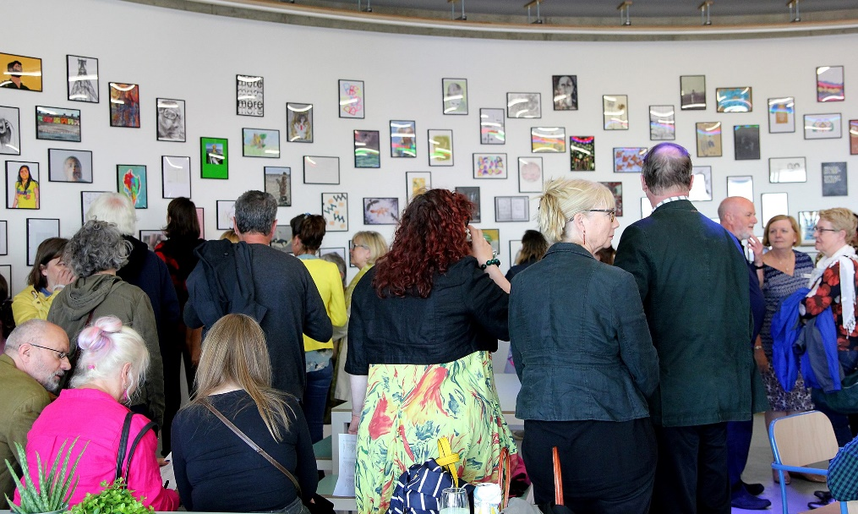

The vision for the partnership, is to create a venue that will stretch its use into the broad community, meeting expectations of residents and visitors alike. Appealing to cultural and creative use, as well as speaking to green, health and wellbeing, and local agendas, we are looking to create an offer that is obtained through a local supply chain and showing an eagerness to adopt environmentally sustainable practices (Twenty One is already equipped as a cycle friendly venue) and appealing to a diverse visitor spectrum, catering to differing dietary requirements and contributing something different to the traditional seafront offer. Where appropriate we are open to reappraising our expectations relating to Twenty One in line with the expertise and judgment of the market and the mutual benefits made possible when working in partnership.

The tourism offer will be built on the catering provision as well as the cultural programme, giving audiences a reason to visit at all times of the day and throughout the year. We intend for the partner to work closely with SBC, FPG, local organisations and charities to host events and take part in initiatives that benefit Southend as a place and a community.

As the nation emerges from lockdown restrictions, the venue can play an important role in re-establishing space for creativity and culture in the community. We are looking to appoint a partner to reopen the venue as Government guidelines allow.

# Programme Highlights

Over the initial year of operation, the following was achieved through the venue;

* Hosted 125 events supported by 40 local groups or organisations working with over 400 artists attracting 1600 visitors.
* Commercial hires from Google and Ted Baker due to interest in the aesthetics of the space
* Visit from John Glen MP from Department for Digital, Culture, Music and Sport
* Fundraising events for South Essex Mind, Project 49, Essex Feminist Collective, Southend Pride, Leigh Folk Festival and Oxfam
* Performance from local poetry collectives Spinning Yarns and Sundown Arts, bands T-Bitch, 54 Plates and Petty Phase and dance collective Old Kent Road
* Performances from Australian violinist Adam Cadell, Rough Trade signed band Pica Pica and Canadian guitarist Eric Chenaux
* Edinburgh Festival preview comedy performances from: Nathan Cassidy, Chris Stokes, Abbie Murphy and Mawann Rizwan (the latter recently hosting a BBC special)
* Events held in partnership with Metal, University of Essex, South Essex College, TOMA and Culture as a Dare
* Children’s events and network meetings hosted by SAVS

Twenty One Venue Press:

* ‘Southend-on-Sea: The arty way is Essex’ The Guardian: <https://www.theguardian.com/travel/2017/jul/23/southend-essex-seaside-arts-festivals-seaside-family-holidays>
* ‘10 Things to Discover in Southend’ Essex Life

Twenty One Exhibition Press:

* Catherine Hyland - The Guardian, Tank Magazine, It’s Nice That, Photography Now
* Paul Anthony Harford - Galleries Now, ArtWatch

This list is included to illustrate the demand and potential of the venue, and its ability for creative and commercial hires to drive a successful income model. The prospective *Delivery Partner* will be free to identify their own programmes and partners, but should be inclusive of the whole Southend cultural community.

# The Opportunity

We are looking for expressions of interest from socially engaged and innovative organisations or individuals interested in working with us to be a *delivery partner* to provide a catering offer which is in step with the vision for Twenty One. We seek engagement and dialogue with interested parties about the future running of the site, to enhance understanding on all sides of what is achievable as part of this unique, aspirational and step-changing development.

In response to the expressions of interest we receive relating to this document, successful applicants will be sent a questionnaire to complete, the Council will then interview up to a maximum of 3 potential *delivery partners*.

The potential delivery partner should be aware of the following before making their expression of interest;

* Twenty One is owned by SBC, who should receive a rental contribution as a %[to form part of bid] of turnover from all trading activities from the venue (i.e. venue hire/ticket sales, catering, bar etc). Under the terms of the partnership, SBC do not expect a rental contribution at a commercially equivalent level. SBC understand Twenty One may be an opportunity to test a concept which could give rise to a sustainable commercial offer. Full access will be provided to business support services to help achieve this.
* The delivery partner will be responsible for all business related costs, including utilities, licenses of approx. £14K and rates of approx. £26K
* SBC will maintain servicing of fire and security alarms under existing contracts, with costs of approximately £3K p.a. which the Delivery Partner will be liable for.
* Business models for operating the venture should include income generation through venue hire at an affordable rate for cultural and community use, and commercial hire at an appropriate level as well as a catering offer, and any external funding support. We expect that the *Delivery Partner* will engage with and give opportunities to the local creative and cultural sector.
* FPG will oversee any partnership agreement, and through their expertise can provide support with reaching the creative community through existing channels set up to promote the venture, and to support with identifying and applying for potential funding opportunities as appropriate. In doing so, FPG and SBC cultural and community event needs will be built into any agreement, under mutual agreement by all parties.
* SBC are offering an initial 3 year lease, with a mutual break clause at 12 months then rolling for the rest of the term on 6 months’ written notice.

The venue offers the following

* Broadly circular single space public area circa 130 sq.m.
* Glass frontage opening to small outdoor area
* Separate ‘Back of House’ space circa 40 sq.m.
* 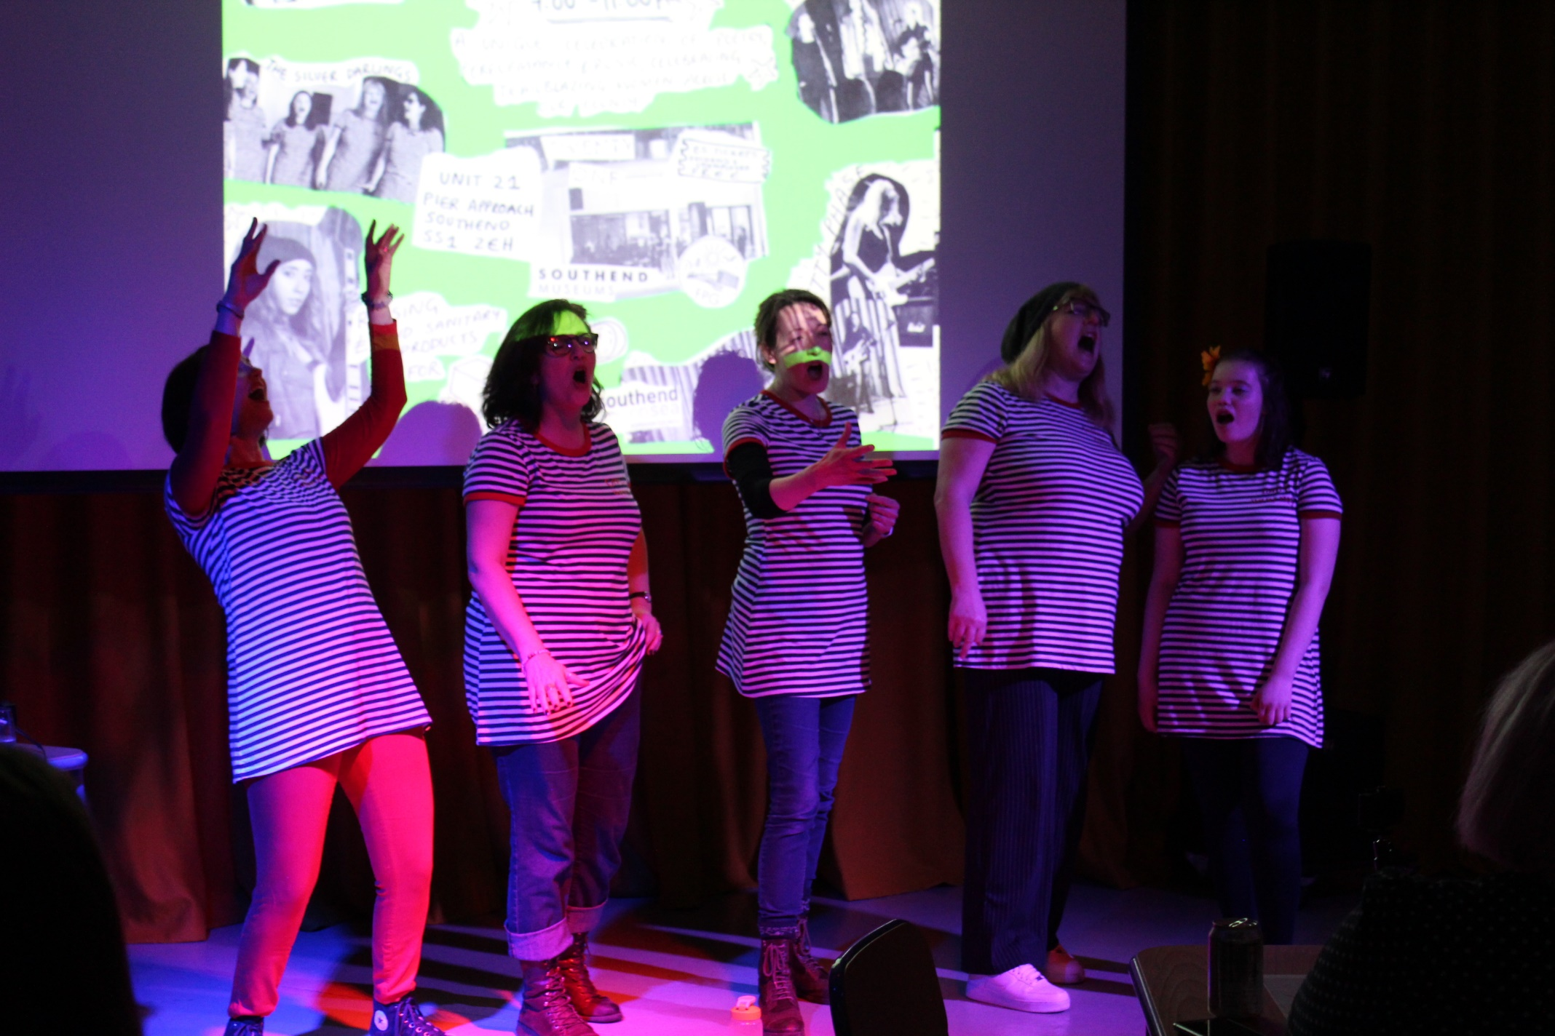Counter and kitchen space circa 32 sq.m.Fitted out licensed basic kitchen and events space. (no extraction)

All measurements are approximate and interested parties should satisfy themselves in this regard. Viewings of Twenty One can be arranged following the EOI process, ahead of the next stage.

# The Expression of Interest (EOI) Process

Southend Borough Council is carrying out this exercise in the form of an open EOI for a *Delivery* *Partner* to present a proposition to fulfil the potential of Twenty One. Your interest, in being our *Delivery Partner* and in taking part in this process must be by responding to our EOI.

1. **Stage 1: Respond to EOI by 12.00 noon on Tuesday 6th July 2021**

* Email: [twentyone@southend.gov.uk](mailto:twentyone@southend.gov.uk)
* As part of the EOI, please answer the following questions.

Each question must be answered in no more than 500 words (additionally graphics and charts can be provided)

(NB: web links, associated information or appendices will not be read or reviewed)

1a Your Organisation. Please describe yourself, your organisation or your consortium, and your experience and ethos including key personnel, any appropriate licences you already hold or your willingness to apply for licences

1b Your Experience. Please demonstrate the experience you have of managing a commercial and professional space for food and beverage, social, creative and cultural activities in relation to the needs of this partnership and the vision for Twenty One.

Decision-making process: A review Panel set up by Southend on Sea Borough Council will decide which EOI’s will progress to Stage 2 of this selection process. The presenters of the shortlisted EOIs will receive further instructions on submission to Stage 2. The review panel’s decisions at Stage 1 and Stage 2 will be final and at the discretion of the Council.

1. **Stage 2: Delivery Partner Questionnaire (9th to 19th July 2021)**
   * Successful EOI’s will be sent a Questionnaire.

A selection of scored questions for evaluation.

1. **Delivery Partner Panel Review**
   * Assessment of submissions

NB: The Panel’s decision is final, and the progression to interview is at the discretion of the Council.

1. **Operator Interview (w/c 26th July)**
   * Interviews with a maximum of the top three ranking *Delivery Partners*.

We envisage this will be an informal, open and frank process where a range of the strategies, expectations and ways of working can be discussed to inform and focus our subsequent approach. These interviews may be scheduled for in person meetings or video/teleconferencing meetings as appropriate and convenient having regard to the prevailing circumstances and guidance

1. **Partnership Agreement**
   * Following evaluation of the submissions, the Council will make a decision on which, if any, shall be accepted.
   * Any acceptance of a submission by the Council shall be in writing and shall be communicated to the *Delivery Partner*.
   * Upon such acceptance the Council and *Delivery Partner* shall become binding contractual parties, and, notwithstanding that, the appointed *Delivery Partner* shall execute a formal contract in writing upon request of the Council.

If you have any questions about this opportunity (and note that the responses to these will be shared with all interested parties), please **Email:** [twentyone@southend.gov.uk](mailto:hayleydixon@southend.gov.uk)

For the avoidance of doubt, any submissions received after **12.00 noon on Tuesday 6th July 2021** will be regarded as a late submission. Late submissions will NOT be considered. All Expressions of Interest and responses must be sent to [twentyone@southend.gov.uk](mailto:hayleydixon@southend.gov.uk)

Southend-on-Sea Borough Council

Civic Centre, Victoria Avenue

Southend-on-Sea SS2 6ER[www.southend.gov.uk](http://www.southend.gov.uk/)

Email: twentyone@southend.gov.uk

  [twitter@southendbc](https://twitter.com/southendbc)  
  [Facebook.com/SouthendBCOfficial](https://www.facebook.com/SouthendBCOfficial)   
  [Flickr.com/southendbc](https://www.flickr.com/photos/southendbc)  
  [Instargram.com/southendbc](https://www.instagram.com/southendbc/)

3