Drawing 3. Disabled Parking Bays (plan 1

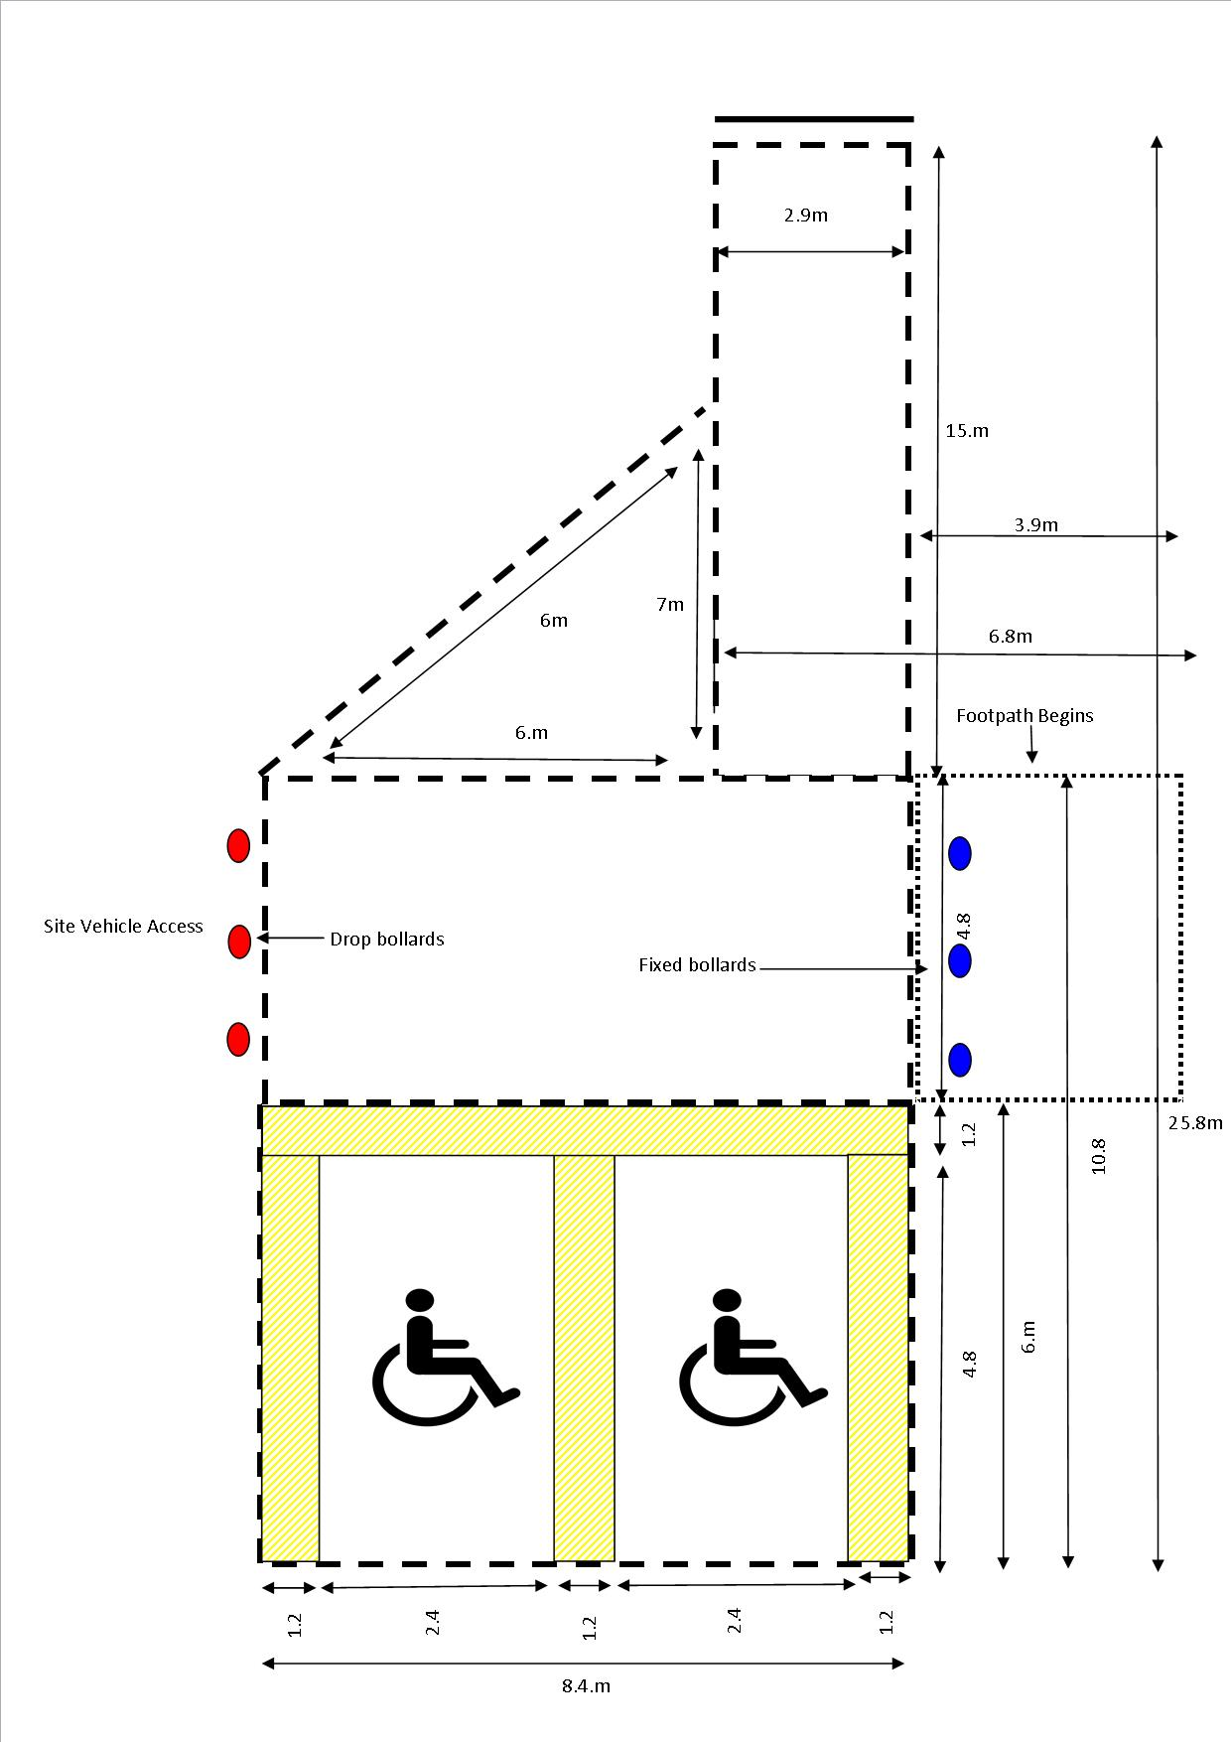
Drawing 3. Disabled Parking Bays (plan 2)

