Invitation to Quote for Stand Build
AHDB Exports Stand

SIAL China, Shanghai International Expo Centre, 28 – 30 May 2024

Contact Name: Chloe Lane Email: chloe.lane@ahdb.org.uk

Company Name: AHDB Website: www.ahdb.org.uk

Address: Middlemarch Business Park Tel: +447775884851
Siskin Parkway East
Coventry
CV3 4PE
United Kingdom

Show Name: SIAL Shanghai, China Show Dates: 28 – 30 May 2024

Hall: E5 Stand Number: E567

Stand Size: 90 sqm (15m by 6m) Open Sides: 4

Budget: £30,000

Show Venue: Shanghai International Expo Centre

Deadlines: Latest date for questions/clarifications – 1 March 2024

Quotation to be received by – 8 March 2024

Award notification date – 15 March 2024

Contract Period: 18 March – 3 June 2024

- Introduction

This document outlines the requirements for the AHDB Exports stand at SIAL Shanghai, China.

AHDB Exports are part of AHDB (the Agriculture, Horticulture Development Board) and based in England. We are a non-departmental Government public body working to promote meat both at home and abroad.

For more information about our work visit www.ahdb.org.uk

2. Event Objectives

To provide a platform for levy and non-levy paying meat producers to create new business relationships with international meat buyers and promote meat in the local market.

AHDB have booked a prime location for our stand (stand no. E567) The floor plan can be viewed in Section 6 showing our exact location.

The AHDB stand measures 15m x 6m, a total floor-space of 90sqm and is open on 4 sides. The maximum stand build height in the hall is 5.5 metres.

The look and feel of the stand are important and must portray the quality of British meat (Pork) and be clearly British. The stand should be open and inviting, encouraging visitors to engage and experience British products.

The stand will need to be seen from a distance and be visually appealing - high level branding should reflect guidance in Section 5 below.

The objectives of the stand are to:

• Provide an impactful, visible platform promoting British meat.
• Give presence to stand partners representing British companies and products.
• Provide space for British companies (co-exhibitors) exporting into the Chinese market.
• Enable meat samples to be prepared and allow food tasting for customers and visitors.

Solutions incorporating sustainability and energy efficiency are encouraged in your response – note that all lighting should be low heat creating.

Stand Build Requirements

To include all electrics (to include 24 hour electrics for refrigeration units), hot and cold-water supplies, wastewater disposal.

Stand build commences at 2pm on 25th May and must be completed by 10pm 27th May.

Please refer to the organiser’s stand regulations when creating your designs (document shared).

The stand needs to have the following elements and provisions:

- High level GREAT branding
- Space for 5-7 co-exhibitor booths (see previous examples in section 7)
- Graphic panels of sufficient area to promote Quality British Meat and shared visual messaging
- Open meeting and seating area
- Information point
- Lockable storage space

Information point - To be used by AHDB staff:

- Welcome/ reception desk with lockable storage underneath and graphic to the front
- Electrical sockets for charging items
- 1 x A1 display chiller with display grass (Lowe Refrigeration)
- Plasma TV on rear wall, with space for branding around TV
- Hand sanitising point
- Waste bin

Open meeting area:
- Low tables and chairs to provide a meeting point.
- Placement and number of tables/chairs should allow visitors to walk around the stand freely and without obstruction
- Hand sanitising points for stand visitors coming onto the stand or using meeting tables

Cooking demo area (Please refer to the organiser’s stand regulations)
- Counter with storage underneath for chopping boards and pans etc.
- Graphic on front of counter
- Cooking equipment for meat samples

Co-exhibitor booths:
- 5 - 7 x designated sections with branded reception counters and stools (see previous examples in section 7)

Storeroom (Please consider the flow of people entering the stand when positioning the storeroom)
- Lockable door
- 1 x H3A fridge underneath the counter for cold drinks storage (Lowe refrigeration or equivalent)
- 1 large waste bin
- Wall shelving for literature storage, bar items and personal supplies
- Double electrical socket
- Coat hooks / rack

Consumables - Please provide a price for supplying the following to equip us for the entire show:
- Water cooler and refills
- Coffee machine and consumables for hot drinks
- Refuse sacks – for bins
- Soft drinks (coke/ sprite)
- Daily personal cleaning supplies i.e. hand sanitiser

Other – the successful contractor will be responsible for arranging daily stand cleaning and waste removal pre/post show.

4. Graphics

AHDB will provide full and print ready artwork for all graphics.
Top level branding (i.e. lampshade or banner) needs to be seen from a distance in all directions and draw people to our stand. See Section 5 below for more information on GREAT branding principles.

AHDB graphic panels

The theme will be based on Great British pork using landscape images with live animals and food images. Our key message “Quality Meat from Britain” – will need to be shown in a prominent position.

Our USP is based around a quality product and so the graphic design needs to reinforce this message.

5. Food Is GREAT Branding

AHDB have agreed the following overarching principles for use of the GREAT brand at international events.

- Where the stand design does not incorporate a lampshade, AHDB will design a column or back wall which mirrors the agreed logo and brand hierarchy with GREAT as the primary brand.

- In this instance the GREAT header fascia must be clearly separated from the AHDB panels. Ideally there should be a physical gap no less than the same dimension as the height of the header fascia.

- Where this is not achievable the GREAT header fascia must be a definite different colour. If the AHDB background colour is blue, then the GREAT header must be white (or vice versa).

Branding hierarchy:
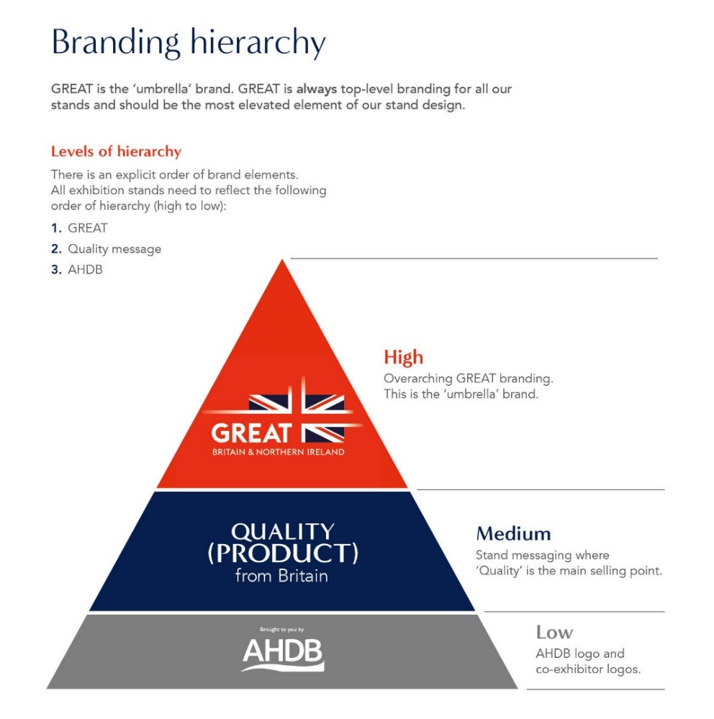

6. Venue & Hall Plan – PLEASE SEE APPENDIX 2

7. Stand Layout & Design

The visuals below illustrate a previous stand of a similar size effectively combining multiple elements i.e. info counter, cookery/sampling area, shared store/kitchen and co-exhibitor pods.

Please consider the flow of people entering the stand when designing the layout, especially with the location of the storeroom. The below example limited access into the stand as the storeroom blocked access from high traffic areas.

The contractor will be responsible for completion and submission of organisers forms relating to the design and construction of the stand, including organiser design approval. A login for the exhibitor portal will be provided after the contract is awarded, and a copy of the full exhibitor manual sent electronically.

PLEASE SEE APPENDIX 1

8. Tender Process

The contractor shall deliver the whole of the services, complete in all parts and furnished with every necessary detail, notwithstanding any omission or inconsistency in the specification.

The quote should include ‘to scale’ visuals of your design and be clearly itemised for all services and provision; where possible split by area (cooking area, storeroom, partner areas etc.) stating if any sub-contractors will be used; graphic dimensions and artwork deadline.

Except as otherwise stipulated in the specific conditions of service required, the contract shall remain at the fixed price and rates shall not be revised.

AHDB’s Event Manager can order reasonable additions to or reduce from the service specified. These amendments shall be requested in writing and agreed by both parties.

9. Evaluation of Tenders

Our award criteria are:

- Understanding of the brief 20%
- Price 25%
- Design, creative impression and equipment 40%
- Ability to meet event timelines, build-up and break-down 15%

Please submit your design proposals to by 8 March 2023.

10. Payment Terms

Please note that all invoices submitted to AHDB require a purchase order number to enter onto our payment system. Our payment terms are 30 days from receipt of the invoice.

