
Document Three – The Existing Skate Ramp and Foundation Surface

Location

Bishopdown Sports Field Recreation Ground
Salisbury
Wiltshire
SP1 3EQ

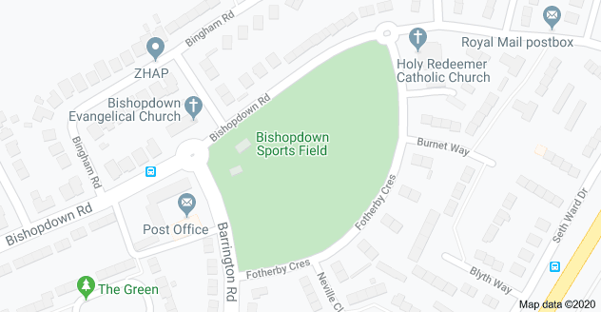

Existing Ramp

The ramp was installed over 10 years ago and has been very popular with freestyle sports enthusiasts across the city. It’s constructed of metal, plywood and metal sheeting and is approximately 20x32 ft in size, in recent years repairs to the ramp have been more frequent and it’s at a stage now, that the plywood surrounds and structures under the metal are decaying in places. The ramp sits on a large concrete pad which appears to be in good condition and should provide a sound base for a new ramp.

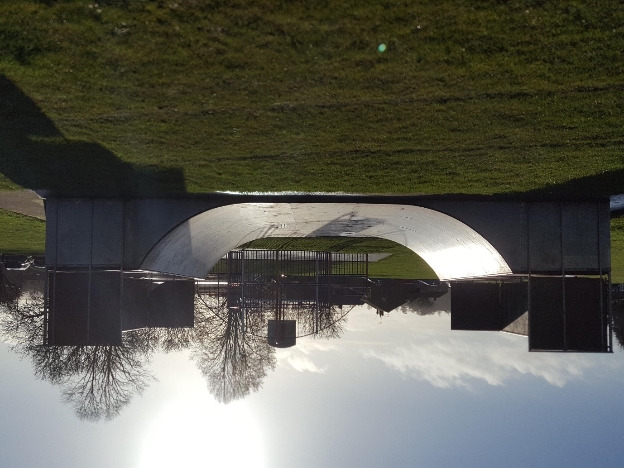

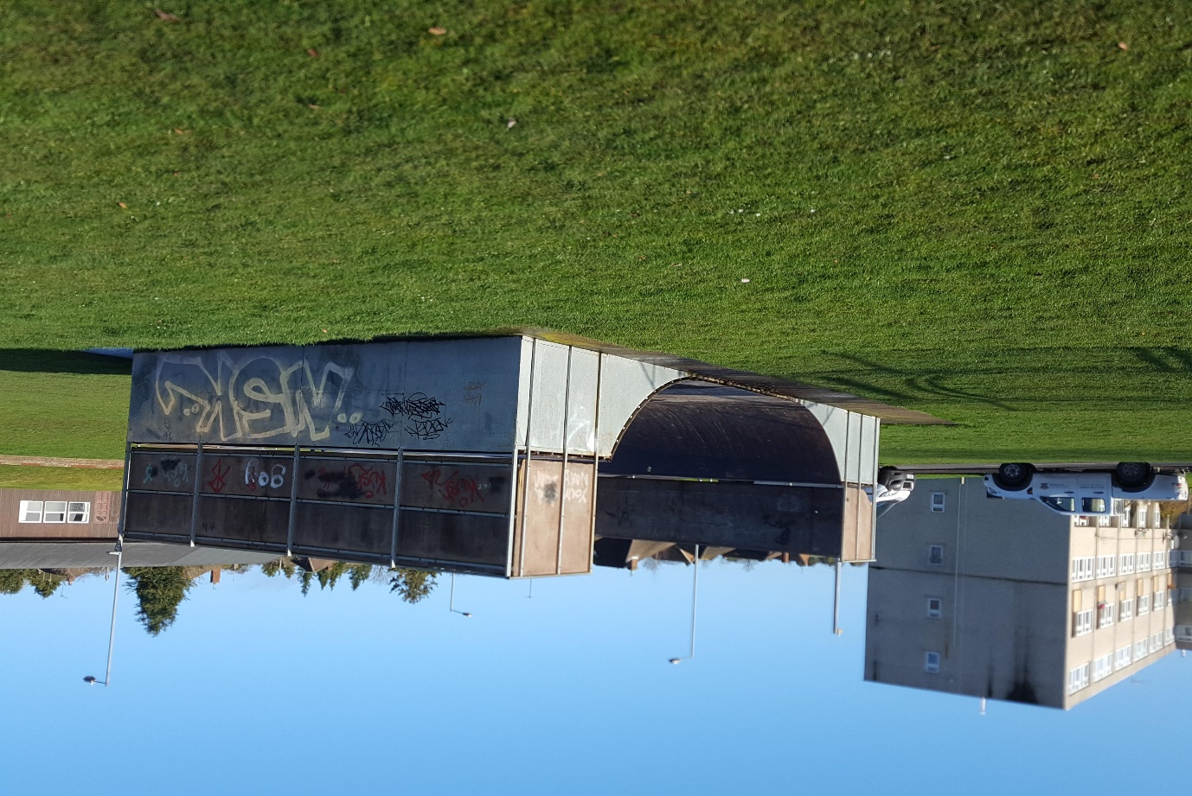

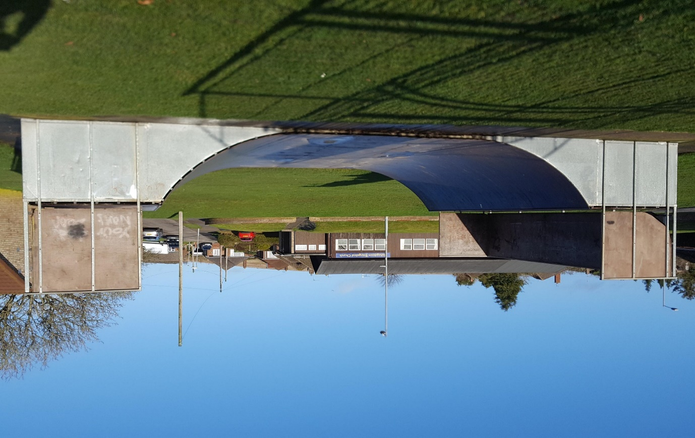

Existing Concrete pad situated under the ramp

