Heart of Yorkshire Education Group
Water Hygiene Contract
2023 – 2025

Castleford College

Wakefield College

Selby College

Author: Ralph Allan
Health & Safety Officer
r.allan@wakefield.ac.uk

 | Contents
1 | Introduction | 3 - 5
2 | Overview of Requirements | 6
3 | Contractor Criteria | 6
4 | Information / Instruction to Participants | 7 - 8
 | Appendices
 | Appendix 1 - College Sites / Addresses | 9
 | Appendix 2 - Specification | 9 - 11
 | Appendix 3 - Evaluation / Scoring Methodology | 12 - 16
 | Appendix 4 - Timetable Schedule | 17
 | Appendix 5 - Conditions / Floor Area | 18 - 23
 | Appendix 6 - Floor Plans | 24 - 47

- Introduction

Heart of Yorkshire Education Group is a large and diverse leading education provider. Serving the communities in North, West Yorkshire, East Ridings and beyond from its campuses in Castleford, Selby, and Wakefield.

As a new, combined institution, the Group was formed following the merger of Selby College and Wakefield College on 1st March 2022.
The Group offers an expansive range of post-16 provision, apprenticeships, higher education, adult qualifications, and distance learning, through its wide variety of full and part-time courses. It also works closely with employers locally, regionally, and nationally to deliver work-based training programmes to meet existing and future skills shortages.
Across its three campuses, the Group serves approximately 10,000+ full-time students, with more than 2,000 Higher Education students and Apprentices. With a combined turnover of £36 million, the Group currently employs more than 890 teaching and support staff.

Heart of Yorkshire Education Group Values

We expect all service providers to align to the Heart of Yorkshire Education Group values.

Heart of Yorkshire Education Group Objectives

In planning the strategic direction of the Heart of Yorkshire Education Group and our three Colleges over the next three years, the Heart of Yorkshire Education Group have established five key strategic objectives. In working towards and ultimately achieving these, the Heart of Yorkshire Education Group will be able to truly excel and provide an outstanding experience for our students, employers, and the communities the Heart of Yorkshire Education Group serve

1.1 Heart of Yorkshire Education Group Estate

Heart of Yorkshire Education Group operates from eighteen sites situated across its portfolio. Eight of these, form the Wakefield College, namely Radcliffe, Harrison, Seacole, Gissing, Beaumont, F Block, New F Block and Waterton (Mechanics’ Theatre). There are also some changing facilities at Stanley Royd Playing Fields. All are within easy walking distance of each other.

Wakefield College is located at the boundary of the Civic Quarter. The surrounding built environment is dominated by educational, health and office accommodation including Wakefield Grammar School, NHS clinics, Council offices and Police.

The Heart of Yorkshire Education Group also operates from one other site in Wakefield, namely Lightwaves. However, since we are minor occupiers at this location, the Heart of Yorkshire Education Group is not responsible for building related maintenance (including water management) at this premises.

Castleford College is a single building. Castleford is ten miles east of the Wakefield College, adjacent to the M62, retail and leisure facilities.

Selby College which forms the remaining eight sites, Jubilee, Renaissance, Engineering, Construction, Support, Nursery, Academy, Sports Pavilion

Selby is a market town in the Selby District of North Yorkshire, 14 miles south of York on the River Ouse.

In line with the Heart of Yorkshire Education Group’s property strategy, the estate is continually developing with the acquisition/disposal/refurbishment of buildings. Suppliers will need to be able to respond to any changes quickly, efficiently, and effectively.

The current estate comprises of a variety of buildings, dating from 1823 to 2017.

Appendix 1 provides the Heart of Yorkshire Education Group’s property addresses.

2. Overview of Requirements

Heart of Yorkshire Education Group is seeking to appoint a contractor to provide Water Management services for a period of two years commencing 1st April 2023.

The service provided must ensure that the Heart of Yorkshire Education Group, as well as the successful contractor, remain compliant with the HSE Approved Code of Practice (L8) (ACOP L8).

The service will include (but not limited to):

- Monthly Temperature Monitoring.
- Quarterly Shower Chlorination; and
- Legionella Water Risk Assessments

The contract will operate on a ‘split responsibilities control programme’ arrangement between the successful provider and the in-house maintenance team. A clearly defined specification of duties is included at Appendix 2.

Instances of non-conformances and recommended remedial works (e.g., removal of dead leg pipe work, plumbing and pipe work alteration etc.) identified by the supplier, must be reported to the Heart of Yorkshire Education Group contract manager to determine action to be taken and by whom
3. Contractor Criteria

Contractors must satisfy the following criteria:
- Evidence of operating in Education and Health or Residential care settings.
- Evidence of working in a variety of premises (e.g., old, modern, small, large); and
- Evidence of membership of accredited industry organisations.
In addition, we require you to:
- Provide the CV of the Managing Contractor and supply evidence of relevant qualifications.
- Return two references from similar clients. (The Proforma for references is available in appendix 3.)

The quality and completeness of this evidence, along with the main proposal, costings and other information supplied, will be rated on a scale of 0 to 5 and will inform the assessment on which the final award of contract will be based.

Appendix 3 provides more detail on this subject.
4. Information/ Instructions to Participants

Evaluation of Bids

Heart of Yorkshire Education Group evaluates bids on a price and quality basis. Price and value are essential to the Heart of Yorkshire Education Group but not at the expense of quality. This bidding exercise will be scored on price (50%) and Quality (50%) basis.

Price. You will submit a value for the requirements of the Heart of Yorkshire Education Group identified in appendix 2. Where an item is identified “as required” you should submit a unit cost per task. (You may also provide discounted costings based on the number of units to be actioned at the same time.) You will include VAT (identified) in all costs.

Quality. Each quality element of the bid will be marked on a scale of 0 to five. An explanation of the value of each mark can be seen in appendix 3.

Within each quote, you may submit a variation that you believe would benefit the Heart of Yorkshire Education Group and improve on the services identified. You must clearly identify such items under a heading of “Alternative Options”.

Supplementary information
The Heart of Yorkshire Education Group is committed to paying invoices within 28 days.

Timescales

The table on page 8 details the deadlines for each key date of the process, please ensure careful consideration is given as these dates/times will not be amended or extended.

It is also important to note the quote returns are required to be in paper format and remind that no electronic copies will be accepted.

Note: There will be no concessions for late deliveries due to third party delivery contractors appointed by the participants.

Anticipated Appointment | Notified on 06/03/23  Contract commencement on 01/04/2023
Contact Details | Mr Ralph Allan (Health and Safety Officer)  - email r.allan@wakefield.ac.uk Telephone 01924789850.  Mrs Diane Henry (Estates Manager)  - email d.henry@wakefield.ac.uk Telephone 01924789723.
Clarifications / Questions | Submitted via e-mail  Miss Beverley Dean b.dean@wakefield.ac.uk  No further e-mails accepted after 6/02/2023  Please note any clarification on questions submitted, the responses will be issued to all interested parties.
Return of Quotes | Return date of 12:00 noon on 17/02/2023 to the contact and address below:  Mr S Cremore  Legal Officer  Heart of Yorkshire Education Group  Margaret Street  Wakefield  WF1 2DH  Please mark the sealed envelope “ITQ Water Management”.  No acceptance of e-mail returns - hard copies only.  Please note, quotations received after this time will NOT be considered within this procurement exercise.

Appendix 1: Heart of Yorkshire Education Group property addresses

Wakefield College | Margaret Street, Wakefield WF1 2DH
F Block | Sandy Walk, Wakefield WF1 2DJ
Waterton | Wood Street, Wakefield, WF1 2EW
Stanley Royd Playing Fields | Eastmoor Road, Wakefield WF1 3SF
Thornes Park | Thornes Road, Wakefield WF2 8QE
Castleford College | Thunderhead Ridge, Castleford, WF10 4AU
Selby College | Abbot’s Road, Selby YO8 8AT

Appendix 2: Specification

- Legionella Risk Assessments in line with HSE Approved Code of Practise L8 (ACOP L8)

Carry out Legionella Risk Assessments to the following sites:

Wakefield College incorporating:

Radcliffe (A Block), Harrison (B Block), Seacole, Gissing (D Block), Beaumont, F Block, New F Block, Waterton (Mechanics’ Theatre), Thornes Park and Sports changing facilities, Eastmoor Road.

Castleford College

Main building.

Selby College incorporating:

Jubilee, Academy, Construction, Sports Pavilion, Aspiration, Renaissance, Engineering, Nursery, Support

Appendix 2 (continued)

- Legionella Control Programme (Monitoring) in line with HSE Approved Code of Practise L8 (ACOP L8)

Carry out a split responsibilities control programme as follows:

Service | Task | Frequency | By whom
Logbook | Set up | Start of  contract | Contractor
 | Maintenance | Monthly | Contractor
 | Audit | Quarterly | Contractor
Awareness training | Deliver appropriate training to Heart of Yorkshire Education Group personnel | As required | Contractor
Calorifiers | Purge calorifier at drain valve until water runs clear, noting the condition of the water | Annually | Contractor
 | Check calorifier flow temperatures (should be minimum 60°C) | Monthly | Contractor
 | Check calorifier return temperatures (should be minimum 50°C) | Monthly | Contractor
Hot Water Services | Non-circulating systems: take temperatures from sentinel points (should be minimum 50°C within one minute) | Monthly | Contractor
 | Circulating systems: take temperatures from return legs of principal and subordinate loops (should be minimum 50°C within one minute) | Monthly | Contractor
 | All HWS systems: check temperatures at a representative selection of other outlets (should be minimum 50°C within one minute) | Monthly | Contractor
 | HWC - Flush expansion vessel | Quarterly | Contractor
POU Water Heaters  (max. 15 litres) | Check water temperatures (should be minimum 50 - 60° C within one minute) | Monthly | Contractor
Combination Water Heaters | Check water temperature at an outlet (should operate at 55 - 60° C) | Monthly | Contractor
Cold Water Tanks | Inspect integral cold water header tanks | Annually | Contractor
 | Check water temperatures remote from the ball valve and incoming mains | Annually (Summer) | Contractor
 | Clean and disinfect tanks with down services | Start of  contract | Contractor
Cold Water Services | Check temperatures at sentinel taps | Monthly | Contractor
 | Check temperatures at a representative selection of other points (should be below 20°C) | Monthly | Contractor
 | Check thermal insulation to ensure weather proofed where exposed to outdoor environment | Annually | Contractor
Showers and Spray taps | Dismantle, clean, and descale removable parts, heads, inserts and hoses where fitted | Minimum quarterly | Contractor
Multiple use filters | Backwash and regenerate as specified by manufacturer | According to manufacturer’s guidelines | Heart of Yorkshire Education Group
Infrequently used outlets | Flush little used outlets until the water temperature stabilises and is comparable to the supply water | Minimum weekly | Heart of Yorkshire Education Group
TMVs | Conduct a TMV site survey | Start of contract | Contractor
 | Service and failsafe checks of all TMVs | Annually | Contractor
 | Failsafe checks of all TMVs | 6 monthly | Contractor
Strainers | Service, clean and disinfect | Annually | Contractor
All outlets | Report condition | As required | Contractor
 | Ensure kept scale free | As required | Heart of Yorkshire Education Group
BIB Taps | Disconnect and drain hosepipes when not in use | As required | Heart of Yorkshire Education Group

Appendix 3: Evaluation/Scoring methodology

Each bid will be subject to an evaluation. The purpose of the evaluation will be to identify the contractor who represents the most advantageous service delivery for the Heart of Yorkshire Education Group.
The evaluation will be conducted by a number of Heart of Yorkshire Education Group representatives, the names of whom are still to be confirmed however, these will be made known to bidders as soon as possible.

Each evaluator will follow the same procedure as laid out below.

The first and most obvious part of the evaluation will be compliance; does the bid document contain all of the information requested? If not, the bid will be discarded.

Documents will be evaluated using scoring system of 0-5. Each layer of information requested is assigned an individual weighting.

The score awarded will be based on the evidence submitted within the proposal. A general guide to the response description and relevant marking is as follows:

0 -1  Unacceptable | Nil or inadequate response. Fails to demonstrate an ability to meet the requirement.
2  Poor | Response is partially relevant but generally poor. The response addresses some elements of the requirement but contains insufficient / limited detail or explanation to demonstrate how the requirement will be fulfilled.
3  Acceptable | Response is relevant and acceptable. The response addresses a broad understanding of the requirement but may lack details on how the requirement will be fulfilled in certain areas.
4  Good | Response is relevant and good. The response is sufficiently detailed to demonstrate a good understanding and provides details on how the requirements will be fulfilled.
5  Excellent | Response is completely relevant and excellent overall. The response is comprehensive, unambiguous, demonstrates a thorough understanding of the requirement, and provides details of how the requirement will be met in full.

Appendix 3(cont.)

Company Name
Contact
Job Title
Company address
Quality Criteria |  | ITQ Score | Weighting | Total
1 | Working Relationship with the Heart of Yorkshire Education Group | Max score 35 (0-5) | 7%
1.1 | Please describe how your organisation will acquire a professional insight and understanding of the requirements and issues involved - max score 12.5 |  | 2.50
1.2 | Please demonstrate how you will ensure that minimum disruption is caused to the needs of Heart of Yorkshire Education Group staff and students in the operation of this contract - max score 12.5 |  | 2.50
1.3 | How would your organisation ensure effective liaison is maintained between its staff and Heart of Yorkshire Education Group staff throughout the contractual period - max score 10.00 |  | 2.00
2 | Management | Max score 30 (0-5) | 6%
2.1 | Please demonstrate on the specific key performance indicators that your organisation would apply to this contract and how they would be measured - max score 10 |  | 2.00
2.2 | Please specify the management structure, including individuals’ roles & responsibilities envisaged to ensure that routine operations are met - max score 10 |  | 2.00
2.3 | Please provide details of how your organisation will ensure that key personnel are fully covered by well briefed staff during periods of annual leave or sickness - max score 7.5 |  | 1.50
2.4 | Please provide copies of staff identification badges that will be used on site during the contract - max score 2.5 |  | 0.50
3 | Competence | Max score 70 (0-5) | 14%
3.1 | Please provide evidence of membership of accredited industry organisations - max score 15 |  | 3.00
3.2 | Please provide details of your organisation’s range of water (and other complementary) services - max score 10 |  | 2.00
3.3 | Please demonstrate how you will identify and prioritise any recommended remedial works - max score 15 |  | 3.00
3.4 | Provide evidence of relevant qualifications and experience and how your organisation updates and enhances your visiting service operatives’ skills and abilities – max score 20 |  | 4.00
3.5 | Please provide a copy of each insurance document held by your organisation which is relevant to this type of contract - max score 10 |  | 2.00
4 | Health & Safety | Max score 65 (0-5) | 13%
4.1 | Please provide a copy of your organisation’s Health & Safety Policy - max score 15 |  | 3.00
4.2 | Please detail your organisation’s procedures relating to Risk Management. Please include a recently completed Risk Assessment - max score 20 |  | 4.00
4.3 | Please provide a company RAMS for the service of a TMV – max score 15 |  | 3.00
4.4 | Please provide supportive evidence to demonstrate the competence of the named person who will complete all Risk Assessments - max score 15 |  | 3.00
5 | Environmental Management | Max score 27.5 (0-5) | 5.5%
5.1 | Please provide details of any environmental management system and/or policy which your organisation may have - max score 7.5 |  | 1.50
5.2 | Please provide details to demonstrate how your organisation utilises modern technology to maximize efficiency - Max score 7.5 |  | 1.50
5.3 | Please provide details of how your organisation would enable the Heart of Yorkshire Education Group to reduce water consumption - max score 7.5 |  | 1.50
5.4 | Please provide details of any hazardous chemicals that your organisation may use in the performance of the contract and how they will be disposed of. Max score 5 |  | 1.00
6 | Quality Assurance | Max score 22.5 (0-5) | 4.5%
6.1 | Please demonstrate how your organisation will ensure that a formal and on-going process of quality assurance will be provided throughout the contractual period - max score 7.5 |  | 1.5
6.2 | Please detail the procedures and mechanisms you would propose to ensure consistent quality of service - max score 7.5 |  | 1.5
6.3 | Please include details of any quality management system which your organisation may have - max score 7.5 |  | 1.5
 |  | Total Quality Score
 |  | Quality Weighting @ 50%
7 | Pricing (lowest bid price/individual bid price x 50) | Max score 50 |  | Total
7.1 | Lowest Bid Price
7.2 | Individual Bid Price
 |  | Total Price Score
 |  | Total Score

Appendix 3 Assessment of Contractors Performance. (Water Services)

General

Name of Client

Name of Contact

Approximate project contract value

Period of contract

Name of Contractor

Name of Contractor Contact

Assessment Please √ as appropriate and provide additional comment as required.
 |  | V. Good | Good | Average | Poor
1. | Organisation
2. | Quality of Contractor Services
4. | Financial Control
5. | Co-operation with Client
6. | Co-operation with others
7. | What as the Contractors attitude to health and safety related matters?
8. | Was the contract completed to specification
9. | If NO, what in your view were the major issues?
10. | Was any part of the contract sub-let
11. | Did the Contractor employ adequate resources of the desired quality to achieve contract specification?
12. | Did the Area manager adequately supervise the contract (if applicable)
13. | Were unreasonable claims or additional costs made?
14. | Any other comments
15. | Bearing in mind the above, would you recommend this Contractor for further Contracts (Qualify if necessary)

Signature

Position

Appendix 4: Timetable

Milestone/Activity | Date/Time
Documents issued to bidders | 11/01/23
Receipt of documents acknowledgement (via email) | 23/01/23
Site Tour | 31/01/23
Latest date for responses to clarifications and questions | 06/02/23
Submission of proposal to Mr S. Cremore - Legal Officer | 17/02/23
Formal presentation to evaluation panel | 28/02/23
Final selection – Unsuccessful and successful participants informed | 06/03/23
Contract commencement | 01/04/23

Appendix 5 Condition as 01/09/2017
Property | Size m2 |  |  | Comment
 | Gross Internal Area (GIA) | Operational Estate | Non-Operational Estate
Wakefield College
Radcliffe
Basement | 549 | 549
Ground Floor | 1064 | 1064
First Floor | 1419 | 1419
Second Floor | 1419 | 1419
Third Floor | 1419 | 1419
Fourth Floor | 1419 | 1419
Total Area | 7289 | 7289
Seacole
Ground floor | 712 | 712
First floor | 697 | 687
Second floor | 697 | 687
Total Area | 2106 | 2106
Beaumont
Ground floor | 1255 | 1255
First floor | 1255 | 1255
Second floor | 944 | 944
Third Floor | 643 | 643
Total Area | 4097 | 3454
Harrison
Ground Floor | 932 | 932
First Floor | 932 | 932
Second Floor | 932 | 932
Third Floor | 932 | 932
Total Area | 3728 | 3728
Gissing
Basement | 21 | 21
Ground Floor | 948 | 948
First Floor | 948 | 948
Total Area | 1917 | 1896
F Block |  |  |  | Disposal Planned
Basement | 72.91 |  | 72.91 | Closed
Ground Floor | 671.6 |  | 671.6
First Floor | 812.8 |  | 812.8
Second Floor | 810.8 |  | 810.8
Extension Ground | 336 |  | 336
Extension Basement | 336 |  | 336
Total Area | 3040.11
Waterton |  |  |  | Lease
Basement | 325 | 325
Ground Floor | 322 | 322
Mezzanine | 40 | 40
First Floor | 323 | 323
Balcony | 22 | 22
Total Area | 1032
Stanley Royd Playing Fields | 39 | 39
Thornes Park | 84 | 84
Castleford College
Ground Floor | 3725 | 3725
First Floor | 3399 | 3399
Second Floor | 3103 | 3103
Third Floor | 926 | 926
Total Area | 11153
Selby College
Jubilee
Ground floor | 2347 | 2347
First floor | 1990 | 1990
Second floor | 2005 | 2005
Total Area | 6342
Academy
Ground floor | 1006 | 1006
First floor | 1006 | 1006
Second floor | 1006 | 1006
Total Area | 3018
Aspiration
Ground floor | 1367 | 1367
Renaissance
Ground floor | 828 | 828
First floor | 812 | 812
Total Area | 1640
Engineering
Ground floor | 1226 | 1226
First floor | 709 | 709
Total Area | 1935
Nursery
Ground floor | 460 | 460
Sports Pavilion
Ground floor | 311 | 311
Support
Ground floor | 236 | 236
%
 |  | Total Floor Area

Appendix 6: Floor Plans

Please note. The following floor plans are for guidance only. It is the responsibility of the supplier to confirm the accuracy of the information presented.

Radcliffe

Basement
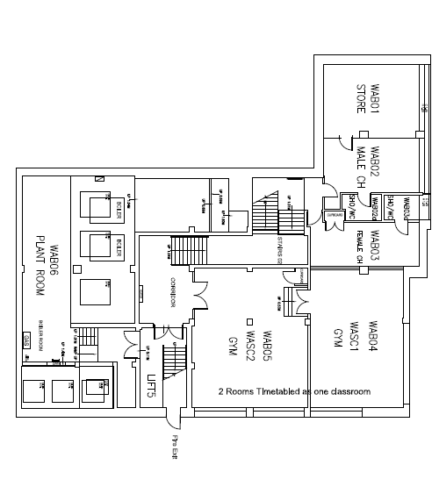
Ground Floor

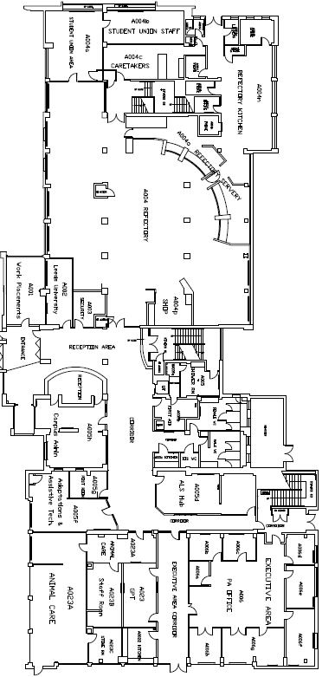

First Floor
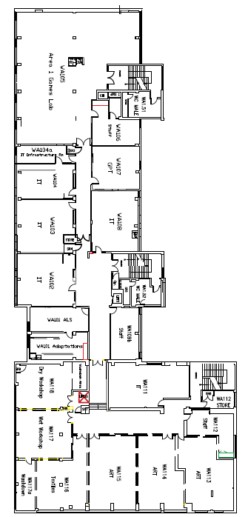

Second Floor
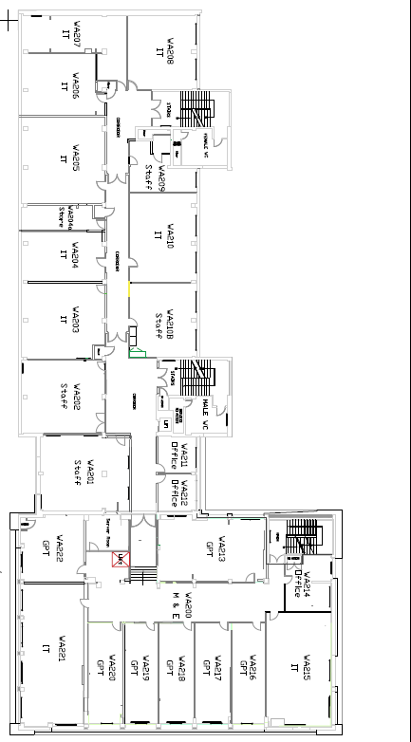

Third Floor
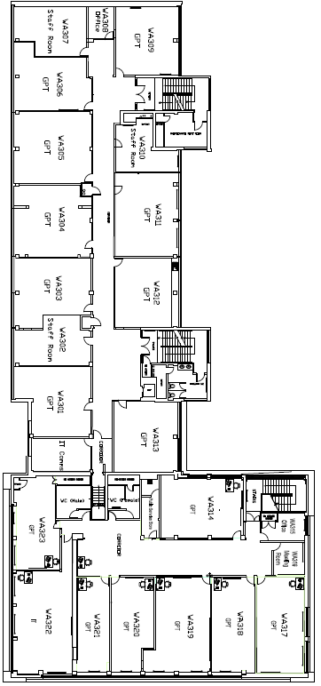

Fourth Floor
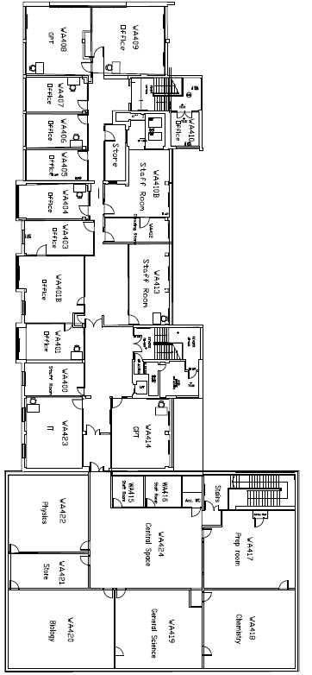
Seacole

Ground Floor
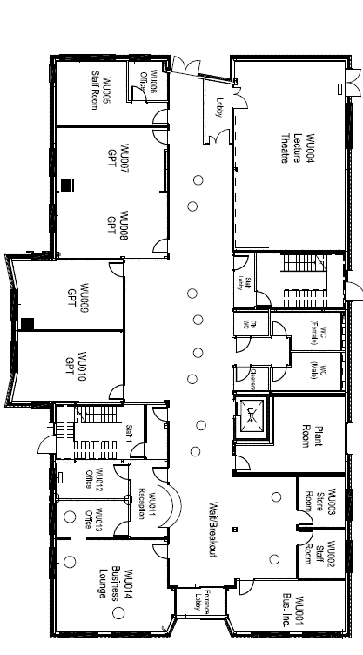
First Floor
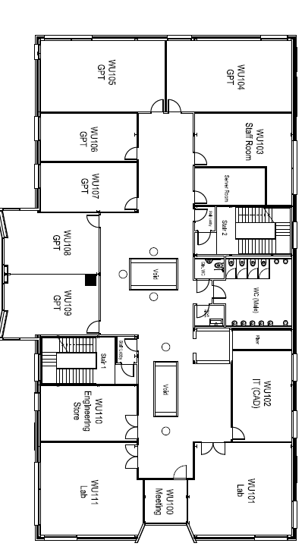

Second Floor
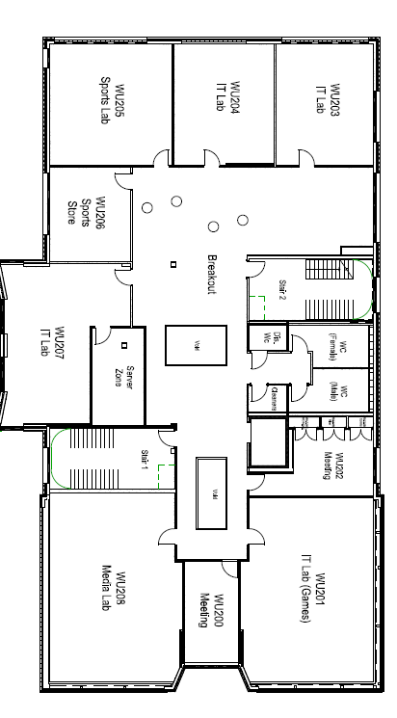

Beaumont

Ground Floor
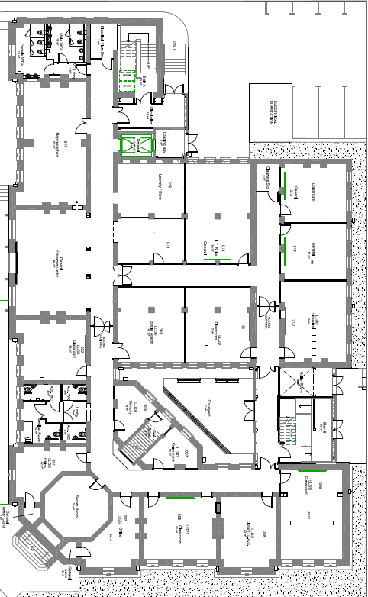

First Floor
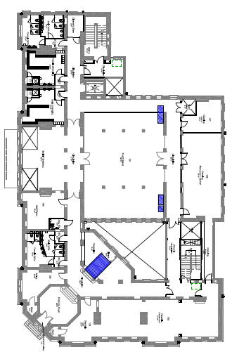

Second Floor
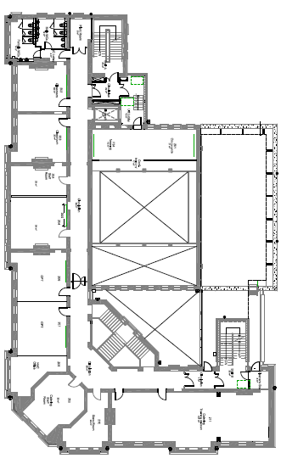

Third Floor

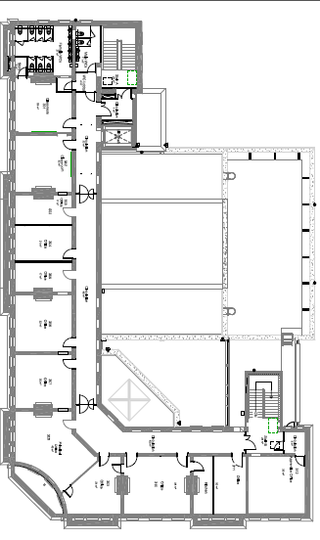

Harrison

Ground Floor
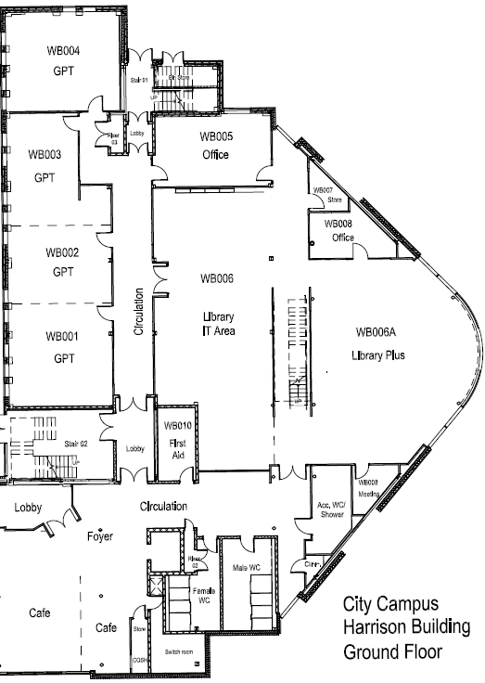

First Floor
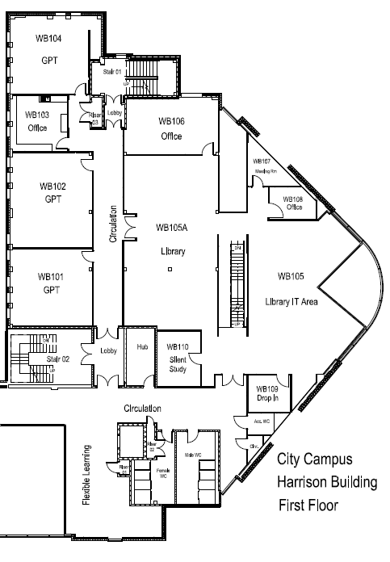

Second Floor
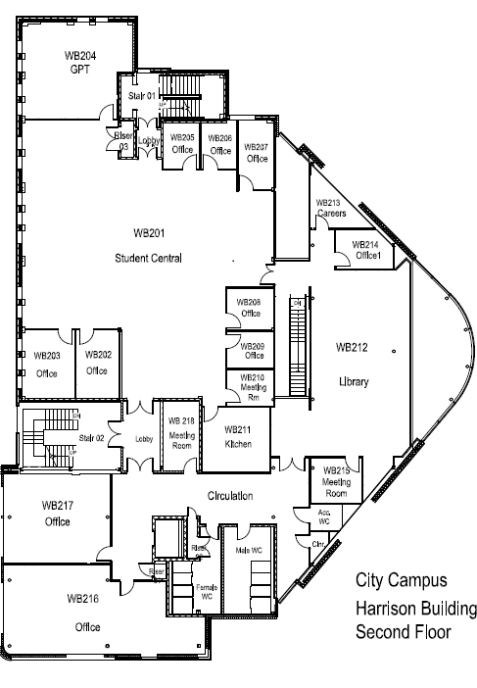

Third Floor
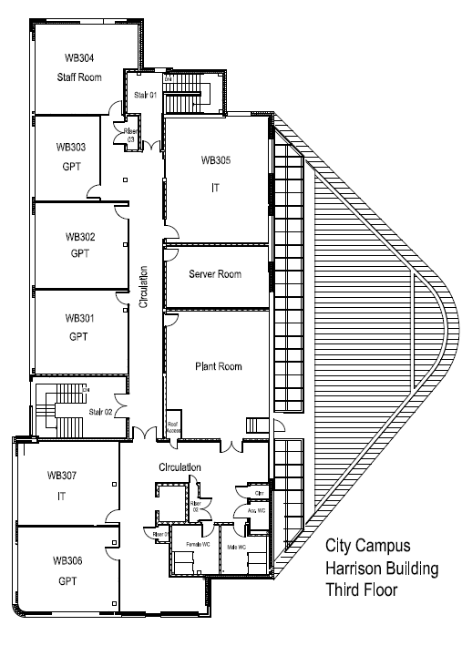

Gissing

Basement
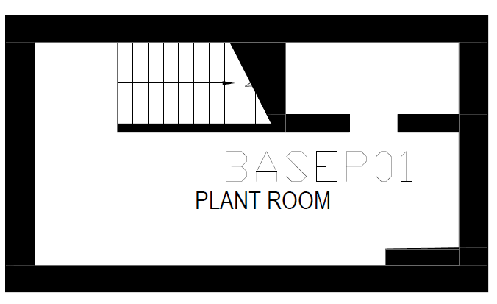

Ground Floor
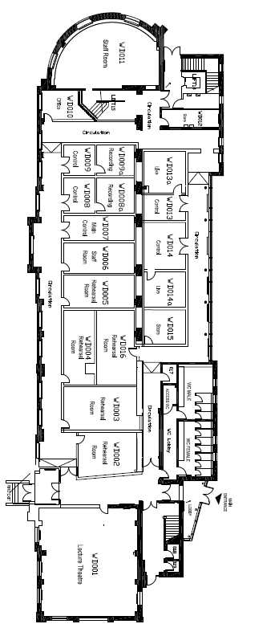
First Floor
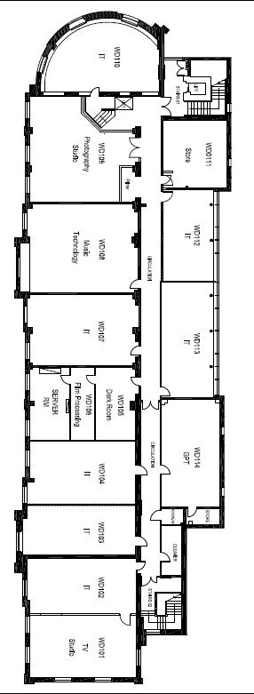

F Block

Ground Floor
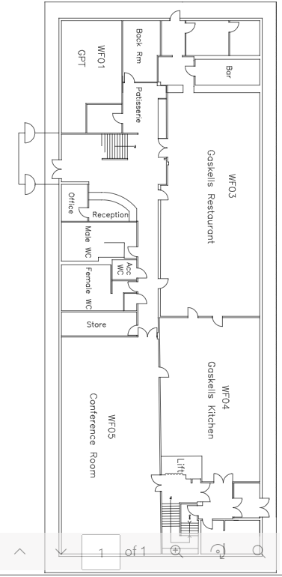

First Floor
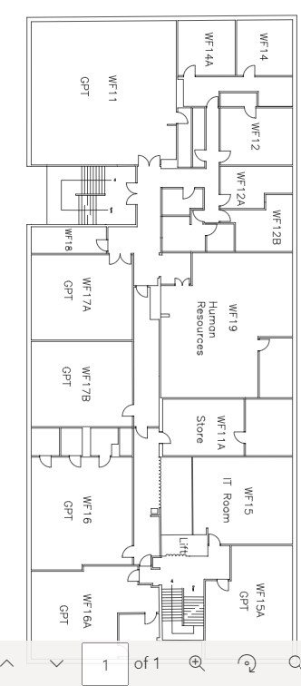

Second Floor
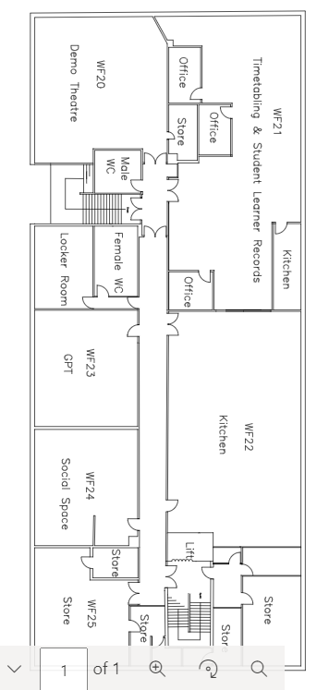

Extension Ground

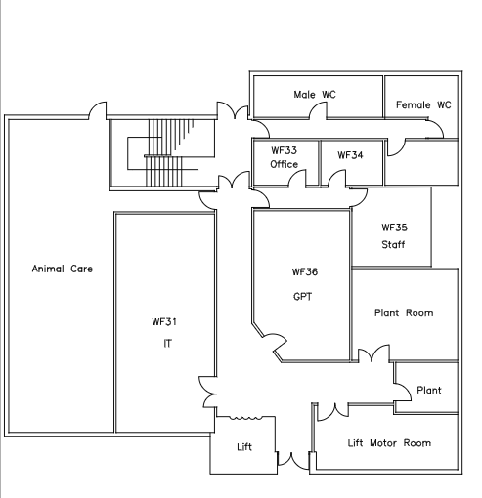

Extension Basement
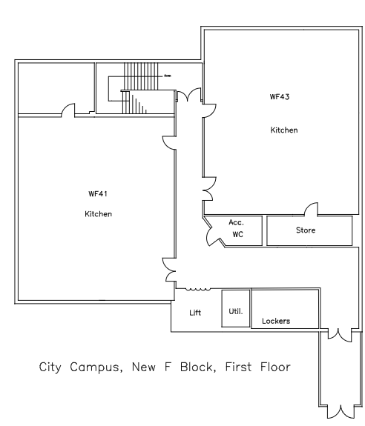

Waterton

Basement
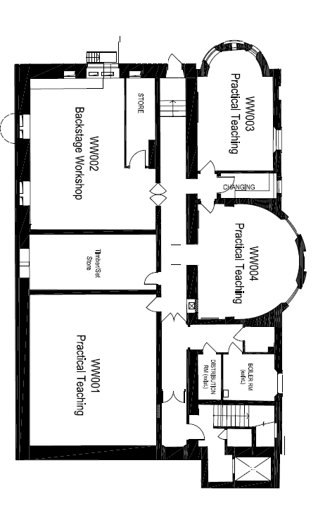
Ground
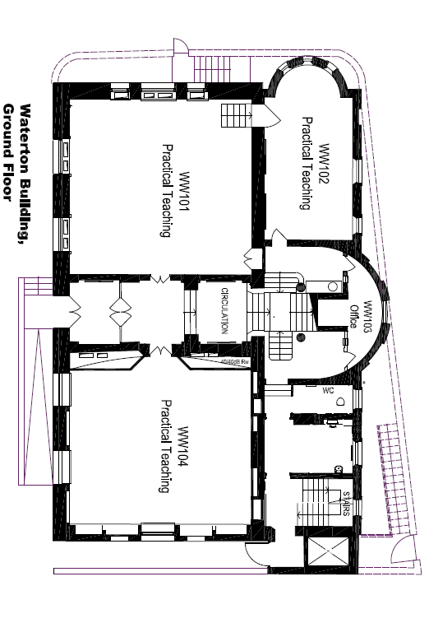
Mezzanine
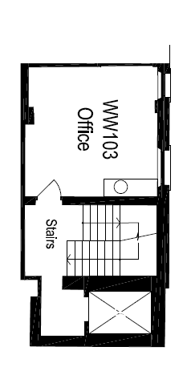
First Floor

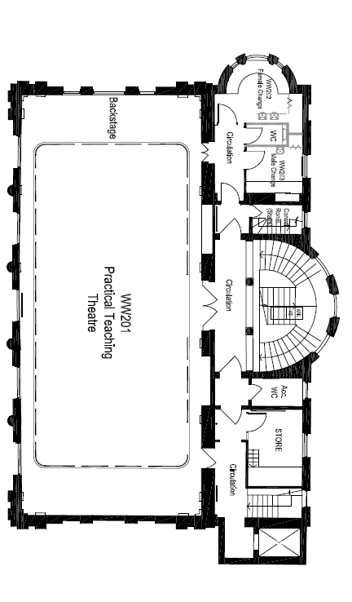
Stanley Royd Playing Fields

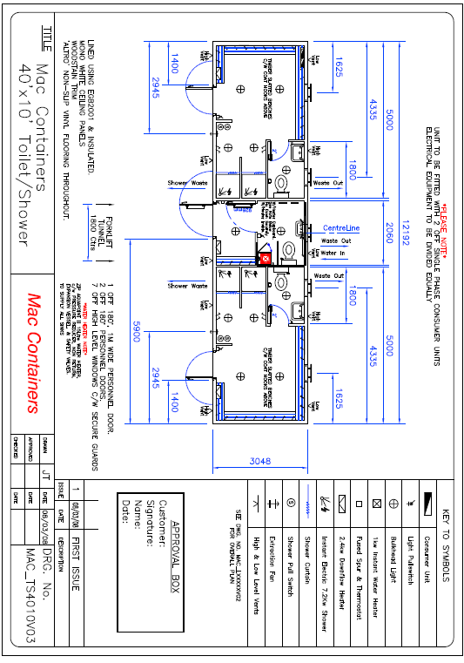

Thornes Park

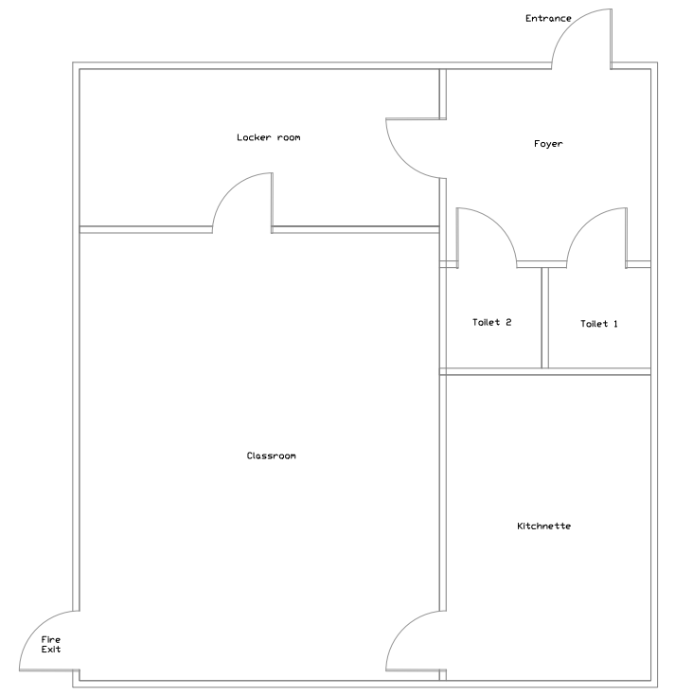

Castleford

Ground
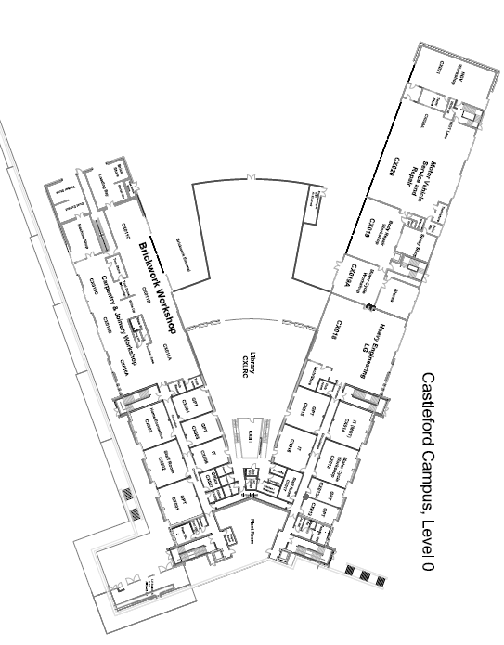

First Floor
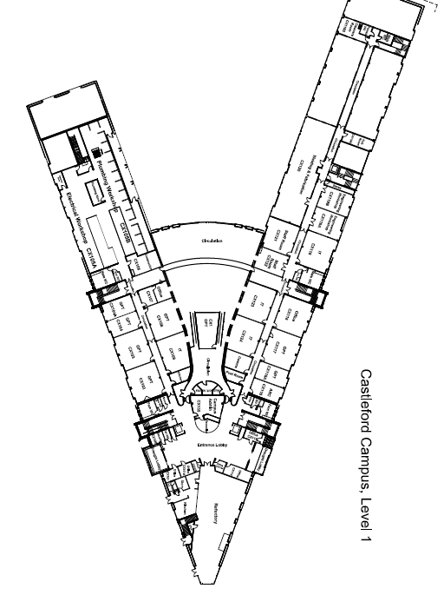

Second Floor
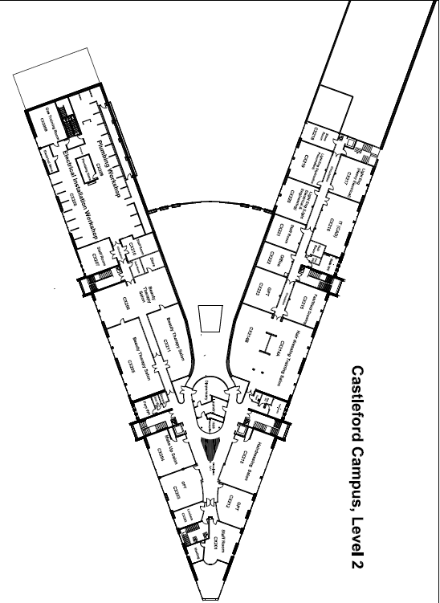

Third Floor
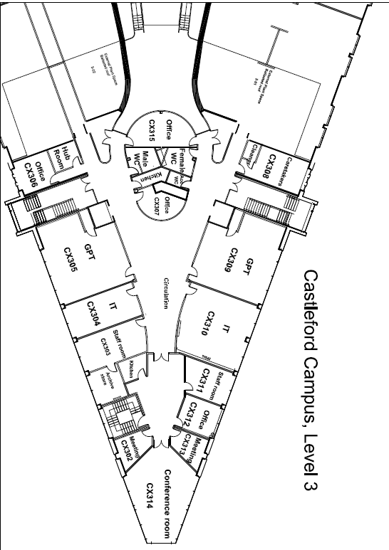

Selby

Jubilee

Ground Floor
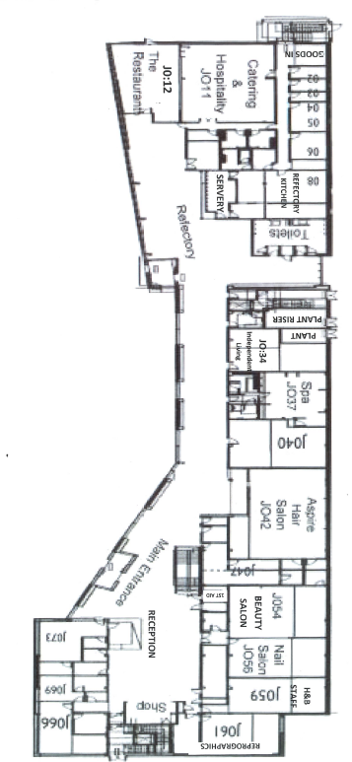
First Floor
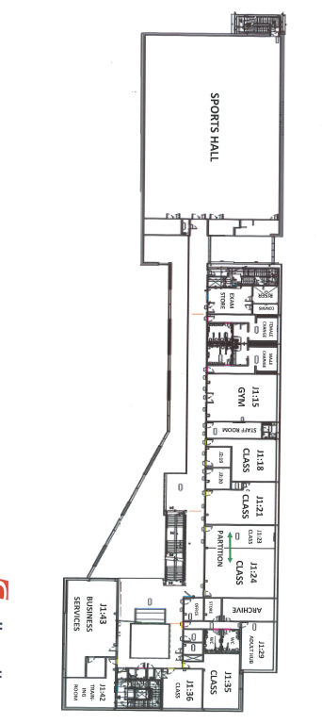
Second Floor
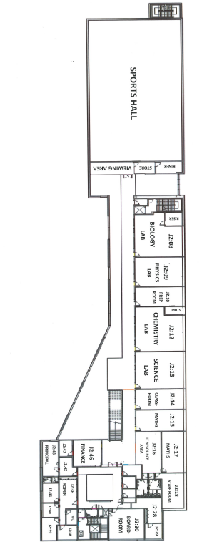

Academy

Ground
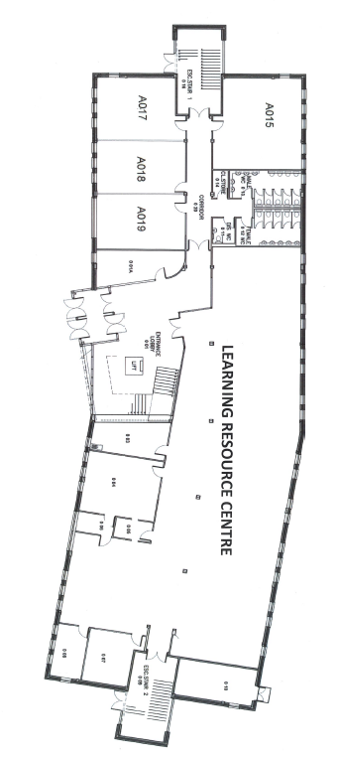
First Floor

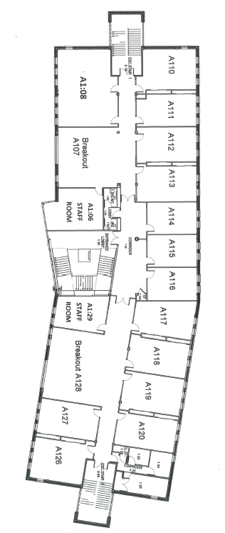
Second Floor
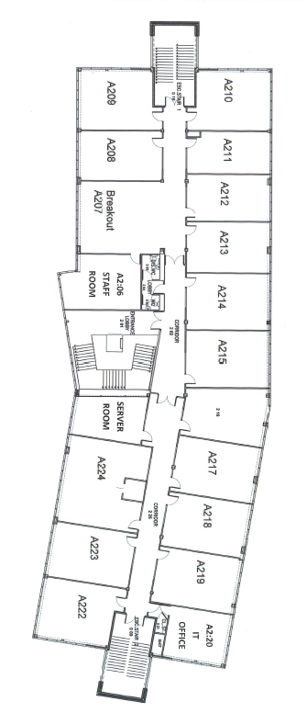

Aspiration
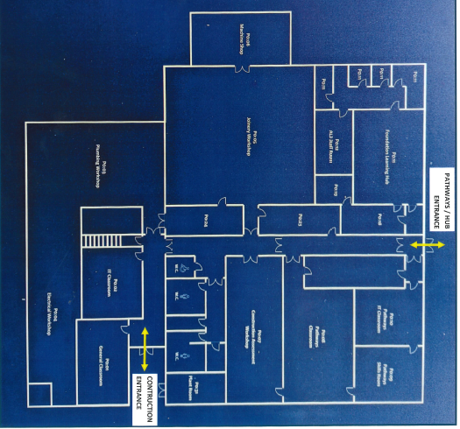

Renaissance

Ground
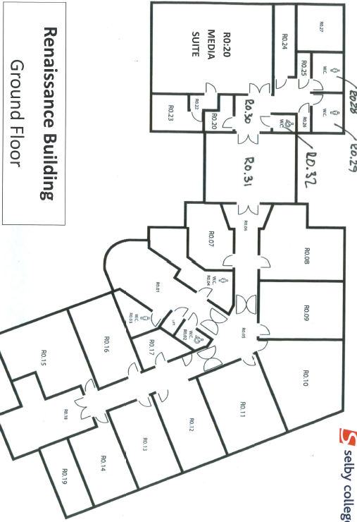
First Floor
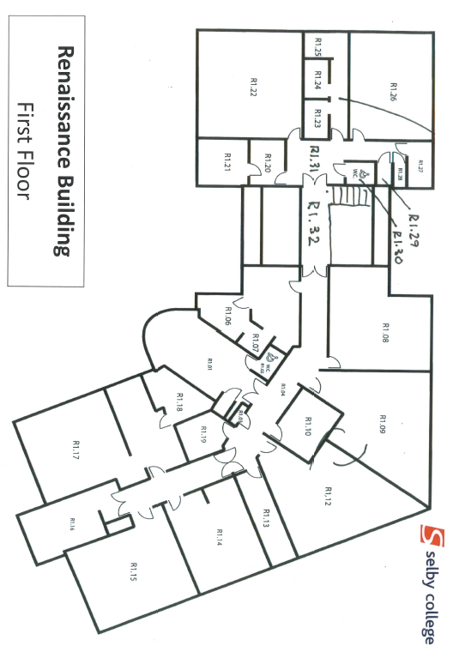

Engineering

Ground Floor
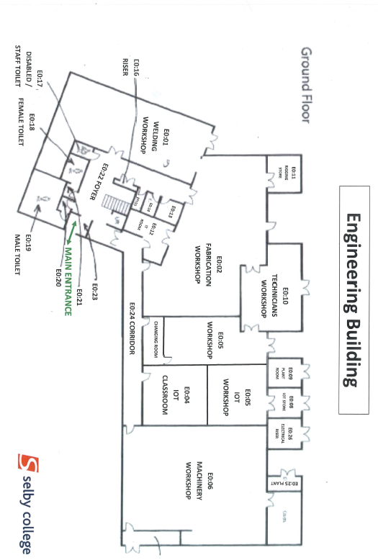

First Floor
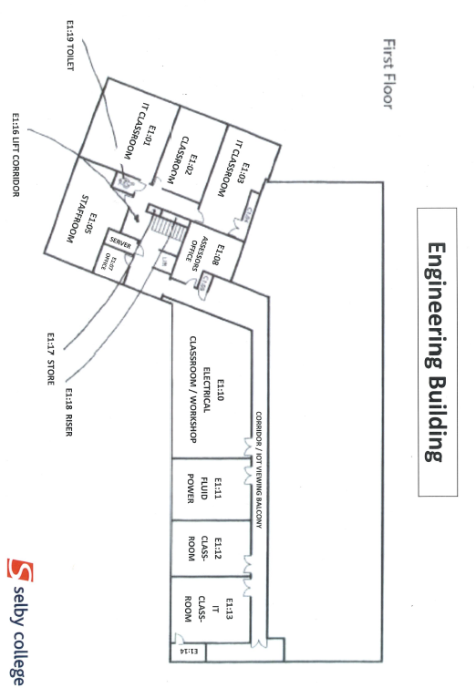
Nursery
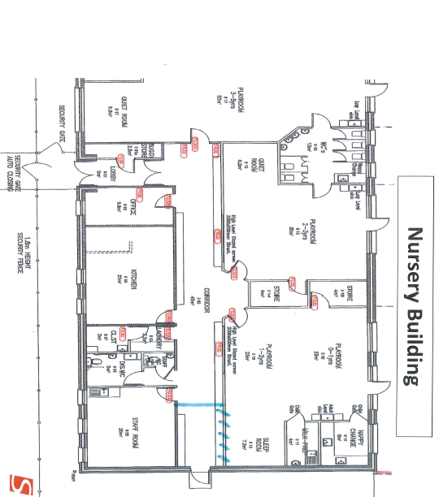

Sports Pavilion
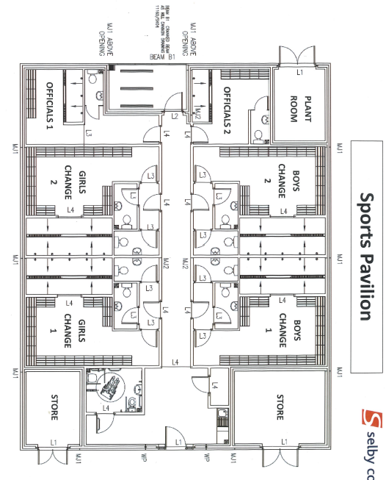

Estates / Support
