

**Sunnyside Football Changing Room Extension Project**

**1. Summary & Background**

This project is for the enhancement and extension of the existing Sunnyside Lane Changing Rooms.

The changing rooms are based at Sunnyside Playing Fields, Yate (displayed within the red circle below). Yate Town Council is both the owner and project actioner

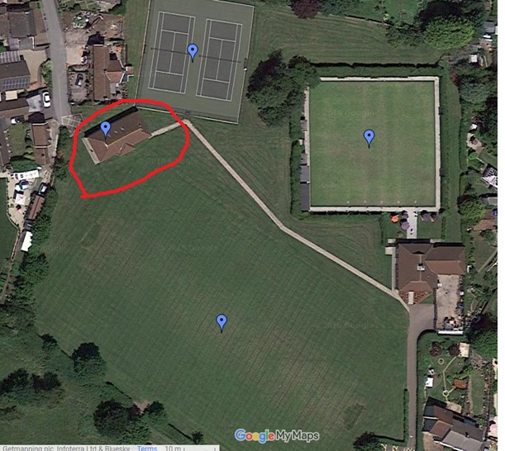

Developing Sunnyside changing facilities is part of our wider vision, for improving opportunities to engage in sport and physical activity within the yate area.

By providing greater capacity and improved facilities, this will make the Sunnyside Football pitches and tennis courts available for more people to use. The enhancement will provide an increase in physical capacity and offer the opportunity for mixed groups to use the changing rooms at the same time. The enhancements will also make the changing rooms accessible to members of the community with restricted mobility, thus allowing a more diverse range of users to enjoy the facility.

The existing facilities are always booked to capacity use during the football season. We turn away booking enquiries due to not having enough changing room capacity (we have 4 pitches – but only 6 changing rooms). These enhancements would allow for another game to be played alongside the existing games on Saturdays and Sundays during the football season (so two more games across the weekend). This shows a clear need for more capacity.

Outside of the football season, there is evidence 3G pitch/es would allow year-round use for things like children’s parties and 5-a-side games, as well as previously unexplored avenues like hockey practice. The addition of 3G pitch/es is something which Yate Town Council aspire to provide in the future.

The improved changing and toilet facilities will also be popular with the users of the tennis courts too. More changing facilities is often requested by the various tennis clubs who use our facility, and would further increase the usage of this facility too.

**2. Brief**

The purpose of the project is to develop an oversubscribed existing community sports changing facility, to increase capacity for existing and future users of Sunnyside football pitches and Sunnyside Pavilion (Bowls and Tennis Club).

The project will deliver the following (in line with the drawing supplied by Askew Cavanna featured in **Appendix 1**):

* Increase the number of changing room facilities from 6 to 9 (including 1 disabled change/toilet);
* The new changing rooms and entrance to the facility to allow easy access for individuals with limited mobility and reduce likelihood of ASB;
* Improved and updated toilets;
* To increase the showering facilities to enable female and male football to be scheduled alongside each other;
* Solar panels to be installed – to help provide hot water and aid with general sustainability;

**3. Full Specification of Works** *(Please see* ***Appendix 1*** *for a comprehensive specification of works to be completed)*

**4. Timeline**

*The timeline for this project can be found in* ***Appendix 2***

**4.1 Key Deadlines**

The Tender process will go live with final documents on 16th April 2018 and the closing date will be 11th May 2018 at 12pm.

The project must be completed no later than November 9th 2018.

Yate Town Council will carry out end of project inspections to ensure the work has been completed to a satisfactory level. Contractors will be expected to enter agreement of a 12 month end of defects period as part of the tender process.

Once practical completion is achieved and any snagging issues resolved, it should be possible for the building to be handed over to Yate Town Council for use straight away.

**5. Other Key Information**

**5.1 Environmental Sustainability**

Yate Town Council is committed to environmental sustainability. We aspire to source and use environmentally sustainable materials wherever reasonably possible

**5.2 Residents**

There are residents within close proximity to the construction so contractors will need to be mindful of this, full information regarding site access and deliveries can be found within the ‘Schedule of Work’ document.

**5.3 Distance of Contractor**

During the analysis of tenders, preference will be given to the lowest cost tenders provided by contractors within the South West region of the UK.

**7. Questions/Inquiries/Site Visits**

Please contact **Lori Ramsay- Community Projects Manager** at Yate Town Council with general inquiries relating to the project on

01454 862595 or [info@yatetowncouncil.gov.uk](mailto:info@yatetowncouncil.gov.uk)

To arrange a site visit **contact Phil Jones- Estates Manager** at Yate Town Council on 01454 866251 or [info@yatetowncouncil.gov.uk](mailto:info@yatetowncouncil.gov.uk)

**8. Scoring Criteria**

Yate Town Council has appointed Askew Cavanna to analyse tender responses on behalf of the Council. Criteria to evaluate the responses will be in line with the items listed within the ‘Schedule of Work’ document in addition to the following criterion:

-Cost;

-Distance of contractor (prefer to be within the South West region of the UK);

-Responses to due diligence paperwork **(Appendix 3).**

**9. Submitting a Tender Response**

9.1 Each tendering firm shall return their response to the address stated below:

Yate Town Council

Poole Court

Poole Court Drive

Yate

South Gloucestershire

BS37 5PP

9.2 Each tender response should arrive in a specially marked envelope bearing the words `FAO TOWN CLERK, TENDER – DO NOT OPEN UNTIL 12pm 11th MAY 2018’ but no other means of identifying the tender, in which the tender is to be sealed and remain sealed until the prescribed date for opening tenders for that contract. All tenders when received shall be endorsed with date and time of receipt. No fax or e-mails will be accepted.

9.3 Returned tenders shall be opened together after the return date by the Clerk, the RFO in the presence of the Chair or Vice- Chair of Council or a member of the committee which will consider the tenders. Opening of tenders shall normally be in advance of the meeting at which they will be considered in order that clarification of any points of detail, which may be necessary, may be obtained from tenderers.

9.4 On recording the tender responses, further contact will be made with each organisation to obtain an email containing the tender documents electronically. organisations will be given until 3pm 11thMay to submit these to Yate Town Council.

9.5 Tenders received outside of the deadline will not be accepted nor considered as part of the tender analysis.