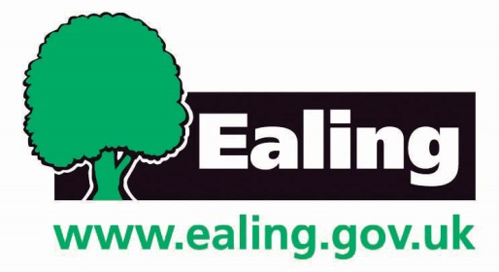

PRIVATE AND CONFIDENTIAL

Soft Market Testing Briefing Note for
Health Visiting and School Nursing Services

Monday 24th April 2017 at 11.30-14.30
Room 4.12 at Perceval House,
12-14 Uxbridge Road,
Ealing
W5 2HL

INFORMATION FOR INTERESTED ORGANISATIONS

The London Borough Ealing is undertaking a soft market testing exercise to determine how best to deliver the health visiting, Family Nurse Partnership, health visitor advisory and school nursing services in accordance with its public health duties and relating to the delivery of the Child Health Programme to the age group 0 to 19 population.

The services will be expected to work as part of an integrated service that also comprises family support and therapies. The service will work at universal, targeted and specialist levels. There will be a strong emphasis on both health promotion and safeguarding children and young people as well as on effective delivery of the health visitor mandated items.

Please see attachments of the draft specification and draft Terms and Conditions for further detail on the service required.

The Council would like to understand from providers how these requirements might best be met and is therefore carrying out a soft market testing exercise to engage in early informal dialogue prior to any formal procurement taking place.

Being a local government organisation we are constantly looking for innovative ways to ensure that our customers receive a high quality service that operate the most cost effectively and efficiently as possible. All of the participating organisations need to achieve value for money in the commissioning and delivery of services our goal is to identify how your organisation can help us run most economically? Please come along with ideas and examples of how you suggest that Ealing can achieve this.

The Soft Market Event will take place on

Monday 24th April 2017 at 11.30 am till 2.30 in Room 4.12
Perceval House,
12-14 Uxbridge Road,
Ealing
W5 2HL

Please note that bidders are not required to attend this event, and may email their thoughts to willsonm@ealing.gov.uk.

All interested organisations are requested to RSVP by emailing wilsonm@ealing.gov.uk no later than 18 April 2017.

All information provided at the event and any subsequent discussions will be strictly confidential and will assist the Council in shaping and scoping requirements and provide insight into the most suitable delivery model for this service. The Council is planning to advertise this service between June and September 2017 with the aim of awarding the new contract by April 2018 and with a start date for the service of October 2018.

Based on the background information provided (see the attached draft Terms and conditions and draft Specification) please come to the event with your views and information on the following. Note that you are not required to fill this in although it would be helpful to us if you were to do so.

1. What, in your experience, are the challenges and success factors for the delivery of services such as this?

2. What innovative approaches do you take to ensure good performance on the health visitor mandated items and to achieve best outcomes for children?

3. How have you added value to these services in other areas that you have worked in?

4. How do you meet the challenge of delivering services within a borough to ensure equity of access to services and outcomes?

5. Can you describe what approaches you take to delivering health visiting services at targeted and specialist levels? Other than the FNP, what other methods of intervention would you consider using?

6. What are your views on delivering against an outcomes based contract, in relation to health visiting and/or school nursing?

7. What do you consider to be the key requirements for developing a workforce to deliver the services outlined in the draft specification

8. What are the skills and roles you see as essential for delivering this service?

9. How do you think schools are most effectively helped by school nursing to support children with health care needs?

10. TUPE may apply to this contract. Would this impact your interest in providing this service and if so what should the Council consider to mitigate any impacts?

11. Which factors in the Specification and Terms and Conditions have, or are likely to influence your level of interest in delivering this service?

12. What social value opportunities could be maximised throughout the delivery of this contract (including any social benefits, economic benefits and/or environmental benefits)?

13. How does your organisation measure success in service areas covered by this contract?

14. Collaboration is important to us. Please outline any potential collaboration opportunities that may help delivery of this type of contract?

15. Due to the value and nature of these services, the Council is legally obligated to comply with the Public Contracts Regulations 2015. The procurement options are outlined below; please choose which you prefer and provide any comments:

Open procedure (an open market tender)
Restricted procedure
Competitive procedure with negotiation

16. Please provide any further comments you may have that would affect your interest in this opportunity

The draft timetable for this commissioning exercise is set out below:

Activity | Indicative Date
Soft Market Testing | Monday 24th April 2017 at 11.30
Issuing of Tender on London Tenders Portal | Between June and September 2017
Award of Contract | April 2018
Mobilisation Contract Live | October 2018

