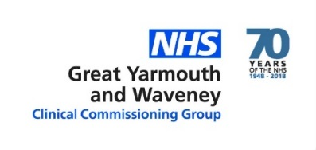

.
Outline Service Specification
Adult Community Services
and Specialist Palliative Care Services 2019-20

1 Local context and strategy

1.1 NHS Great Yarmouth and Waveney CCG (GYWCCG) commissions healthcare for a registered population of 239,525 (Jan 2018). Our population is made up of a combination of urban and rural; affluence and deprivation.

1.2 Our ambition, of ‘better health, better care, better value’, is our abiding principle and guides the way we design and commission services for people living in Great Yarmouth and Waveney. We are committed to integrated working with our health and social care partners and this work was recognised nationally with an HSJ Award for improved working with local government.

1.3 This commitment to integration is further described in the statements below, taken from recent strategic plans.

‘That by 2020 health and social care is integrated across the Great Yarmouth and Waveney area, and delivered to meet the best needs of the population.’ ‘The integration of services to deliver person centred care and support should not be restricted by organisational boundaries, and should build on successful partnerships that exist to deliver those services.’

The theme of integrated, person centred services continues throughout the Norfolk and Waveney Sustainability and Transformation plan (STP) and national policy.

2 What we want to achieve

2.1 To further our vision, GYWCCG are seeking to procure adult community services and adult specialist palliative care services under a new contract from April 2019. Included within the scope of this project are services which are currently delivered by multiple providers in different ways. Absolutely key to this new contract will be the requirement for services to be integrated vertically and horizontally across pathways and organisations, locality based where suitable and a greater focus on ensuring positive patient, carer and system outcomes.

2.2 We want:

- Services to be easily accessible and understandable
- A system of services that work together, providing patients with the right individualised support at the right time in the right place
- A system that records a patient journey, avoiding the need for patients to re-tell their story unnecessarily
- Patients and carers to feel empowered and involved in planning and managing their own care
- A system that is rewarding to work within
- Improved health outcomes for the population

3 Our population and localities

3.1 Our area has four distinct localities; Lowestoft, South Waveney, Gorleston and Great Yarmouth and Northern Villages as illustrated below.

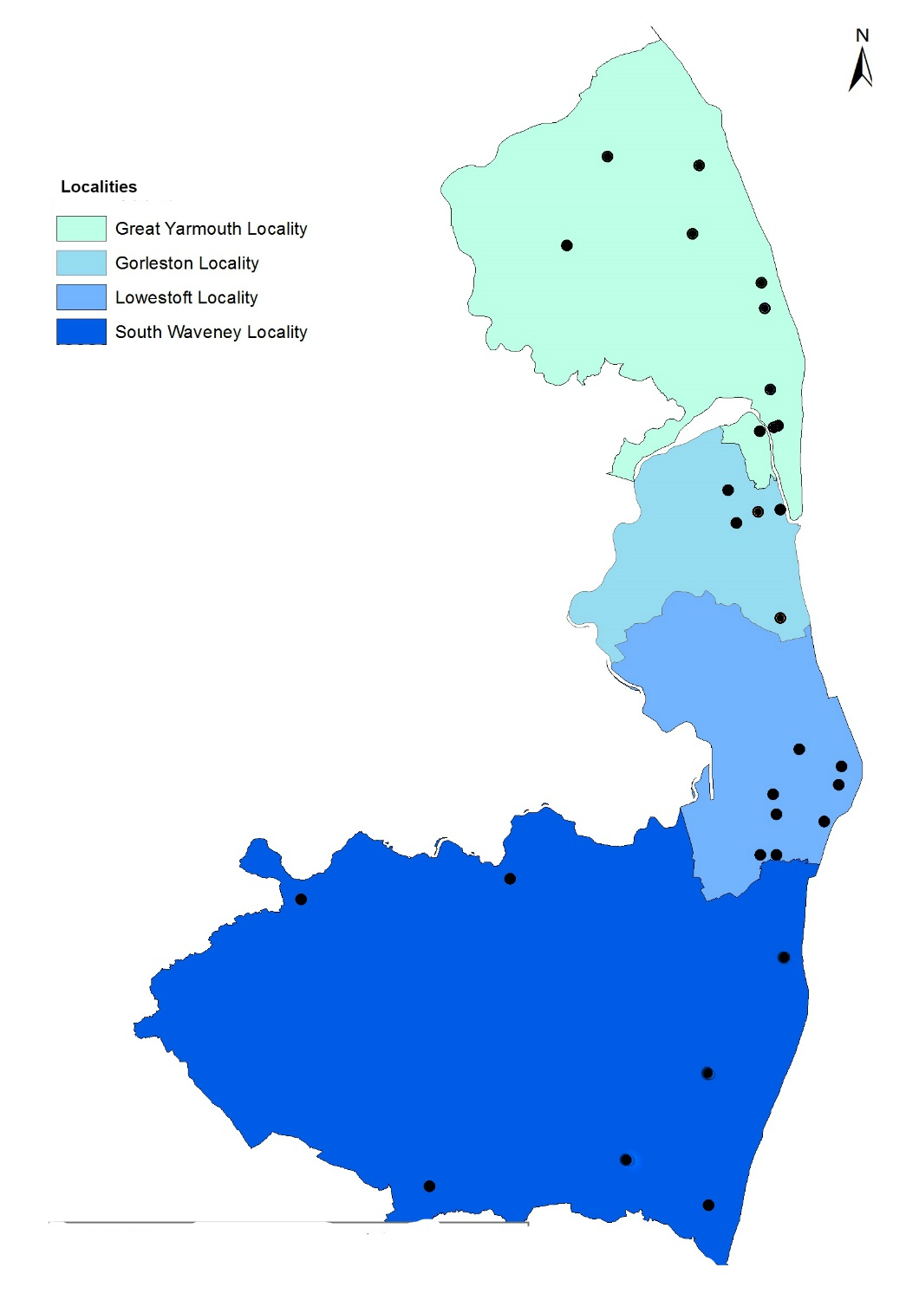

Indicates GP practice

3.2 One of our current priorities is continuing to support the development of resilient and progressive primary care across our four localities, recognising both primary care as the corner stone of health and care provision for our population and the short and long term risks to patients of unsustainable general practice.

3.3 Geographically our localities treat similar populations, and our general practices form natural clusters, providing patient bases of between around 45k and 80k patients. Whilst these are instinctive clusters, they each have different characteristics, which means that collaboration may be different in nature in each of them and be wider than general practice alone (e.g. local authority community hubs and commissioned services).

3.4 Larger groupings of general practice also supports more integrated working with secondary care, community and mental health providers as well as local government. Traditionally providers have been keen to develop local models based on integrated teams around practice groups. Local government have also been keen to expand local pilots (e.g. to support independent living) to achieve greater public sector coherence.

3.5 Locality working is expected to benefit our population because it supports our ambition for residents, regardless of their health needs, to play a central role in their own wellbeing. We believe the key tools for people being able to optimise their health and wellbeing are ones found within their local community, with primary care at its heart, and include:

- being able to access the services they need through primary care, the custodians of their story

- ensuring the role of their family and carers is recognised and appropriately supported, through local support networks

- having the opportunity to be part of their community and build personal resilience

- pathways which are focused on the needs of the individual not based on organisational structures

Patient centred care provided by localities

3.6 Our local authority, social care, voluntary sector and public health partners are all key to supporting these opportunities which are also underpinned by proactive services and locality working. Any future service provision will need to be able make effective connections across these areas to enable access to local services and support networks for our whole population.

3.7 Wherever possible and where service need lends itself, we want services to be configured around localities. Working closely with general practices, who remain the cornerstone of our local health care system and as reflected in our local primary care strategy, will be key to delivery of all community services.

3.8 Service provision must also reflect the distinct demographics of our area, which includes rural and socially isolated communities, pockets of extreme deprivation, lower than average levels of life expectancy and significant numbers of people living with common chronic conditions.

3.9 Services need to focus on the challenges of an ageing population with increasing health needs, a growing need for health and care at or closer to home and the importance of ensuring timely and appropriate admissions and discharges from hospital.

3.10 Appendices at the end of this document show examples from a document produced by Norfolk County Council in February 2017 which reflect some of the key areas of health and wellbeing for the Great Yarmouth and Waveney area.

4 Outcomes
4.1 The new contract will be outcome based, focused on improving:

- Peoples experience of health and care
- Peoples health and wellbeing
- Efficiency and value for money of services
- Integrated services across the system including primary, community and social and secondary care
- Self care

4.2 Outcomes will be assessed by reviewing a wide range of performance information, both qualitative and quantitative. These will include but are not limited to:

- Patient and carer feedback through comments, complaints and questionnaires
- Local peer evaluation
- National standards where relevant to services being delivered
- Nobody admitted or kept in hospital or residential care unnecessarily
- Compliance with NICE guidance relating to specialist palliative care
- Supporting the delivery of choice at end of life, including place of death
- NHS Constitution and national standards
- Supporting and contributing to STP objectives, including locally agreed delivery improvement plans

5 Care Delivery

5.1 Assessments, care planning and care will be delivered close to home wherever it is safe and sensible to do so. Locations may include:

- Patients homes
- Residential care and nursing homes
- Suitable community locations
- Existing NHS estate
- Community Hospital
- Acute hospital wards, discharge hub and outpatient clinics
- Other health and social care sites

5.2 At the heart of care delivery, will be care delivered through shared pathways, integral to which will be collaboration across the acute trust, community teams, GP practices with close links to adult social care reablement services and the voluntary sector.

5.3 Staffing will be organised to meet the identified needs of the population and will be flexible to allow staff to work across organisational boundaries and at all locations. Utilising a multi-disciplinary team approach teams will ensure appropriate case management and risk stratification.

6 Services within scope of this procurement

6.1 This procurement provides an opportunity to achieve fundamental change in the way services are designed and delivered, moving away from historical service line descriptions.
Patient story told once
Holistic care planning and co-ordinated multi-disciplinary and specialised delivery
Communication and care plan held centrally

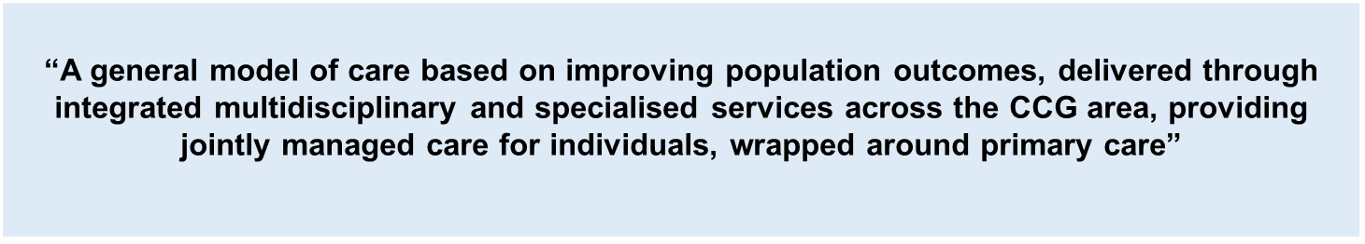

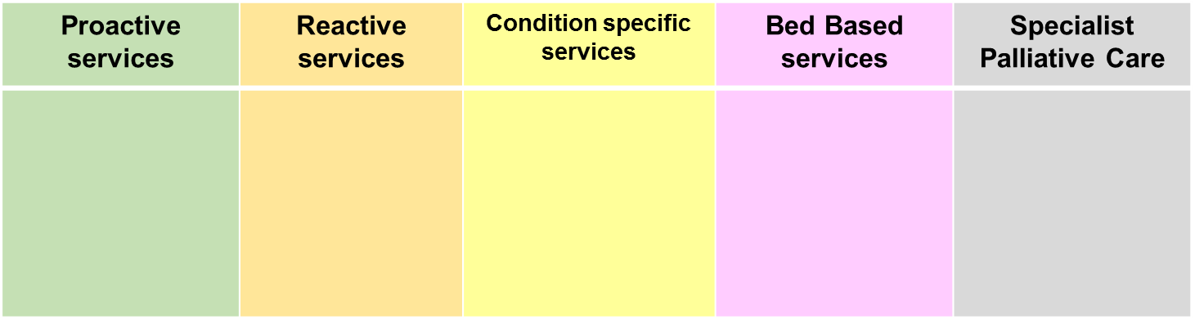

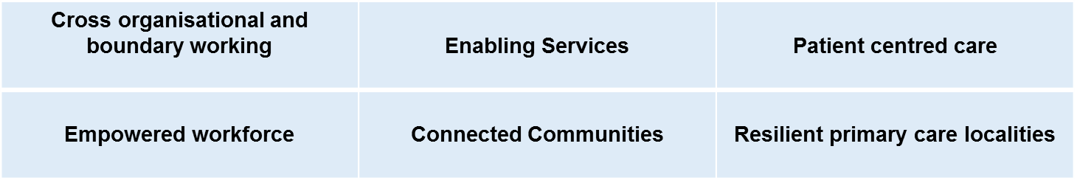

6.2 The categories of services described above focus on form, rather than function, divided in areas but with inevitable overlap.

6.3 It enables GYWCCG to commission a comprehensive community based, consultation led specialist palliative care service which complies with NICE and other national guidance.

Next Steps

- The next section describes the services in greater detail

- The end of the section contains a matrix style document, providing a visual aid to map current service delivery to our future vision.

- Within each category of service, there is a section titled ‘local outcomes’. This highlights some of our main areas of focus.

- Further to this, GYWCCG would also require all services to be compliant with all relevant national standards and further KPIs will be developed as part of the procurement process.

7 Proactive Services

Service Description
Proactive services require strong clinical and operational leadership within local networks. This will empower staff involved in care assessments to make quick decisions, ensuring that any care needed is delivered in a joined up way, in the most appropriate setting.

Staff will ensure that patients are:

- involved in their care planning
- aware of what to expect, when and why
- informed to support their own care, including how to recognise changes in their condition, what to do if they do and who to contact
Routine services will be delivered across a variety of community settings to both ambulant and housebound patients by a workforce including nurses, therapists and generic workers and include planned appointments and interventions.

Service provision will need to “wrap around primary care” and be configured to serve our four distinct localities, with reference to the unique nature of each area, adapting to the needs of their demographics, rurality, transport, disease prevalence etc.

Prompt access to specialist advice and services will be key to team leaders being able to respond to needs and deliver appropriate planned care (e.g. triage and administration, pharmacy, equipment). These must work together to provide seamless care for patients, a single point of referral and ensure that general practice are informed/have access to information in respect of care being delivered to their patients as appropriate.

These services will be required to adopt a collaborative multi-disciplinary team approach to risk stratification (using clinical tools) and management with clinical judgement and care planning at their heart to keep people as happy and healthy in their own homes as long as possible. Strong links with a wide range of support networks, both voluntary and statutory will be essential to ensure that care is individualised, enables independence, resilience and promotes self-care as well as choice.

Proactive services will support the delivery of educational and public awareness programmes. They will link into public health initiatives such as smoking cessation and alternatives to A&E.

Local Outcomes
Well informed patients, engaged in their own care planning and equipped with knowledge and skills for self-care related to any health conditions.

Services which are accessible and meet the identified needs of local populations.

Key areas of focus
Location of clinics and service delivery to reflect the identified needs of local populations, including home visits for housebound patients and links with primary care.

Ongoing holistic assessment, multi-disciplinary team (MDT) review and care planning, including advance care plans for individuals with degenerative conditions.

Care delivery organised to maximise resources and avoid multiple appointments and home visits.

8 Reactive Services

Service Description
7 day working across reactive services will be required, with a single point of access and clinical triage to ensure urgent care needs are met in in a consistent and appropriate manner according to need.

7 day working will include referrals, assessment and care delivery to respond to unplanned urgent or crisis care for people whose health or care needs have deteriorated placing them at risk of serious decline in their condition and/or emergency admission to hospital.

These services will also enable an alternative to hospital care and support discharge, e.g. the provision of community IV service, short-term personal care and therapy plans.

Care will be delivered to patients in their usual place of residence.

Prompt access to specialist advice and services (e.g. pharmacy, equipment, community beds, etc.) will be key to teams remaining agile and being able to respond to urgent care needs and system pressures.

Key areas of focus
Personalised and co-ordinated care and support for individuals during a crisis without them having to go to hospital.

Patients, family, carers and GP kept informed about any care received.

Services provided for individuals in crisis in their usual place or residence.

Primary care locality approach to enable joint evaluation of services to promote effective use and ownership of resources.

Local Outcomes sought
Single point of access for all professionals.

Rapid response and health and social care provision for individuals referred from primary care to avoid unnecessary and avoidable emergency conveyance and admission to hospital.

Reduction in the number of people requiring short/long term bedded facilities in acute and community hospital, residential or nursing home.

When people are admitted to a bed, a reduction in the length of stay in the bedded facility, including in-reach to acute and community hospitals.

Increase in the number of people remaining/returning to their own home.

Decrease in the number of long term care placements.

9 Bed Based Services

Service Description
Community hospital/bed provision with robust clinical accountability including:

- Intermediate care (community hospital beds with 24/7 nursing cover)
- Palliative and end of life care
- Admission avoidance/facilitated early discharge
- Reablement
- Fastrack continuing healthcare

These services will provide time-limited clinical based bed provision for predominantly older people who have ongoing medical, nursing and/or reablement needs to avoid, or following, an episode requiring admission to an acute hospital bed that could not be safely managed within the individual’s usual place of residence. The services will also provide support for patients with palliative care needs and for those at the end of their life for whom care within their usual place of residence isn’t desired or possible

Key areas of focus
Maintaining and promoting independence for as long as possible for individuals to remain in their usual place of residence.

Promoting faster recovery for individuals and reduce risks associated with acute hospital stays (e.g. muscle deterioration) wherever it is safe and sensible to do so.

Providing individuals with every opportunity to fulfil their reablement potential after an episode of care in an acute hospital.

Local Outcomes sought
Community bed based care to safely manage individuals to avoid hospital admission or facilitate early discharge that could otherwise not be done in their usual place of residence or other community setting.

10 Supporting and Enabling

Service Description
These services are integral to the delivery of health and care provision within the community, and must be responsive, adaptable and supportive.

Examples include but are not limited to, community pharmacy support, home oxygen and wheelchair and posture service.

Medicines management provider service – pharmaceutical advice for service provision and medicines supply within community services and community inpatient facilities.

Home oxygen service – assessment and ongoing review of home oxygen supply.

Wheelchair and posture service – for patients with a permanent disability, including but not limited to assessment, prescription provision, adaptation and specialist seating. Provision for out of hours support, domiciliary visits, rapid access for end of life, progression of neurological conditions, etc. and implementation of personal wheelchair budgets.

Local equipment management - promote and facilitate equipment to enable admission prevention and rapid discharge. The provider will hold the Great Yarmouth and Waveney community equipment budget and manage peripheral stores, provide a local interface with the Norfolk and Waveney ICES (Integrated Community Equipment Service), engage with acute and other providers and users of ICES within Great Yarmouth and Waveney (including but not limited to the recall, reclaim and management of medical devices in their own services).

Key areas of focus
Prompt access for all community services to specialist advice and equipment to enable the delivery of holistic and seamless service provision across all settings.

Local Outcomes sought
Joined up, prompt and responsive provision of support for individuals under the care of adult community services and specialist palliative care. To include all aspects of care and interventions across all settings.

11 Condition specific services

.Diabetes

Service Description
The overall aim of the model of care for adults with diabetes is to increase the capability and capacity of the healthcare system as a whole to meet the needs of growing numbers of people with the condition and to ensure equity of access and the highest care; within the resources available and within the local context.

There will be an increased focus on maintaining health and wellbeing, early diagnosis and intervention, and support for individuals to manage their own care.

The service will deliver tier 2 Intermediate Diabetes services and tier 3 consultant adult services, type 1 patient education and professional education in an integrated model.

Key areas of focus
Delivery of an Intermediate Diabetes Service in the community. This service should support primary care management and be integrated across the health care system.

Local Outcomes sought
Improvement in diabetes treatment targets performance
Improvement in diabetes care processes performance
Reduction in secondary care outpatient activity
Improvement in Type 1 education performance
Individuals to have self care plans in place

Stroke

Service Description
Stroke Early Supported Discharge Teams provides early, intensive rehabilitation service for stroke patients.
Teams support individuals to leave hospital at the earliest opportunity and return to their own homes so that independence can be maximised as quickly as possible following stroke.
- To provide an individual bespoke package of rehabilitation for eligible individuals following a stroke in their own home, 7-days a week
- To improve the uptake of early supported discharge services for individuals with a Barthel Score greater than 9
- To ensure carers are appropriately educated and trained to recognise common causes of illness following stroke that result in avoidable admissions e.g. constipation, urinary tract infection
- To contribute to reductions in hospital re-admission rates
- To facilitate timely discharge from inpatient facilities
- To facilitate a reduction in length of hospital stay following diagnosis of stroke
- To ensure equity of access to early supported discharge
- To reduce the likelihood of mental health problems in carers and patients
- To include capacity for on-going evaluation of early supported discharge services
- To improve patient and carer satisfaction
- To effect transfers of care in a person-centred and timely way
- To facilitate improvements in the overall pathway including performance in national audits
- To ensure appropriate access to community rehabilitation services and long-term care provision following early supported discharge where required
- To facilitate appropriate interaction between health and social care to maximise benefit to improved stroke pathway and outcomes

Key areas of focus
This is a community based service with in-reach as appropriate. Treatment and assessment will take place in the individual’s home or usual place of residence or in the workplace. The service will include:-

- Speech and language therapy - assessment and treatment in communication and swallowing
- Physiotherapy – assessment and treatment
- Occupational therapy – assessment and treatment
- Mood screening and level 2 intervention and access to psychological support

Local Outcomes sought
- To ensure that people who have had a stroke achieve maximum independence and reduce reliance on long term care.

12 Specialist Palliative Care services

Service Description
The specialist palliative care service will be a consultant led community based service ensuring individuals have access to consistent palliative and end of life care across Great Yarmouth and Waveney by:

- Co-ordinating and managing holistic, joined up palliative care and end of life services across a variety of settings (e.g. individuals homes, acute and community hospitals, primary care localities, residential homes, etc.) during key stages of care pathways through a single point of access

Key areas of focus
The service will offer a wide range of responses across specialist palliative care delivered across seven day working, and including 24/7 access to advice, including

- Acute advisory teams
- Outpatient and day therapies
- Specialist palliative care beds within a hospice, community hospital or accredited care home setting
- Community based specialist palliative care, including night sits and support in care home settings

It will also include provision for (not an exhaustive list) :

- Supported self-care
- Domiciliary care and care homes (including enhanced)
- Primary care, including out of hours and attendance at Gold Standard Framework meetings
- Community nursing teams
- CHC Fastrack
- Education and training for all care settings
- Bereavement care
- Prescribing support

The outcome will be the provision of holistic, person centred care through:

- the proactive co-ordination, case management, advance care planning and anticipatory care for all people will palliative care needs and at the end of life
- shared inter-organisational governance arrangements for referral routes, acceptance and discharge criteria
- shared operational and communication protocols to manage interdependencies, shared data collection to show delivery of outcomes as a system

Local Outcomes sought
Well informed individuals and carers able to jointly plan and engage in their palliative and end of life care, including advanced care planning and choosing their preferred place of death

- Improved quality of life of all individuals with a palliative or end of life diagnosis
- More individuals being cared for and dying in their preferred place of care (PPOC)
- Earlier and more effective discharge from acute and community hospitals
- Reduced unplanned crisis admissions in the last year of life
- Ability to deliver more complex clinical interventions closer to home (note: community specialist palliative medical oversight is required for this element)
- Improved quality of life for people with long term conditions with a view to transitional care
- Co-ordinate and increase the existing pool of volunteers to support care in liaison with voluntary sector organisations
- System-wide coordination of stakeholders, partners to facilitate high quality care
- Working with a GP facilitator in relation to Gold Standard Framework meetings
- Closer alignment with social care through an integrated team model
- Highly competent, empowered and informed workforce delivering palliative care in the community and the provision of education to wider stakeholders as part of the day to day running of the service

13 Mapping of historic services to service categories

The table below provides a visual aid describing how the historic service lines broadly map into the new service categories.

Current service line descriptions |  | Proactive Services | Reactive Services | Bed Based Services | Supporting and Enabling Services | Condition Specific Services
District Nursing |  | X | X
Out of Hospital Teams |  |  | X | X
Physiotherapy | 1 | X | X | X
Neurology |  | X | X | X
Occupational Therapy | 2 | X | X | X
Podiatry |  | X |  |  |  | X
Falls Prevention service |  | X | X
Palliative care domiciliary support | 3 |  | X
Intermediate Care Beds |  |  |  | X
Pharmacy & Medicines Management |  |  |  |  | X
Specialist Nursing | 4 | X | X | X |  | X
Specialist Palliative Care Specialist Nursing |  |  | X | X | x
Community Matrons | 5 | X | X
Wheelchairs |  |  |  |  | X
Community Equipment (Management) |  |  |  |  | X
Specialist Equipment |  |  |  |  | X
Continence & Lower urinary tract service |  | X | X
SALT Adults |  | X | X
Tuberculous nursing service |  |  |  |  |  | X
Dietetic Services |  | X | X
Integrated Diabetes service |  |  | X |  |  | X
Insulin Pump provision |  |  |  |  | X
Home oxygen assessment service |  |  |  |  | X
Stroke – early supported discharge |  |  | X |  |  | X
Pulmonary rehabilitation |  | X
Cardiac rehabilitation |  | X
Beds with Care |  |  |  | X
1 – Service Line currently delivered by multiple providers 2 – Service Line currently delivered across multiple providers 3 – Delivered in partnership
4 – Includes specialist nursing delivered across multiple providers, including respiratory, pulmonary rehabilitation and stoma. 5 – Service Line currently delivered by multiple providers

14 Conclusion

14.1 GY&WCCG see the procurement of community services as an opportunity to engage openly with providers on providing joined up as it moves close to its ambition of an integrated care system.
14.2 GY&WCCG are committed to ensuring continuity of care for patients and support for the workforce throughout the process and recognises the need to maintain productive relationships with its partners across the system during this period.
14.3 GY&WCCG will work with the provider to continuously drive an improvement in outcomes and positive experience for patients and their families and carers, through the provision of accessible and effective care pathways.

15 Appendices

Appendix 1

Wider determinants of Health – NHS Great Yarmouth and Waveney

Appendix 2
Lifestyle and long term conditions – NHS Great Yarmouth and Waveney

Appendix 3
Causes of early deaths – NHS Great Yarmouth and Waveney

Appendix 1

Wider determinants of Health – NHS Great Yarmouth and Waveney

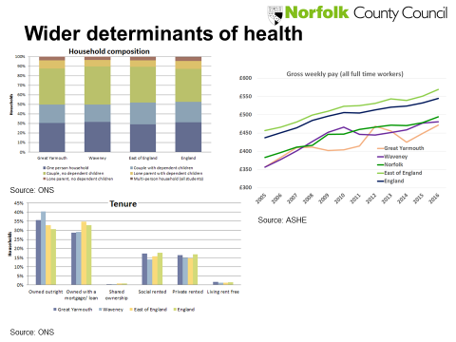

Appendix 2
Lifestyle and long term conditions – NHS Great Yarmouth and Waveney
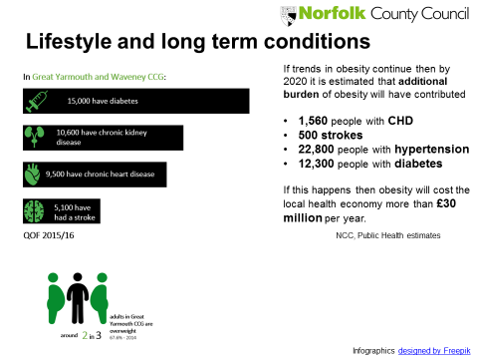
Appendix 3
Causes of early deaths – NHS Great Yarmouth and Waveney
