Market Testing
Home First – Discharge to Assess Services

West Sussex County Council in partnership with the county’s Clinical Commissioning Groups and NHS Trusts are developing plans for the provision of care and support services to enable people to be effectively and efficiently discharged from hospital. The plans may potentially include the commissioning of domiciliary care as part of a larger and multi-disciplinary service that supports people from the point of discharge. WSCC wishes to seek the views of domiciliary care providers for how these services may be best commissioned.

Background
Currently, a person’s pathway out of hospital may take one of several routes and potentially through a variety of services commissioned by Health and Social Care. The majority of social care assessments currently take place within the hospital setting with the individual being discharged from hospital at the point where capacity of any follow-on service allows. Limited capacity within community based provision often increases the amount of time a person remains admitted to hospital.

Plans currently being developed will enable patients who are clinically optimised and no longer in need of an acute hospital bed to be discharged home with support prior to a health and/or social care assessment. The home based assessment will determine if an on-going service is required, which type of service is appropriate and also the right level of support.

WSCC currently commissions Care and Support at Home services through framework arrangements with the majority of services being long term domiciliary care. WSCC also commissions a separate Community Reablement Service. Demand for services is currently greater than the supply with providers unable to develop the required levels of capacity. The rural areas of the county present particular challenges to ensuring sufficiency of supply. WSCC arranges services across three geographical locations; Northern, Southern and Western. Care and Support at Home framework providers are commissioned to deliver across one or more entire geographical areas

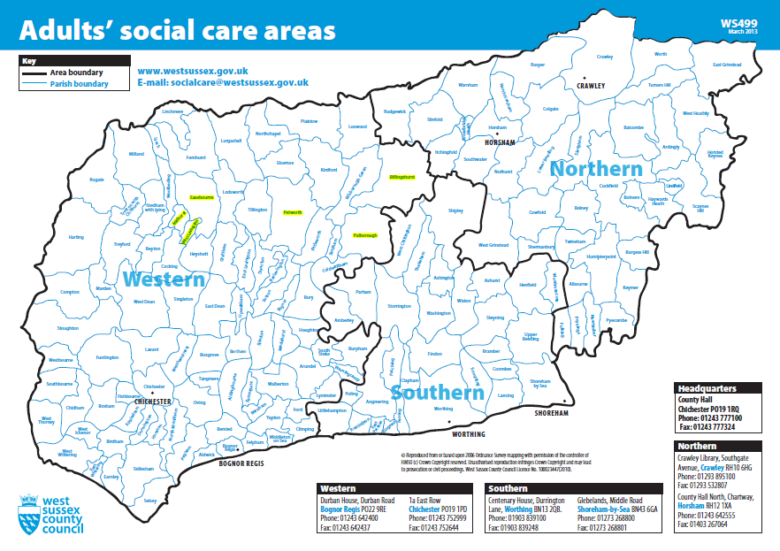Current Plans
WSCC is considering commissioning a domiciliary care service as part of, and to support, the Home First model. The service will form part of a greater service alongside health clinicians and other services to provide care and support to people being discharged from hospital and for some people, prior to a follow on service starting.

It is anticipated that there will be a need for between 500 and 1,000 hours to be delivered on a weekly basis across the whole county. Levels of demand will vary across areas and throughout the year. It is also anticipated that the service will operate and take referrals every day of the week. It is planned to commission the service to begin delivery in 2020.

Key features and requirements of the service are listed below.

- Full geographic coverage of West Sussex. Be able to deliver services across the whole area.
- Quick Response. Be able to respond to referral requests quickly and start new packages of care within short timescales.
- Guaranteed levels of capacity. Be able to ensure the minimum requirements of capacity are maintained at all times.
- Flexible levels of capacity. Be able to respond to increased demands through seasonal peak periods.
- An outcomes based approach. Be able to support customers to re-gain skills and achieve goals.
- Collaborative. Be able to work with health clinicians and other services, including incoming providers, to maximise service for customers.

Request for Provider Views
The purpose of this document is to seek views from providers on how these services may be best designed and commissioned to deliver the key requirements. Listed below are specific areas WSCC would be interested to receive the views from providers. We would be grateful if you could consider the information provided and respond to questions on the attached pro-forma.

 | General interest | - Is this sort of service something your organisation is interested in?  - Do you currently deliver similar services?  - Would you potentially submit a tender?
 | Geographical Coverage | - Should services for the whole county be offered as a single lot?  - Should services for separate operational areas be offered as individual lots?  - How best can the services be commissioned to ensure the levels of capacity and geographic coverage are delivered?
 | Payment Model | - Block and buffer hours model  - Suggestions for other models  - How best can the services be commissioned to ensure value for money?
 | Broad charges | - Without knowing specific in regards to areas, volumes or specification is there a broad price range you would cost these services at?  - What factors would affect your charges the greatest?
 | Impact on other services | - How would delivering this service impact on your other services?  - How best can the services be commissioned to minimise impact on other services and maintain capacity levels?
 | Other

How to Respond
Please complete the attached pro-forma and return by Friday 3rd May to

AdultsCommissioning@westsussex.gov.uk

