THETFORD TOWN COUNCIL
Thetford Town Council is seeking tenders for the grounds maintenance including grass cutting, litter picking, watering of floral displays for the period of 1 April 2020 – 31 March 2025.
TTC/19/004
Overall Requirement
This is a five year contract with a reserved annual break clause by Thetford Town Council (to be the subject of an annual satisfactory performance review of the contractor).

Quotation Requirements:
- Written quotation (Annual Cost per year – Years 1 to 5 showing inflationary increases if desired)
i.e. Year 1 - £xx.xx
Year 2 - £xx.xx
Year 3 - £xx.xx
Year 4 - £xx.xx
Year 5 - £xx.xx
- Copy of public liability insurance
- Copy of company Health and Safety Policy
- Sample Method Statements
- Sample Risk Assessments
- The council has an expectation that contractors will include a copy of their environmental strategy/policy which explains how your company takes care of the environment. It may include
recycling, energy use, and ways of improving biodiversity.
Failure to supply any of the above will result in the Tender being rejected.
Contact name and number: Tina Cunnell, Town Clerk, (01842) 754247. Quotations to be received by Friday the 13th of December 2019 the winning contractor will be contacted by Friday the 7th of February 2020. The contract will be paid monthly (on invoice). The regular annual cost divided monthly over the period April – March (inclusive). Any additional works commissioned during the month should have a separate order number and be itemised and invoiced separately.
Sealed inner envelopes to be clearly marked ‘Tender – Grounds Maintenance,
For the Attention of the Town Clerk, Thetford Town Council.
Postal Address: The Carnegie, Cage Lane, Thetford, Norfolk, IP24 2DS. Tel: 01842 754247.
Details of the winning contract will be published IAW Local Government Transparency Code 2014.

Tina Cunnell
Thetford Town Clerk

General Notes for Contractors:
- Please itemise the quotation per section using the attached tables.
- Please note that where there is grass cutting it is expected that the area is litter picked before mowing.
- Where hedge cutting and leaf clearance activities take place the arisings should be cleared to a designated area on site.

Section A - Organisation Details
 | Full name of organisation tendering
 | Registered office address
 | Named contact for this contract:
 | Email
 | Phone
- 6.3 | Company or charity registration number.
- 6.4 | VAT Registration number.
- 6.5 | Type of organisation  e.g limited company/sole trader
Section B - Health & Safety
Please provide a copy of your health and safety policy |  |  |  | Yes |  | No
Note: if your organisation has less than 5 employees, the Thetford Town Council still requires you to have a written Health and Safety Policy.
Note: Please enclose Sample Method Statements, Sample Risk Assessments for the types of works included in this contract.
In no more than 200 words can you please state how your company ensures the well being of your employees and the public. Listing what measure you use to comply with health and safety legislation.

Please provide details of the health and safety training you provide to employees, relevant to this contract in the box below eg herbicide use/machinery use. If from your answer we deem that adequate training is not/or has not been carried out, we will reject your bid in full.
Section C - Insurance
You must either confirm that you have the following levels of insurance in place for each and every claim rather than on an aggregate basis or, alternatively, undertake that should you be awarded a contract under this procurement such levels of insurance will be available to you and that you undertake to maintain these levels of insurance for the duration of the contract.
Insurance Policy |  | Indemnity Value (£) |  |  | Yes |  | No | Will secure if successful
Employers Liability |  | Min £5m per claim
Public Liability |  | Min £10m per claim
Section D – Environmental Responsibility
The council has an expectation that contractors will include a copy of their environmental strategy/policy which explains how your company takes care of the environment. It may include recycling, energy use, and ways of improving biodiversity.
In less than 150 words please give examples of how you have put your environmental policy/strategy in place.
The Town Council receives funding from Natural England as we have sites of Special Scientific Interest. In not more than 200 words can you please give examples of the types of conservation work you have undertaken delivering against a higher level stewardship agreement?
Section E – Partnership and flexible working
The Town Council want to have a very positive and constructive relationship with there contractor for general site maintenance. Whilst we have tried to specify what we need in the contract we realise that this may change. e.g. In exceptionally dry weather we might ask for additional litter picking instead of mowing.
In no more than 200 words can you please state how your company would work with the Town Management Team to ensure the resources that we have for site maintenance are used wisely ensuring best value for money for the council.

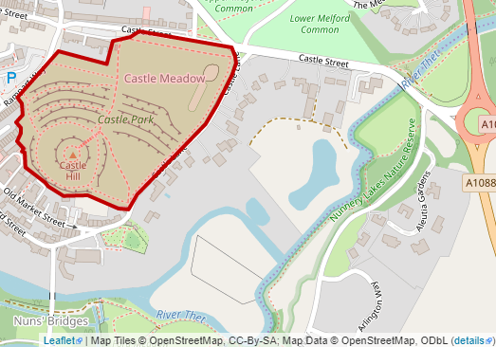
Section 1 Castle Park – Post Code IP24 2DN
Thetford Castle Park is a busy public park in the centre of Thetford. The site is also a nationally significant Scheduled Monument. It contains substantial Iron Age earthworks and a motte and bailey castle constructed following the Norman conquest of 1066. The Scheduled Monument designation carries statutory protection (under the Ancient Monuments and Archaeological Areas Act of 1979). This means that any form of penetration below ground level would require obtaining Scheduled Monument Consent from English Heritage. The Total area of the park is approximately 53,900 sqm (includes play park).
Castle Park (31,600 sqm of the Ramparts and Mound)
Description | Detail | Price
Vegetation management ramparts | To be cut once a year in September to approximately 2 cm or less. All arisings to be removed from ramparts and disposed on site.  (Please note that the council is consulting on the grazing of this area and this may not be included in the contract)
Vegetation management mound. | To be cut once a year in September to 2cm or less. Stumps of the scrub to be treated with systemic herbicide. Ivy perimeter is to be constrained within existing boundaries and not left to spread.  Mound top to be strimmed fortnightly through the period 1st of April – 31 September of each year 14 visits.  All arisings to be removed from mound and disposed of on site  (Please note that the council is consulting on the grazing of this area and this may not be included in the contract)  The gradient of the mound is substantial, and an anchor point will be required. Contractors will need a detailed risk assessment for activities.
Access pathway through ramparts | To be cut and maintained as necessary through the period 1 April – 30th September each year 14 visits.
Main recreation area 1 (17325 sqm) | To be cut fortnightly through the period 1st of April – 31 September of each year 14 visits.
Basal shoots Castle Street | To remove the epicormic growth annually from the trees alongside Castle Street Sept- Feb.
Smaller recreation area (4250 sqm) | To be cut fortnightly through the period 1st of April – 31 September of each year 14 visits.
Blue bell wood (3000sqm) | To be cut monthly from 1st of June - 30th of September each year (5 cuts a year after the bluebells have flowered).
Litter picking whole of grounds | Two hours of litter picking 2 operatives to be carried out of the whole site three times weekly including the mound and play areas.
Litter Bins | All refuse receptacles including dog bins to be emptied at least three times per week on a Monday, Wednesday and Friday mornings. (Including bank holiday weekends)

Section 2 - Barnham Cross Common – Post Code IP24 2DN

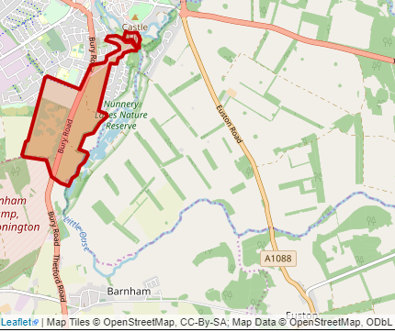
Barnham Cross Common is a Site of Special Scientific Interest (SSSI) and is also designated at a European Level for its Woodlark, Nightjar and Stone Curlew habitats. Mixtures of bare ground with closely grazed grasses and other plants are vital to many species of insect such as the exotically named Brush-Thighed Seed Eater and Set-a-side beetles are found in the area with many species of mining wasps, bees and other invertebrates. Barnham Cross Common is claimed to support the richest diversity of ants of any other site within East Anglia.
The Town Council has fenced Barnham Cross common and now has animals grazing the area. The fencing has caused the town council some additional challenges to managing the site as per the Higher-Level Stewardship agreement

The vegetation management at this site is about maintaining public paths and improving wildlife habitat. Works will include removal of scrub and trees, creating soil disturbance and bare ground through rotovating soil inversion including ploughing of small areas.
.
Barnham Cross
Description | Detail | Price
Litter/fly tipping removal.  Mainly carparks and high used areas of site | Allow 8 hours a fortnight litter picking and removal of rubbish and fly tipping from site.  Council staff to provide information on problem areas.
Vegetation management carparks | Cutting back all vegetation within the small, medium and large carparks and entrance aprons in May, July, Sept
Removal of vegetation inside of fence lines | Flailing and removal of vegetation from 2-3 metres inside fence lines with disposal of arisings at agreed location onsite to be agreed with Natural England. To be completed in Oct/Nov  (1042 metre west side and east side 1345 metre)
Removal of vegetation outside of fence lines | Flailing of bunds alongside Bury Road to be completed in September. (West side approx. 857 metres and east side 1345 metre)
Keeping access paths clear | Mowing/strimming of track/pathway outside fence line 2-3 metre wide in September. Pathway on the far western edge of the site adjacent to boundary edge pine lines. (Elm Rd side 1279 metres)
Scrub and tree removal | Please submit a price per hectare for the removal of areas of scrub and trees. The vegetation matter created will be dealt with onsite with agreement from natural England.
Surface scape | Please submit a price per surface scrape of one hectare
Rotovating of surface | Please submit a price per rotovating of one hectare

Section 3 – London Rd Cemetery
London Rd cemetery is traditionally laid to lawn The Council however are establishing 3 large new wildflower meadow areas (with signage explaining this to the public).
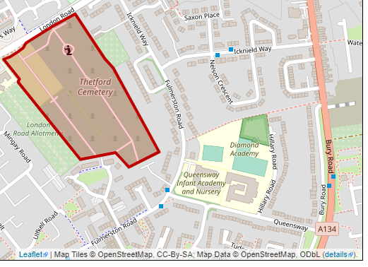
Log piles are also being established as habitat for a wide range of insect species, and a new pond and wildlife garden will be part of a memorial garden in the near future. The Map below shows the wildflower meadows. The remaining areas are the lawn areas

London Rd Cemetery
Description | Detail | Price
Mowing wildlife areas | Mow a metre along the path edges and a curved metre path through the wildflower areas as per drawing. Strim around the headstones and other obstructions.  Mow whole area in September and rake arisings and move to disposal area on site.
Mowing lawn cemetery area | Supply all machinery and operatives to mow 1st of April – 31 September of each year 14 visits.
Hedges | To maintain the top and sides of all the hedges surrounding the cemetery and the extension. Cuttings to be composted on disposal area onsite.  Annual cutting back between Sept- Dec
Herbicide spraying | Supply NPTC qualified and certified operatives to supply appropriate sprays, to apply to hard surfaces, gravelled areas, and bases of buildings, on three occasions per year. April, June, Sept.
Leaf removal | To remove all leave fall at the end of November. Leaves to be composted at disposal area onsite.
NB Any tributes that are moved must be replaced to their original positions
NB Mowing areas may change during the contract period. If less mowing is required the council would expect staff time to be deployed on other maintenance tasks in the cemetery.

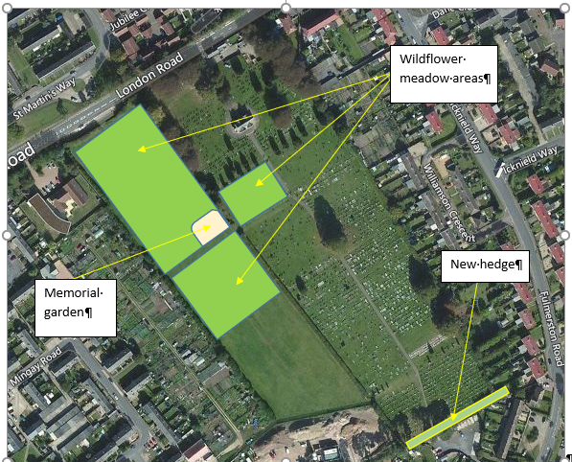
The Map on the left shows the wildflower meadows. The remaining areas are the lawn areas.
We would like the contractor to mow a two metre strip along the edges and a two metre strip parths through the wild flower area.

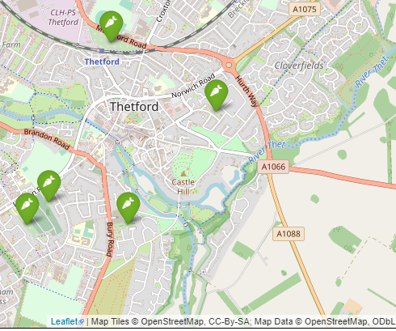
Section 4 - Thetford Allotments
Thetford Town Council has over 200 allotments on sites in:-

- Bury Road, IP243EH
- London Road, Mingay Rd IP24 3JL
- Mundford Road, Station Rd IP241ND
- Icknield Way, IP24 3AZ
- Magdalen Street IP24 2DA

There are additional more detailed allotment maps in the appendices

This tender relates to regular maintenance on all sites except Magdalen Street.

Allotments detailed maps below
Description | Detail | Price
Grass cutting and general maintenance | Supply all machinery and operatives to mow/strim paths and communal areas monthly April to September (6 visits).  Remove all litter and debris before commencing the mowing process.
Hedges/Shrubbery | To supply all the equipment and operatives once a year in the Autumn.  Remove all litter and debris before commencing.  To maintain the top and sides of all the shrubbery surrounding.
Allotment Clearance | Please provide a cost for two operatives to do allotment clearance for five days a year.  They will be required to removing fencing/rubbish and some brush cutting/strimming of whole area. Rubbish to be loaded onto council vehicles for disposal. This activity would normally take place in September.
Please note we have removed the herbicide spraying from the allotment section.
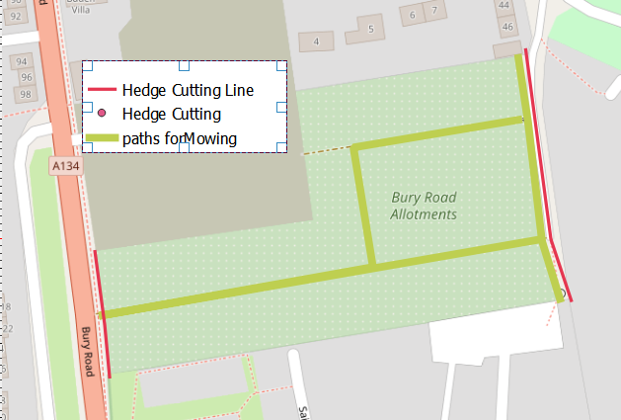
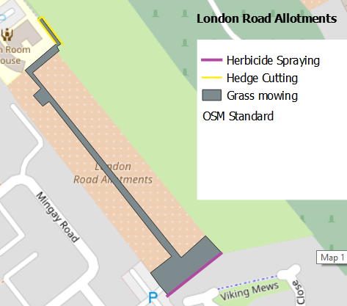

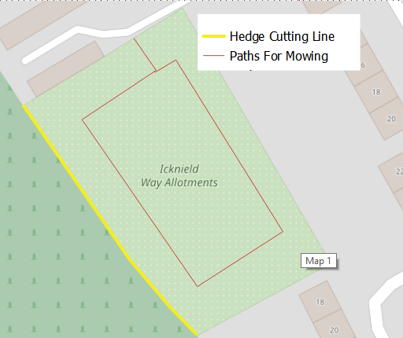
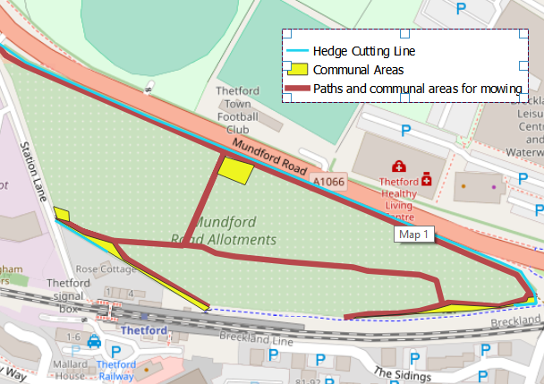
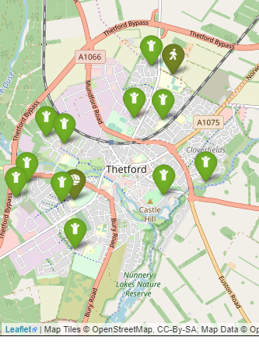
Section 5 - Thetford Play Areas
Thetford Town Council own and manage 11 play areas within the parish boundary. These are
- Bergamont Close - IP24 2XE
- Redcastle Play Area – IP24 3PT
- Castle Park – IP24 2DL
- Edinburgh Way – IP24 1DS
- Elm Road Play Area
- Fairfields – IP24 1JN
- Harriet Martineau Way IP24 1TR
- Maine Street IP24 3QH
- Pine Close IP24 3LA
- Richard Easten Way IP24 1ED
- Thetford Skate Park, Croxton Road – IP24 1LH
In the Appendices there are maps of the sites which are marked to indicate areas for mowing and shrubbery that requires cutting back. An additional detailed map for Thetford skatepark is featured below.
NB: Please note there are play areas indicated on map that not owned by the council
Play Area detailed maps attached
Description | Detail | Price
Grass cutting and general maintenance | Supply all machinery and operatives to mow/strim paths fortnightly from the 1st of April – 31 September of each year 14 visits. Remove all litter and debris before commencing the mowing process. 3 sites on Richard Easton Way, Elm Rd, Bergamot, Maine Street and Skate Park
Hedges/Shrubbery | Remove all litter and debris before commencing.  To maintain the top and sides of all the shrubbery surrounding the play areas.
Herbicide spraying | Supply NPTC qualified and certified operatives to include herbicide, to apply to fence lines on two occasions per year.  April and July.
Croxton road skate park | Trim the hedgerow down Jo Blunt’s Lane by the the skate park as per map below
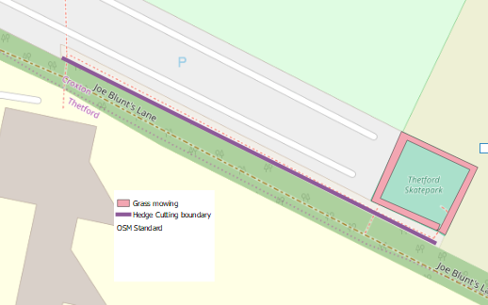
Croxton Skatepark
Pink Area – Mowing
Purple area – Shrubbery to cut back

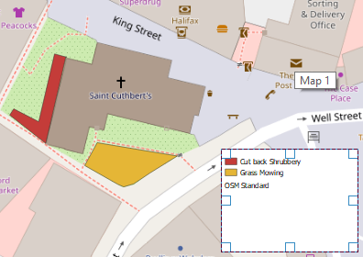
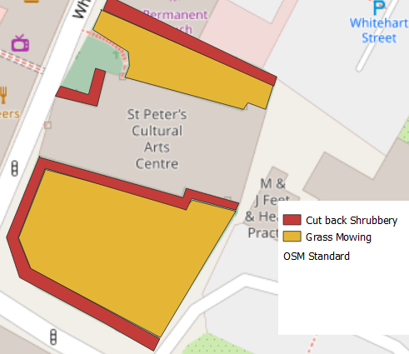
Section 6 – St Cuthbert’s and St Peter’s Church Yard
St Cuthbert’s and St Peter’s
Description | Detail | Price
Grass cutting and general maintenance | Supply all machinery and operatives to mow areas marked in yellow monthly from the 31st of March to the 30th of September  (7 visits).
Cut back Shrubbery | To cut back the top and sides of all the shrubbery surrounding the Churches as highlighted in red after the growing season September/October.

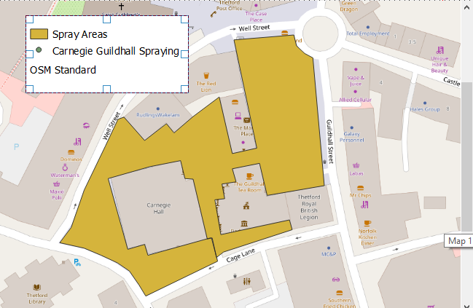
Section 7 – Carnegie, Guildhall and Market Place Spraying
The market place, Guildhall and Carnegie is the centre of the Town and needs to look attractive to visitors. Perennial weeds make the area look untidy and require regular spaying and removal.
.

Carnegie, Guildhall and Market Place Spraying
Description | Detail | Price
Herbicide spraying | Supply NPTC qualified and certified operatives to include chemical to weeds growing in the area, on three occasions per year April, June, August. To be completed between 6am- 8am in the morning. Dead weeds to be removed within 10 days of spraying.

Section 8 – Ramsey Close, Fredericks Wood, Maine Street Wood, Ford Meadow and Dane Close
The Town Council own patches of land across the town. The plan is to turn Ramsey Close into a natural play area and Dane Close into a community garden. Until these projects happen both areas require litter picking and mowing.
Ramsey Close, Fredericks Wood, Ford Meadow and Dane Close
Description | Detail | Price
Ford Meadow  52°24'31.4"N 0°45'18.9"E | Strim alongside both sides of path alongside fence line in May, July, September. Cut back overhanging tree vegetation once a year in October.
Dane Close IP24 3BD | Litter Pick the whole site  Supply all machinery and operatives to mow/strim paths monthly from the 31st of March to the 30th of September (7 visits).
Main Street Wood  52°24'49.5"N 0°43'35.9"E | Mow pathways fortnightly 31st of March to the 30th of September (14 visits).  Mow grass land and remove arisings once a year.  Cut back hornbeam hedge in October and remove arisings
Frederick’s Wood  52°25'24.9"N 0°45'26.1"E | Strimming back 1m along the top (north-west) path to The Covert avoiding the area of planted shrubs.  Strimming 2-3m back from the lower (south-west) woodland edge path to The Glade / The Covert  (Areas marked on map below)
Ramsey Close IP24 2LS | Litter Pick the whole site Supply all machinery and operatives to mow/strim whole site monthly from the 31st of March to the 30th of September (7 visits).
After the improvements have been made the mowing will change in Ramsey Close & Dane Close.

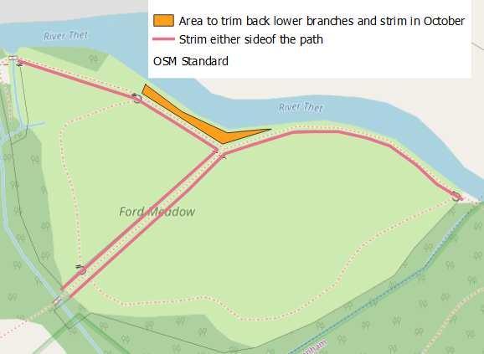
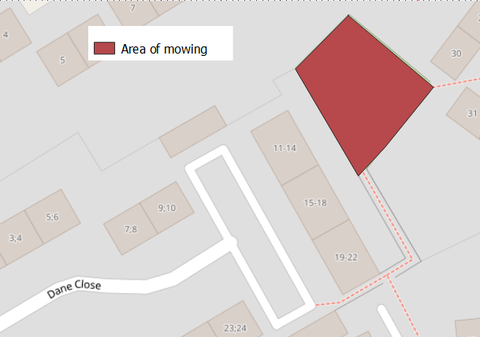

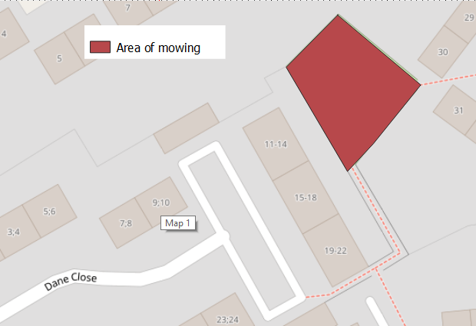
Ford meadow
Dane Close
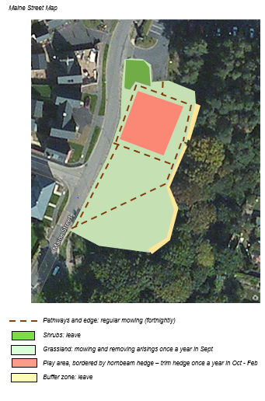
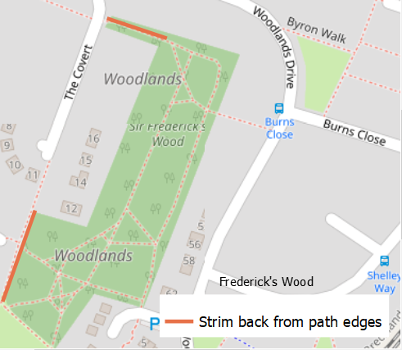

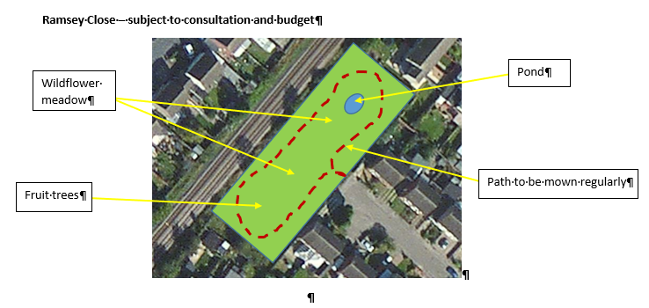

Section 9 – Horticultural Projects

Hanging Baskets and window troughs

Price
- Collection of 129 baskets, 5 barrier planters and 22 trough liner from Diddlington.

- To check all baskets fixtures every year and renew any that are not safe.

- Installation of 129 x 14-inch baskets, 5 barrier planters and 22 trough liner between the 26th of May and the 2nd of June.
- To be delivered and positioned on site - preferably a Sunday or at a time to avoid traffic. Permits for vehicle access to King’s street must be obtained from Norfolk County Council.
- Maintenance of 129 baskets, 5 barrier planters, 5-barrel containers, 2 half barrel containers, watering trough and marketplace roundabout 22 trough liners from end of May – mid October.
- To water the baskets daily June to mid-October before 8 am
- To use a soluble feed every week to maintain good growth and flowering and would expect to be using this until at least early October. e.g. Hortimix Extra
- Baskets, barrier planters and trough liners to be removed approximately mid-October and the contents delivered to the cemetery compound
- The Town Council may wish to add additional planters or baskets to the tender. Could you please supply a price it would like to add an additional hanging basket and an additional planter

Contract Management
Required reporting |  | Price
 | Completion of Monthly Compliance Tick sheets which details what maintenance tasks were completed and when they were undertaken. This to be returned with monthly invoices.
 | Quarterly 2 hours monitoring meetings to discuss any issues and changes to schedules
 | Provision of named contact to deal with day to day issues

References
Please provide details of up to two contracts from either the public or private sector, that are relevant to our requirement.. Works contracts may be from the past five years. (The customer contact should be prepared to speak to the purchasing organisation to confirm the accuracy of the information provided below if we wish to contact them). Note that where possible referees should not solely be linked to the TTC and that we may contact your referees without telling you again.
Reference 1 - Organisation name:

Customer contact, name, phone number and email

Contract Start date, contract completion date and contract value

Brief description of contract (max 150 words) including evidence as to your technical capability in this market.

Reference 2 - Organisation name:

Customer contact, name, phone number and email

Contract Start date, contract completion date and contract value

Brief description of contract (max 150 words) including evidence as to your technical capability in this market.

