HASLINGFIELD SKATEPARK PROJECT

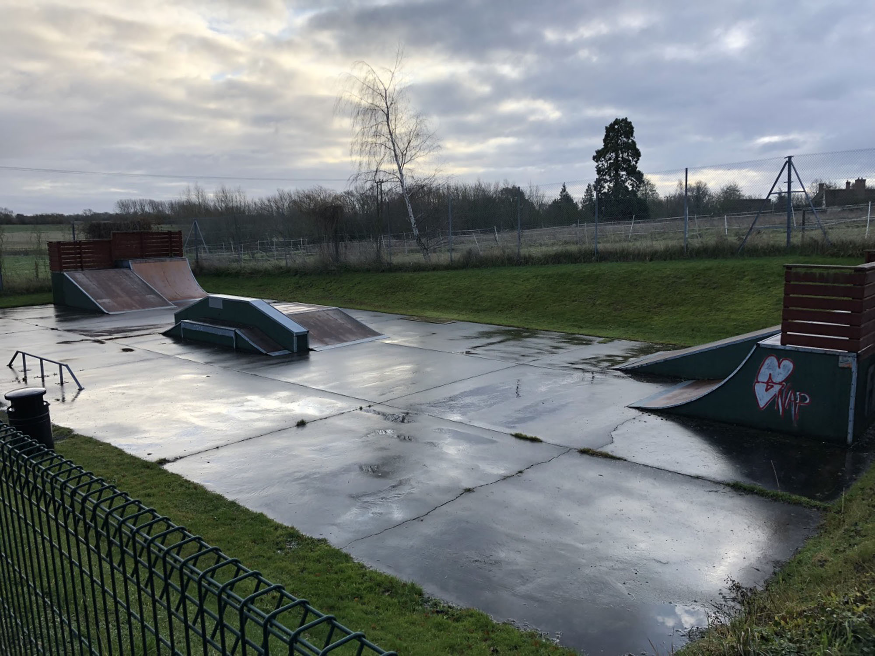

# INTRODUCTION

The current skate park was built back in 2007 and mainly funded by local business, lottery funding and community support.

The skatepark and land is owned and maintained by the Haslingfield Parish Council.

It is used by all ages, from young children on scooters, to young adults, using skateboards and BMXs. The users are mainly from Haslingfield but also come from surrounding villages, some as far as Royston.

It is used all year round, on weekends during the summer months there are on average of 20 users a day.

There is also a basketball court on site.

# CURRENT SITUATION

Unfortunately, due to its age and construction of its time, the skate park is in need of a complete overhaul.

The ramps are mainly constructed out of wood, including the framework and surfaces, overtime these ramps have suffered from wear and tear, from use, resulting in cracks and damage in the wood, allowing moisture to enter thus rotting the structures over time.

The parish council have repaired and replaced various parts of each ramp unit but we have now reached a point of non economic viability, any money spent now on repairs would not last long and the money would be better spent on investing in new ramps and equipment.

The basket ball court is also in need up of updating, the surface is covered in moss and algae which when wet can be very slippery and dangerous. The hoops and nets are broken and rusty.

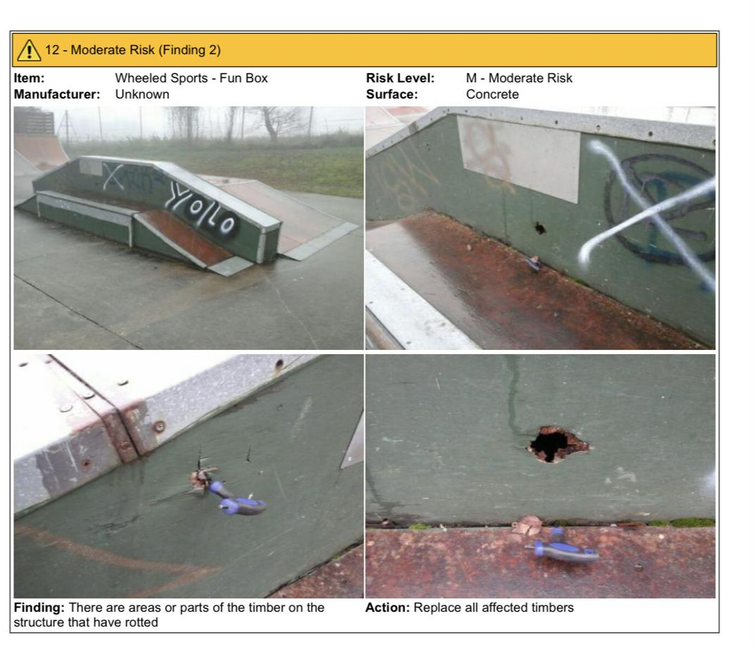

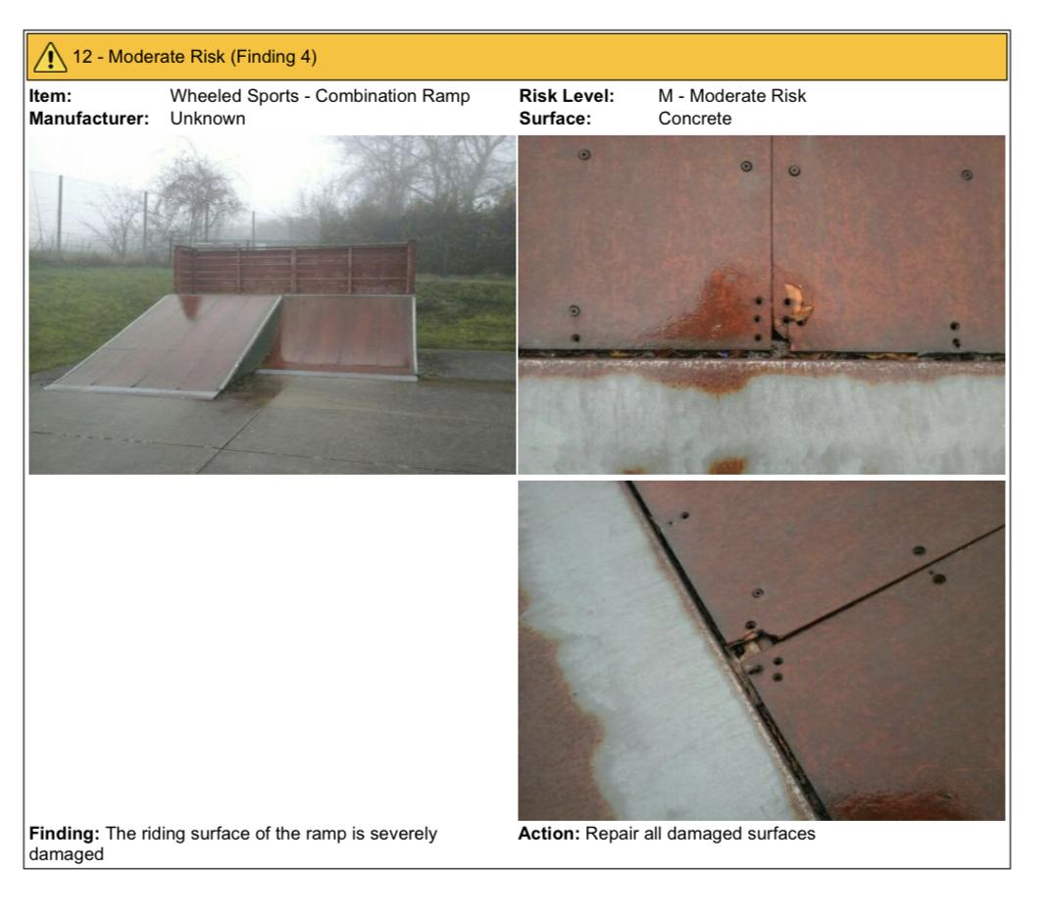

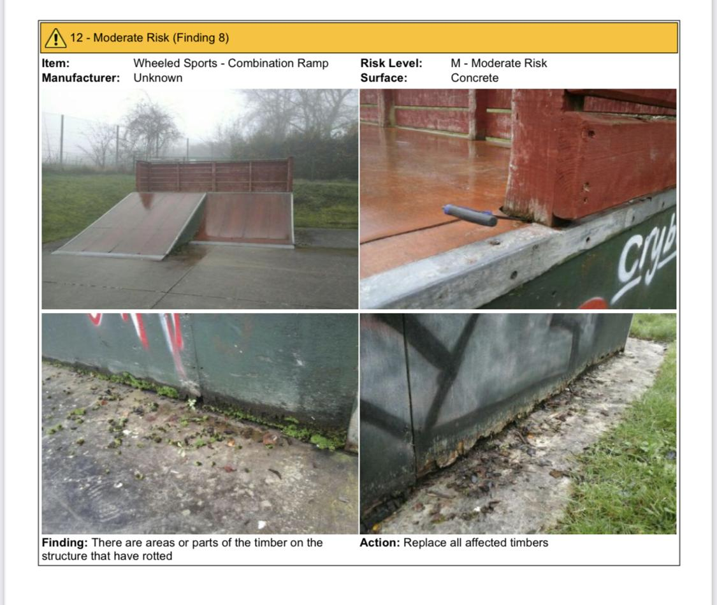

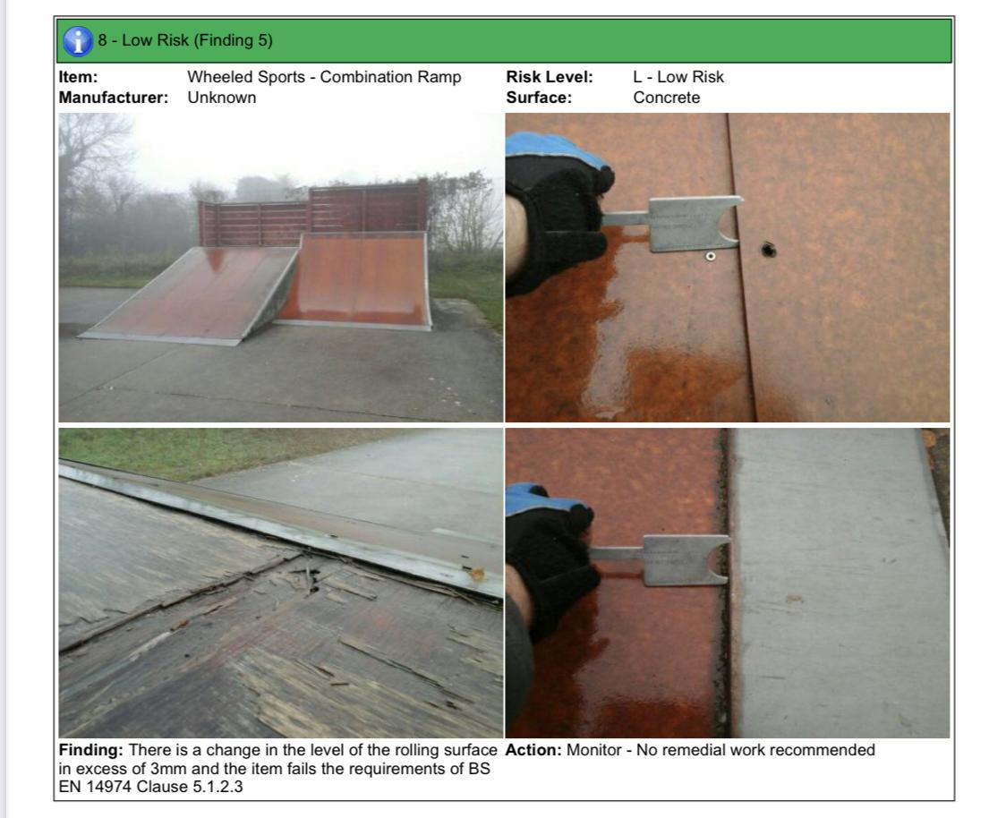

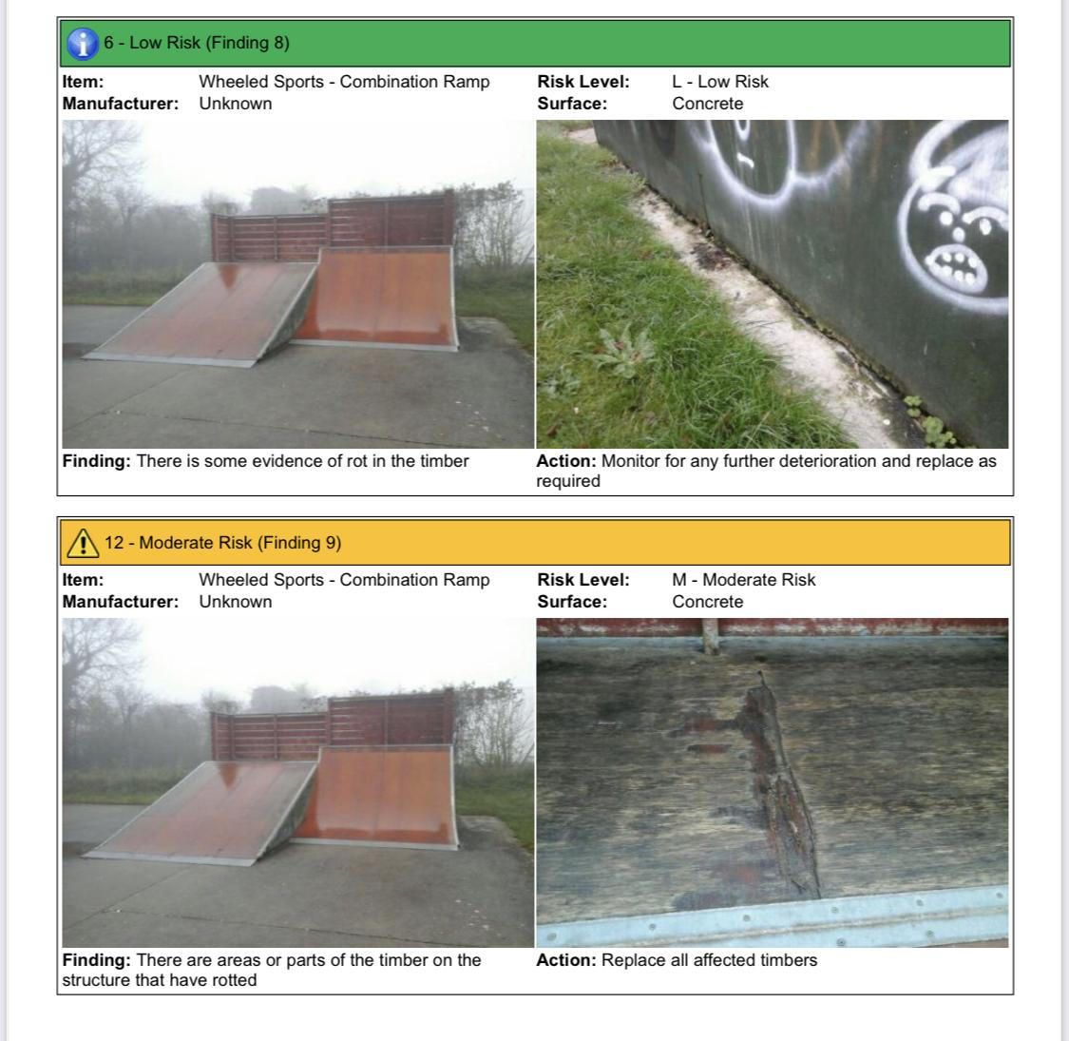

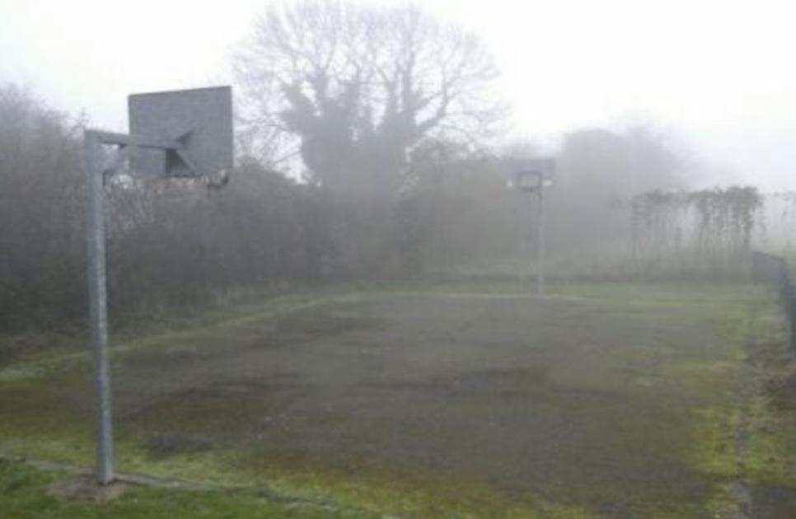

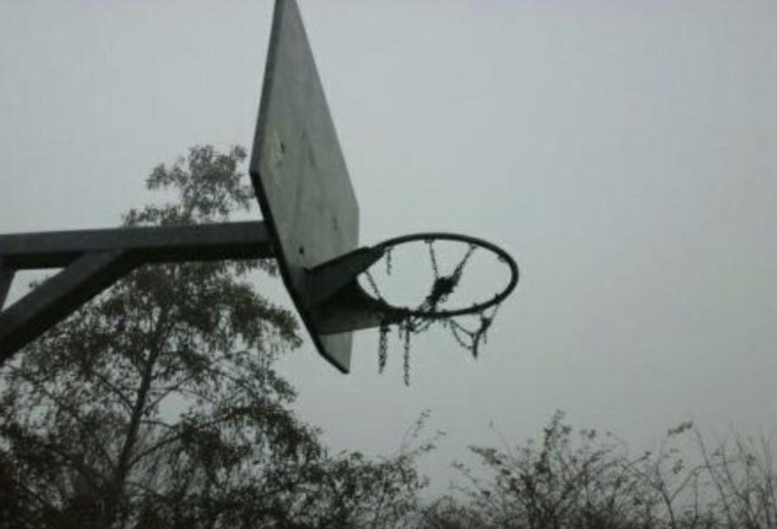

# DEMAND

We have conducted surveys on site, in the village and online and it is clear that the skatepark is a much loved community asset that would be even more utilised if it was renovated and modernised in someway.

The general consensus is that a new concrete skatepark would serve an even wider range of users of all ages and utilise the space much more - Rolling runs, ramps and a few fun boxes for example.

A space for seating would also be beneficial. And some users have suggesting taking away the basket ball court and replacing this area with a BMX run.

# PLAN

We have spoken to various contractors and obtained prices for like for like ramps, these are sufficient and would be a marked improvement, but what is clear from demand and perhaps a more long term solution would be to invest in a brand new concrete skatepark.

Some images of similar sized concrete skate parks, something like this would be the perfect solution for our skatepark.

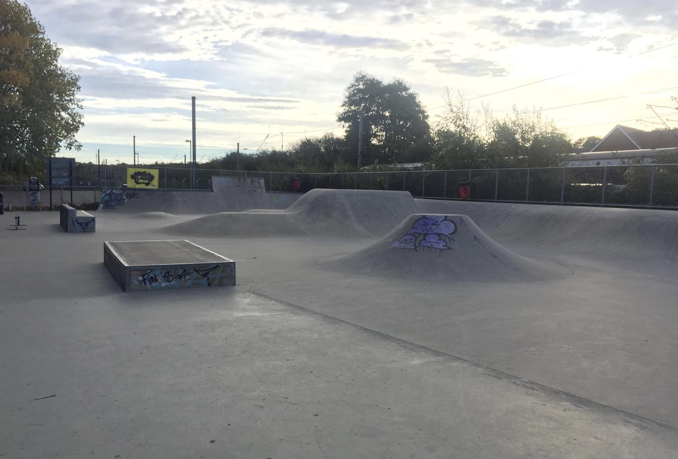

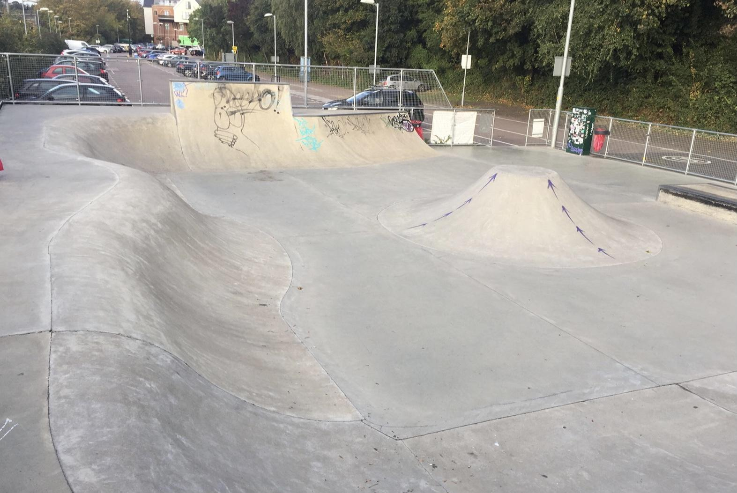

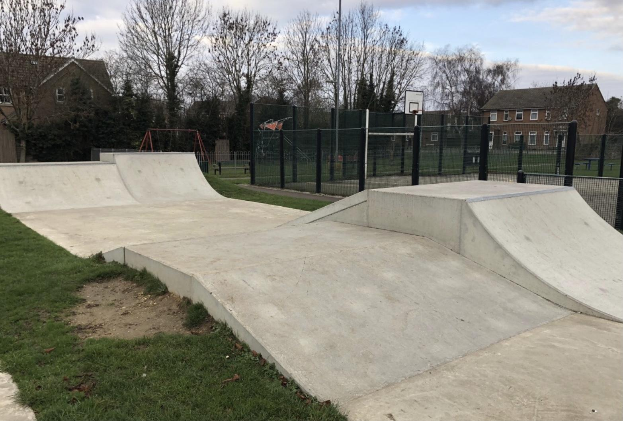

# FINANCING

We are in the process of applying for an Amey grant. This grant is on offer for non profit organisations such as ourselves to improve community facilities that are working 10 miles, as the crow flies, from a landfill site. We currently are 7.7 miles from Milton Recycling centre.

This grant is for projects up to £100,000, of which we would have to raise 11%. We currently have this 11% already in place.

# NEXT STEPS

We’d now look for you to provide some detailed plans - we’re open to ideas and suggestions to best use the space.

Then, costings and timescales for completely renovating our skatepark and installing new concrete ramps, runs and units etc. This could also include other facilities such as covered seating areas etc. as detailed in the demand.

Once we have these plans and details we can submit our application for the grant and hopefully have approval

Other Information

Site address:

Haslingfield Skatepark

Porkers Lane

Haslingfield

CB23 1JP

Rough Dimensions:

Basketball Court – 17m Long x 13m Wide

Skate Park – 30m Long x 15 Wide

Access:

The site is down a gravel track which is suitable for large HGVs, however the entrance to the actual skate park is limited, see below images

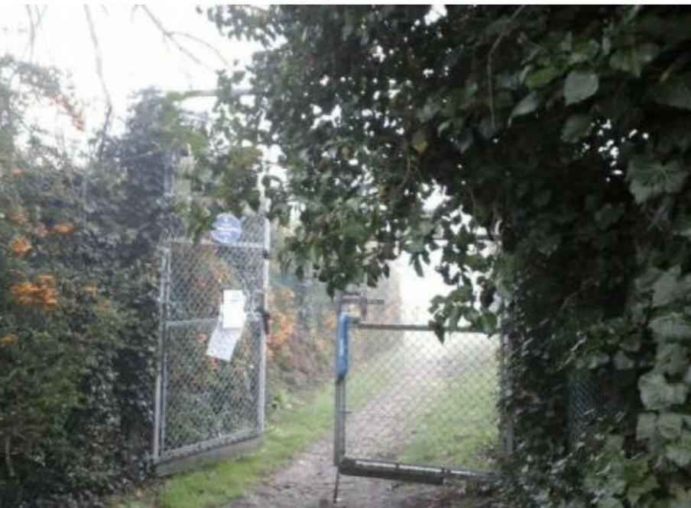

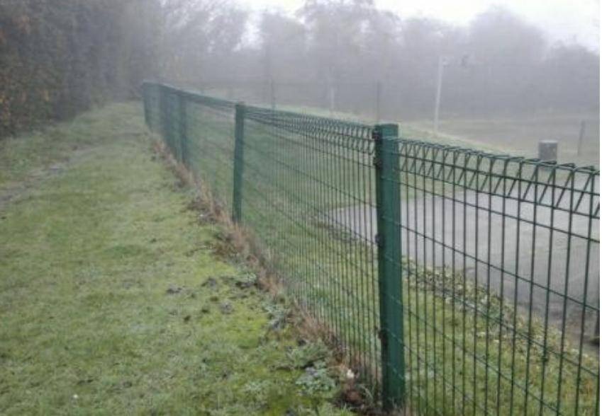

Please contact me if you require further information.

Thanks for your time

Ben Mavely

Haslingfield Parish Council

07732076830

[ben.mavely@haslingfieldparish.co.uk](mailto:ben.mavely@haslingfieldparish.co.uk)