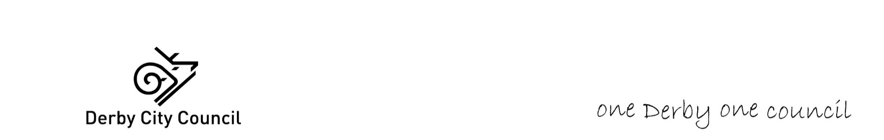**Soft Market Testing – D2 & NHS ICB Specialist Homes Provision**

**Summary Overview**

D2 (Derby City Council and Derbyshire County Council) are working together to procure a block contract to deliver 2 x 2bed specialist homes across the D2 footprint with a joint commissioning and delivery approach between the Derby and Derbyshire ICB (Integrated Care Board) and LAs (Local Authorities), to provide services for CYP with challenging behaviour and/ or complex mental health needs we can significantly improve outcomes for this group.

The service will be supported by a wrap-around therapeutic support offer from Derby and Derbyshire ICB and priority working from Social Care due to the complexity of need.

The tender comprises of 2 homes, one of which will be provided by the local authority (Derby City Council) and operated by the provider in accordance with the lease agreement and the other one (Derbyshire County Council) will need to be purchased or leased by the provider who will retain full responsibility for the property.

The homes are being developed to provide short-medium stays for children at risk of inappropriately entering CAMHS inpatient services, moving from these services, and/or where there has been a history of placement breakdown due to behaviour which challenges where emotional/mental health is a core factor. Support will focus on stabilisation to enable transition to a longer-term placement.

D2 have identified a cohort of children with complex emotional and mental health needs that require support when transitioning from secure welfare children’s home placements and those that are discharged from child and adolescent mental health inpatient provision and/ or acute paediatric wards. There is also a need for collaborative specialist children’s homes as a preventative intervention, to avoid the need for secure welfare accommodation or unnecessary mental health inpatient admission.

The presentation of the Children & Young People who will be supported may include, but is not limited to children who:

* Present with significant difficulties including mental health and / or emotional and behavioural disorders.
* Are generally aged 12 to 18 but could possibly be younger.
* Have experienced 3 or more Placement breakdowns over 12 months or in a placement in an unregistered children’s home discharged, from CAMHS Inpatient (Tier 4), Secure or acute paediatric hospital.
* Have threats or attempts to self-harm and/or suicide leading to a hospital stay.
* Have Autistic Spectrum Disorder (ASD), Attention Deficient Hyperactivity Disorder (ADHD), Neuro Developmental (ND) Condition traits or diagnosis.
* Have experienced Trauma.
* Are experiencing severe emotional distress or disruption and breakdowns of relationships.
* Are accessing CAMHS and/or hospital stay for either physical or mental health.
* Require additional support to keep them safe i.e., Children at risk of Sexual Exploitation (CSE/CRE)
* Display challenging behaviour i.e., verbally and/or physically aggressive towards others, causes damage to property and self-harm.

A formal mental health diagnosis is not required to meet admission criteria, but young people will generally present with:

* Acute and/or prolonged presentation of emotional/psychological deregulation, poor impulse control placing the young person or others at serious risk, and/or symptoms of serious mental illness that places the individual or others at risk; this will include high-risk, self-harm.

and/or

* Challenging behaviour of high frequency and intensity, despite intense multi-agency support, which threaten the immediate safety of the child or those around them and restrict everyday activities (e.g., exclusion from school or home environment).

All Children & Young People will have Child in Care Status under the [Children Act 1989](https://assets.publishing.service.gov.uk/government/uploads/system/uploads/attachment_data/file/1000549/The_Children_Act_1989_guidance_and_regulations_Volume_2_care_planning__placement_and_case_review.pdf).

As part of the procurement process, we would like to consult initially with the market on the feasibility of the model of delivery with a D2 tender with a number of questions we would like potential providers to respond to.

We have also provided a response document for interested parties to complete and return.

We are asking for responses to be sent to by email to Catherine.young@derby.gov.uk no later than 5.00pm Friday 31st January 2025.