Where we have been asked questions regarding this procurement, the answers to which may be relevant to all bidders, these questions have been reproduced below along with the associated answers.

**Question 1**

Please can you confirm if the liability is capped? We can see that the insurance requirements states a minimum requirement however there is nowhere in the Terms and Conditions that a cap on liability is detailed. This suggests liability is uncapped, please can you confirm if this is the case and if so are we able to put a cap on liability and if we are able to propose changes?

**Answer 1**

The Council would confirm that the liability for this project is uncapped and the Council will not accept caps on liability, proposed by Bidders.

**Question 2**

Please can we arrange a site visit for Corby East Midlands International Pool and Lodge Park Sports Centre?

**Answer 2**

Please arrange site visits directly with Kevin Williams (Leisure Manager) on telephone number 01536 400 033.

Please note that questions arising from site visits should be e-mailed to the Council at [procurement@corby.gov.uk](mailto:procurement@corby.gov.uk) for a response. Thereafter, questions and associated answers will be e-mailed to all Suppliers who have registered an interest in this project, to ensure openness and transparency for all Bidders.

**Question 3**

Please can you provide building floor plans for Corby East Midlands International Pool and Lodge Park Sports Centre?

**Answer 3**

Please find floor plans below, which have been uploaded to the Contracts Finder advert at [www.contractsfinder.service.gov.uk/Notice/c7d37cfc-7b85-4b46-91ba-a1d130ca6c26](https://protect-eu.mimecast.com/s/tS29COA7TPlVxUv7hqr?domain=contractsfinder.service.gov.uk) and can be accessed by **double clicking on the icons below**.



**Question 4**

The Specification states “There is no requirement to include emergency light fittings at either Corby East Midlands International Pool or Lodge Park Sports Centre”. Where existing light fittings are combined emergency type & are to be upgrade to LED, is it correct to assume that these will need to be replaced with combined emergency type?

**Answer 4**

All emergency lights at Corby East Midlands International Pool and Lodge Park Sports Centre are already LED fitted. These do not need to be replaced.

**Question 5**

The Corby East Midlands International Pool drawings (included at Answer 3) refer to a Lighting Schedule 106-E-171, would it be possible to have a copy of this, please?

**Answer 5**

Please find all available lighting Schedules and Diagrams for Corby East Midlands International Pool, including Lighting Schedule 106-E-171, below, which have been uploaded to the Contracts Finder advert at [www.contractsfinder.service.gov.uk/Notice/c7d37cfc-7b85-4b46-91ba-a1d130ca6c26](https://protect-eu.mimecast.com/s/tS29COA7TPlVxUv7hqr?domain=contractsfinder.service.gov.uk) and can be accessed by **double clicking on the icons below**.



**Question 6**

Would you be including the external sports field at Lodge Park Sports Centre as I don’t see any layout provided in the link?

**Answer 6**

Yes, the external sports field is to be included within the scope of these works, however no layout is available for this location

**Question 7**

It has been mentioned that the emergency lighting throughout has been changed to LED and is to be excluded, however after a recent on site survey there is some emergency lights that have not been changed for LED, shall these be excluded still?

**Answer 7**

These lights fall outside of the scope of works of this project. The Council will address these lights outside of these works.

**Question 8**

In terms of the as fitted switching arrangements there is some areas that relay on PIR’s to switch the lighting. Some PIR’s may be dated and not suitable for switching the new LED Lights due to inrush current. There is no mention of the switching arrangements in the tender shall this be excluded at this stage?

**Answer 8**

If Suppliers feel the facility would benefit from the payback period and energy use and the PIR’s can be included as a part of the budgeted sum, they can be included.

**Question 9**

Should there be any decorating issues from replacing certain lights, will this be completed by others?

**Answer 9**

No, decorating and making good are to be completed as part of this project.

**Question 10**

At both Lodge Park Sports Centre and Corby East Midlands International Pool, are the outside lights included (i.e. floodlights, lighting columns etc.)?

**Answer 10**

The astro turf floodlights at Lodge Park Sports Centre are to be included and the car park lights if budget allows. The Council are not looking for the lighting columns outside of Corby East Midlands International Pool being changed.

**Question 11**

Can you confirm the standard of lighting for the Swimming Pool area and the Astro turf pitches at Lodge Park Sports Centre, as there is different lighting levels required, depending on the standard required, e.g. competition swimming requires 500 lux and 1500 lux for Olympics?

**Answer 11**

Please find all available details on Lux lighting levels for Lodge Park Sports Centre, below, which have been uploaded to the Contracts Finder advert at [www.contractsfinder.service.gov.uk/Notice/c7d37cfc-7b85-4b46-91ba-a1d130ca6c26](https://protect-eu.mimecast.com/s/tS29COA7TPlVxUv7hqr?domain=contractsfinder.service.gov.uk) and can be accessed by **double clicking on the icon below**.



Regarding the lighting at Corby East Midlands International Pool, the Council has to operate under the rules of FINA, the world governing body for competitive swimming. FINA Rule FR 2.13 Lighting states that "light intensity over starting platforms and turning ends shall not be less than 600 lux". As the pool is used for long course (50 metre) and short course (25 metre) competitions and as the Referee and Judges need to clearly see all of the swimmers the minimum 600 lux is required for the entire pool. Lights should be on a switch system as they currently are so less lights can be used for general leisure swims.

**Question 12**

There are some wall lights in the reception / café area of the Swimming Pool that were originally used for decorative purposes. Can these be removed for energy and cost savings etc.

**Answer 12**

The lights are used to create a warm feeling in the café and foyer. They can be changed but with quite a low lux level or it will lead to making good in the areas when they are removed. Any new fittings would not need to have an up-light and a down-light and could just be a round low lux level fitting. The Council would need to continue to turn these lights on or off when required, as presently.

**Question 13**

In preparing the tender we have just noticed the below statement at paragraph 7.3 of the Specification (page 6/10):

*The Supplier and any and all sub-contractors (where relevant) must be registered members of the NIC EIC approved contractors scheme holding the18th Edition wiring regulations certification or equivalent and hold all relevant qualifications to undertake commercial electrical installations.*

We are members of the Electrical Contractors Association (ECA) and this is normally accepted as a relevant electrical contracting trade membership alongside the NECEIC. Our install sub-contractor is a NICEIC member and all electricians will be 18th Edition registered with T+I for test and inspection. Please can you confirm whether ECA membership is acceptable for the lead supplier as an alternative to the NECEIC?

**Answer 13**

The Council understands that Electrical Contractors Association (ECA) is a recognised body, founded in 1901 for which, companies have to demonstrate best practice etc. to become registered. If a bidder can prove they are members and taking into consideration that all workers for this project will be NIC CIC registered, this is acceptable.

**Question 14**

Do the fittings have to meet any standards with regards to diffuser material TP(a) or TP(b)?

**Answer 14**

The requirements are established by Building Regulations Approved Document B, which sets out the fire safety of buildings. Section B2 covers internal fire spread.

TP(a) relates to polycarbonate diffusers with a thickness of at least 3mm. There is no restriction on the use of TP(a)-rated diffuser material.

TP(b) the total area of diffuser panels must not exceed 15 percent of the total floor area. The maximum area of one diffuser, or group of diffusers, must not exceed 5m x 5m. There must be a 3m spacing between each 5m x 5m diffuser grouping.

In offices and other rooms, the total area of diffuser panels must not exceed 50 percent of the total floor space.

Unless the manufacturer’s information states clearly that the luminaire being offered contains a diffuser that complies with either a TP(a) or TP(b) rating it must not be used and the diffusers will not be considered for the works.

**Question 15**

There are light fittings at Corby East Midlands International with dimming capability linked to daylight sensors; do the new fittings require the same functionality?

**Answer 15**

If the light fittings can be turned off or turned on in groups or individually to alter the amount of light given, then they can be changed. If they can’t, the same sensors will be required.

**Question 16**

Is it possible we could have CAD drawings for the layouts?

**Answer 16**

Unfortunately, the Council does not have CAD drawings of the layouts, so is unable to provide these for consideration/use.

**Question 17**

Are the outside security lights and lights that cover the car park at Lodge Park Sports Centre to be included as part of the tender?

**Answer 17**

These lights are to be included and please find below, eleven (11) images of the lights that need replacing with LED’s.

***Images 1 - 3***

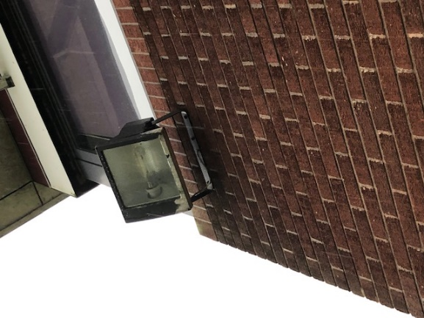 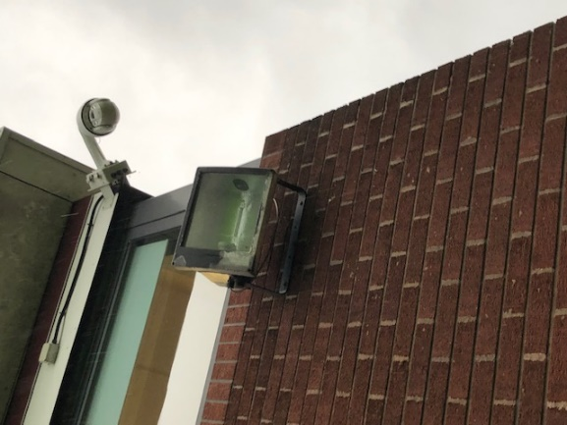 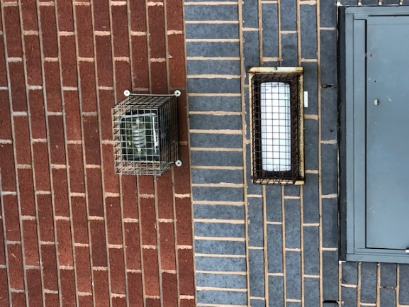

***Images 4 - 5***

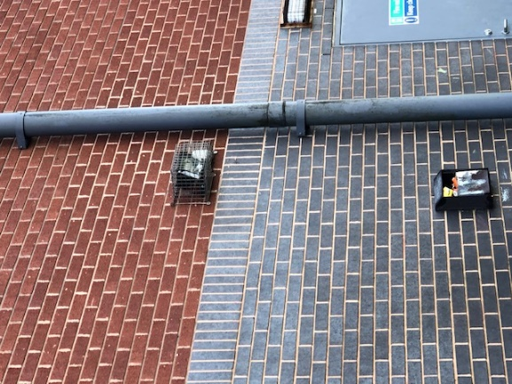 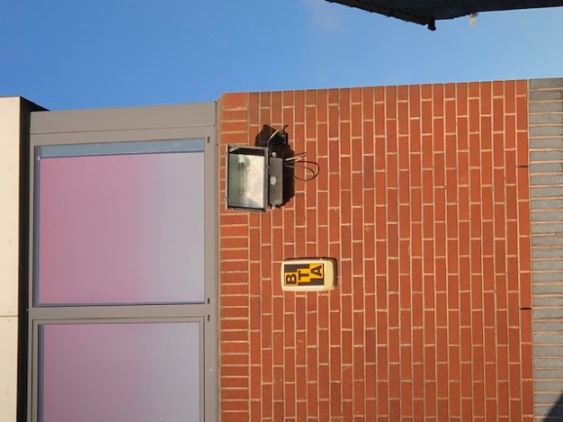 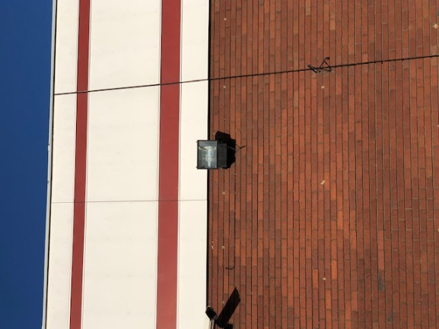

***Images 6 - 8***

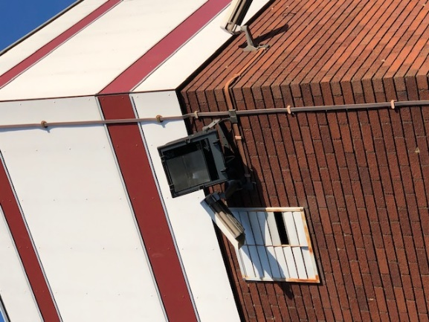 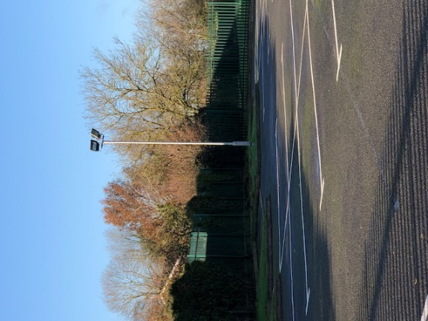 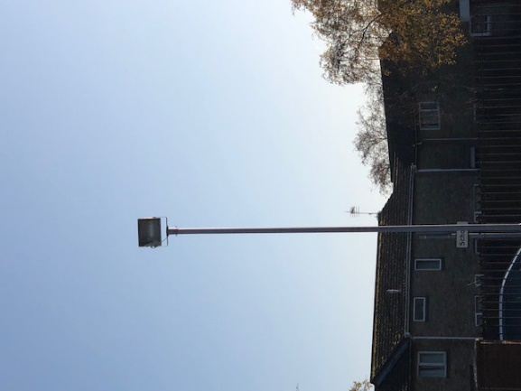

***Image 10 - 11***

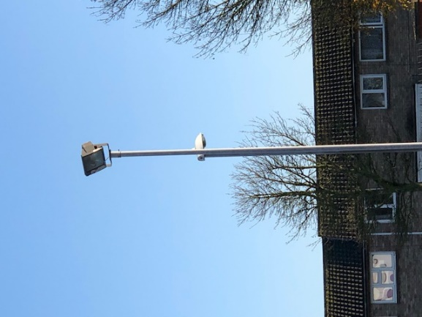 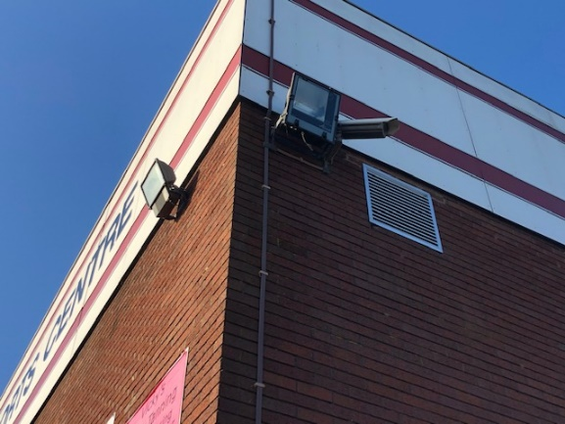

**Question 18**

Is the all-weather pitch/Multi-Use Games Area at Lodge Park Sports Centre within the scope of this tender? If so;

**18.1.** What is the power of the HQI-T lamps in the existing sports floodlights?

**18.2.** What is the mass (KG) of each of the existing sports floodlights?

**18.3.** What is the maximum recommended total loading (KG) of the existing hinged columns (each)?

**18.4.** Approximately how many hours per week are the lights in use (on average)?

**18.5.** Given that it is unlikely that the columns would be able to support the mass of LED luminaires required to provide equivalent illumination, could a non-LED solution be proposed?

**Answer 18**

**Yes**, the all-weather pitch/Multi-Use Games Area at Lodge Park Sports Centre is within the scope of this tender

**18.1.** 2,000w

**18.2.** & **18.3.** The octagonal masts are HL250’s, for which the maximum head load is 100kgs, but the windage figure has to be considered too. Please find additional details in the Datasheet attached, which have been uploaded to the Contracts Finder advert at [www.contractsfinder.service.gov.uk/Notice/c7d37cfc-7b85-4b46-91ba-a1d130ca6c26](http://www.contractsfinder.service.gov.uk/Notice/c7d37cfc-7b85-4b46-91ba-a1d130ca6c26) and can be accessed by **double clicking on the icon below**.



**18.4.** During the winter months, the lights are in use around thirty five (35) hours per week. There will a gradual reduction of this as we move into winter and spring when the daylight is good enough that the Centre does not need the lighting.

**18.5.** In order to compare Bidders on an equitable basis, the Council would ask that all Bidders price for an LED solution. If, during the pre-start and mobilisation period, it is determined that an LED solution is not viable, due to loading restrictions on the columns, for example, a solution will be agreed between the Council and Winning Bidder at this time.

**Question 19**

New twin spot LED emergency fittings have been mounted to the walls of the pool hall at Corby East Midlands International Pool. Type A2E no longer operate in emergency mode/ replacement LEDs will not be required to operate in emergency mode?

**Answer 19**

There is no need for new LED’s to operate in emergency mode, and twin spots will remain in place.

**Question 20**

Types QE at diving board end of Corby East Midlands International Pool are no longer in use. This is allegedly because they cannot be accessed to be repaired. Are these within the scope of this tender or to be disregarded?

**Answer 20**

These will need to be included within the scope of the tender.

**Question 21**

Types N1E pendants in the gallery at Corby East Midlands International Pool no longer provide any emergency lighting function, and the static inverter originally installed has been removed. Are the N4E LED wall packs already fitted sufficient to provide emergency anti-panic/escape lighting throughout the gallery seating area or do the replacements for N1E types need to be fitted with emergency battery packs, and wired for emergency function?

**Answer 21**

These will just need to be replaced but do not need to act as emergency lights.

Yes, the N4E LED wall packs already fitted sufficient to provide emergency anti-panic/escape lighting throughout the gallery seating area.

**Question 22**

Types A2D (downlight function) directly illuminate the pool side and pool surface at Corby East Midlands International Pool. This contravenes guidelines for the lighting of swimming pools, due to disability glare which would be caused to swimmers, and reflectance of their light off of the pool surface - which will make swimmers less visible to lifeguards. Are the LED replacements for these to be mounted similarly (to directly light the pool side and water surface) or should all pool lighting be indirect (uplighters), as per guidelines?

**Answer 22**

Lights should be in line with Swim England / Sport England / FINA guidelines for competitive swimming

Whether the LED replacements for these are to be mounted similarly (to directly light the pool side and water surface) or should all pool lighting be indirect (uplighters), as per guidelines, is a decision for the Contractor, in line with best practice.

**Question 23**

Does the DMX Pulsar Lighting need replacing?

**Answer 23**

Yes, the DMX Pulsar Lighting does need replacing, as it is not presently LED.

**Question 24**

Please can you provide CAD drawings for the swimming pool area to confirm the new LED fittings will achieve 600+ LUX, elevations and sections require?

**Answer 24**

Previously answered under Question 16. Unfortunately, the Council does not have CAD drawings of the layouts, so is unable to provide these for consideration/use. The only drawings available are those which have already been issued.

**Question 25**

Would it be possible to get the elevations drawings, as without ceiling heights, it is very hard to produce a reliable lighting design?

**Answer 25**

Previously answered under Question 16. Unfortunately, the Council does not have CAD drawings of the layouts, so is unable to provide these for consideration/use. The only drawings available are those which have already been issued.

**Question 26**

In regards section 6.0 Quality Requirements of your Document 2 – Specification, which states:

*Section 6.1. Undertake a full site survey at both sites to identify the type and requirement for lighting levels and identifying electricity savings and the payback period of the project for each site.*

**26.1.** Please confirm the unit electricity cost (pence/kWh) you wish the savings estimate and payback report to be based upon; for both Corby East Midlands International Pool (CEMIP) and Lodge Park Sports Centre (LPSC)?

**26.2**. Please confirm the number of hours, per week, you wish the savings estimate and payback report for CEMIP to be based upon?

**Answer 26**

**26.1.1. CEMIP**

| **Site Name** | **Rate 1 Price (p/kWh)** | **Rate 2 Price (p/kWh)** |
| --- | --- | --- |
| Corby East Midlands International Pool | 16.608 | 10.588 |

**26.1.2. LPSC**

| **Site Name** | **Rate 1 Price (p/kWh)** | **Rate 2 Price (p/kWh)** |
| --- | --- | --- |
| Lodge Park Sport Centre | 17.572 | 10.639 |

**26.2.1. CEMIP** - The pool is open for seventeen and a half (17:30) hours per day between Monday and Friday (inclusive) (05:00 to 22:30) and sixteen and a half (16:30) hours per day between Saturday and Sunday (inclusive) (05:00 to 21:30)

**26.2.2. LPSC** - The Centre is open for sixteen and a half (16:30) hours per day between Monday and Friday (inclusive) (06:00 to 22:30); fourteen (14) hours on Saturday (08:00 to 22:00) and fourteen and a half (14:30) hours on Sunday (08:00 to 22:30).