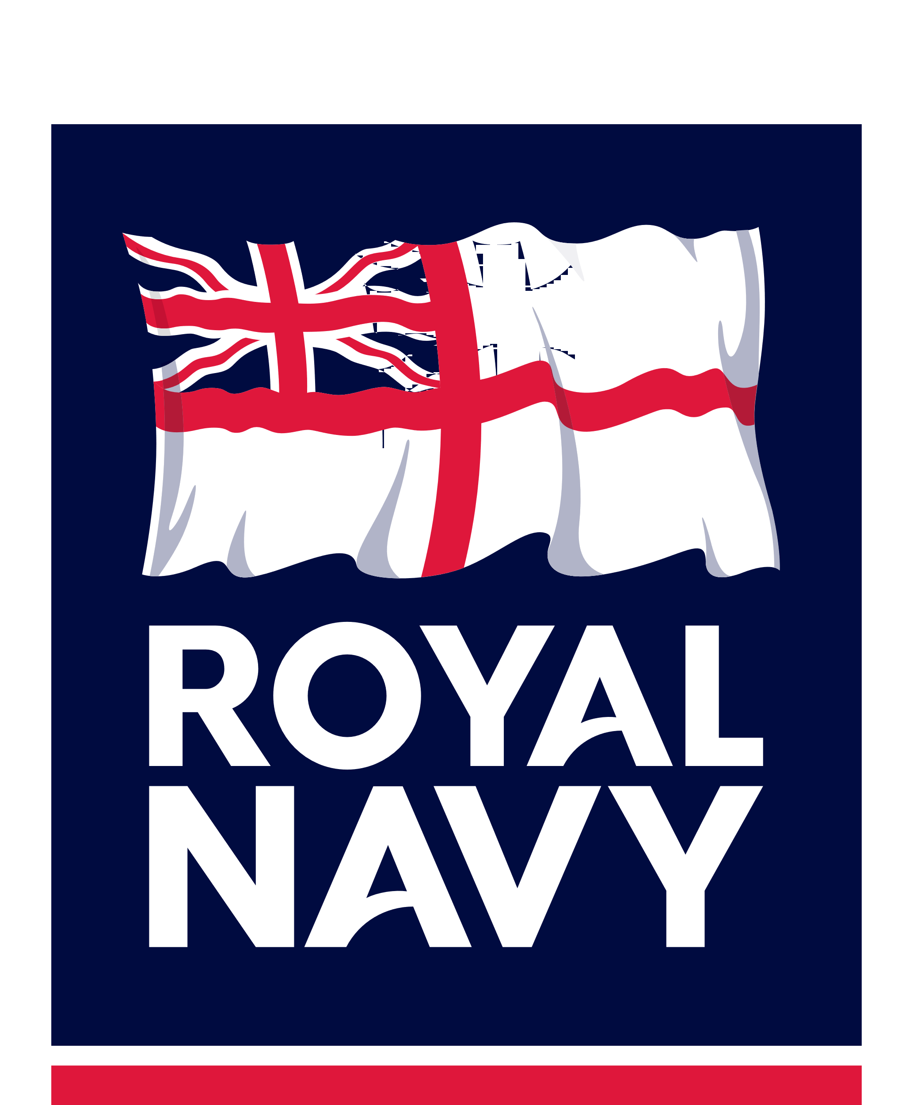
Table of Derogations

Table C.2 Table of Derogations
PART A
The draft Contract is accepted WITHOUT Derogations [Checkbox]
PART B
The draft Contract is accepted WITH the following Derogations [Checkbox]
The Contract mark-up is provided as PDF [file_name] [Checkbox]
Clause/Schedule Ref. (Category 2 only) | Summary of Derogation |  | Reason for Derogation | Impact of Derogation
[state Clause [n] or Schedule [n] paragraph [n], including references to all consequential changes to drafting] | [Summarise the Derogation, including descriptions of all consequential changes to drafting] |  | [State the reason for the Derogation, and if deemed commercially sensitive to the Tender, state the reason for such commercially-sensitive status] | [State the impact of the Derogation on the Financial Model, presenting a value for money case and as applicable detailing the impacts on the Authority's risk profile]
PART C
Tenderer Inputs are provided for each of the Contract terms below. [Checkbox]
Contract Element |  | PDF document name |  |  | [Checkbox]
Clause 45 (Indemnities) |  |  |  |  | [Checkbox]
Clause 46 (Limitations on Liability) |  |  |  |  | [Checkbox]
Schedule 4 (Payment, Performance and Incentivisation Mechanism) |  |  |  |  | [Checkbox]
Schedule 12 (Assets) |  |  |  |  | [Checkbox]
Schedule 14 (Commercially Sensitive Information) (DEFFORM 539A) |  |  |  |  | [Checkbox]
Schedule 15 (Warranted Data) |  |  |  |  | [Checkbox]
Schedule 16 (Project and Ancillary Documents) |  |  |  |  | [Checkbox]
Schedule 17 (Intellectual Property Rights) |  |  |  |  | [Checkbox]
Schedule 23 – Key Sub-Contractors |  |  |  |  | [Checkbox]
Schedule 25 – Financial Distress |  |  |  |  | [Checkbox]
Schedule 27 - Authority Dependencies |  |  |  |  | [Checkbox]
Schedule 28 – Key Personnel |  |  |  |  | [Checkbox]

Signature:
Job Title: (Director, Senior Manager, Secretary etc.)
Name: (in BLOCK CAPITALS)
Duly authorised to sign this Declaration Statement for and on behalf of: (Tenderer's name)

