- 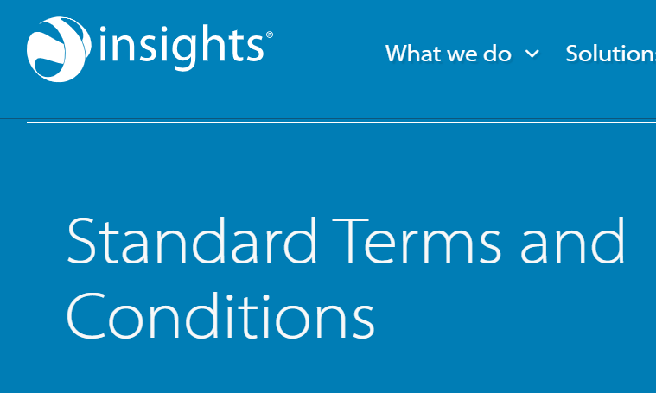Contact Us

These terms and conditions apply to any order for the supply of Insights Products and Services from any member of the Insights Group (“Insights”) to you (hereinafter “You” or the “Client”). If you are happy to agree to these terms and conditions, please sign here.
By ordering any Products and/or Services from Insights You agree to these Standard Terms & Conditions (the “Conditions”) which shall be deemed incorporated into all Orders. These Conditions apply to the exclusion of all other terms including those that the Client seeks or has sought to impose or incorporate, or which are implied by law, trade custom, practice or course of dealing.
INTERPRETATION
In these Conditions, the below terms are defined as follows:
    - “Client Practitioner” or “CP” means an Insights Accredited Practitioner who is an employee or contractor of the Client;
    - “Event” means a booked workshop, course or other meeting which is set to occur on a specific date or specific dates, and for which Products or Services are ordered by the Client;
    - “Insights Accreditation” means a multi-day train-the-trainer course at which Insights or the licensee trains individuals to use and deliver specific Products;
    - “Insights Accredited Practitioner” means an individual who successfully completes an Insights Accreditation and is accredited by Insights to use and deliver one or more specified Products;
    - “Insights Group” means The Insights Group Limited (Scottish company number SC166543) together with any company or other business organisation that is under its common control (whether legal or factual);
    - “Insights Online” means the online platform through which (i) individuals may access the Insights Evaluator Questionnaire and (ii) CPs can generate and access Products such as the Personal Profile and Team Wheels;
    - “Insights Product” means a product, service, or Practitioner Material that is: i) developed by, or owned by, or licensed to an Insights Group member; and i) marketed or used under the brand and trademarks of the Insights Group, iii) supplied pursuant to an Order
    - “Intellectual Property Rights” means: all patents, copyright, registered designs, unregistered designs, trademarks, Confidential Information, know how, inventions, database rights, trade secrets, moral rights, and any rights of a similar nature which are listed in or are capable of being registered in any jurisdiction now or in the future;
    - “Online Units” means a Product consisting of pre-purchased credits that can be exchanged within Insights Online for Personal Profiles;
    - “Order” means a document containing a description of the Products and Services, details of the prices, delivery dates, and delivery location to be completed by the Client and supplied to Insights which has been accepted by Insights in accordance with clause 2.2;
    - “Recipient” means the individual data subject named as the subject within an Insights Product;
    - "Practitioner Material" means a presentation aid or material (other than a Product) that contains Intellectual Property of the Insights Group and which is made available to CPs by an Insights Group member;
    - “Products” means a goods (including a presentation aid or material containing Insights Intellectual Property) that is to be supplied by Insights to a Client; and
    - “Services” means a service that is to be supplied by Insights to a Client under an Order which includes an Event.

  - BASIS OF CONTRACT AND ORDERS
    - 2.1 The Order constitutes an offer by the Client to purchase Insights Products or Services in accordance with these Conditions.
    - 2.2 The Order shall only be deemed to be accepted when Insights issues written acceptance or fulfils the Order (whichever is earlier) on which date the Contract shall come into existence (“Commencement Date”).
    - 2.3 Any quotation given by Insights shall not constitute an offer and is only valid for a period of [30] Business Days from its date of issue.
    - 2.4 Orders shall be subject to, and shall incorporate these Conditions.
    - 2.5 The Client waives any right it might otherwise rely on in any term endorsed upon, delivered with, or contained in any Client documents that are inconsistent with these Conditions.
  - CLIENT PRACTITIONERS, INSIGHTS ACCREDITATION, AND ONLINE UNITS
    - 3.1 A Client may seek Insights Accreditation of one or more of its employees or contractors as Client Practitioners (CP) on an annual basis.
    - 3.2 Where a Client has one or more CPs, it may purchase Online Units to generate Personal Profiles within Insights Online.
    - 3.3 Insights reserves the right to assess the suitability of Client employees or contractors to become CP’s and may at its reasonable discretion grant Insights Accreditation to such Client employees or contractors, subject to payment of an annual fee (“Annual Licence Fee”) and their ongoing compliance with any policies provided to them by Insights from time to time. An Annual Licence Fee is payable in respect of each and every CP.
    - 3.4 The Annual Licence Fee permits CP access to designated Insights Products, and access to Insights Online and Insights Connections. Insights reserves the right to remove Insights Accreditation and revoke any licence granted (including, without limitation the licence to use Insights Products), where Annual Licence Fees have not been paid in a timely manner.
  - CLIENT OBLIGATIONS
    - The Client shall:
      - (a) ensure that the terms of the Order are complete and accurate;
      - (b) co-operate with Insights in all matters relating to the Order; and
      - (c) comply with mandatory policies and/or conditions provided to Client or CP from time to time.

- CHARGES AND PAYMENT
- 5.1 In consideration of Insights providing Products and Services to the Client pursuant to an Order, the Client shall pay the price as set out in the Order or if no price is quoted, as set out in an Insights price list at the date of delivery.
- 5.2 Insights shall give the Client at least 30 days’ notice in writing of any increase in the price.
- 5.3 Unless otherwise agreed in an Order, prices are exclusive of the following costs and charges which shall be invoiced to the Client:
(a) VAT (where applicable);
(b) Shipping Products to the Client;
(c) Any venue hire, equipment hire, and catering required for an Event; and
(d) Expenses reasonably incurred in connection with delivery of the Services by Insights (including travel, accommodation, and subsistence).

- DELIVERY OF PRODUCTS
  - 6.1 Insights shall deliver the Products to the location set out in the Order or other such location as the parties may agree.
  - 6.2 Insights shall not be liable for any delay in the delivery of the Products caused by any event beyond its reasonable control or due to the Client’s failure to provide adequate delivery instructions.
  - 6.3 The Client must report any complaints and/or alleged non-conformities or defects in the Products to Insights, in writing, within 48 hours of the date on which the Products were delivered, failing which the Client will lose its right to claim for any defect and/or non-conformity.
  - 6.4 If the alleged defect and/or non-conformity is reported to Insights in accordance with 6.3, Insights will at its own option and discretion: (1) replace any Products that have been determined by Insights to be non-conforming or defective, or (2) issue a refund for any Products that have been determined to be non-conforming or defective. Insights will not be liable for any non-conformities or defects to the extent that such non-conformities or defects were not caused by Insights.
  - 6.5 The risk in the Products shall pass to the Client upon delivery.
  - 6.6 Parties agree that the remedies outlined in clause 4 are full and adequate compensation for any damage arising from a non-conformity or defect.

- CANCELLATION & POSTPONEMENT
Insights cancellation and postponement charges are as follows:-
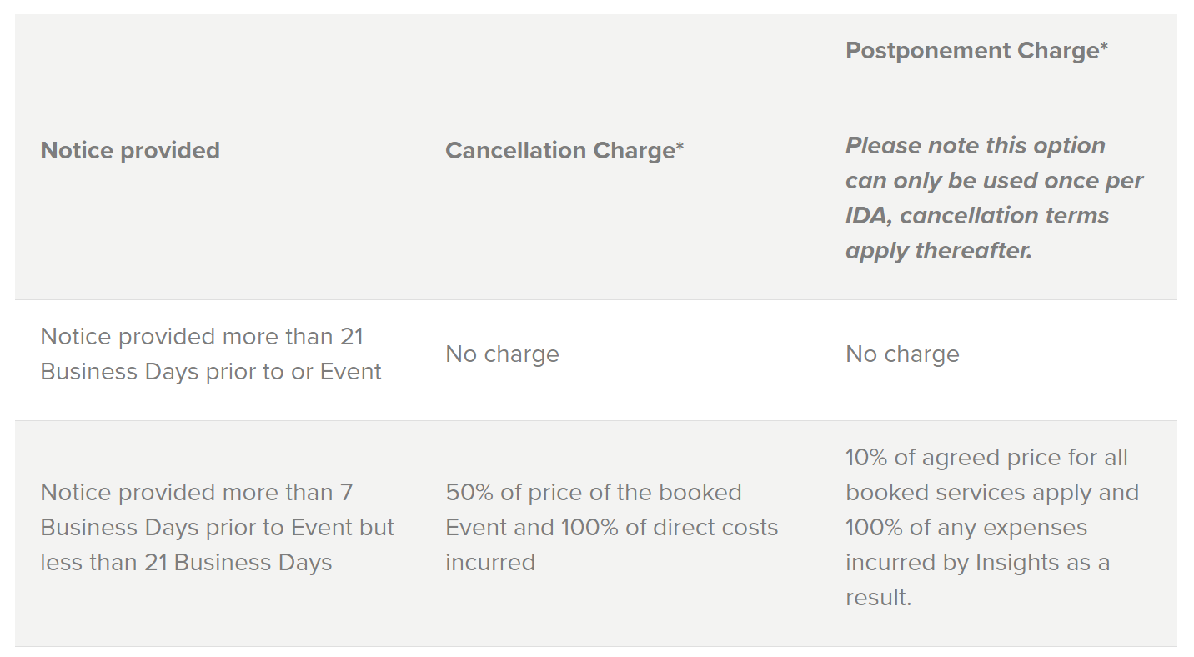
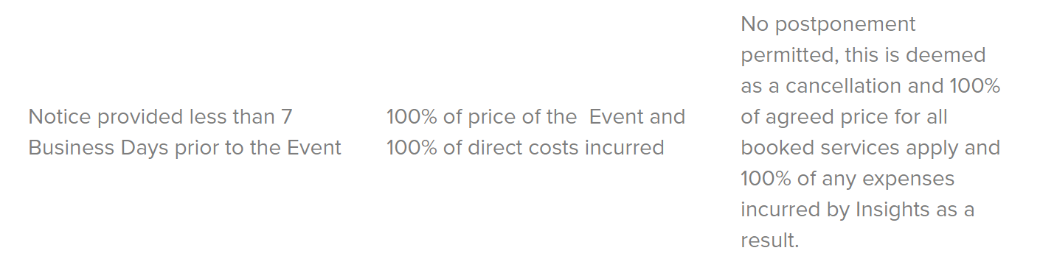

    - INVOICING AND PAYMENT
  - 8.1 Insights may invoice the Client once any of the following occur:
8.1.1 Online Units are credited to the Client’s Insights Online account;
8.1.2 Products specified in an Order are shipped;
8.1.3 Services specified in an Order are shipped;
8.1.4 The date agreed by both Parties is set out in an Order.
- 8.2 The Client must pay invoices within 30 days of the invoice date. Time shall be of the essence. If the Client fails to make a payment under the due date, in addition to any other remedies it may have at law or otherwise Insights may suspend further delivery of Products and Services in addition to any further remedies available at law.
- INTELLECTUAL PROPERTY
  - 9.1 Insights grants to the Client a non-exclusive, royalty-free, revocable licence to use the Intellectual Property Rights contained within the Insights Products to the extent necessary in accordance with these Conditions.
  - 9.2 Insights warrants that:
  - 9.2.1 It has the right to grant the Intellectual Property Rights in clause 9.1; and 9.2.2It owns or has the necessary licenses to use, all Intellectual Property Rights relating to the Insights Products for the purposes set out in these conditions.
- 9.3 Nothing in an Order or these conditions is intended to transfer or assign ownership of any Intellectual Property Rights before the relevant Order was agreed upon. In particular, the Client shall not acquire any right, title, or interest in or to the Intellectual Property Rights of The Insights Group, Insights, any member of the Insights’ Group, or its licensors.
- 9.4 Insights retains all Intellectual Property Rights relating to all Insights Products, Services, and Practitioner Materials. Any Intellectual Property Rights generated by Insights and/or the Client Practitioner in delivering an Insights Product or facilitating an Event shall become the exclusive property of Insights upon creation.
- DATA PROTECTION
  - 10.1 Each Party shall comply with all data protection laws applicable to it including but not limited to, the a) the EU's General Data Protection Regulation (EU) 2016/679 (the GDPR); (b) any national legislation implementing the GDPR (including the UK GDPR) or Directive 2002/58/EC of the European Community; and (c) any similar national privacy laws. Each party shall ensure that it has all necessary consents and notices in place to allow for its processing of personal data pursuant to this agreement.
  - 10.2 Insights will provide Client Practitioners with Insights Products which contain personal data. Such Products are provided to Client Practitioners for the purpose of enabling them to generate and deliver such Insights Products to Recipients in the context of an internal Client Event facilitated by such CP (the “Permitted Purpose”). CPs may not deliver, run or facilitate any Events incorporating Insights Products to anyone other than the Client.
  - 10.3 The Client acknowledges that Insights is providing such Insights Products containing Personal Data only for the Permitted Purpose and warrants that it will, and will procure that its Client Practitioners will not use such Insights Products for any other Purpose unless it has a lawful basis for doing so.
  - 10.4 The Client acknowledges that Insights is providing such Insights Products containing Personal Data only for the permitted purpose and warrants that it will, and will procure that its Client Practitioners will not use such Insights Products for any other Purpose unless it has a lawful basis for doing so:
  - 10.5 The Client is solely and fully liable for its own processing activities under data protection laws and for the acts and omissions of its employees and/or contractors (including, without limitation, CPs),
  - 10.6 Should personal data require to be transferred outside the UK or EEA to any country which is not recognised as providing an adequate level of protection for Personal data in accordance with applicable data protection law, Insights and the Client shall enter into the UK International Transfer Addendum to the EU Standard Contractual Clauses. Where required, the UK International Transfer Addendum [addendum-international-data-transfer.docx (live.com)], is hereby incorporated into this agreement.
- INDEMNITIES & LIMITATION OF LIABILITY
  - 11.1 Insights warrants that all worked performed hereunder shall be performed in accordance with accepted standards for work of a similar nature.
  - 11.2 Subject to clause 11.4, neither Party will be liable to the other Party for consequential or indirect losses arising out of or in connection with the supply, receipt, or use of the Products and Services or for loss of profit, loss of use, harm to reputation, or loss of goodwill whether such losses are direct or indirect, and whether or not such losses were foreseeable by either Party.
  - 11.3 Subject to clause 11.4 the entire aggregate liability of each Party in relation to these Conditions will not exceed two times the amount paid or payable for Products and Services pursuant to all Orders in the 12 months immediately preceding the date on which the claim arose.
  - 11.4 Clauses 11.2 and 11.3do not apply to any claims or losses which cannot be excluded by applicable law.
- TERM & TERMINATION
  - 12.1 Either Party may terminate these Conditions by giving not less than 30 days prior written notice to the other Party.
  - 12.2 Either Party may terminate these Conditions immediately if the other Party commits a material breach of any term of this Agreement and fails to remedy that within a period of 30 days after being notified to do so.
  - 12.3 Without affecting any other right or remedy available to it, Insights may suspend the supply of Products and Services and revoke any license to use Products if the Client fails to pay any amount due under this Agreement on the due date for payment.
- ENTIRETY OF REGULATORY TERMS
  - 13.1 Each Party acknowledges that it has not entered into these Conditions in reliance of, and shall have no remedies in respect of, any representation or warranty that is not expressly set out in these Conditions.
  - 12.2 To the furthest extent permitted by law, all warranties, conditions or other terms implied by law are excluded.
- VARIATION
  - 14.1 No variation to these Conditions shall be valid or effective unless it is in writing and duly signed or executed by, or on behalf of, each Party.
- GOVERNING LAW & JURISDICTION
  - 15.1 The Conditions and any dispute or claim (including non-contractual disputes or claims) arising out of in connection with it or its subject matter or formation shall be governed by and constructed in accordance with the laws of Scotland and each party irrevocably agrees to the exclusive jurisdiction of the Scottish courts unless the Parties explicitly agree in writing to the jurisdiction detailed in the Order.

