NMRN Portsmouth Tender Specification
Provision of Cleaning Services

Overview

1.1 – The National Museum of the Royal Navy Portsmouth (NMRNP) is a museum with three sites located around Portsmouth Harbour that showcase the history and heritage of the Royal Navy. Portsmouth Historic Dockyard is home to three historic Royal Navy ships, HMS Victory, HMS Warrior, and HMS M33, as well as the National Museum of the Royal Navy galleries.
The National Museum of the Royal Navy Portsmouth will be opening The Royal Marines Museum Experience, located in Portsmouth Historic Dockyard, in 2026 and this will be added to the contract.
The Royal Navy Submarine Museum and Explosion! The Museum of Naval Fire Power can be found in Gosport, on the western side of Portsmouth Harbor. The sites operate historic the submarines, HMS Alliance, Holland 1, and X-24, as well as galleries, admin offices, workshops, gift shops, F&B outlets, and corporate hire facilities (in Portsmouth and Gosport).
Portsmouth Historic Dockyard itself draws c.550,000 visitors annually.
1.2 - The Museum is looking to appoint a contractor to undertake regular daily invasive cleaning of the Museum’s toilets and washroom accommodation (public and staff facilities), as well as perform basic daily housekeeping in offices and communal spaces such as emptying internal bins and hoovering.
1.3 – The Portsmouth Historic Dockyard site is typically open to visitors 7 days a week 10am – 5pm. The Gosport sites are typically open to visitors Wed – Sun only from 10am-5pm. During Hampshire school holidays, the Gosport sites also open on Mondays and Tuesdays. Cleaning is required on each day the sites are open.
1.4 – NMRN Portsmouth sites are located at the following addresses:
- National Museum of the Royal Navy, Hm Naval Base (Pp66), Portsmouth PO1 3NH.
- Explosion! The Museum of Naval Fire Power, Heritage Way, Priddy's Hard, Gosport PO12 4LE.
- The Royal Navy Submarine Museum, Haslar Jetty Road, Gosport PO12 2AS

Scope of Work
  - - Cleaning Schedule to be carried out listed in terms of MINIMUM standards in the following buildings:
- Portsmouth Historic Dockyard (PHD): Storehouse 10, Storehouse 11, Storehouse 12, HMS Victory Gallery, Historic Ships Workshop, Boathouse 6 (from summer 2026). Note: All staff working in PHD will require security clearance to enable access to site prior to public opening times.
- Royal Navy Submarine Museum: John Fieldhouse Building, Holland 1 Building, Admin Office.
- Explosion! The Museum of Naval Firepower: Main Museum building and Building P (The Night Hunters Exhibition).

2.2 - Daily (inc. weekends and bank holidays), Clean the Toilets (M, F, Disabled - before opening at 10am) in all locations: -
- Staff areas
- Coffee Shop (Explosion Museum)
- Galleries

2.3 - All toilet accommodation –
- Clean basin, taps and mirrors.
- Clean tiled splash backs and unit surfaces.
- Remove marks from doors and soap dispensers.
- Damp dust all pipes, cisterns, hand dryer bodies and ledges to a height of 5ft 6”.
- Clean and disinfect urinals.
- Clean and disinfect toilet bowls.
- Sweep then mop wash the floor area.
- Clean, disinfect both sides of the toilet seat and dry polish.
- Empty waste bins and replace bin liner.
- Replenish as required the toilet rolls and hand soap cartridges.
- Clean the baby changing unit where fitted.
- Ensure all cubicle toilet brushes and holders are clean.

2.4 - Daily (inc. weekends and bank holidays), inside
- Empty the internal waste bins in all areas.
- Replace bin liner where necessary.

2.6 - Rolling Deep Clean Program. A 4-week cyclical program to be determined and scheduled by the supplier in agreement with NMRN.
The areas allocated within each site can be changed by the contractor, as long as all areas are covered within the rolling 4-week period.
- The cleaning of galleries and corridors / stairwells.
- Remove / Clear cobwebs.
- Wiping interactives / touchscreens.
- Sweeping and mopping floor surfaces / lifts.
- Office desks and fittings.
- Report anything in need of repair or replacement to the Operations Manager.
- Glasswork (auto doors and display cases).

2.7 – all equipment and consumables should be provided by the contractor. Storage can be provided at the museum.

3.0 TUPE
Tenderers will be aware of the issues surrounding the application of the Transfer of Undertakings (Protection of Employment) Regulations 1981 ("TUPE") and the European Acquired Rights Directive 77/187 ("the Directive"), to the competitive tendering process. Having made careful consideration of the potential contract in question, the National Museum’s view is that TUPE and the Directive will apply to this contract.
Note to Tenderers- At time of advertisement the hours are being confirmed with the incumbent suppliers for NMRN Portsmouth Gosport sites.
3.2 These requirements may change through the due diligence process but are correct at the time of writing.
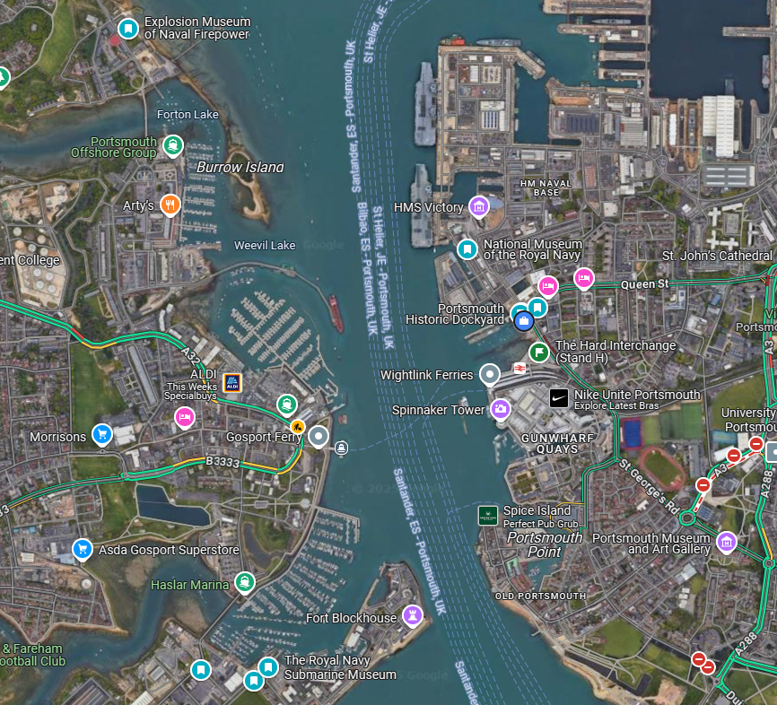
NMRN Sites

