1st June 2020
Dear Sirs,
Western Sussex Hospitals NHS Foundation Trust
Re: St. Richards Hospital West Block Ventilation Plant
Expressions of Interest
Authority's reference number: FT/1423/PZE
Western Sussex Hospitals NHS Foundation Trust is seeking expressions of interest in this project from suitably qualified providers. If you are interested and consider you have the capacity and capability to deliver the works in line with the specification provided and timescale indicated please confirm your interest and contact details to the undersigned by 12 noon on Thursday 11th June 2020 together with the following information:
- Please provide relevant experience details of ventilation contracts including the date and location of all NHS and Health projects where you were primary contractor.

- Please can you indicate if you wish to conduct your own survey of our hospital sites and indicate the duration you will require for this survey if applicable.

- In your response please also indicate your estimated required duration in weeks for producing a proposal and submitting it to the Trust.

N.B. Please do not submit any project costs at this stage as this will be requested at the tender stage.
Yours faithfully,
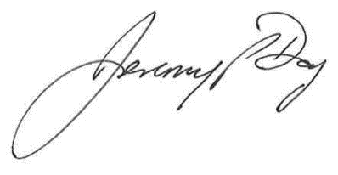
Jeremy Day
Divisional Procurement Lead – Estates & Facilities

Email: Jeremy.day@wsht.nhs.uk
For and on behalf of
Western Sussex Hospitals NHS Foundation Trust

