Exhibition Brief
Coastal Forces: Spitfires of the Seas

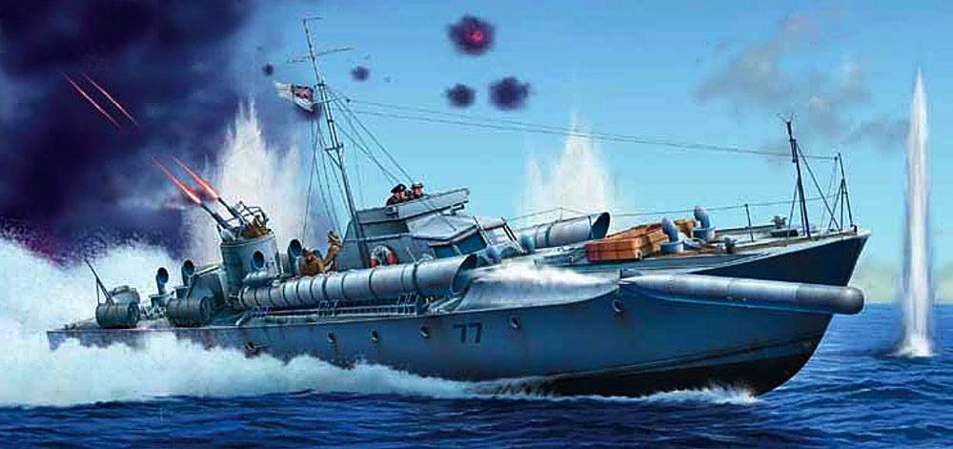

Location: Building P (Old Mine Store), Explosion Museum, Priddy’s Hard

Opening Date: Summer 2019

Overview: In partnership with the Coastal Forces Heritage Trust, the National Museum of the Royal Navy intends to create an engaging, interactive experience and exhibition gallery centred on the historic craft, Coastal Motor Boat CMB331 and Motor Torpedo Boat MTB71. It will tell the story of the Royal Navy’s Coastal Forces from inception in August 1916 to its demise in the late 1950s. The emphasis should be on excitement and entertainment, firmly rooted in historical authenticity.

Exhibition Aims

- Delight and enthral visitors by revealing the danger and risk, but also the exhilaration and drama, which characterised service in small, fast warships.
- Highlight the very varied and different experiences of those who served in Coastal Forces.
- Raise awareness about the history of Coastal Forces and the contribution made by those who served in it to victory in the First World War, Second World War and Cold War.
- Celebrate the achievements of Coastal Forces.
- Inspire visitors to find out more about Coastal Forces.
- Emphasise the local story of Coastal Forces at HMS Hornet in Gosport, and their national and international presence at bases around the British coast and overseas.
- Explain the legacy of Coastal Forces in today’s Royal Navy Archer-class P200 Patrol Boats, and the many privately operated historic craft, notably NMRN’s local partners operating Harbour Defence Motor Launch 1387 (Medusa) and Motor Gun Boat 81.

Key Themes & Interpretative Approaches

Without sacrificing authenticity but by making maximum use of modern technology, the most important aim must be to convey energy and excitement.

- The story of Coastal Forces is a thrilling and dynamic one. It is a story of very small teams of young men, often reservists with no previous experience of serving at sea, drawn from every Allied nation.
- They were operating small, well-armed but very basic and extraordinarily fast ships, invariably at night in unfamiliar waters, which required immense skill.
- Coastal warfare could involve hours waiting patiently in the dark, engines stopped or idling, waiting for a target, followed by incredibly intense, frenetic actions fought at very high speeds and finished in just a few minutes. In WW2, Coastal Forces took part in over 1,000 of these close-fought actions.
- Operations might include protecting friendly and attacking enemy convoys of merchant ships; hit-and-run attacks on enemy ports and bases; countering enemy light coastal forces, notably Germany’s WW2 ‘E-boats’ (schnellbooten); clandestine operations to insert or extract agents and special forces.
- Coastal Forces operated with distinction all over the world, but notably in the Baltic (WW1), English Channel (WW1 and WW2), Mediterranean and Adriatic (WW2), North Sea and Norway (WW2).
- Key figures include Augustus Agar VC; Robert Hichens DSO*, DSC** 5 MID; Sir Peter Scott, CH, CBE, DSC & Bar
- CMB331 and MTB71 must be at the heart of the interpretive plan.

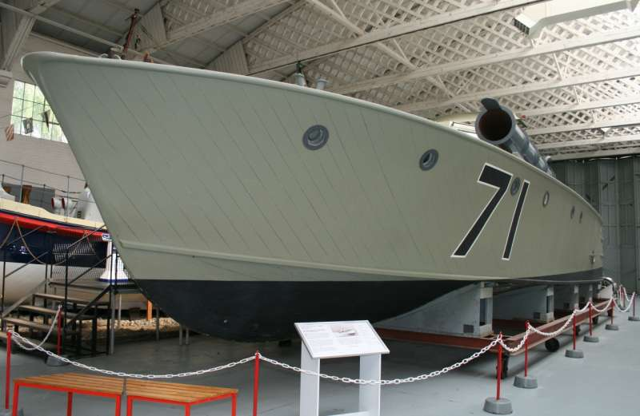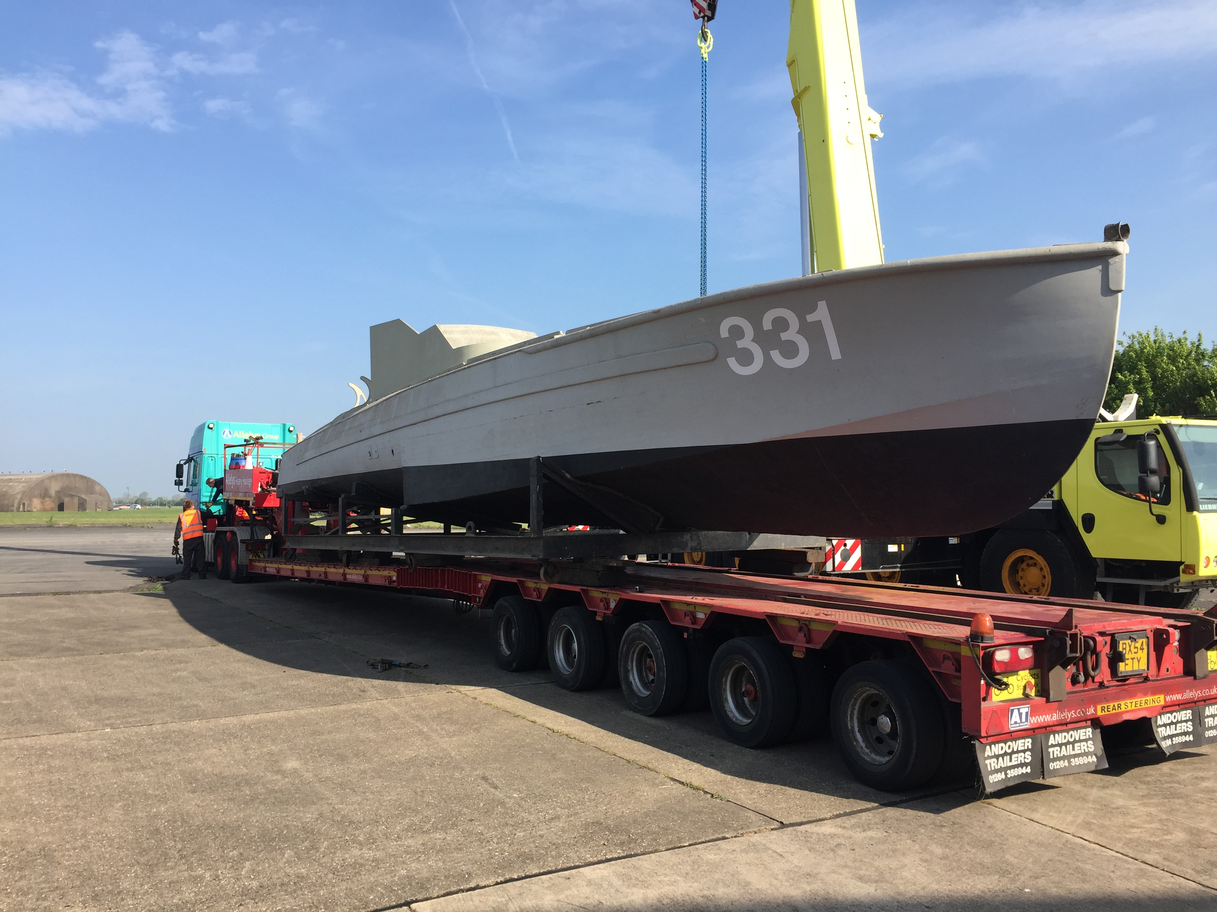

- The interpretive emphasis must be on the personal experiences of participants, with appropriate reference to their wartime opponents.
- A secondary theme might explore technology, focussing on the revolutionary design and capabilities of the boats, which evolved very fast as each war progressed.
- This theme could look at the unique skills of the boat builders: John Thorneycroft, Peter du Cane (Vospers), Hubert Scott Paine (British Power Boat Company), Noel Macklin (Fairmile Company).
- Supporting displays can draw on archival material, models and other artefacts presently held by the Coastal Forces Heritage Trust and NMRN, with appropriate loans where appropriate.
- A supporting historical summary of Coastal Forces, prepared by CFHT, is appended to this brief.

Audiences: The visitor profile for exhibitions at NMRN (P) includes:

- Local residents
- Family groups
- Visiting tourists including those from overseas
- School and cadet groups
- Serving personnel and their relatives
- Veterans and veterans’ associations
- Special Interest eg Family or military historians

The general visitor, most of whom are visiting for the first time, make up the majority of the NMRN (P) profile.

Exhibition Team
NMRN: TBC
CFHT: TBC

Key Milestones
TBC

Date | Activity
Design
Content development
Installation and fit-out

Related Activities

Opening Event
TBC

Learning and outreach activities
A range of different activities will be developed to appeal to a broad spectrum of different audiences. A new outreach session will be developed focusing on Coastal Forces to be delivered to local community groups during and beyond the life-span of the exhibition.

Souvenir guide
TBC

Online content
A digital resource will be developed for online visitors. This will draw on exhibition content but the wholesale expansion of Coastal Forces during WW2 made it a genuinely national story and so it should also be used as a portal for material generated by other NMRN sites. Online content might also include a database of important Coastal Forces sites and surviving craft

Interpretation at other NMRN sites

Hartlepool. NMRN plans an important related Coastal Forces gallery focussing on the WW2 Rescue Motor Launch RML497, at Hartlepool. These plans are not as advanced but the two narratives should complement each other.

Fleet Air Arm Museum. Links could be drawn to the Coastal Forces Air/Sea Rescue role, using craft like RML497

NMRNP: Links could be made to HMS M.33’s role in the intervention against the Bolshevik Revolution, and to any proposed gallery content dealing with this period.

Links should be made to operational craft, particularly those operated by NMRN partners and affiliates eg MGB81, MTB102, HDML1387 (Medusa)

