Reference 058769 | 2nd February 2023

Roy Emmerson
c/o Great Dunmow Town Council
Foakes House
47 Stortford Road
Great Dunmow
Essex
CM6 1DG

Dear Roy,

Re: Public Toilets White street Car Park Great Dunmow Essex CM6 – CCTV report and recommendations

Thank you for your instruction to attend the above site. Further to this please find our report and recommendations.

Details of our Recent Works;

Site; CCTV Survey - Foul and surface Underground drainage Survey
Date of Works; 20th January 2023
Your Ref; Order no 81
Our Ref; 160124

Works Carried Out;

Meet Roy on site, walked site, Made safe work areas and access. Conducted a cctv survey of all accessible underground drainage systems, see report for further details and information. Flow tested all rwp and fwg to confirm lines into system. Replaced covers removed all tools and equipment disinfected and cleaned up working areas leaving site safe and tidy

Further Works Required

7x4" patches to repair and seal system, Picote miller machine and high pressure water jetting required to descale various lines. Attempt to remove pan connector. Two lines to be blanked off as now redundant Please see CCTV report and footage for further details

Below are a selection of images for the various remedial works

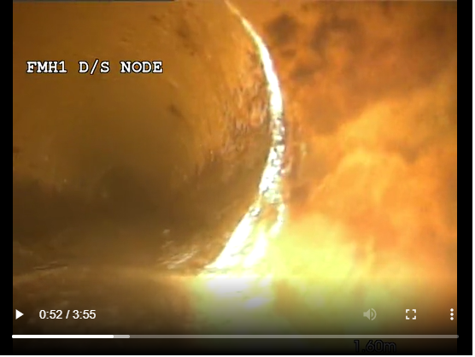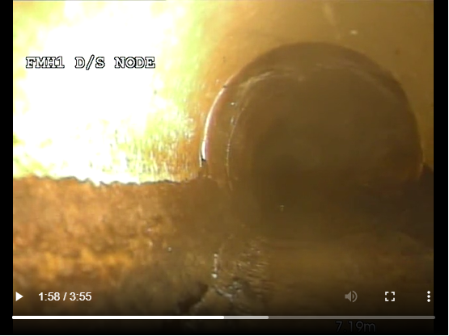

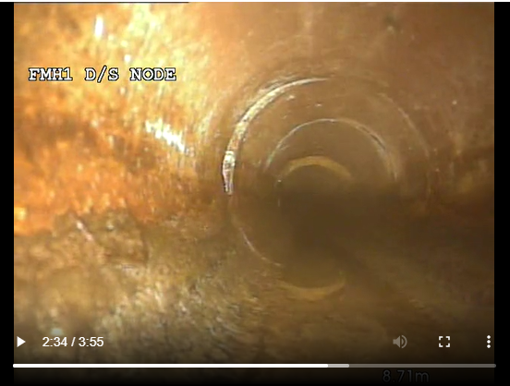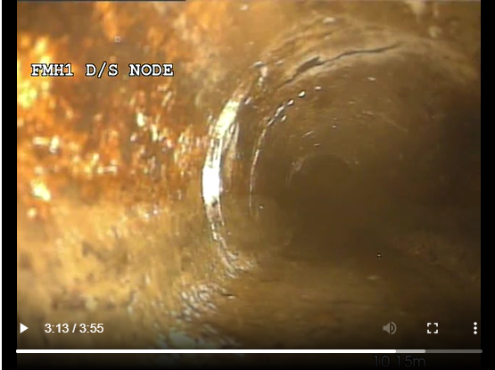

Above are a selection of the seven areas that required patches. Further detail can be found on pages 1, 8 and 9 of the CCTV report

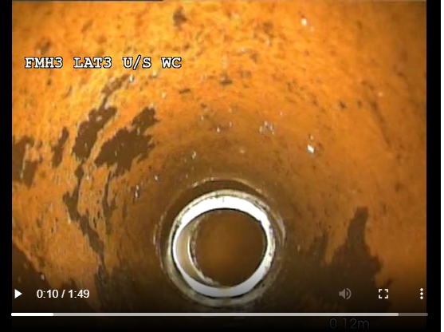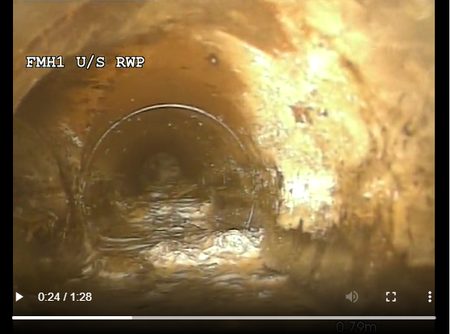

Above are two images the fist a white pan connecter lodged to the drain the second an area requirement descaling with the Pieco and high pressure water jetting. Further detail in the CCTV report on pages 10 and 13.

Below a plan of the drainage surveyed

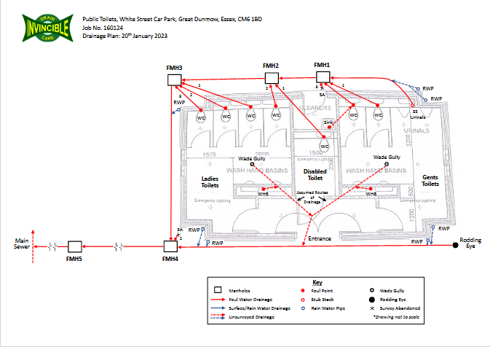

Cost for Remedial works

Labour £2295.00 + Based on a two man team up to four in hour’s shifts.

Parts and materials £567.00 + VAT

Total cost of operation £2862.00 + VAT

I trust that this will meet with your approval, however should you have any questions, comments or require any additional information then please do not hesitate to contact me on 020 8819 8523 or alternatively on 07852 347899.

With Kind Regards

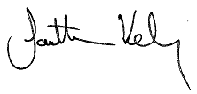
Jonathan Kelly
Account manager

Terms & Conditions

1. Variations
The prices offered are for the work described and do not include for any additional work which becomes apparent or necessary once the authorised operation has commenced. Should such a situation arise, we reserve the right to re-negotiate our quotation.

2. Delay
The prices quoted are based upon the assumption that our engineers can commerce work upon arrival at site, that continuity of work can be achieved and that the work is to take place on a non-emergency basis, unless otherwise stated. If downtime is experienced due to circumstance s beyond our control, then pro-rata charges at the agreed rate will apply.

3. Access
All manholes must be accessible with vehicular access being available where appropriate and access points being available to all blind connections.

4. Confined Spaces
Should we be required to enter any confined space as defined by the Health a Safety at Work Act or any manholes chamber deeper than 1.2 meters, we reserve the right to amend our quotation to include for the required safety equipment in order to satisfy Health a Safety legislation, unless specific provision has been made within our quote.

5. Contamination Levels
Unless otherwise stated, charges for any high-pressure jetting clearance activities included within the proposal are based upon the removal of silt (maximum average 5·10%contamination), loose scale and encrustation with the pipework. Should we encounter any extraordinary object(s) requiring special equipment or techniques, we will advise you immediately and we reserve the right to renegotiate a further charge for the extra work.

6. Investigation
In the event that we locate any problem area(s) of drainage requiring further investigation which prevents us from completing the work to any particular area, a separate report will be submitted. This will detail our findings together with recommendations for remedial action together with the associated cost implications.

7. Seized Covers
Should there be a risk of permanent damage to any manhole cover or access point owing to lack of maintenance or seizure then the defect will be recorded and a report submitted detailing the extra work required to enable the necessary work to be conducted from the location or locations in question.

8. Excavations
Our quotation is based upon the assumption that the ground is firm and conditions uniform, allowing for economical working to the method specified. Unless otherwise stated, no allowance has been made for rock, buried debris and clay stones, running silt or running ballast. Should such variations become apparent then you will be immediately notified and work suspended pending agreement of variation charges.

9. Rates
Quoted charges have been based upon normal working hours (i.e. between 08:00 and 17:00) during weekdays, unless otherwise stated.

10. Utilities
Our quotation is subject to sufficient access and provision of an adequate water supply.

11. Waste Uplift
In the case of waste disposal, charges are calculated that any premises waste codes provided are both valid and accurate and that the description of the waste to be removed has not been misrepresented. Errors or omissions in either can result in a load being rejected by the accepting treatment plant, and demurrage charges may apply if the plant cannot be legally discharged of its load.

12. Waste Disposal
If charges have been estimated then these will have been based upon estimated levels of contamination disposal charges are calculated by the related facility based upon waste stream analysis that is sampled at point of disposal. Silted content rates can increase quite significantly.

13. Validity
The price quoted is valid for 90 days from the date of quotation.

14. VAT
All prices are subject to VAT at the prevailing rate.

Terms & Conditions

1. Variations
The prices offered are for the work described and do not include for any additional work which becomes apparent or necessary once the authorised operation has commenced. Should such a situation arise, we reserve the right to re-negotiate our quotation.

2. Delay
The prices quoted are based upon the assumption that our engineers can commerce work upon arrival at site, that continuity of work can be achieved and that the work is to take place on a non-emergency basis, unless otherwise stated. If downtime is experienced due to circumstance s beyond our control, then pro-rata charges at the agreed rate will apply.

3. Access
All manholes must be accessible with vehicular access being available where appropriate and access points being available to all blind connections.

4. Confined Spaces
Should we be required to enter any confined space as defined by the Health a Safety at Work Act or any manholes chamber deeper than 1.2 meters, we reserve the right to amend our quotation to include for the required safety equipment in order to satisfy Health a Safety legislation, unless specific provision has been made within our quote.

5. Contamination Levels
Unless otherwise stated, charges for any high-pressure jetting clearance activities included within the proposal are based upon the removal of silt (maximum average 5·10%contamination), loose scale and encrustation with the pipework. Should we encounter any extraordinary object(s) requiring special equipment or techniques, we will advise you immediately and we reserve the right to renegotiate a further charge for the extra work.

6. Investigation
In the event that we locate any problem area(s) of drainage requiring further investigation which prevents us from completing the work to any particular area, a separate report will be submitted. This will detail our findings together with recommendations for remedial action together with the associated cost implications.

7. Seized Covers
Should there be a risk of permanent damage to any manhole cover or access point owing to lack of maintenance or seizure then the defect will be recorded and a report submitted detailing the extra work required to enable the necessary work to be conducted from the location or locations in question.

8. Excavations
Our quotation is based upon the assumption that the ground is firm and conditions uniform, allowing for economical working to the method specified. Unless otherwise stated, no allowance has been made for rock, buried debris and clay stones, running silt or running ballast. Should such variations become apparent then you will be immediately notified and work suspended pending agreement of variation charges.

9. Rates
Quoted charges have been based upon normal working hours (i.e. between 08:00 and 17:00) during weekdays, unless otherwise stated.

10. Utilities
Our quotation is subject to sufficient access and provision of an adequate water supply.

11. Waste Uplift
In the case of waste disposal, charges are calculated that any premises waste codes provided are both valid and accurate and that the description of the waste to be removed has not been misrepresented. Errors or omissions in either can result in a load being rejected by the accepting treatment plant, and demurrage charges may apply if the plant cannot be legally discharged of its load.

12. Waste Disposal
If charges have been estimated then these will have been based upon estimated levels of contamination disposal charges are calculated by the related facility based upon waste stream analysis that is sampled at point of disposal. Silted content rates can increase quite significantly.

13. Validity
The price quoted is valid for 90 days from the date of quotation.

14. VAT
All prices are subject to VAT at the prevailing rate.

