Request for Quotation
Ref: ENV0000389C
Title: Radcliffe & Redvales Phase 1

Section 1

Who is the Environment Agency?
We are an Executive Non-departmental Public Body responsible to the Secretary of State for Environment, Food and Rural Affairs. Our principal aims are to protect and improve the environment, and to promote sustainable development.

Further information on our responsibilities, Corporate Plan and how we are structured can be found on our Website.

https://www.gov.uk/government/organisations/environment-agency/about

What do we spend our money on?
We are a major procurer of goods and services within the UK, spending circa £600M per annum, our major spend areas are:

- Flood and Coastal Risk Management (design, construction and maintenance)
- ICT and Telecommunications
- Vehicles and Plant
- Environmental Consultancy and Monitoring
- Temporary Staff and Contractors
- Facilities Management, Energy and Utilities
- Flood Management and Water Related Services

What do we need from our suppliers?
Suppliers are vital in supporting the delivery of our corporate plan. We aim to support the economy and society whilst delivering more environmental outcomes for every pound we spend. In many areas we are leading the way on environmental and technical developments. It is our role to ensure that suppliers clearly understand our corporate aims and objectives and know that we are committed to delivering the best value most sustainable solutions, taking into account the whole life cost of our procurement decisions. We promote diversity and equality and treat all of our suppliers fairly.

Our procurement strategy may be of interest to you as a potential supplier. It sets out our priorities and key commitments in a range of areas such as delivering our corporate plan, Government policy, supplier management and sustainable procurement:

https://www.gov.uk/government/organisations/environment-agency/about/procurement#procurement-strategy

Further information
For further information and to see our commitments to Diversity and Equality, please visit our website.

https://www.gov.uk/government/organisations/environment-agency/about/procurement
https://www.gov.uk/government/organisations/environment-agency/about/equality-and-diversity

Also, are you up to date on environmental legislation? See links below for further information.

Waste and Environmental Impact - https://www.gov.uk/browse/business/waste-environment
Environmental Regulations - https://www.gov.uk/browse/business/waste-environment/environmental-regulations’

Section 2

Summary

The landscape contract comprises of establishment aftercare for trees and hedgerow.

- Production of standard Risk Assessments and Method Statements (RAMS) and a site specific programme of works.
- Hire and maintenance of a 3 in 1 welfare facility.
- Establishment aftercare of 237 trees and shrubs.
- Establishment aftercare of 141m of hedgerow.
- Aftercare maintenance of 2,800m² wildflower area.
- Control of Japanese Knotweed and Himalayan balsam (Provisional Item).
- Annual litter picking.
- Annual maintenance and top-up of mulch.

- The following plans have been provided by Mott MacDonald
  - ENV0000389C-MMD-DZ-00-DR-L-0307009-S2-C03 FLM Dumers Lane 1 of 1
  - ENV0000389C-MMD-DZ-CP-DR-L-0307040-S2-P02 Close Park Seeding Plan
  - ENV0000389C-MMD-DZ-CP-DR-EN-0302015-C03 Close Park WFD Area
  - ENV0000389C-MMD-DZ-00-DR-L-0307023-S2-C01 FLM Close Park 2 of 2
  - ENV0000389C-MMD-DZ-00-DR-L-0307008-S2-C03 FLM Close Park 1 of 2

Contract Length

It is anticipated that this contract will be awarded to one supplier for a period of four years from the date of the contract being awarded. Prices will remain fixed for the duration of the contract award period. We may at our sole discretion extend this contract to include related or further work. Any extension shall be agreed in advance of any work commencing and may be subject to further competition. Any amendment to contract prices for the extensions are to be by negotiation.

The contract Terms and Conditions shall be those of the JCLI as detailed within Appendix B.

Contact Details and Timeline

Landscape Contract Support will be your contact for any questions linked to the content of the quote pack or the process. Please submit any questions by email and note that both the question and the response will be circulated to all tenderers.

Key elements of the process have been reviewed. Anticipated dates for planned activities are below:

Activity | Due Date
Supplier responses for Request for Quote | 5pm Friday 10.12.2021
Evaluation of Request for Quote submissions | Week Commencing 06.12.2021
Award of contract | Week Commencing 13.12.2021
Project/Contract start date | 10.01.2022

It should be noted that these timescales and activities may be subject to change.

Section 3

Evaluation Criteria

We will award this contract in line with the most economically advantageous tender (MEAT) as set out in the following award criteria:

- Price –70%
- Quality – 30%
The following quality criteria are weighted in accordance with the importance and relevance attached to each one.

We ask for a maximum of 2 sides of A4 (Arial, size 11) to cover the following quality criteria
- Your key personnel, who will be directly involved with this contract.
- Copy of your BALI certificate (not included in the page limit)
- Your recent experience of carrying out similar contracts – provide summary of three examples and contact details
- Health and safety qualified staff
- How would you demonstrate your compliance on this contract commensurate with the Environment Agency (EA) Safety, Health, Environment, Welfare (SHEW) Code of Practice (CoP) – copy included with this tender
- How will you supervise your work to ensure a high quality is maintained throughout the contract?

The criteria listed above will be assessed on a 0 to 10 basis and will reflect the following judgements:
Rating of Response  The tenderer provides a response which in the opinion of the evaluators is: | Score
Very good - Addresses all the Authority’s requirements with all the relevant supporting information set out in the Bidder Pack. There are no weaknesses and therefore the tender response gives the Authority complete confidence that all the requirements will be met to a high standard. | 100
Good - Addresses all the Authority’s requirements with all the relevant supporting information set out in the Bidder Pack. The response contains minor weaknesses and therefore the tender response gives the Authority confidence that all the requirements will be met to a good standard. | 70
Moderate - Addresses most of the requirements with most of the relevant supporting information set out in the Bidder Pack. The response contains moderate weaknesses and therefore the tender response gives the Authority confidence that most of the requirements will be met to a suitable standard. | 50
Weak - Substantially addresses the requirements but not all and provides supporting information that is of limited or no relevance or a methodology containing significant weaknesses and therefore raises concerns for the Authority that the requirements may not all be met. | 20
Unacceptable - No response or provides a response that gives the Authority no confidence that the requirement will be met. | 0

Section 4

Information to be returned

Please note, the following information requested must be provided. Incomplete tender submissions may be discounted.

Please complete and return the following information:
- completed Schedule of Rates (Appendix A);
- confirmation that terms and conditions are accepted (Appendix E. Please note that the terms cannot be amended later).
- Quality Evaluation information (max 2 sides of A4 page) – as per request in Section 3.
- Completed Mandatory Questions (Appendix F)

Section 5

Additional Information

Copyright and confidentiality

Unless otherwise indicated, the copyright in all of the documentation belongs to the Environment Agency, and the documentation is to be returned to us with your tender. The contents of the documentation must be held in confidence by you and not disclosed to any third party other than is strictly necessary for the purposes of submitting your quote. You must also ensure that a similar obligation of confidentiality is placed upon any third party to whom you may need to disclose any of the documentation for the purposes of the tender.

Accuracy of documentation

You should check all documentation; should any part be found to be missing or unclear you should immediately contact us at the address given in the covering letter. No liability will be accepted by the Environment Agency for any omission or errors in the documentation which could have been identified by you.

Amendments to documentation

Prior to the date for return of tenders, we may clarify, amend or add to the documentation. A copy of each instruction will be issued to every Tenderer and shall form part of the documentation. No amendment shall be made to the documentation unless it is the subject of an instruction. The Tenderer shall promptly acknowledge receipt of such instructions.

Alternative Offers

Alternative offers may be considered if they constitute a fully priced alternative and are submitted in addition to a quotation complying with the requirements of the Invitation to Quote Documents. If, for any reason you wish to submit an alternative offer without a fully compliant tender please contact us in accordance with the details in the covering letter.

Continuity of personnel

The Contractor shall employ sufficient staff to ensure that the Services are provided at all times and in all respects to the Project Standard. It shall be the duty of the Contractor to ensure that a sufficient reserve of staff is available to ensure project delivery in the event of staff holidays, sickness or voluntary absence

The Environment Agency will be notified immediately of any changes to personnel associated with the project. The Contractor will ensure that every effort is made to replace outgoing staff with personnel of equal calibre and expertise. All new members of staff undertaking work for the Project will need to be agreed by the Environment Agency prior to commencement.

At all times, the Contractor shall only employ in the execution and superintendence of the Contract persons who are suitable and appropriately skilled and experienced.

Intellectual property rights

All results, including material and tools produced, developed or paid for under this contract shall be the property of the Environment Agency.

References

The Environment Agency may request recent and relevant references prior to the award of the project.

Contract award

This Request for Quote is issued in good faith but we reserve the right not to award any or all of this work.

The JCLI Landscape Maintenance Works Contract 2017 will apply to this contract.

DATA PROTECTION ACT

Protection of personal data

In order to comply with the Data Protection Act 1998 the Contractor must agree to the following:

- You must only process the personal data in strict accordance with instructions from the Environment Agency.

- You must ensure that all the personal data that we disclose to you or you collect on our behalf under this agreement are kept confidential.

- You must take reasonable steps to ensure the reliability of employees who have access to personal data.

- Only employees who may be required to assist in meeting the obligations under this agreement may have access to the personal data.

- Any disclosure of personal data must be made in confidence and extend only so far as that which is specifically necessary for the purposes of this agreement.

- You must ensure that there are appropriate security measures in place to safeguard against any unauthorised access or unlawful processing or accidental loss, destruction or damage or disclosure of the personal data.

- On termination of this agreement, for whatever reason, the personal data must be returned to us promptly and safely, together with all copies in your possession or control.

Appendices

APPENDIX A – SCHEDULE OF RATES – See Excel spreadsheet

APPENDIX B – JCLI TERMS & CONDITIONS – See Word document

APPENDIX C – SAFETY HEALTH ENVIRONMENT AND WELLBEING (SHEW) CODE OF PRACTICE – See PDF document

APPENDIX D – MINIMUM REQUIREMENTS – See Folder

APPENDIX E – FORM OF AGREEMENT

APPENDIX F – MANDATORY QUESTIONS – See Word document

Appendix E
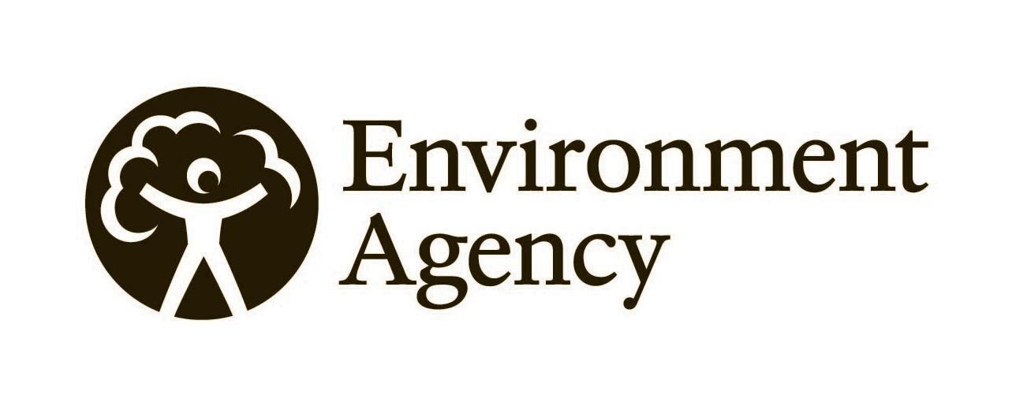
Form of Agreement

Contract Name: Radcliffe & Redvales Phase 1

I/We hereby certify that I/we have not, and will not in future, canvassed or solicited any Member, Officer or employee of the Environment Agency in connection with the award of this work package or any other Work package or proposed Work package for the service of Works, Maintenance or works and Maintenance and that no person employed by me/us or acting on my/our behalf has done any such act.

Having examined the Work Package Document and being fully satisfied as to my/our abilities and experience in all respects to satisfy the requirements of the Work package Document, I/we hereby offer to provide upon the terms and conditions of the Contract, the Works/Maintenance/or works and maintenance therein, and site specific contractors information supplied and approved specified at the rate shown in the Pricing Schedule of the Work package.

This work package and additional information provided by us, together with the JCLI terms and conditions and the Environment Agency's written acceptance thereof, will form a binding agreement between us.

Proposed Cost: Tendered cost to be inserted by contractor here

Signature of Supplier: _______________________________________________

Name in Print: _______________________________________________

Company Name: _______________________________________________

Telephone No. (s): _______________________________________________

Dated this: _______________________________________________

