**Invitation to tender**

**For grass cutting and general horticultural work**

**Invitation to tender**

**For grass cutting and general horticultural work**

You are invited to submit your tender for **grass cutting and general horticultural work** for Steeple Bumpstead Parish Council (SBPC)

The contract will last for a period of three years, starting in **January 2025**, and may be extended if agreed by both parties for an additional period of up to 3 x 1-year extensions.

All work must be carried out in an environmentally friendly manner. All areas included in the contract are public open spaces and work should be conducted so as not to interfere with public use of these spaces.

SBPC reserve to right to offer the contract to a contractor who provides the best value for the council, not necessarily the lowest price

**BUDGET**

The Parish Council has a small budget for these works, the Council’s current precept is £44k for all Council expenditure.

**DEADLINE**

Completed tender documents should be returned no later than 22.00, 31/10/2024 see submission notes below.

Contract commencement is expected to be midday 20/01/2025

Detail of tender

**Confirmation Of Intent to Respond**

Tenderers are requested to confirm their intent to respond by emailing [clerk@steeplebumpstead-pc.org](mailto:clerk@steeplebumpstead-pc.org) to confirm their participation as soon as possible

**Site Visits**

Contractors interested in responding to this tender may arrange an accompanied visit to the site by contacting the Parish Clerk by email or the Council’s Chairman. Unaccompanied visits may be made at any time. Tenderers are advised to make such a visit to ascertain all relevant conditions and means of access etc.

**Further Information**

Further required information should be requested by emailing [clerk@steeplebumpstead-pc.org](mailto:clerk@steeplebumpstead-pc.org). Such information should be sought before 20/10/2024

**Completion of the tender**

The form can be completed online or by hand and then scanned in to be emailed for submission. Please do not include your business name in the answer to any questions.

**Contract Term**

The contract will last for a period of three years, starting in 20/01/2025

The contract may be extended for up to a total of 3 years, in 1-year increments, if agreeable by both parties

All work must be carried out in an environmentally friendly manner. All areas included in the contract are public open spaces and work should be conducted so as not to interfere with public use of these spaces

**Performance monitoring**

The contract will be subject to regular performance meetings and the contractor is required to submit performance indicators, please ensure this is included in your submission costings

**Termination**

Either party may terminate the contract at any time by providing three months’ notice in writing

**Evaluation**

55% Quality & Innovation 45% Price

Quality & Innovation will be assessed by your answers and references provided

**Submission**

Completed tender documents should be returned no later than 22.00, 31/10/24 by email to: [**office.steeplebumpstead.pc@gmail.com**](mailto:office.steeplebumpstead.pc@gmail.com) **(please note this is an unmanned email address – please send any queries to the clerk at** [**clerk@steeplebumpstead-pc.org**](mailto:clerk@steeplebumpstead-pc.org) **)**

Or if you prefer, you may send your tender documents by post in a sealed envelope Marked Tender Documentation to;

Julia Howard

Parish Clerk

c/o 86 Highfields

Great Yeldham

Essex. CO9 4QH

**APPLICATION**

|  |  |
| --- | --- |
| Company Name: |  |
| Address: |  |
| Contact Name: |  |
| Phone: |  |
| Mobile: |  |
| Email: |  |
| Please provide 3 referees / references*, ideally at least 2 will be 5+ years old and one more recent. If you are unable to do this, please explain in the box below.  *SBPC is committed to reducing costs and therefore would prefer email and phone communication, rather than postal. If you have references you may email them in with your application. By providing referee details you are giving permission for them to be contacted as part of the tender analysis (prior to award of contract) | |
| Reference 1 |  |
| Reference 2 |  |
| Reference 3 |  |
| I confirm that I have read the full document, my answers are accurate and that I agree to terms written within this document.  Name:  Date:  Signature: | |

**Tender Specification**

**Grass Cutting & General Horticultural Works in and Around the Village of Steeple Bumpstead, Essex**

**For**

**Steeple Bumpstead Parish Council (SBPC)**

The Moot Hall

Chapel Street

Steeple Bumpstead

Essex

CB9 7DQ

|  |  |
| --- | --- |
| **Prepared by:** | **Mrs Julia Howard** |
| **Date:** | **3rd July 2023** |
| **Ref:** |  |

*Please provide explanations and expand on your answers wherever possible;*

*if you have not written it down, it cannot be assessed and scored as part of your answer.*

*Space is not restricted; you may use as many sheets to answer your questions as you need.*

*Answers will be assessed individually, so please repeat anything that is asked for, even if it’s been asked and answered before.*

**Question 1**

How far away is your base and how many miles, by road, will you need to travel to undertake this contract if you will be coming from a different location (use CB9 7DQ in your calculation.)

**Question 2**

1. How many staff do you employ
2. Will you employ additional staff if you are awarded this contract
3. If so, would you look to recruit locally

*Please provide explanations and expand on your answers*

**Question 3**

Have you had issues with poor performance and please describe how you managed this and the outcome of the contract

**Question 4**

Have you ever had a contract terminated early, please explain why

**Question 5**

What steps will you take to minimise your carbon footprint, both as a business and in undertaking this contract

**Question 6**

Do you offer work experience and/or apprenticeships

**Question 7**

The area suffers from flooding at times, and can be very dry at other times. How would you handle the cut schedule in such extremes

**Question 8**

How would you innovate to improve efficiency and reduce costs in the longer term, please describe measures even if they may incur additional initial costs but ultimately will reduce the contract costs year on year?

**Question 9**

Tidiness and ‘going the extra mile’ is really important, Steeple Bumpstead is a small village with a lively community. For example, If you were doing a routine cut and found there to be lots of new weeds and litter inside the play area, describe how would you deal with this?

**Question 10**

IT compliance – although this is a landscapes tender, the routine monitoring of the contract will require completion of Excel forms. Can your company manage these? Do you have additional admin staff or would you be the direct contact for all enquiries? Please describe any contracts you hold which also have performance monitoring and how you manage this.

**Pricing – please refer to the 2 maps in the appendices**

|  |  |
| --- | --- |
| **Item** | **Cost** |
| **Cut grass on the following areas every two weeks from the start of April to the end of October as the season dictates (max 18 cuts)**  **Strim around obstacles as appropriate, making sure that you are not damaging posts/trees**  **Grass & other vegetation must be cut/strimmed right up to the boundary of the area**  **Sweep all cuttings from pavements/highways**     * The triangle at Haverhill Road/The Endway junction **1** * Claywall bridge/outside and around Humphrey’s Meadow **2** * Claywall bridge/opposite gate to Humphrey’s Meadow **3** * Left hand side of bottom of Home Close by the bin if any grass left **4** * Outside the cemetery in Finchingfield Road **5** * Right and left sides of entrance into Bower Hall Drive **6** * Grassed area opposite school beside 43 Bower Hall Drive **7**       Total max yearly cost | **Cost per cut**  **£**  **£**  **£**  **£**  **£**  **£**  **£**  **£ ______________** |
| **Cut the grass on the Camping Close/Bellropes every two weeks from**  **the start of April to the end of October as the season dictates (max 18 cuts)**  **Strim around obstacles as appropriate making sure that you are not damaging posts/trees**  **Grass & other vegetation must be cut/strimmed right up to the boundary of the area including ditches**  **Sweep all cuttings from pavements/highways**    Total max yearly cost | **Cost per cut**  **£**  **£ ______________** |
| **Cut the grass and remove any vegetation from paths, graves and other areas in St Mary’s Churchyard 9 and the cemetery 22 every two weeks from the start of April to the end of October as the season dictates (max 18 cuts) parts, to maintain both areas in a good overall condition.**  **Strim around gravestones/obstacles as appropriate making sure that you are not damaging posts/trees/gravestones**  **Grass & other vegetation must be cut/strimmed right up to the boundary of the area**  **Sweep all cuttings from graves/pavements/highways**    Total max yearly cost | **Cost per cut**  **£**          **£ ______________**  **£** |
| **Cut the grass on Main part of Humphrey’s Meadow every two weeks from the start of April to the end of October as the season dictates (max 18 cuts) 10**  **Maintain the area to rear of Houses every 4 weeks from the start of April to the end of October as the season dictates (max 9 cuts) 11 Grass & other vegetation must be cut/strimmed right up to the boundary of the area**  **Strim around obstacles as appropriate making sure that you are not damaging posts/trees**  **Sweep all cuttings from pavements/highways**    Total max yearly cost | **Cost per cut**  **£**  **£**  **£ ______________** |
| **Cut the SBPC maintained footpaths surrounding the village (as marked on attached map) two times. First cut to be March/April and second cut June/July. (exact dates to be confirmed with SBPC before work commences) To include overhanging greenery as appropriate**    Total max yearly cost | **Cost per cut**  **£**  **£ ______________** |
| **Cut the following hedges twice a year (following nesting)**   * Humphrey’s Meadow hedge, both sides and top **12** * By path between Pottery and Church Yard **13** * By path between Church Street and Church Yard **14** * By Village Hall leading to Camping Close **20**     Total max yearly cost | **Cost per cut**  **£**    **£ ______________** |
| **Strim/cut back overhanging branches and spray weeds with**  **an appropriate weedkiller as necessary**   * By path between Church Street and Church Yard **14** * From Fox & Hounds to 2 Church Street **15** * By path between Pottery and Church Yard **13** * Path between 2 Finchingfield Road & Bendyshe Court **16** * Path between School and Barker Close **17** * Footpath 29 to rear of school **18** * Path between Camping Close/Bellropes and Churchfields/St Mary’s Walk **19** * Edge of top car park on Camping Close **20**     Total max yearly cost | **Cost per cut/spray**  **£**  **£**  £  £  £  £  £  £  **£ ______________** |
| **Strim/maintain plantation area each side of Village Hall entrance road and each side of fence, once a month from start of April to end of October as season dictates (max 7 occasions) Weed garden area in front of re-cycling bins 21**    Total max yearly cost | **Cost per cut**  **£**  **£ ______________** |
| **Hourly rate for ad-hoc work**  **Breakdown of other costs including those relating to the administration of this contract**  Total max yearly cost | **£**  **£**  **£ ______________** |
| **Total Yearly costs all items (total)** | **£ ______________** |

# Mandatory Requirements

The contractor must include copies of the following documentation with their tender submission (or commit to achieving these if awarded the contract)

* Public liability Insurance – Minimum £1,000,000
* Employers Liability insurance (not less than £5,000,000)
* Spray operators ‘Certificate of Competence - PA6A’
* Copy of your Health & Safety Policy
* Example of a risk assessment used on another contract
* A valid waste transfer certificate
* An indicative programme of works to be provided each year in April* (so we know when you plan to make cuts – understanding that they may vary slightly according to weather conditions) *timeframe can be moved to suit your business needs and keep the costs down
* Subcontracting is not permitted unless by prior agreement with the PC

The successful contractor must provide all machinery, equipment & fuel necessary to carry out the work and ensure relevant maintenance and servicing. The successful contractor must also ensure staff are provided with, appropriate training and any PPE necessary.

A staff training schedule must be produced on request

The contractor must dispose of any risings/cuttings in an appropriate manner, off site (this should be included in all quoted costing above).

All prices quoted should be exclusive of VAT

**Terms of Payment**

Payment by the council will be via the invoice process.

Invoices received will be presented on a payment list to the next monthly Parish Council meeting (with the exception of April and August) to be approved by full Council.

They will then be raised for payment by the clerk/RFO within 14 days and following electronic authorisation will be paid by bank transfer. It is intended that this will be within 30 days of receipt of a full tax invoice. Please ensure this process is costed appropriately in your submission.

Payment will be held at any time should the work undertaken be deem unsatisfactory or outside the schedule of works

**Inflationary uplift**

*A 2% inflationary increase may be applied each year, where the CPI inflation is 2% or greater.*

*The Parish Council will consider any further requests for increases where justified, provided they are presented in writing by 15th October of the year prior to the increase.*

**Procurement Timetable**

The key dates for the procurement procedure are set out in the table below although Steeple Bumpstead Parish Council reserves the right to vary key dates on notice to all Tenderers.

|  |  |
| --- | --- |
| Issue Invitation to Tender (ITT) | 26/09/2024 |
| Clarification Questions from Tenderers Deadline | 20/10/2024 |
| Deadline for submission of Tenders | 31/10/2024 |
| Evaluation and Consultation | 18/11/2024 |
| Council Decision and Contract Award Date | 09/12/2024 |
| 10-Day Standstill Period | 23/12/2024  (contract award + 10) |
| Confirm Commencement date | 20/01/2025 |
| Rectification period minimum | 1 month |

**Evaluation**

The Council will determine the bid that it believes delivers the greatest benefit to users for the price it pays.

Quality & Innovation will be assessed by reference to responses in the Tenderer’s Proposal and any supporting information provided by the Tenderer, including three references of which two should ideally be at least five years old.

If, in its reasonable judgement, the council identifies a fundamental failing or weakness in a bid then that bid may, regardless of its other merits, be excluded from further consideration.

The decision of the council will be final in this matter.

**Appendices**

1. **Steeple Bumpstead Village map**

**Street Map and Green Areas**

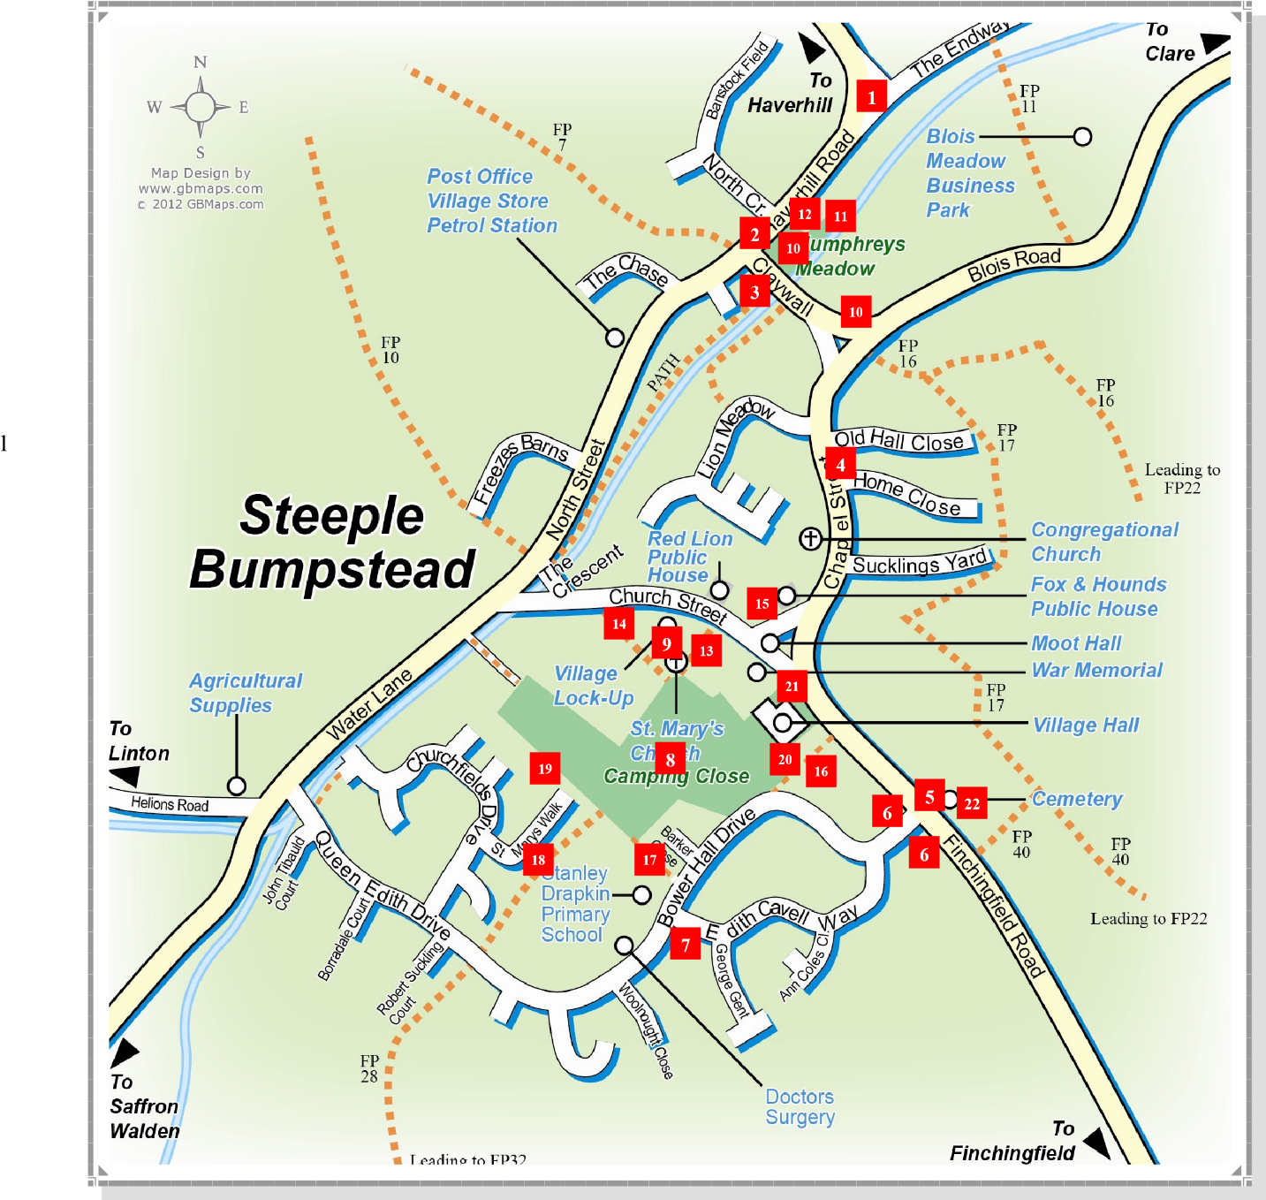

1. 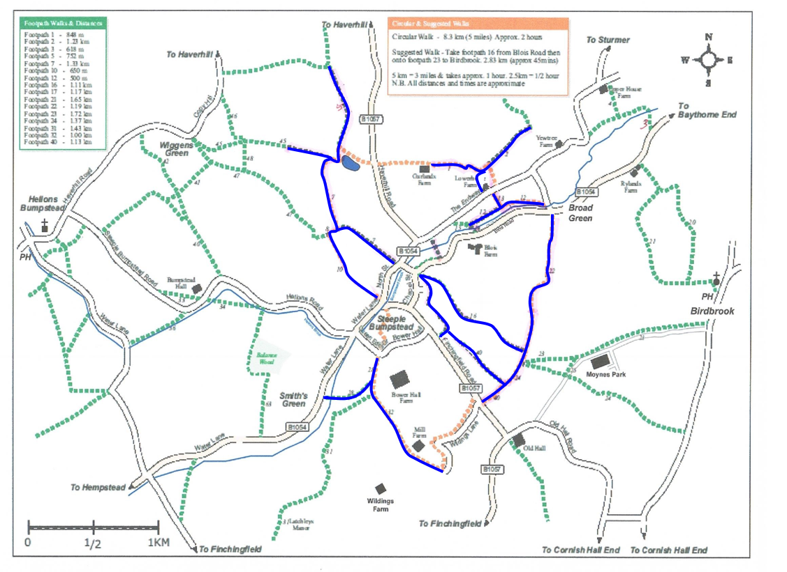**Steeple Bumpstead Footpath map**