Moss Side Farm
Wheelchair access and standing

Specification

1.1 Site Background information
Moss Side field was formerly agricultural land and is now being re-wet as part of a wetter farming project. Within this is a garden area including a Fen Flower Garden, Orchard, space for compost loo and shed and a former equestrian menage which has a polytunnel and standing for bog plants.

1.2 Contractor Experience
Contractors are invited to tender for this work, which will require not only skill and experience of this type of work but particularly on boggy, difficult to navigate peat soils. Successful Contractors must demonstrate knowledge of and have regard for the sensitive nature of wetland hydrology and ecology. It is not expected that this work will be sub-contracted out and must therefore be undertaken by the successful Contractor.

1.3 Nature of work
Disability access path and passing points
Location Moss Side Farm, Rindle Road, Astley, Leigh M29 7LT
Wheelchair Accessible Pathway Design

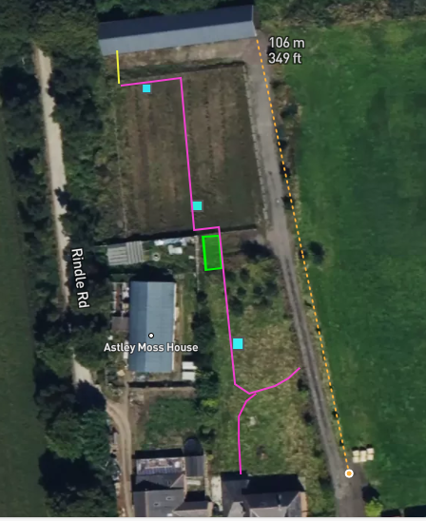
Marked pink
- Long:134 metres
- Width: Minimum of 1200mm
- Ground is level with acceptable slope
Marked yellow
- Increase the path height from Menage to Open Barn by an additional 200mm.
- Long: 8 metres
- Width: Minimum of 1200mm with ramps either side
- Ground is level with acceptable slope

Marked blue
- 3 x Mobility scooter passing places
- Long: 2.5 metres
- Width in additional to the existing 1200mm Total = 2400mm wide.
- Ground is level with acceptable slope
Marked green 8 metre wide conclave between garden and menage
- Hard standing to accommodate a metal shed with dimensions 1524mm x 2134mm
- Excavation with soft standing to accommodate a compost loo with vault and soakaway Option B. https://natsol.co.uk/install/SITE%20SOAK.pdf 4000mm x 3500
- Ground is level with acceptable slope

Path and hard standing materials
- The new path starts at the gate onto site through a lawned area onto peat soil that is currently a garden and horse sand menage.
- The track needs to be 1.2 metres wide and the surface made suitable for easy wheelchair use.
- A light yellow granite crusher run on substrate is preferred to not affect the pH of the peat soil underneath and to provide a visual aid for those with visual impairments. However, other shades of granite are acceptable.
- Base Layer: Add a 100mm of larger crushed granite stone and compact it thoroughly. This layer forms the foundation of the path.
- Top Layer: Add a 50mm layer of finer crusher run on top of the base layer and compact it again. This top layer should be smooth and level to ensure a firm, stable, and slip-resistant surface.
- Material must be natural and clean.
- A slightly raised recycled plastic border will follow along the edge of the track on both sides to keep the granite in location.
- Compaction: Ensure the surface is firm, stable, and slip resistant. Add and compact additional granite crush and run as needed to maintain a smooth, stable surface.
- The path will require an appropriate camber to prevent pooling.

2.0 Contact Information
Project Manager
Jenny Griggs 07880 081994 jenny.griggs@naturalengland.org.uk

3.0 Access
The site can be reached via access point are main gate to Moss Side Farm Astley, Manchester M29 7LS. This road is in a dilapidated state but is wide enough and stable enough to allow access for large machinery.
The garden location SJ 70392 97113
W3W: shaky.tickles.pacemaker
A google maps pin https://maps.app.goo.gl/gneZeDm8SSgkFBXa7 for the gate to Moss Side Farm.

4.0 Project Management
- Day-to-day management and supervision of all machines and operatives will be the responsibility of the Contractor.
- The Contractor will be required to liaise weekly with Natural England (NE) during the project and provide progress reports when required.

5.0 General Principles

5.1 Prevention of enrichment/pollution of the sites
It is vital to the management of the site that there is no nutrient enrichment or spillage of chemicals, of any kind, onto the site. The Contractor shall meet high environmental standards by providing (and using) spill kits for all equipment and using bio-fuels and bio-lubricants in all machines where possible.

5.2 Method of works
Due to the difficulty of transporting any weight around on the peat surface, the work will need to be planned such that access and/or movement of material is done solely on foot or by low ground pressure plant/vehicles.

5.3 Peat/mineral interface
The Contractor must be careful to avoid disturbing the peat and care needs to be taken when excavating/scraping/moving. The client will need to be informed immediately of any occasion where the underlying mineral surface is accidentally exposed.

6.0 Works to be carried out

See 1.3

7.0 General work requirements
- All operatives will hold current, relevant certification for all machinery and the contractor will have appropriate public liability insurance cover. All certification, public liability insurance documents and a Health and Safety policy statement must be presented with the tender documents.
- All operators will be experienced of working on wet peatland sites undertaking restoration work of a similar kind.
- The contractor shall provide all equipment, all fuel and maintain all equipment required for the completion of the project, including all appropriate PPE.
- The contractor will be responsible for all first-aid within the contract work force, and a practising first-aider with current certification will be present at all times. The contractor will provide appropriate first aid equipment. Lone working will not take place under any circumstances. Welfare facilities can be provided at the close by Moss Side Farm if required.

7.1 Health and Safety
- The successful contractor will be expected to provide appropriate Risk Assessments and Method Statements.
- A Construction Phase Plan will be required with reference to welfare provided to operatives.
- Toilet facilities including warm water and a rest area can be made available at Moss Side Farm.
- Storage of plant can be provided at Moss Side Farm.
8. Timescale
The work is expected to be completed by end January 2025.

APPENDIX 1

PRELIMINARIES / GENERAL CONDITIONS
The successful contractor will:
Produce written risk assessments and method statements on all areas of operations.
Allow for production of Construction Phase Plan prior to the start of the works.
Maintain security, safety and protection of the site and works in accordance with HSE guidance and this specification.

Quantities
ITEM | DESCRIPTION | QTY | UNIT OF WORK
1.1 | 1.2 metre wide wheelchair accessible path in granite preferably yellow | 134 | metres
1.3 | Passing spaces wide enough for two mobility scooters to pass | 3 | each
1.4 | Soft standing to accommodate a wheelchair accessible compost loo 4000mm x 3500 and wheelchair access to that (which is the path in 1.1) | 1 | each
1.5 | Hard standing to accommodate a tool shed 1524mm x 2134mm and wheelchair access to that (which is the path in 1.1) | 1 | each

B

