17th July 2019
Contract for Drone Demonstration and Development Project – Clarification Q & A
Clarification Question 11:  In Table 3 Scenario 1 “Maritime Search/Surveillance – search for objects of interest in a 5NM x 5NM box with a last known position in the centre of the box. This shall be conducted in BVLOS conditions and in non-segregated airspace.” Presumably, the angular alignment of the square box is also given? | MCA Response:  In a live tasking the alignment would be given. In this case the location and alignment should be stated by the bidders and ideally would take account of the proposed operating location.
Clarification Question 12:  In table 3 Scenario 2 “Littoral Search – perfunctory search for objects of interest in a 10NM x 1NM box with a last known position at one end of the box.” Again, is the angular alignment of the rectangular box also given? | MCA Response:  In a live tasking the alignment would be given. In this case the location and alignment should be stated by the bidders and ideally would take account of the proposed operating location
Clarification Question 13:  In the Use Cases, under the Purpose of Mission section, are the purposes only as defined in the RHS box, i.e. 4 items from Location of missing vessel to “provide info to ‘talk in’ … - but not delivery of an item, and so on? Or, does the Mission Purpose include the items in the LHS box and in the RHS box?  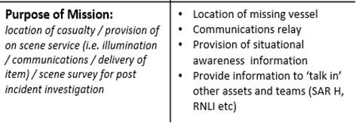 | MCA Response:  The LHS box is a generic list provided as an example only. The detail in the RHS box are the tasks to be completed for the specific use case.

