HDC202411 Request for quote for: Detailed design and build of Wetland and Habitat Improvements for Biodiversity Net Gain at Whitewater Meadows

Date opportunity posted | 10th June 2024
Last date for clarifications | 11th July 2024
Quotation return date | 12 noon, 26th July 2024
Estimated Contract Value | £165,000
Quotation shall be returned to | procurement@hart.gov.uk
With the subject line | Detailed design and build of Wetland and Habitat Improvements for Biodiversity Net Gain at Whitewater Meadows - 2024
Contact in case of queries | Mike.Barry@hart.gov.uk

Introduction
  - The Council invites quotations for this opportunity in accordance with the terms and requirements of this document and any Schedules attached.
  - Document contents:
1 Introduction 1
2 Specification 2
3 Information for Bidders 4
4 Evaluation and award process 6
5 Quotation response: Bidder details and declaration 8
6 Quotation response: Bidder submission 9
7 Terms and Conditions of Contract for Services 10

Appendix 1: Whitewater Habitat BNG Proposals
Appendix 2: Proposed UKHab - Whitewater Meadow
Appendix 3: Whitewater SANG Map
Appendix 4: Whitewater LIDAR

Specification
  - Key contract dates:
Intended Start Date | August 2024
Duration | 6 Months
Intended End Date | Feb 2025
Extension Details | Up to 6 months as necessary (weather dependent project)

  - Aim:
    - Hart District Council (HDC) is inviting tenders for the creation of an enhanced area of habitat at Whitewater Meadows which would include creating wetland features, increasing the accessibility of the existing paths, and tree and hedgerow planting. This work would form the foundation of habitat improvements for biodiversity net gain (BNG) units.
  - Objectives:
    - The Council’s main objectives for the habitat improvements are:
- Detailed design of habitat proposals to include; levels for reprofiling of northern field to create wetland and carry water away from paths, tree species and tree planting locations, and spoil locations, in line with the habitats proposed in the BNG proposals (Appendix 1).
- Implement the designed proposals in line with updated detail design.
  - Timetable:
Tender Submission | June 2024 | Tender to be submitted with a deadline in July
Stage 1 | August 2024 | Contract awarded August
Stage 2 | September - October 2024 | Detailed Design of wetland area and planting regime
Stage 3 | September - October 2024 | Engagement with stakeholders (EA)
Stage 4 | October – Nov 2024 | Works implemented

  - Scope:
2.5.1. Please see link and drawings below of biodiversity net gain proposals –
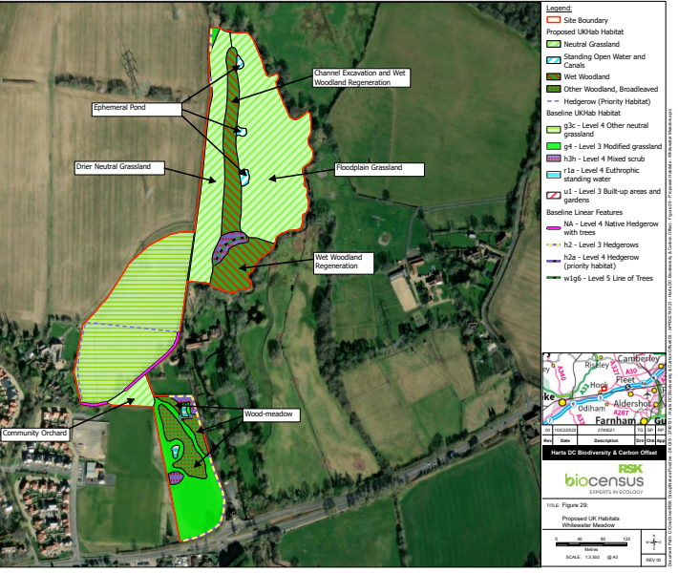
A full pdf of this drawing is provided; please see Appendix 2 - Proposed UKHab - Whitewater Meadow

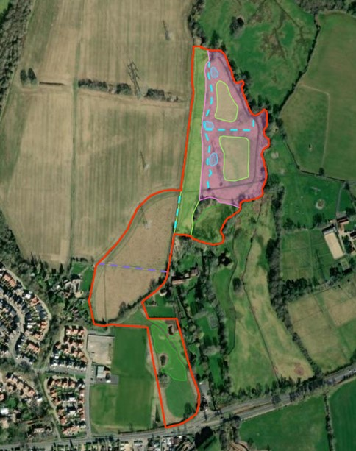
Indicative map of habitat areas proposed.

A site visit is recommended prior to design or submission of a tender. To organise a site visit, please email Mike.Barry@hart.gov.uk.

- In addition to the proposed habitat works (above), some channels and pathway improvements are proposed to better carry water to the wetland area and make paths more accessible year-round. These works could involve the re-use of spoil from the wetland reprofiling and/or culverts and short-term bridges such as sleepers.
- There are both gas and national grid constraints to working on site and design of habitats must take these into consideration, with appropriate permission to work in the vicinity of gas lines and power lines.
- Tree planting should consist of standards where possible planted in line with best practice; which will include fencing of small areas of the amenity field.
- A standard landscape works contract will be required.
Note: due to protected species constraints, the works must be undertaken outside of bird nesting season, such that the main wetland creation is completed by March 2025 with the less impactful path works and tree planting to follow.

    - The project does not include ongoing maintenance passed an agreed snagging period.
  - Deliverables:
    - The successful bidder must:
- Provide a detailed design that delivers on the outline BNG proposals.
- Delivery of habitat proposals and pathway improvements.
- Where necessary, to supply the relevant health and safety certification (upon completion of construction) for drainage design, construction methodology, risk assessments, and longer-term maintenance plans.

  - Monitoring arrangements:
    - The Council may monitor the performance of the Services by the Supplier.

Information for Bidders
  - All quotation response documents must be returned to the email address stated on page 1 by no later than the quotation return date also stated on page 1. Quotations received after this time will only be accepted in exceptional circumstances and at the council’s discretion.
  - If there appears to be an error or omission in a quotation the Council shall invite the Bidder to confirm the submitted price, including errors/omissions, or amend the submitted price to correct these errors/omissions. All amendments or confirmation of quotation must be confirmed in writing by the Bidder.
  - If the Council considers a query may have a material effect on quotation responses, all suppliers will be notified without delay via email.
  - The Council reserves the right to disregard any quotation where:
- in the opinion of the council, there is sufficient doubt as to the Bidder’s ability to perform the contract for the submitted price; or
- it does not fulfil a mandatory or pass / fail requirement; or
- it contains qualifications that conflict with the Request for Quotation instructions.
  - Quotations and supporting documents shall be in English and any contract subsequently entered into and its formation, interpretation and performance shall be subject to and in accordance with the laws of England and Wales.
  - All prices quoted shall, unless otherwise stated, include profit, transport, labour, materials, fuel and plant charges, insurance and all other expenses of every kind which under the conditions of Contract are borne by the Bidder. Prices quoted shall be in UK Sterling and exclusive of Value Added Tax. Value Added Tax shall be applied at the appropriate rate ruling at the date of any invoice.
  - Bidders must not take part in any publicity activities with any part of the media about the Contract or this opportunity without getting the Council’s written agreement first. This includes the Council’s agreement on the format and content of any publicity.
  - This opportunity is made available in good faith. The Council give no warranty as to the accuracy or completeness of the information contained in it. The Council also disclaim any liability for any inaccuracy or incompleteness. The Council reserve the right to cancel the Quotation process at any point.
  - The Council are not liable for any costs resulting from any cancellation of this Quotation process or for any other costs that Bidders may incur by Tendering for this Contract. Bidders must obtain at their own expense all the information that they need for the preparation of their Quotation.
  - Bidders will be deemed to fully understand the processes that the Council must follow under relevant legislation, and where the value of the opportunity is deemed to be above relevant thresholds, will adhere to the requirements set out in such legislation.

Evaluation and award process
  - The contract, if awarded, will be awarded, based on the following criteria:
Criteria |  |  | Score
Price (calculated as per 4.2): |  |  | 40%
Quality (which is scored on against the sub-criteria below): |  |  | 60%
 | Experience | 10%
 | Method Statement and approach | 20%
 | References and case studies | 30%

  - The percent share will be given the maximum score available. Other scores will then be calculated as a proportion of this based on the formula below:
Lowest price
Price of next quote to be considered

  - The Price element of the evaluation will only be scored once the Quality criteria have been assessed.
  - Each section in the Quality criteria will be scored using the following template:
Exceptional demonstration by the supplier of the relevant ability, understanding, skills, facilities and quality measures required to provide the services with evidence to support the response, where appropriate. | 5
Good demonstration by the Supplier of the relevant ability, understanding, skills, facilities and quality measures required to provide the services with evidence to support the response, where appropriate. | 4
Satisfactory demonstration by the Supplier of the relevant ability, understanding, skills, facilities and quality measures required to provide the services with evidence to support the response, where appropriate. | 3
Contains minor shortcomings in the demonstration by the Supplier of the relevant ability, understanding, skills, facilities and quality measures required to provide the services with evidence to support the response, where appropriate and/or is inconsistent or in conflict with other proposals with little or no evidence to support the response. | 2
Satisfies the requirement but with considerable reservations of the supplier’s relevant ability, understanding, skills, facilities and quality measures required to provide the services, with little or no evidence to support the response. | 1
No response or irrelevant response provided. | 0

  - Any responses scoring less than 2 for any Quality criteria, may be considered to not meet the requirements, and therefore fail the evaluation and the quotation may be rejected. As per 4.3, the Price element will not be assessed in those circumstances.
  - Bidders will be notified via email as soon as possible of any decision made by the council during the quotation process, including notifying Bidders of the intended award.
  - As part of the notification of award process, Bidders will be provided with details of the points awarded for their submitted responses in line with the evaluation criteria above.
  - Bidders must not undertake work without first having received an Official Purchase Order as written notification that they have been awarded the contract and are required to start work.

Quotation response: Bidder details and declaration

  - Please complete the following and sign to confirm that your quotation is fully compliant with the Specification, and all Terms and Conditions as stated within this documentation.
Company Name:
Address:
Telephone:
E-mail:
Signed:
Print Name:
Position in Company:
Date:

Quotation response: Bidder submission

  - Please complete the following pricing schedule in full (values must be exclusive of VAT).
[Breakdown as needed] | £
[Breakdown as needed] | £
[Breakdown as needed] | £
Total cost for contract term | £

  - Please complete the following section which will be used to score the Quality criteria.
Experience
- Please detail other habitat creation projects you have completed with links to photographs if possible.

Method Statement and approach
- Please detail your method statement and/or construction plan and H&S plan/risk assessment.
- Please detail how you ensure works undertaken will be as sustainable as possible, for example reducing the impact on the environment from equipment, reducing vehicle movements etc.
References / Case studies
- What relevant previous experience of similar projects do you have? This should be demonstrated with examples of relevant case studies you have previously undertaken.
- Please provide two suitable references from clients

Terms and Conditions of Contract for Services

The Council intends to enter into a JCLI 2017 Landscape Works Contract with Contractors Design to be finalised with any successful supplier

