Dear Supplier,

**RE: Guidance for accessing the tender documents.**

Thank you for your interest in this contract opportunity.

Before you can access any information, you need to register, and then create a supplier profile on the university’s e-sourcing website: [NEUPC – Procurement Portal (delta-esourcing.com)](https://neupc.delta-esourcing.com/).

Some people have reported that they need to sign out and then back in again, before proceeding, which is always worth a try.

The following screen shots make reference to our procurement ref PFB033LTU, but can be used as a template to guide you to the tender documents:

**Click “View Invites and Responses”**

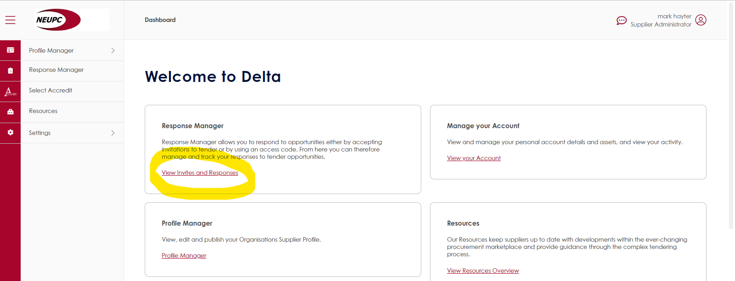

**Enter the Access Code and click “Submit”**

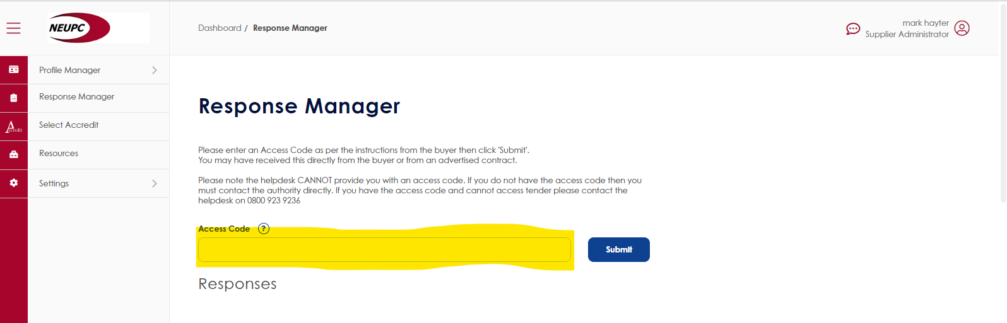

**Click “Accept Opportunity”**

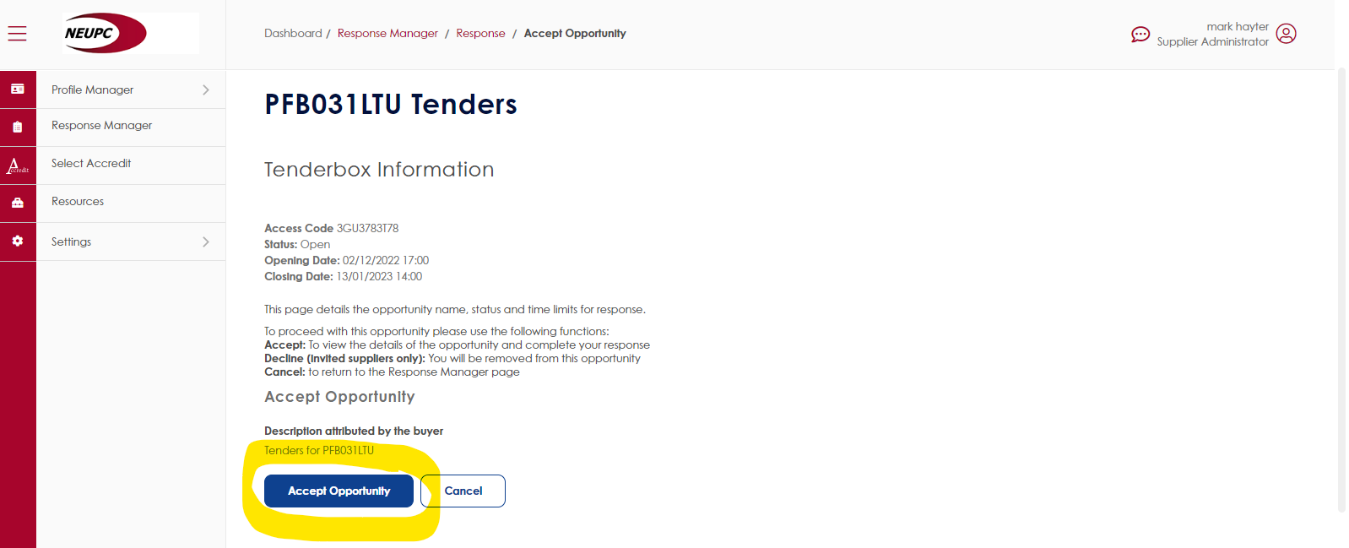

**The tender documents are made available for you to view, and download**

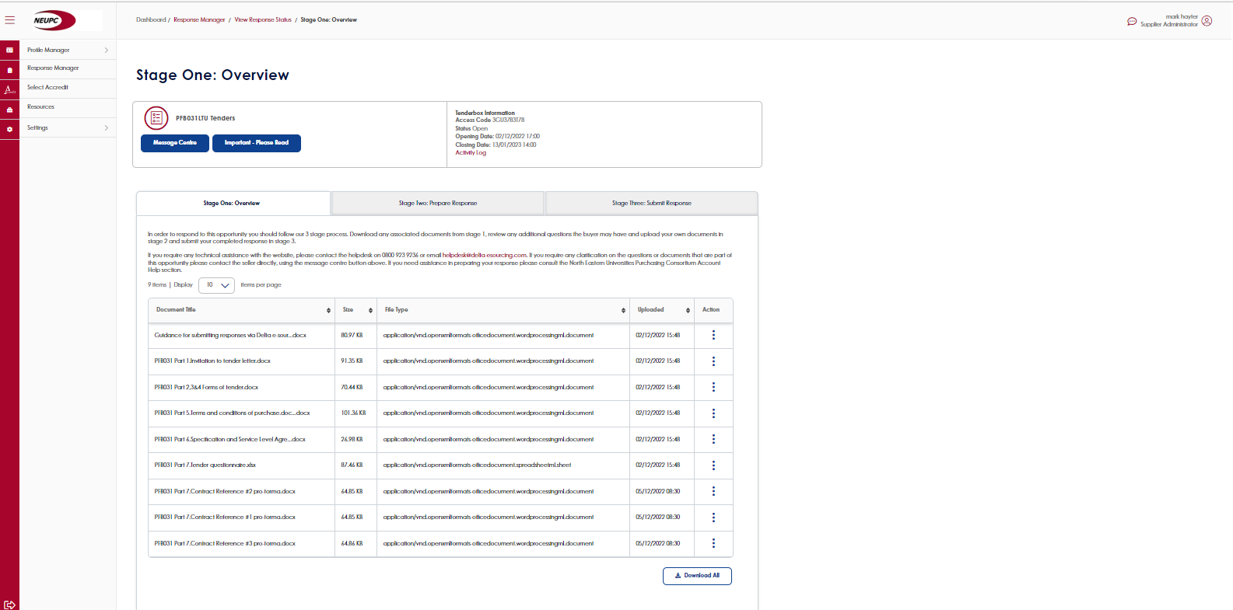

When you are ready to upload your tenders, proceed to the next ‘tab’ along:

**Stage Two: Prepare Response**

**Use the “Browse file” button to select the files from your local device, then click “Upload”**

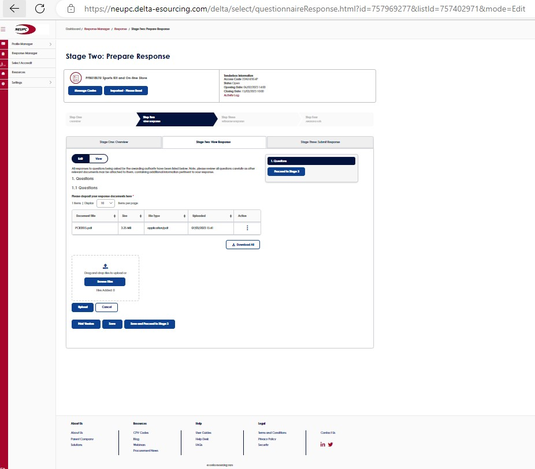

Once all your tender documents are uploaded, move to the next tab along:

**Stage Three: Submit Response**

**Click “Submit response”**

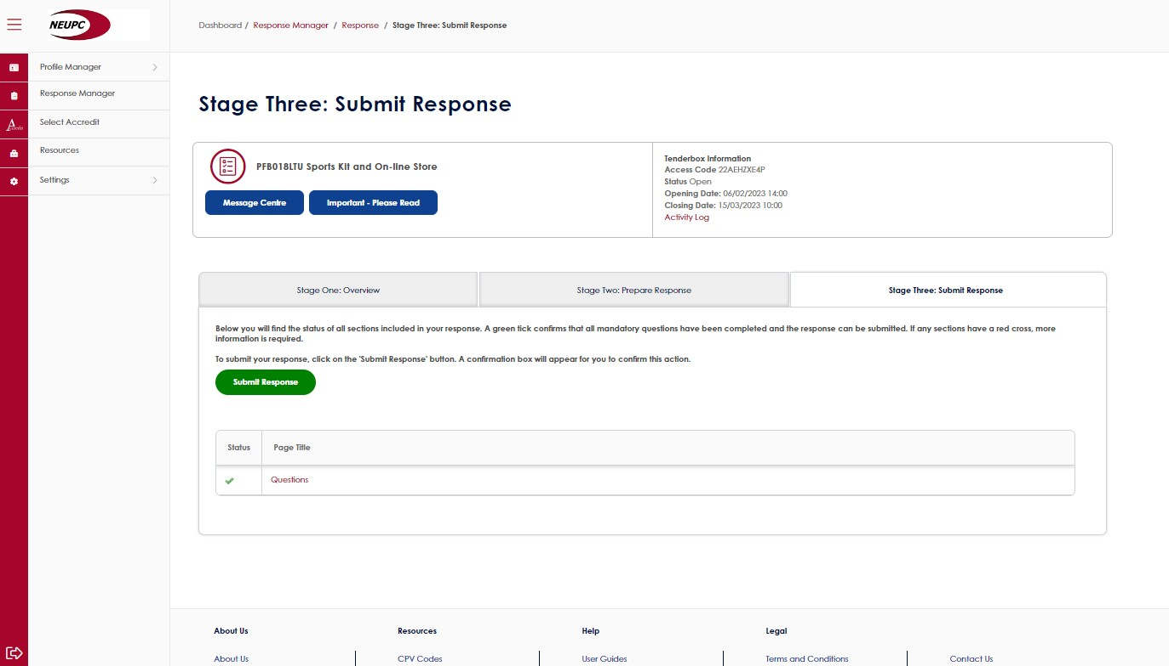

I trust that this is of assistance

**Mark Hayter**

Head of Procurement

Leeds Trinity University, Horsforth, Leeds, LS18 5HD

+44 (0) 113 283 7100  |  [m.hayter@leedstrinity.ac.uk](mailto:m.hayter@leedstrinity.ac.uk)  |  [leedstrinity.ac.uk](http://www.leedstrinity.ac.uk/)

Follow us on:  [Twitter](http://www.twitter.com/leedstrinity)  |  [Facebook](http://www.facebook.com/leedstrinity)  |  [Instagram](http://www.instagram.com/leedstrinity)  |  [YouTube](http://www.youtube.com/leedstrinity)