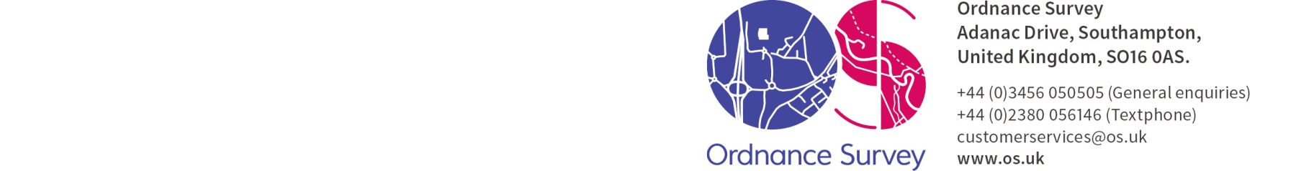

E-mail: tenderenquiries@os.uk
Date: 27th June 2018
RFQ Ref: OPO737.2018

To whom it may concern,
OBLIQUE AERIAL IMAGERY OF MANCHESTER – REQUEST FOR QUOTATION (‘RFQ’)
Ordnance Survey Ltd is a company registered in England and Wales (company registration number 09121572) whose registered address is at Explorer House, Adanac Drive, SOUTHAMPTON, SO16 0AS, UK (OS). OS is a limited company in which the entire share capital is owned by the Department for Business, Energy & Industrial Strategy (BEIS). OS is the national mapping agency of Britain and is responsible for the surveying, production, maintenance, and marketing of a wide range of geographic information, relied on by government, business, and individuals. Further information can be found on our website: http://www.os.uk
This RFQ sets out OS’s requirements for the future procurement of oblique aerial photography in a pre-defined area of Manchester, England.
The requirement is in support of investigative work that Ordnance Survey is undertaking in the potential uses of aerial oblique imagery. Specifically, OS requires a supplier to fly a geographic target as specified in Section 6. If you require any additional information to provide the required submission, please submit any questions to me at tenderenquiries@os.uk (marked for the attention of Alex Bassett), no later than Wednesday 11th July 2018. OS reserves the right to issue the response to any clarification request made by you to all participants.
Please note that OS is currently looking for quotations in response to the requirements only - OS reserves the right to:
- cease this quotation process at any time without any liability (whether in contract, tort or negligence) to the participant; and
- not award a contract following receipt of submissions from participants.
All OS’s technical and commercial information contained within this RFQ must be considered confidential and must not be disclosed to a third party.
OS requires you to provide a total cost for each element described below:
Manchester target
ACTIVITY | DESCRIPTION | COST £ | Marks Available
Oblique Aerial Imagery Capture | Total cost of acquisition of Oblique Aerial imagery to the camera specification and capture specification as defined in Sections 2 and 3, covering the extent described in section 6. | [ ] | 200 MARKS
Processing of Imagery and provision of additional data | Provision of data as described in deliverables in Section 4. | [ ] | 200 MARKS
Costs submitted in accordance with this RFQ must be inclusive of all pricing elements including VAT. OS would like a total price for each activity. OS reserve the right to award contract for the provision of either:
- one of the abovementioned Activities, for which pricing has been requested
- both of the abovementioned Activities, for which pricing has been requested

All quotations must be returned no later than Friday 13th July 2018.
OS has no liability for any costs incurred by the participant in preparing or evaluating this quotation. The request and submittal of the quote does not constitute a purchase agreement between OS and the participant. OS reserves the right to amend, add or delete its requirements from this RFQ. This RFQ does not constitute an order or contract offer and there is no obligation for OS to accept your submitted proposal.
I look forward to receiving your response.
Yours sincerely,
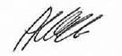
Alex Bassett, Supplier Relationship Manager

APPENDIX A STATEMENT OF REQUIREMENTS

1 Background
OS is investigating supply options for capturing oblique camera data to support existing projects. Oblique Camera technology is seen as an alternative technology which could potentially assist in the requirements for the initiative, in a more efficient manner than technologies currently tested (such as vertical large format camera systems).
2 Oblique Camera Specification
Any oblique camera system would be considered as long as the sensor contains a minimum of 4 oblique lenses and one nadir lens, and it meets the following specification criteria:
3 Flying Specification
For the purposes of the quotation exercise, our flying specification is as follows:
- Manchester, England (images depicting the geographical area and the national grid coordinates as listed in section 5 below)
- A Ground Sample distance (GSD) (NADIR) of 5cm or less. Note: If this is not achievable due to either limitations of the camera or local air traffic control restrictions, please state the highest GSD that you can achieve.
- 80% forward and 80% lateral overlaps. Note: If this is not achievable due to either limitations of the camera or local air traffic control restrictions, please state the highest overlaps that you can achieve.
- Under 0.2m RMSE accuracy (Planimetric & Height)
- Flown at a sun angle of no less than 30°
- Overall colour and light balancing to be suitable for use within a GIS system and suitable for producing evenly balanced and mosaiced Ortho-imagery
Notes for response: Participants must ensure that the response demonstrates that it can meet all of the abovementioned requirements (150 MARKS AVAILABLE)

4 Deliverables
- Processed camera RGB images (Nadir and Oblique) in a format that can be read by standard image processing software (e.g. GEO-TIFF)
- Aerial Triangulation results*
- Orientation files
- Camera files
- Radiometry files
- Flight diagram
- Calibration files
- GPS / INS data as .pdf file(s)
Deliverables to be provided in a removable hard drive
* Ground Control Points can be supplied if required.
Notes for response: Participants must ensure that the response demonstrates that it can meet all of the abovementioned requirements (150 MARKS AVAILABLE)

5 Timescales
If weather conditions are conducive, and flying permissions are satisfied, then the imagery should be acquired between 20th July 2018 and 20th August 2018. All deliverables must be delivered within 2 weeks of acquisition.
Notes for response: Participants must ensure that the response demonstrates the ability to mobilise in order to meet the timescales provided (300 MARKS AVAILABLE)

6 Geographical Area – Manchester
Minimum Area (100% coverage required)
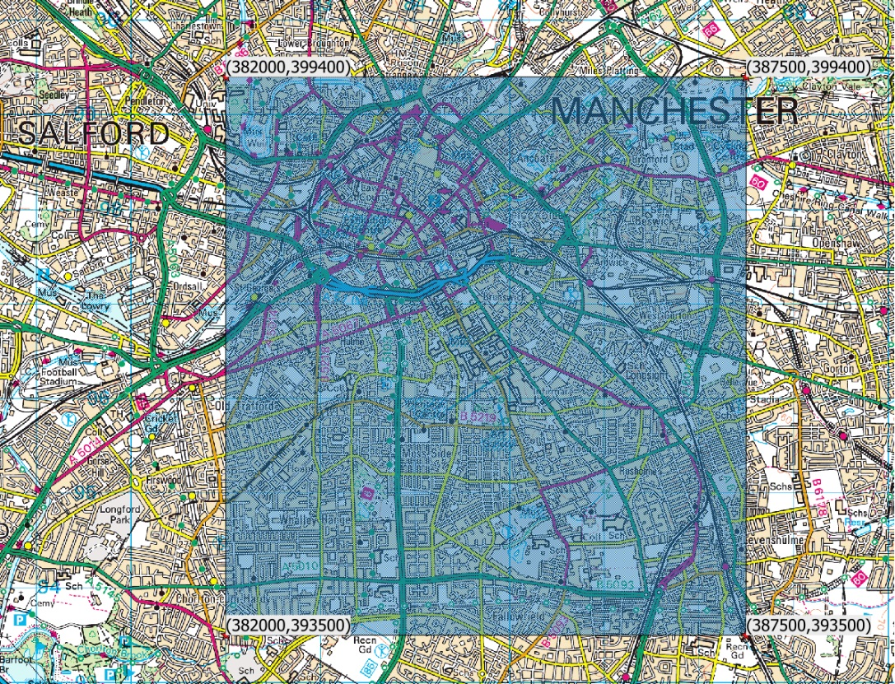

Manchester Maximum Area: | Eastings | Northings
North West Corner | 382000 | 399400
South West Corner | 382000 | 393500
North East Corner | 387500 | 399400
South East Corner | 387500 | 393000

APPENDIX B REQUIREMENTS, EVALUATION AND AWARD & CRITERIA

1 The criteria are as follows:
a) the Participant's response to the Flying Specification and Deliverables requirements (sections 3 & 4 of Appendix A);
b) the Participant’s response to the Timescales requirements (Section 5 of Appendix A); and
c) the Participant’s response to the pricing requirements.

2 OS’s requirements are set out in Appendix A and it has allocated each of the criteria an overall weighting (expressed as a percentage) reflecting its relative importance to OS:
a) response to the deliverables requirements 30% (300 MARKS)
b) response to the timescales requirements 30% (300 MARKS)
c) response to the pricing requirements 40% (400 MARKS)

3 Further detail concerning the requirements, sub-criteria, sub-weightings and marking schemes are contained in Appendix A. Section 3, 4 & 5 requirements will be evaluated using the following scoring methodology:
Score | The Participant:
0 (Inadequate) | a) does not provide a response to the requirement/s; or  b) responds to the requirement/s, however fails to address the specific issues (if any) identified by OS; or  c) fails to provide any evidence (where applicable) to support its response.
1  (Concerns) | a) responds to the requirement/s, however, has only partially addressed the specific issues (if any) identified by OS; and/or  b) provides insufficient evidence (where applicable) to support its response; and/or  c) responds to all the requirement/s with insufficient detail raising significant concerns about the Participants ability to meet all the requirement/s; and/or  d) provides a response which raises significant concerns about the Participants ability to meet the requirement/s.
3  (Potential) | - provides a full response to the requirement/s, however the supporting evidence only partially addresses the requirement; and/or  - provides a response to the requirement/s, which raises concerns about the Participant’s ability to meet the requirement/s.
5  (Capable) | provides a full and comprehensive response to the requirement/s, supported by evidence (where applicable), to indicate the Participant can fully meet the requirement/s and does not raise any concerns about the Participants ability to meet all of the relevant requirement/s and/or to deliver the services to the required standard.
If a score of 1 is applied, 1/5 available marks for that question will be awarded (rounded up to the nearest whole number).
If a score of 3 is applied, 3/5 available marks for that question will be awarded (rounded up to the nearest whole number).
If a score of 5 is applied, all available marks for that question will be awarded.
For example:
If there are 10 marks available for a question and a score of 3 is applied to a Participant’s response, the Participant will be awarded 6 marks for that response. If there are 5 marks available for a question and a score of 3 is applied to the Participant’s response, the Participant will be awarded 3 marks for that response.

4 Pricing shall be evaluated as follows:
The Participant providing the lowest all-inclusive price shall be awarded 200 Marks. The marks awarded to other respondents shall be calculated as a proportion of the lowest all-inclusive price (Lowest all-inclusive price / Respondent all-inclusive price x 200)
Example
Respondent A: £750
Respondent B: £500
Respondent C: £1,000

Respondent A (500 / 750 = 0.66) x 200 = 133 Marks
Respondent B (Lowest all-inclusive Price) = 200 Marks
Respondent C (500 / 1000 = 0.50) x 200 = 100 Marks

APPENDIX C TERMS & CONDITIONS
Please note that any order placed, will be under OS’s Goods and Services Contract. It must be noted that this contract will not be altered and submission of a formal response shall be deemed as acceptance of the Terms & Conditions.
APPENDIX D COMPANY INFORMATION
Please complete and return the attached Company Information form, this will not be scored as part of the evaluation process but will held on our records for information purposes. However, if the information contained in this form, highlights any areas of concern about the viability of your organisation, we reserve the right to eliminate any proposals put forward by you. If your company is not currently registered in the UK, you should still try to answer each question, substituting any appropriate professional, commercial or other registration within your domestic jurisdiction.
Full name of the potential supplier:
Registered office address (if applicable):
Registered website address (if applicable):
Trading status: | public limited company  limited company  limited liability partnership  other partnership |  | sole trader  third sector  charity  voluntary organisation
Date of registration in country of origin:
Company registration number:
Charity registration number:
Head office DUNS number:
Registered VAT number:
If applicable, is your organisation registered with the appropriate professional or trade register(s) in the member state where it is established?
Yes
No
If you responded yes, please provide the relevant details, including the registration number(s):
Is it a legal requirement in the state where you are established for you to possess a particular authorisation, or be a member of a particular organisation in order to provide the services specified in this procurement?
Yes
No
If you responded yes, please provide additional details of what is required and confirmation that you have complied with this:

Trading name(s) that will be used if successful in this procurement:
Relevant classifications (state whether you fall within one of these, and if so which one): | Yes:  No | Voluntary Community Social Enterprise (VCSE)  Sheltered Workshop  Public service mutual
Are you a Small, Medium or Micro Enterprise (SME)? | Yes  No
Please confirm an organisational structure chart is enclosed: | Yes  No
Are you a subsidiary to another company? | Yes  No
Details of immediate parent company (if applicable): | Full name of the immediate parent company:  Registered office address:  Registration number:  Head office DUNS number:  Head office VAT number:  Please enter N/A if not applicable:
Details of ultimate parent company (if applicable): | Full name of the ultimate parent company:  Registered office address:  Registration number:  Head office DUNS number:  Head office VAT number:  Please enter N/A if not applicable:
Brief history (not more than 200 words) of your organisation:

Names & Responsibilities of Owners / Directors / Executive Directors / Partners / Trustees / Management Committee (as applicable)
Name | Responsibility
Does the Participant have any Information Assurance and Security certification, for example Cyber Essentials, Cyber essentials PLUS, ISO27000 series, or equivalent?
Yes
No
If yes, please give details below and include in your response a copy of your ISO 27001 certificate, detailing what your statement of applicability covers:

Is your organisation registered with the Information Commissioners Office for the processing of personal information?
Yes
No
If yes, please provide your registration number.

APPENDIX E CERTIFICATE OF NON-CANVASSING AND NON-COLLUSION
WE CERTIFY THAT:
1 the Tender submitted is a bona fide tender intended to be competitive;
2 that we have not, nor any person employed by us or acting on our behalf has:
2.1 canvassed or solicited any member, officer or employee of OS in connection with the Tender submitted or the award of the contract; and
2.2 fixed or adjusted the amount of the Tender with any third party (or solicit any third party to fix or adjust their tender); and
2.3 communicated details of our Tender to any third party, other than OS or, where the Tender is submitted on behalf of a consortium, to other consortium members; and
2.4 prevented or dissuaded any third party from tendering; and
2.5 promised, offered, given, requested or accepted any advantage or inducement or consideration directly or indirectly to any third party in connection with the Tender.
3 we will not, nor any person employed by us or acting on our behalf will at any time undertake any of the acts in paragraph 2 above.
4. This bone fide form of offer must be signed by an authorised signatory: in the case of a partnership, by a partner for and on behalf of the firm; in the case of a limited company, by an officer duly authorised, the designation of the officer being stated. By signing this document, you are agreeing that you have the authority to submit a tender and enter into a Contract on behalf of the company that you represent.

Signature
On Behalf of
Name
Title
Date

