Bicester Town Council
Play Area Refurbishment Programme – Brief for Tendering

Contact Details:
Organisation: Bicester Town Council
Web: www.bicester.gov.uk
Name: Chris Johnson
Position: Operations Manager
Email: chris.johnson@bicester.gov.uk
Telephone: 01869 252915

Closing Date for Tenders: Friday 26th January 2018
Start Date for Successful Tender: Monday 19th February 2018
Competition Date for Successful Tender: Friday 6th April 2018

Notes for Tenderers:
To achieve this Council’s objectives from these refurbishments the following areas need to be considered:

- Robust and high-quality equipment
- Increased play provision
- Large choice of equipment options
- Removal of all old equipment
- Financially viable
- Scheme to encourage positive customer feedback
- Visually attractive to visitors/residents
- Natural features
- Visually blends in with the current site surroundings

Play Area Number: 2

Location: Launton Meadows, Boston Road, Bicester

Location Details: The play area is in a large open space surrounded by a combination bund of trees and scrubs. The site is on the outskirts of a large family housing estate and is considered to be one of the oldest play areas in the Town and the usage is moderate. Due to the poor state of the equipment it is not used that much by local/town residents and tends to draw an unwanted crowd of people on a regular basis.

Size: 595 sqm

Age Range: Multi

Maximum Budget: £35k

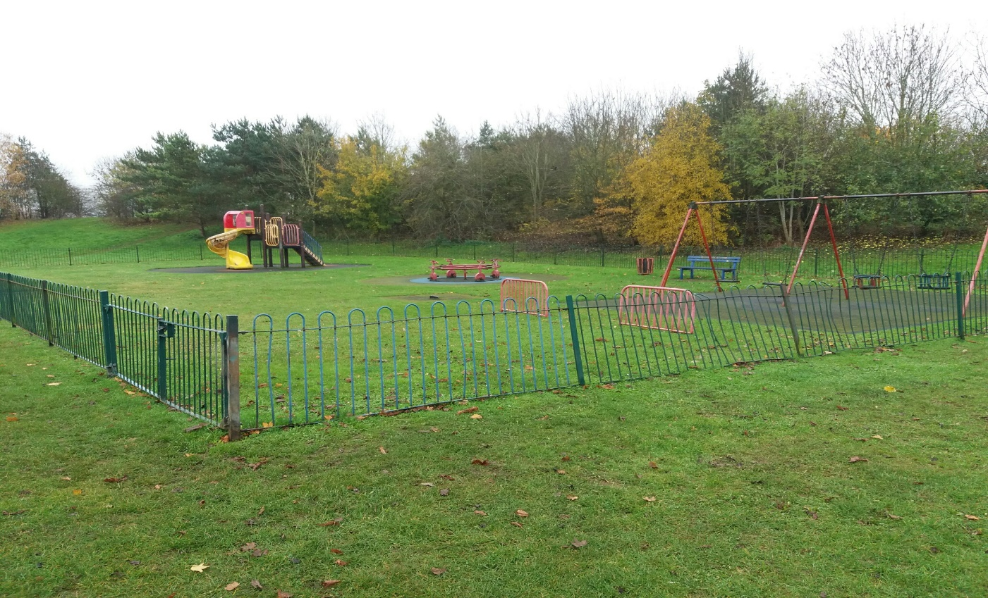

Play Area Number: 37

Location: Kestrel Way Open Space, Langford Village, Bicester

Location Details: The play area is in an open space surrounded by a combination bund of trees and scrubs. The site is situated on the old part of Langford Village is well used by families on the estate. The current design is poor and not very child friendly, offering a non-exciting level of play. The open space and play area is heavily used with the latter requiring urgent attention to bring it up to a modern standard.

Size: 486 sqm

Age Range: Multi

Maximum Budget: £30k

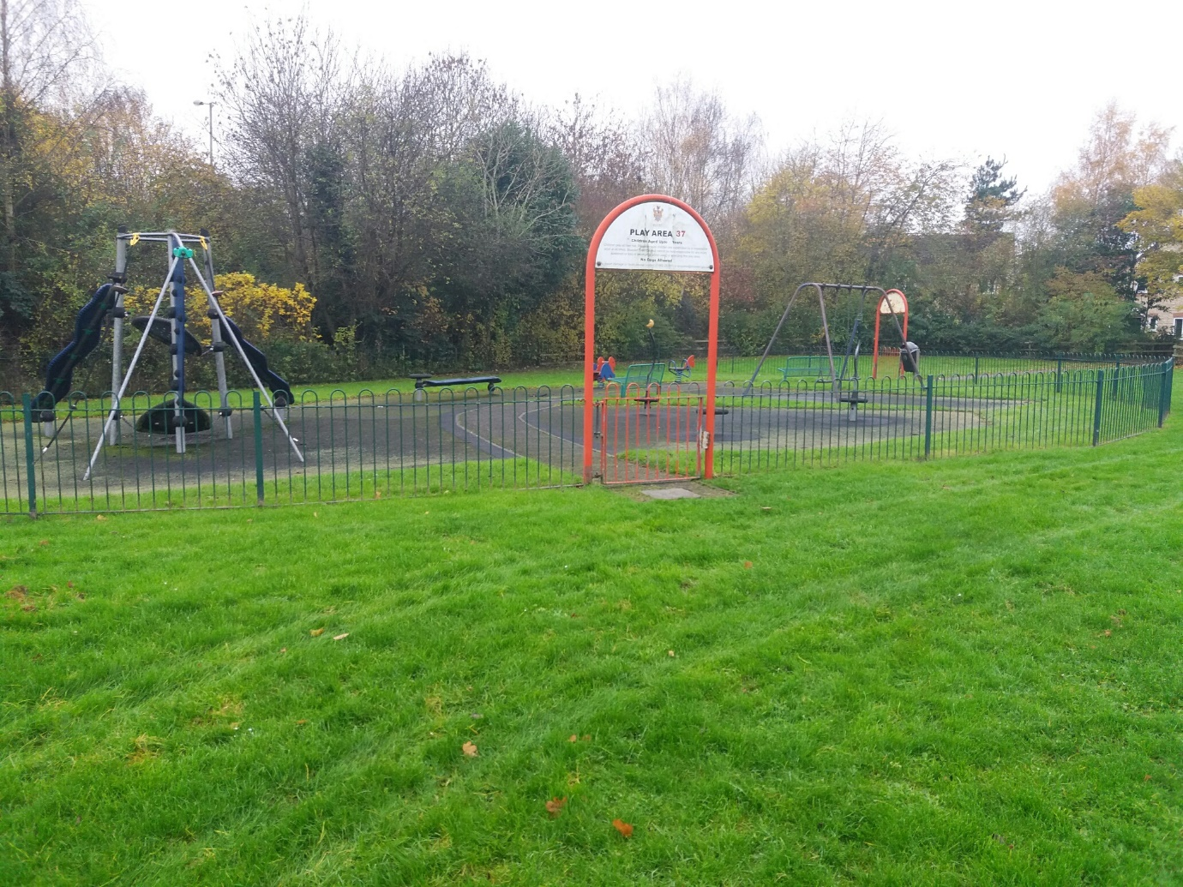

Play Area Number: 55

Location: Villiers Road, Bicester

Location Details: This play area is currently in an unsafe and unattractive condition. It boosts a large space perfect for a larger multi play items and zip wires. The site is based in a family estate and the local resident would be delighted with a scheme that is robust, fun and offers a large amount of play provision. One of the oldest play areas in which this Town Council owns but offers a lovely space for play provision.

Size: 1806 sqm

Age Range: Multi

Maximum Budget: £50k

