APPENDIX 1
ORDER FORM
FRAMEWORK AGREEMENT (000942)
Managing Temporary and Permanent Recruitment
FROM
Contracting Authority | Government Actuary’s Department (GAD)
Address | Finlaison House  15-17 Furnival Street  LONDON EC4A 1AB
Invoice Address | Finance team  Email Address for invoices: accounts.payable@gad.gov.uk
Contact Ref | Name: John Rainford  Phone: 07837 890 764  e-mail: john.rainford@gad.gov.uk

TO
Provider | Reed Specialist Recruitment Ltd
Address | 1st Floor Northampton 900  900 Pavilion Drive  Northampton, NN4 7RG
Contact Details | Name: Tracey Dawes  Phone: 07817 141656  Email: tracey.dawes@reedglobal.com
Key Personnel | Head of Talent Delivery: Lauren Vint-McGee  Senior Operations Manager: Jon Budd

      - TERM

  - Commencement Date
    - This Contract shall commence on 18th October 2021

  - Expiry Date

    - This Contract shall expire on 15th April 2022, with the option to extend to 13th May 2022

      - SERVICES

2.1 – Reed to deliver a graduate recruitment campaign to secure 12-16 trainees and analysts for the 2022 intake – the service will include:

- Designated resources
- Support with role advertisements including review of JD/advert, direct engagement with universities and associated societies
- Introduction of our Applicant tracking system which will host a GAD specific application form and reporting capabilities
- Initial sift against your specific criteria
- Standard competency tests
- Numerical, Inductive and Deductive reasoning test package
- Co-ordination of any assessment centres
- Co-ordination of the candidate process
- Supply of paperwork to allow GAD to on-board
- End of campaign report, including D&I statistics for applicants at all stages

In addition, GAD reserve the right to request assessors for deploy at assessment centres.

2.2 Base Location

Remote
2.3 As per Clause 13.5.1 the refund scale for with regards to a Permanent Placement leaves within the first ten (10) weeks of their Placement and a suitable replacement is not found is as follows:

Given the reduction on standard terms of business, we are unable to offer a rebate on the placement fee.

2.4 Implementation Plan Details

Project plan and milestone reporting to be shared on a weekly basis
2.5 Key Personnel

Head of Talent Delivery: Lauren Vint-McGee
Senior Operations Manager: Jon Budd
Solutions Director – Tracey Dawes

      - AMMENDMENTS TO TERMS AND CONDITIONS

If amendments are to be made by the provider and contracting authority, please include these here and sign Appendix 4.

      - PAYMENT PROVISIONS

Contract Price | Monthly management fee of £7,692.75*  *Our payment cycle is every 4 weeks, as such the first invoice will be £3,589.95 which will be invoiced w/c 1st November followed by £7,179.90 every 4 weeks thereafter.  Per placement fee for each graduate £1,000  In addition, GAD wishes to reserve the right to require Reed to provide assessors for use at assessment centres where each assessor is chargeable at £350 per day per assessor.  Numerical, Inductive and Deductive reasoning test package at cost of £25.25 per person
Funding
Invoicing Arrangements | Email Address for invoices: accounts.payable@gad.gov.uk  Monthly management fee will be invoiced every 4 weeks (2 weeks to start) and placement fee will be invoiced upon selection and appointment of each graduate and included within the next invoice, all with 30 days payment terms.

      - CONFIDENTIAL INFORMATION

The following information shall be deemed Commercially Sensitive Information or Confidential Information:
We would expect this call off contract to be deemed confidential

      - SPECIAL TERMS AND CONDITIONS

TBC

SIGNATURE PAGE

SIGNED BY OR ON BEHALF OF THE PARTIES
Authorised to sign for and on behalf of the Contracting Authority
Signature | 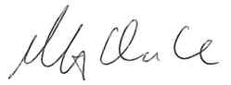
Date | 21.10.2021
Name in Capitals | MARTIN CLARKE
Address | Finlaison House, 15-17 Furnival Street, London, EC4A 1AB

Authorised to sign for and on behalf of the Provider

Signature | 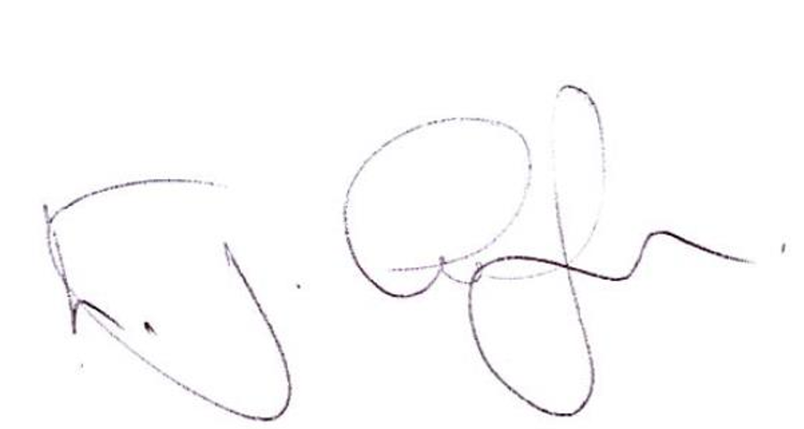
Date | 19.10.21
Name in Capitals | LEE GUDGEON
Address | 900 Pavilion Drive, Northampton, NN4 7RG

Appendix 4

CALL-OFF TERMS AND CONDITIONS VARIATION FORM

CALL-OFF TERMS AND CONDITIONS FOR SERVICES

[Name of Lot] ……………………………………………………………………………………………

No of Order Form being varied:………………………………………………………………………

Variation Form No:………………………………………………………………………………………

BETWEEN:

[ ] ("the Contracting Authority")

and

[ ] ("the Provider")

1. The Order is varied as follows; [list details of the Variation]

2. Words and expressions in this Variation shall have the meanings given to them in the Contract.

3. The Contract, including any previous Variations, shall remain effective and unaltered except as amended by this Variation.
Authorised to sign for and on behalf of the Contracting Authority
Signature
Date
Name in Capitals
Address

Authorised to sign for and on behalf of the Provider

Signature
Date
Name in Capitals
Address

