Specification for Replacement of the Environmental Controllers for the Rothamsted Glasshouses.
Contents
Replacement of 124 Environmental Controllers for the Rothamsted Research Glasshouses. 6
Contacts 6
References 6
Project Management. 6
Tendering Process 6
General Terms and Conditions 8
Quantity of compartments and arrangement 9
Location 9
Local road map 10
Aerial view 11
Photograph of typical glasshouse. 13
View of internal corridor (G29) 14
View of typical control board 15
Close up of current controller 15
View of central PC. 16
View of mimic for Building 54 17
View of mimic for Glasshouse 33 17
View of Mimic for 1 compartment which has no vents 18
View of Mimic for 1 compartment which has screen open (grey) 18
Mimic for compartment showing vent positions 20
View of hot water control valves 21
View of vents. 22
Some of the compartments have air-conditioning using heat pumps. 22
View of mimics for compartments in building 54 and 56 23

Architecture of Environmental Control Systems in B54 24
Architecture of Environmental Control Systems in B56 25
Alternative architecture 26
Option using present relay board and low voltage interface. 29
View of Relay board and ribbon cable top left. 29
Ribbon cable pin out for control relays 30
List of Required features and Desired features 32
Supplier Details 32
Feature List 32
Backwards compatibility 32
Overall System Architecture 33
Environmental Specification 33
Controller Details 34
Inputs to controller from compartment Aspirated screen 34
Other Inputs to controller from compartment without aspiration 34
Meteorological Station 35
Relay Control of Valves, screens, lighting etc. 35
Parameters stored in Controller 36
Alarms 36
CO2 Control 37
Vent cooling 37
Extreme weather features 38
Clock Type Selection: 38
Hot Water Heating 38
Heat demand and cool demand on AC 39
Measured parameters/sensors Resolution and accuracy 40
Software specification 41
Statistics of measured Variables 42
Thermal Screen Control: 43
Misting Control 43
Supplementary Lighting 44
Heating control parameters 44
Irrigation and Misting controlled by RH, temperature or time 46
Supplementary Lighting 46
Humidity Measurement and Control 47
CO2 Control 48
Secondary Heating and Cooling 48
Mimic Features 49
Health & Safety 51
End of document. 52

Replacement of 124 Environmental Controllers for the Rothamsted Research Glasshouses.

Contacts
John Elliott Electronics Engineer
01 582 938 484 john.elliott@rothamsted.ac.uk

References
Rothamsted is the longest running agricultural research station in the world, providing cutting-edge science and innovation for nearly 170 years.
Our mission is to deliver the knowledge and new practices to increase crop productivity and quality and to develop environmentally sustainable solutions for food and energy production.
www.rothamsted.ac.uk/

Project Management.
Rothamsted research has a large number of Glasshouses, divided into compartments, which are used for plant research. These use Environment Control systems which are reaching the end of their serviceable life and need replacement.
John Elliott is responsible for assessing the present system and surveying the range, cost and available features of commercially available Environment Control Computers with a view to presenting recommended options to the board. The replacement program will be a “rolling” one, lasting 1 – 3 years to minimise disruption of the daily research activities. The glasshouse controllers will be installed one house at a time, i.e. in groups of between 2 and 16 depending on which house is involved.

Tendering Process
A package of documents has been created to describe requirements and terms and conditions.
If you are interested in tendering for this Contract, please notify rres.purchasing@rothamsted.ac.uk who will send an NDA document. On receiving the signed NDA document, the package of documents including Covering letter, Specification, Terms and Conditions, Supplier Questionnaire, Deliverables and Costing will be sent to the applicant.
The contract will be put out to tender in compliance with European and British regulations.
There will be a period of 35 days for interested parties to submit bids for this contract.
They will be welcome to visit the site by appointment.
During that time, questions for clarification will be answered and distributed to all suppliers who have notified their interest.
There will then be a month for Rothamsted staff to read the tenders and compare them to select the most suitable one.
All interested parties will be notified of the result.
There will then be a 10-day mandatory standstill period during which time we are obliged to advise all tenderers of the outcome.
All bids will be studied and compared with potential internal designs.
Rothamsted Research will not be bound by the range of bids or to choose the lowest cost or to necessarily to select from the bids. The priority will be to provide a similar quality of service to that provided by the previous system. Ability to stage the installation to minimise disruption of research will be very important.
The winning candidate will be selected by a committee at Rothamsted.
A minimum trial system consisting of 2 controllers and 1 meteorological station will be procured and installed pending award of the main contract in two compartments of Glasshouse 28. It will be operated and tested for functionality by Rothamsted staff for about 2 months. 1 controller will be fitted to a compartment with conventional hot water and vent control of temperature. The other one will be fitted to a compartment using a heat pump for temperature control.
If the results are satisfactory, the main contract will be ordered and a rolling program of installation started.
If the results are not satisfactory, the other candidate systems will be examined in the light of those results, the most suitable of the remaining candidates selected and a trial performed on that system.
There is sufficient technical expertise on site to install the systems ourselves or by subcontractors supervised by ourselves. However, it is anticipated that the supplier may want to supervise the installation of the evaluation systems, at least initially, to ensure correct installation, set-up and training.
It is desirable that the replacement systems will be similar in functionality and specification to the present one which is installed in the Glasshouse complex at Rothamsted. The features are listed in the following pages.
There is a table of “Required” and “Desirable” features for a candidate system. This is a table of characteristics of the actual candidate Control System recommended by the Tendering Supplier with tick boxes for whether the recommended System supports that feature as a standard feature. It is most important that this table is filled in as completely as possible because it will be used to compare the quality of match compared to the specification and to other tenders. If all the boxes are ticked, without regard to standard specification, this will be regarded negatively.
We wish to avoid bespoke features which are not standard, tried and tested and documented. The list is long but all parts of it feature in modern glasshouse systems. The glasshouses at Rothamsted are used for a variety of scientific research and need a variety of control modes and parameters to cover that work.
There is then a series of questions regarding more general topics.

The next document in the package is a set of tables listing the deliverables:
- for the evaluation system,
- the main contract of supply
- Installation.
- Ongoing support costs for the system.

General Terms and Conditions
A document describing general terms and conditions is included in the package.

Quantity of compartments and arrangement

Location
There is a complex of 122 glasshouses/greenhouses at Rothamsted Research situated near west Harpenden, North of London.
In building B54, there are 6 glasshouses with 14, 7, 14, 12, 8 and 15 compartments respectively.
In building B56, there are 7 glasshouses with 2, 5, 8, 16, 10, 8 and 4 compartments respectively.

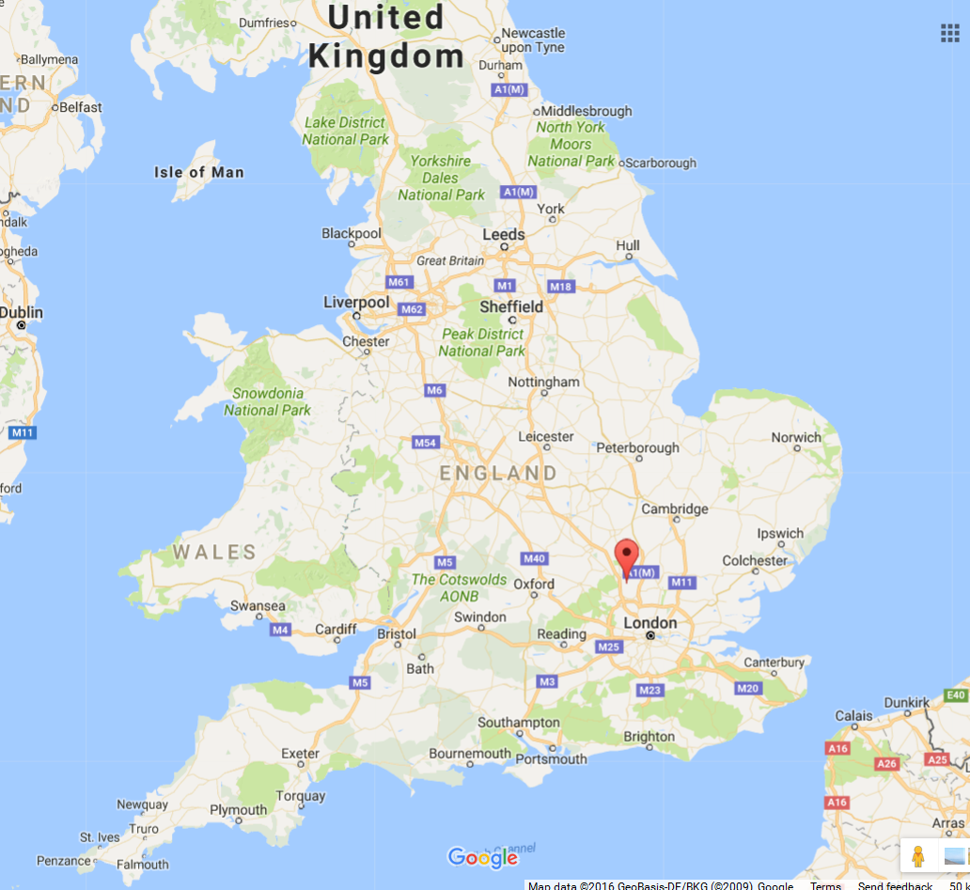

Local road map
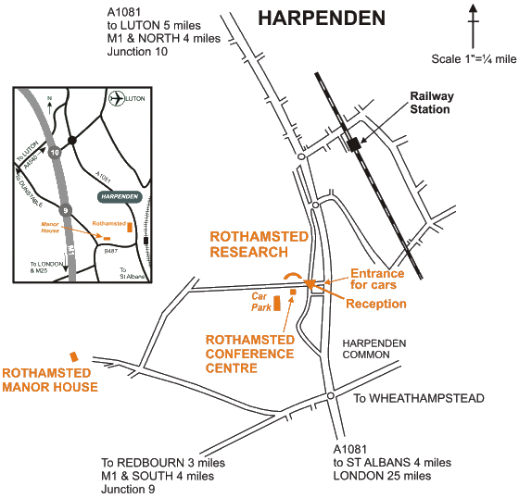

Aerial view
They are shown in the top left quadrant of the aerial photograph shown below.
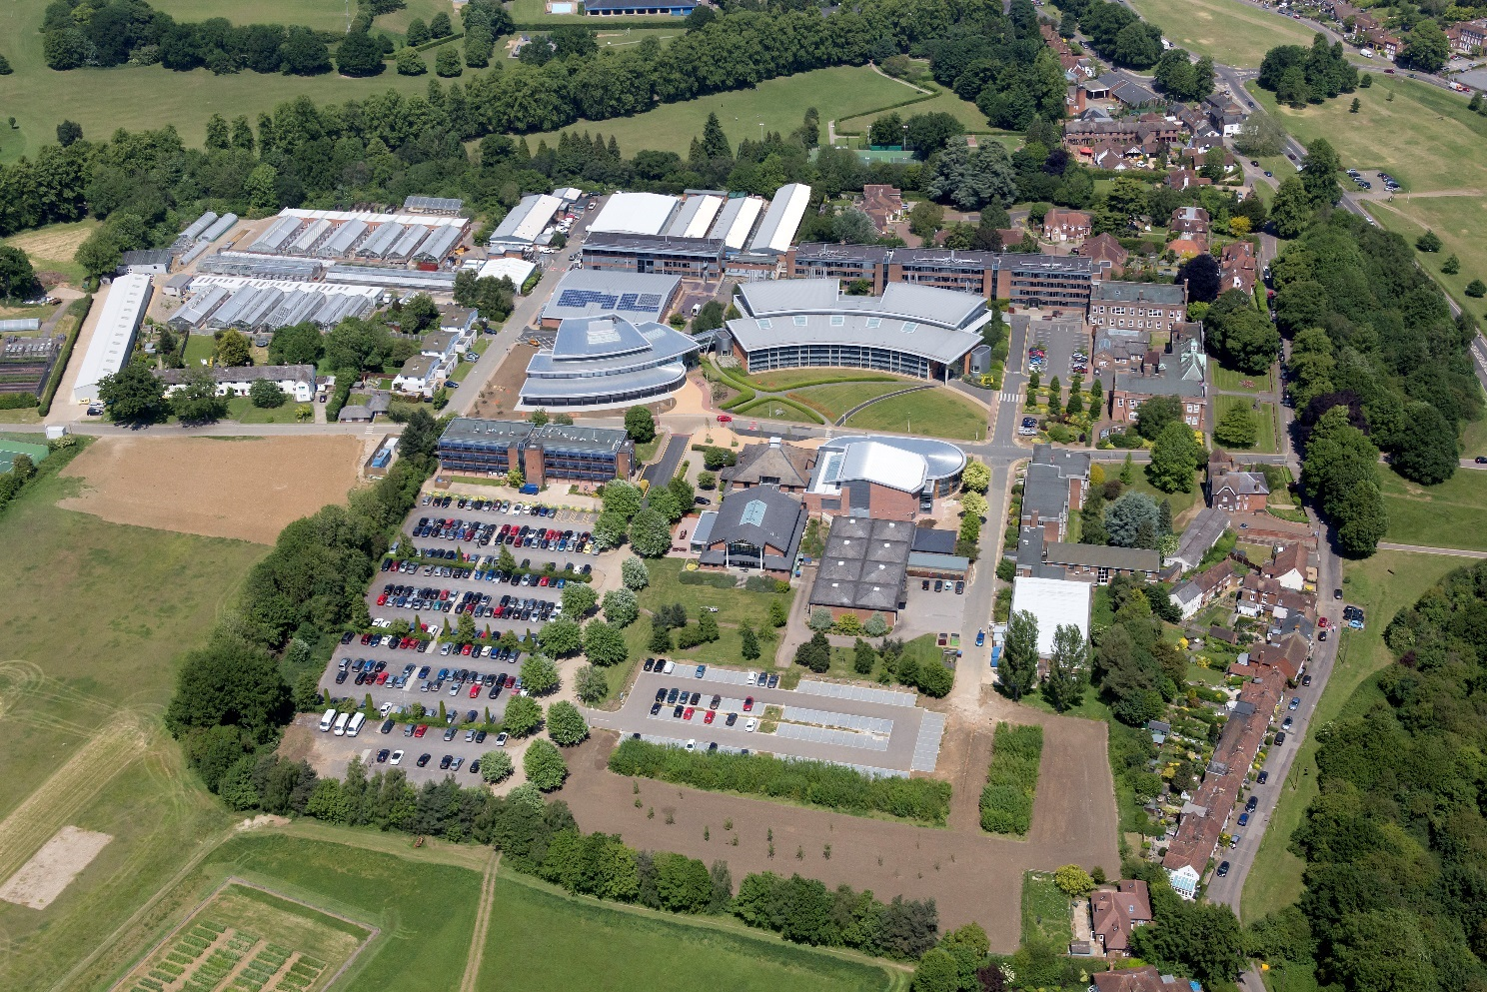
These are arranged in 2 blocks. Each block has a corridor linking several glasshouses, each of which has several compartments lining an internal corridor. There are 2 separate poles with Meteorological station. Each communicates with all the controllers for that building.

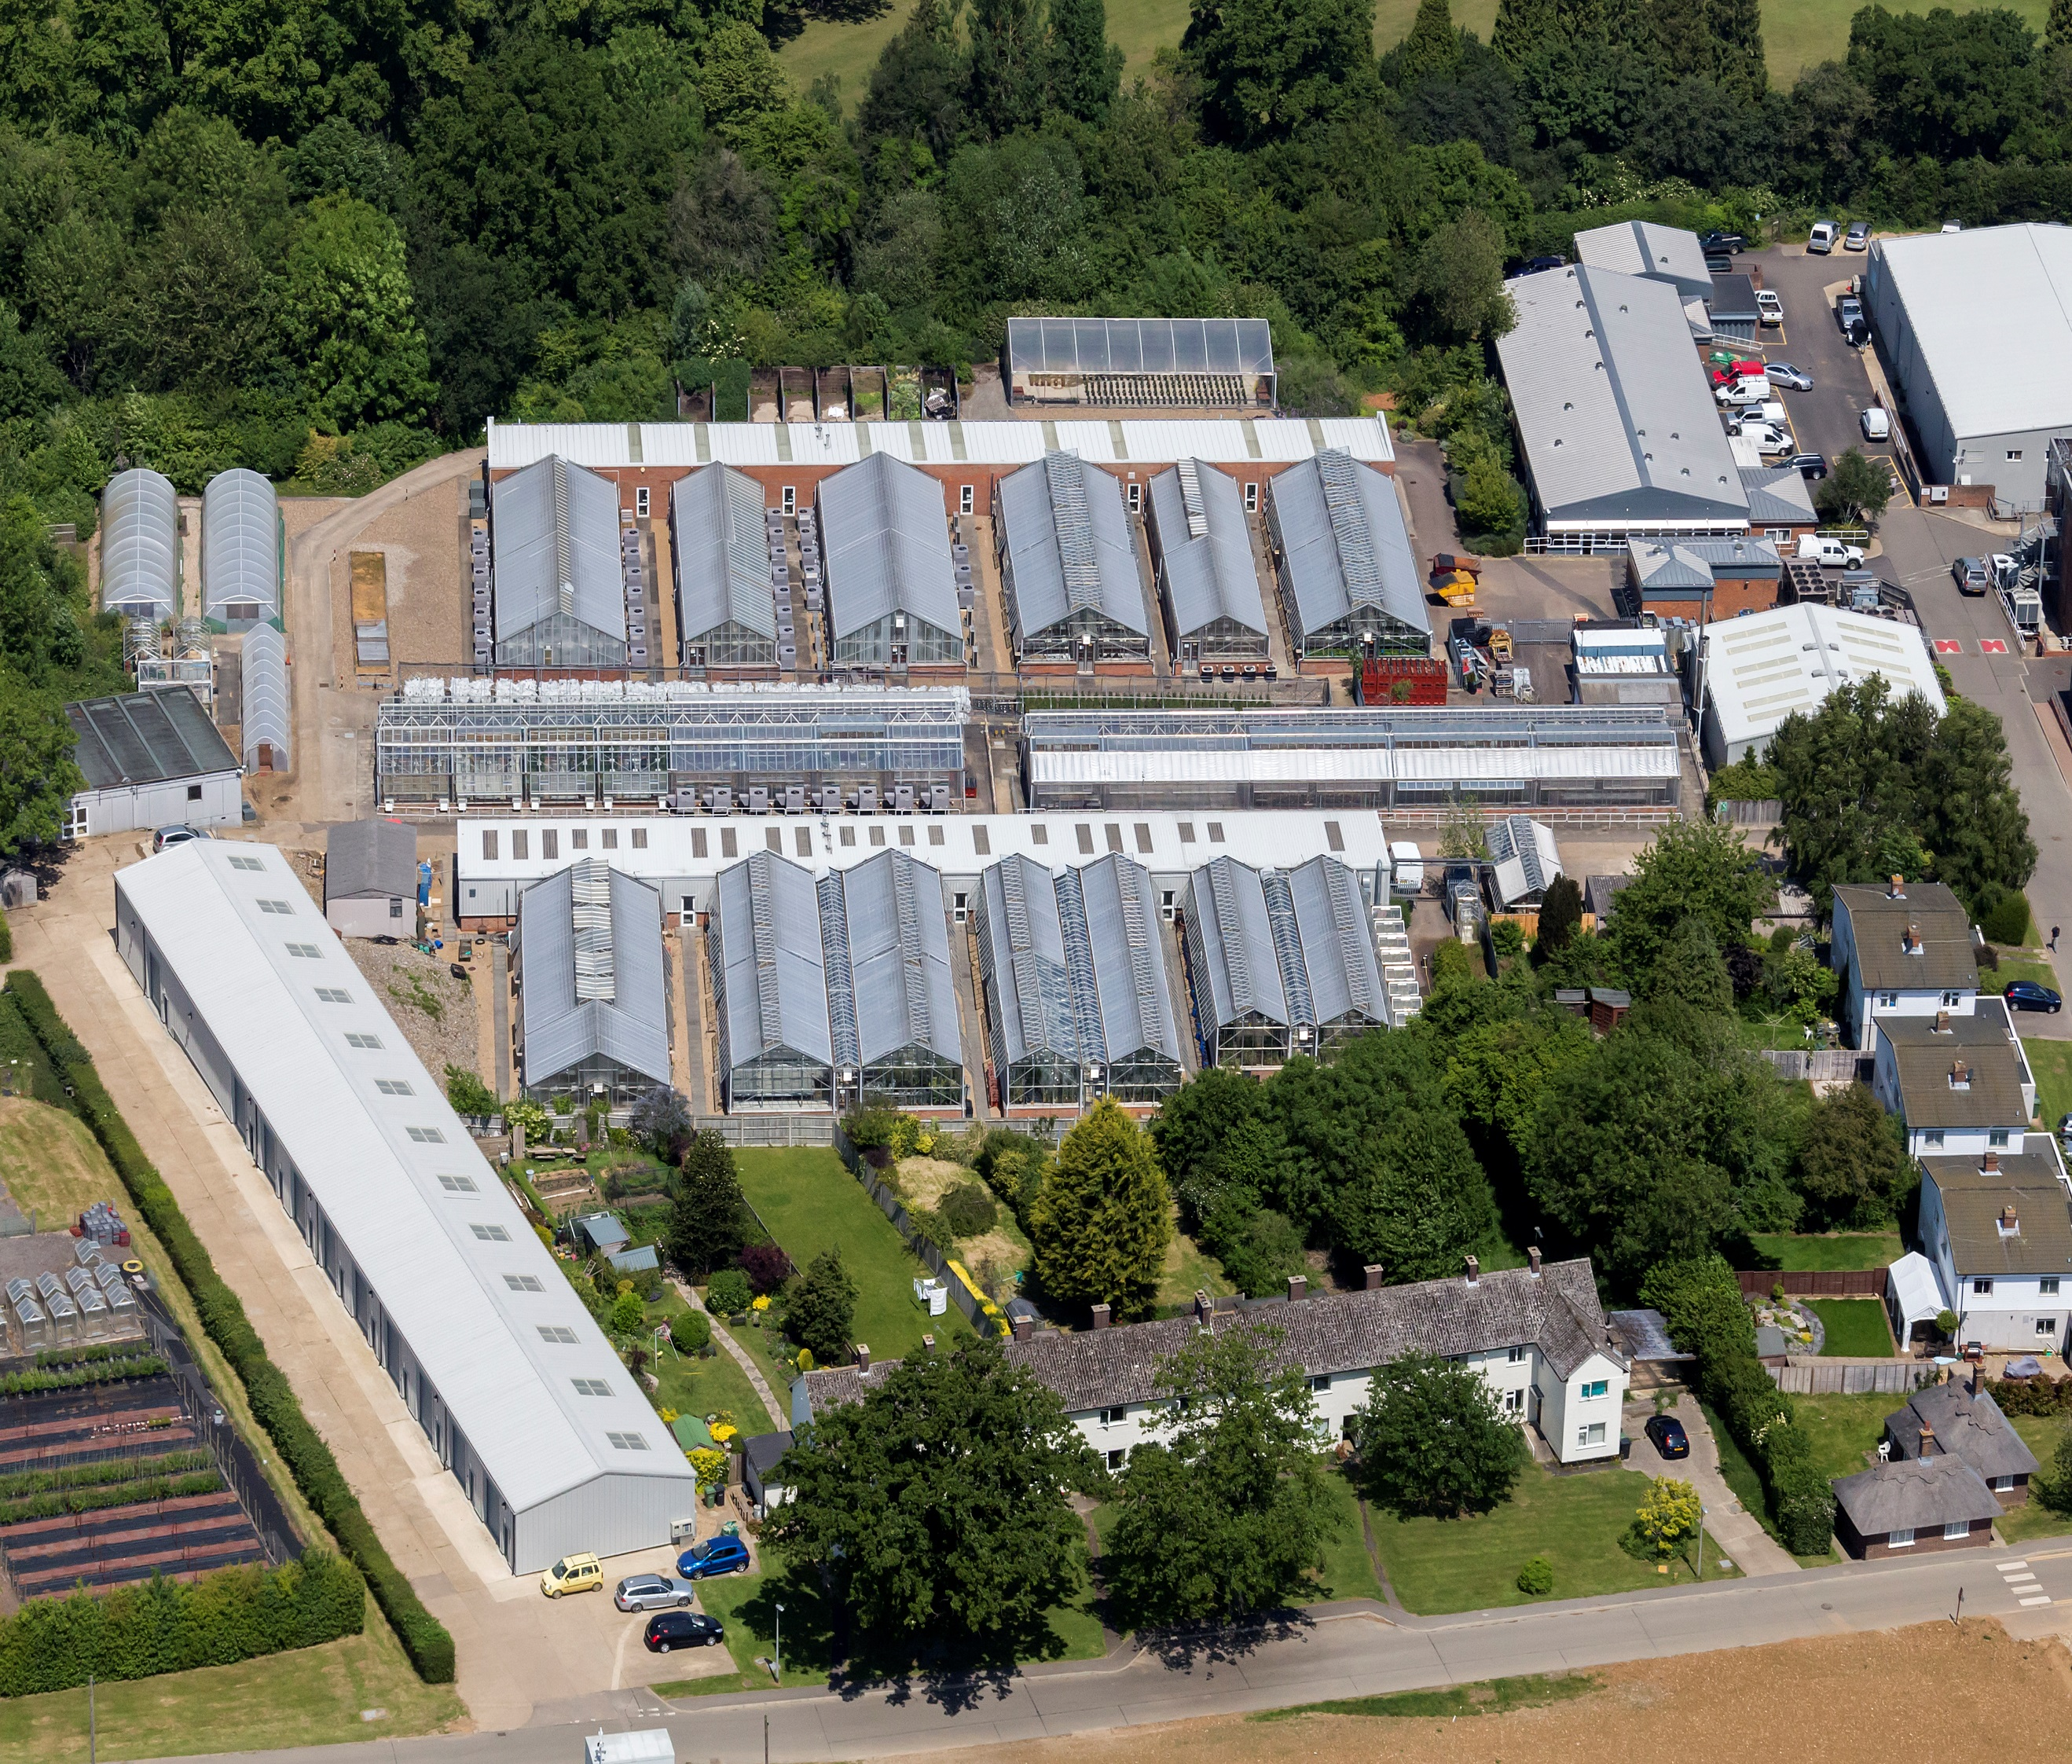
B54
B56

Photograph of typical glasshouse.
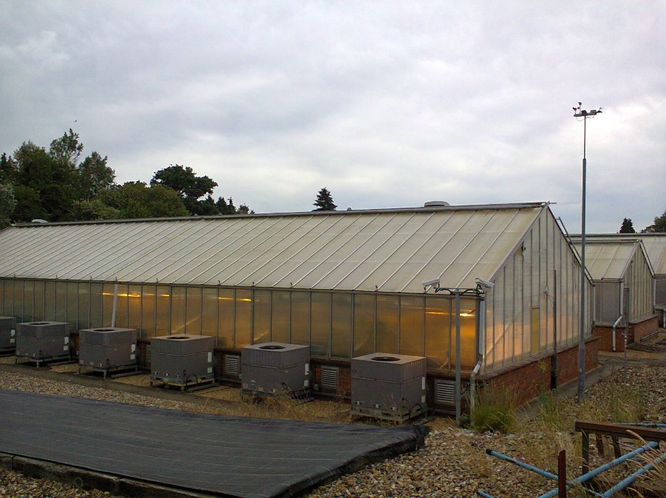
Space between 2 glasshouses
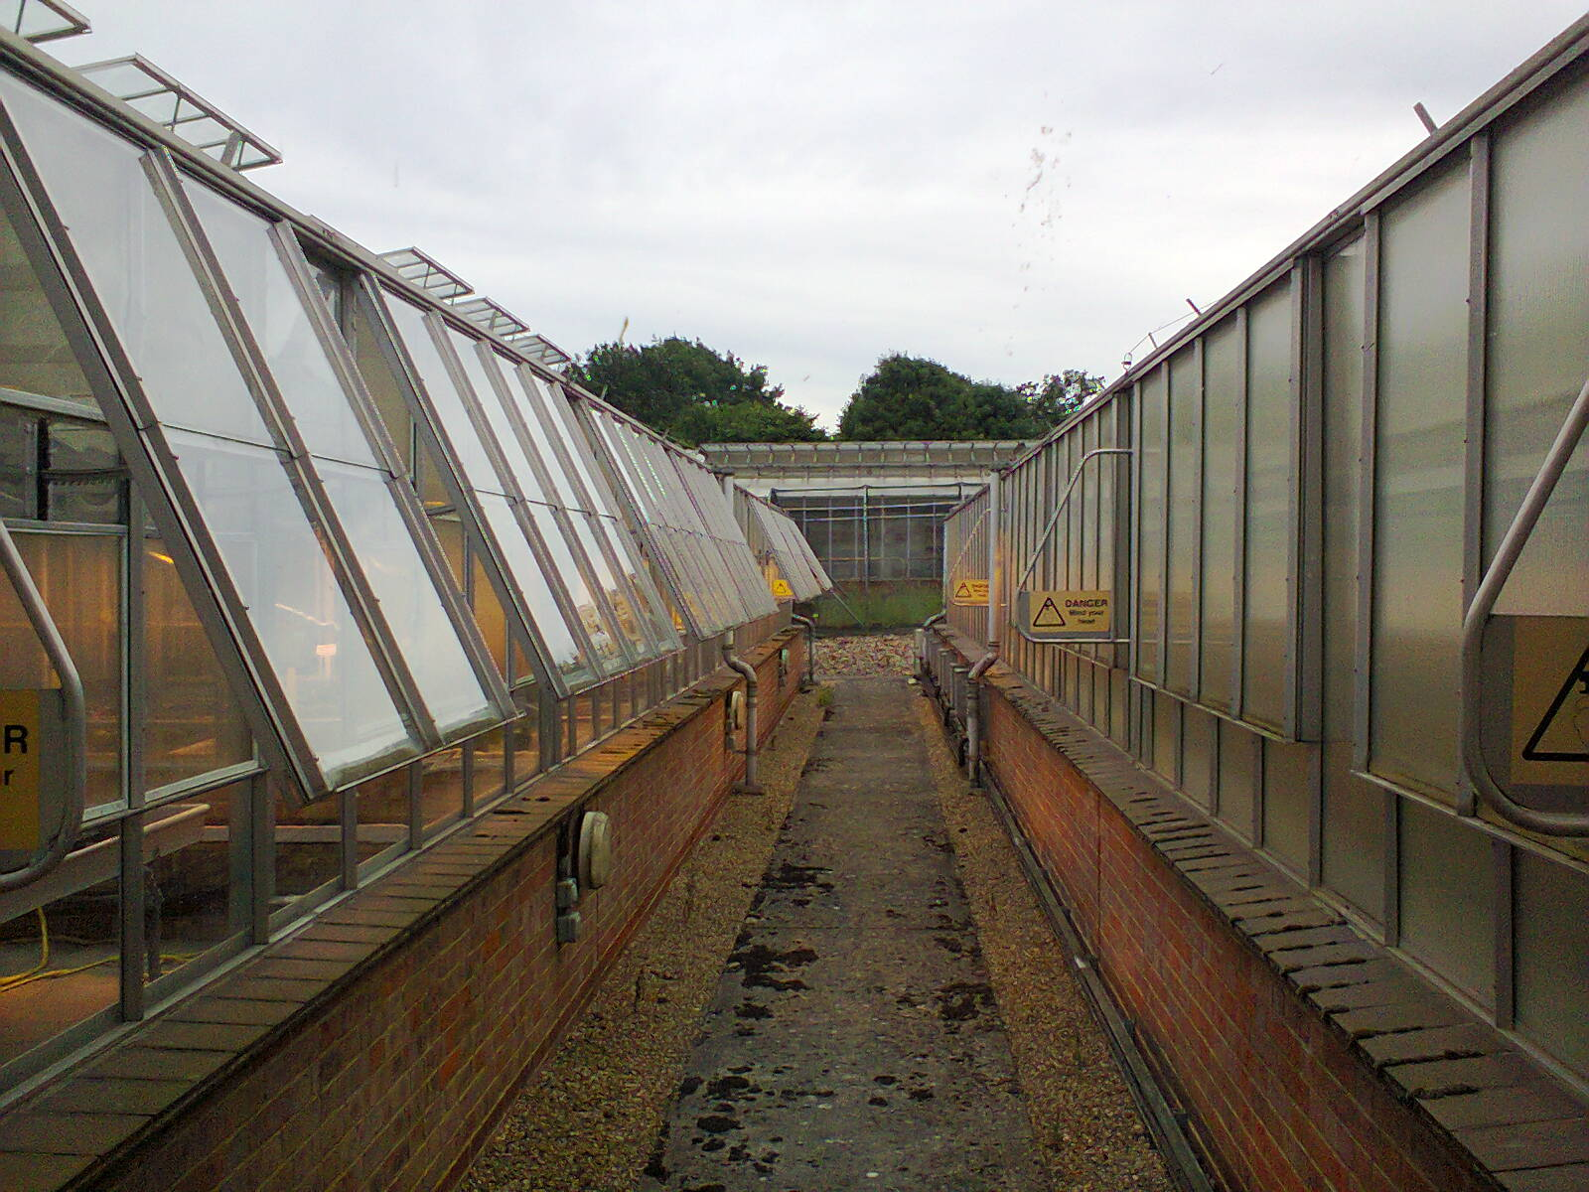

View of internal corridor (G29)
Internal corridor lined with water pipes, power cable conduits, circuit breaker enclosures control computers and doors to compartments.
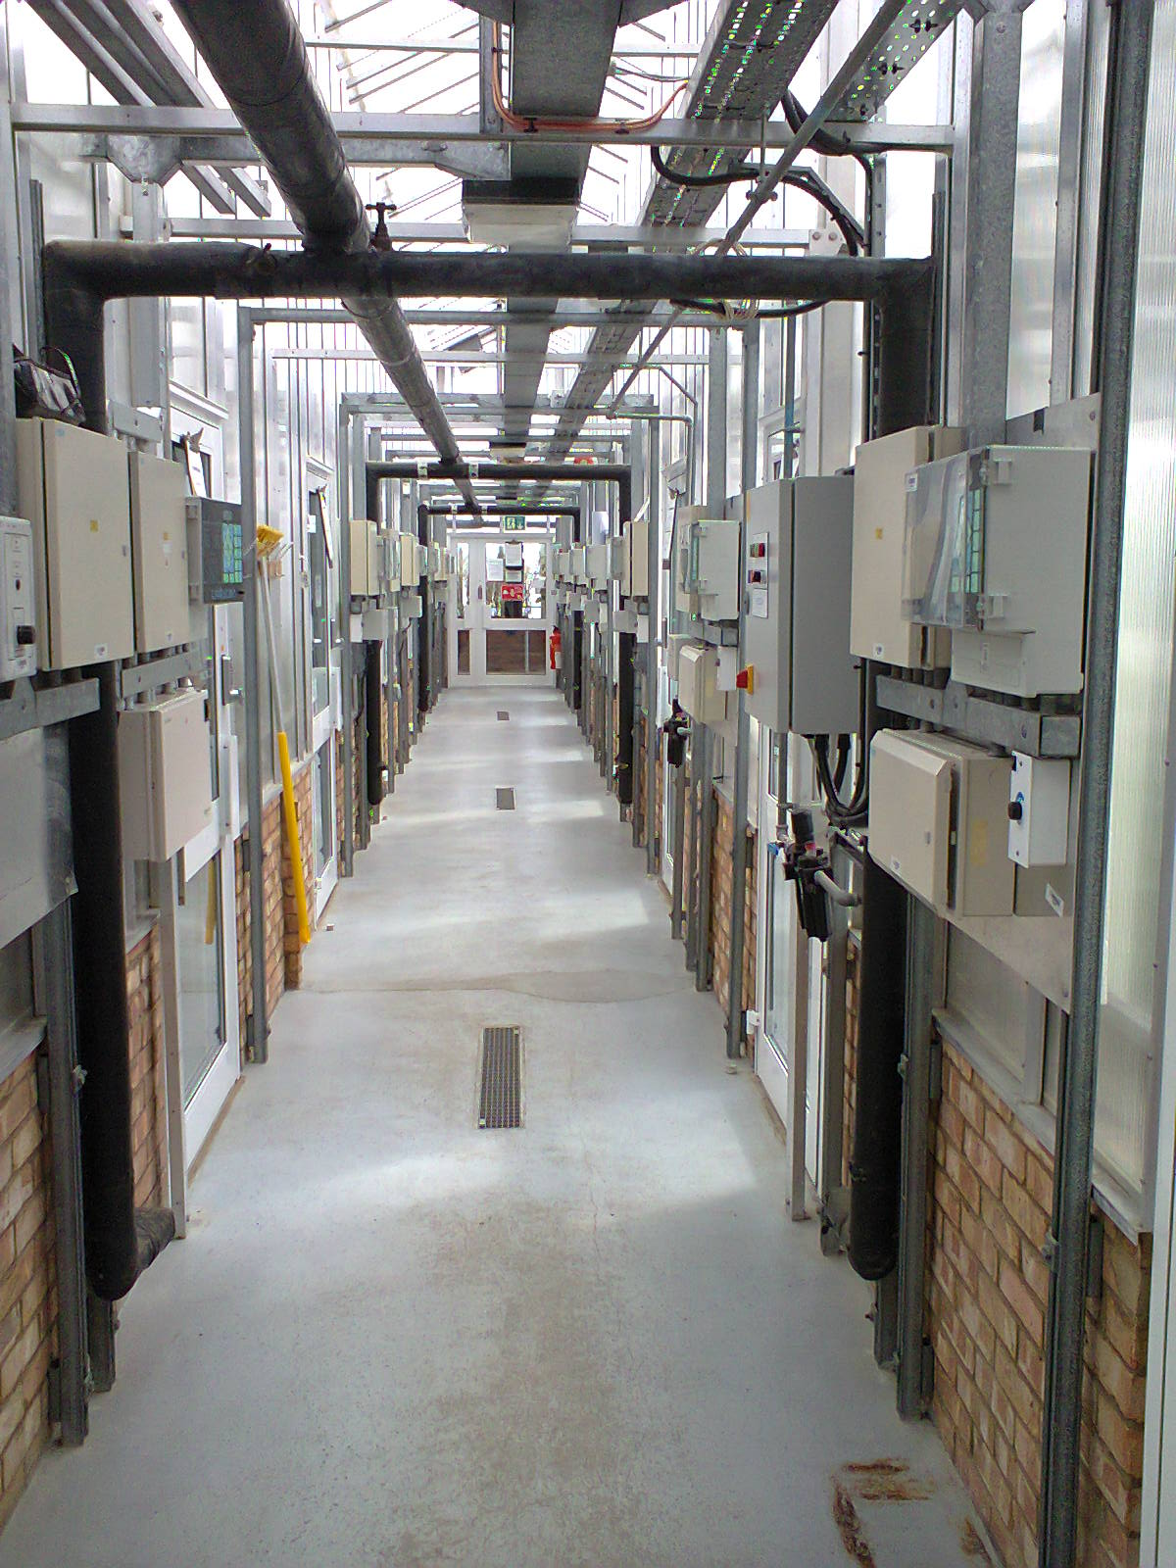

View of typical control board
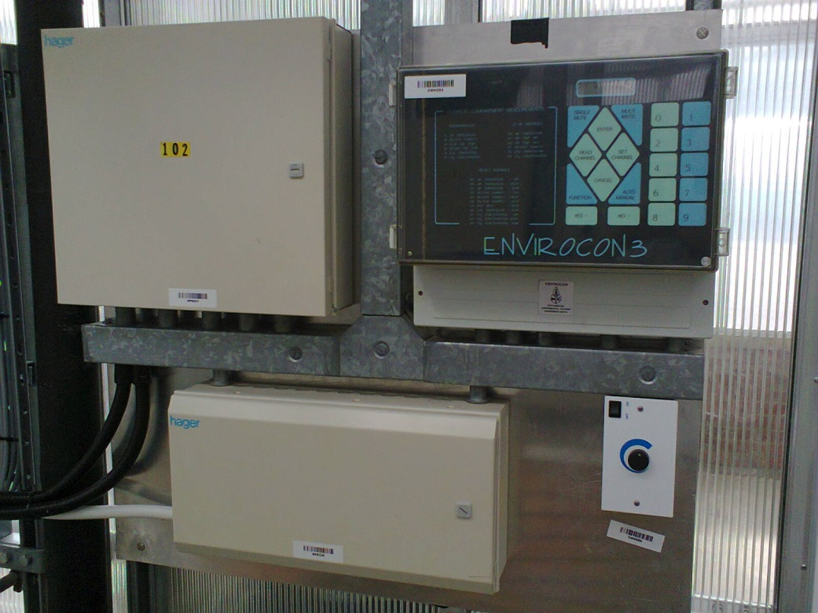

Close up of current controller
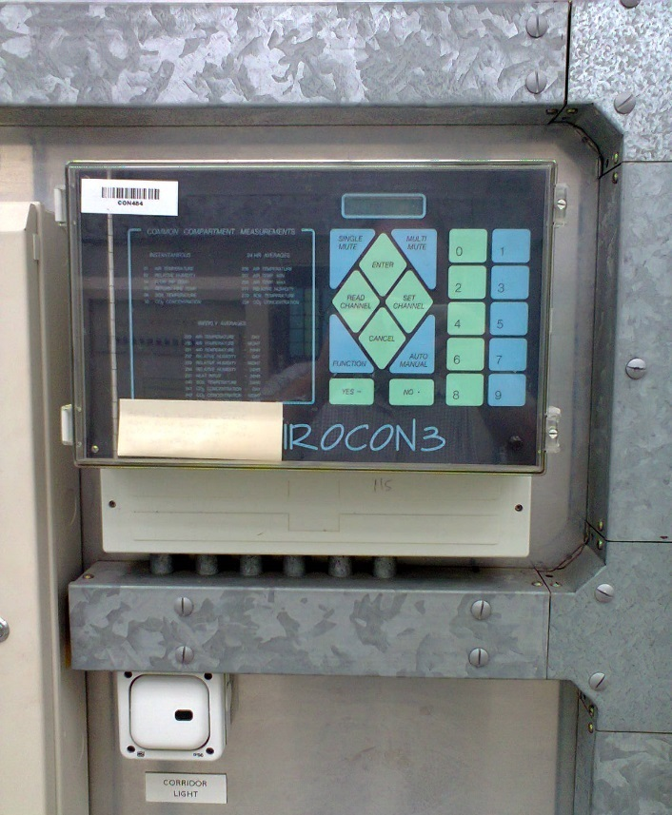
Many of the previous installations have little room for a new controller without repositioning power cables and water pipes. The labour costs for repositioning could be considerable compared to the cost of the actual controller. The ideal size would be within the envelope of the present controller which is (390 mm x 320 mm x 150 mm). However, sizes up to 450mm x 400mm x 200 mm would be considered. The nearer to the ideal, the better.
The present controller has a 2-line LCD display for viewing parameters such as temperature or for viewing and editing control parameters. There is a key pad with numerals and arrows to navigate the control menus. In practice, most of the monitoring and control is effected via a central PC which is linked by RS485.

View of central PC.
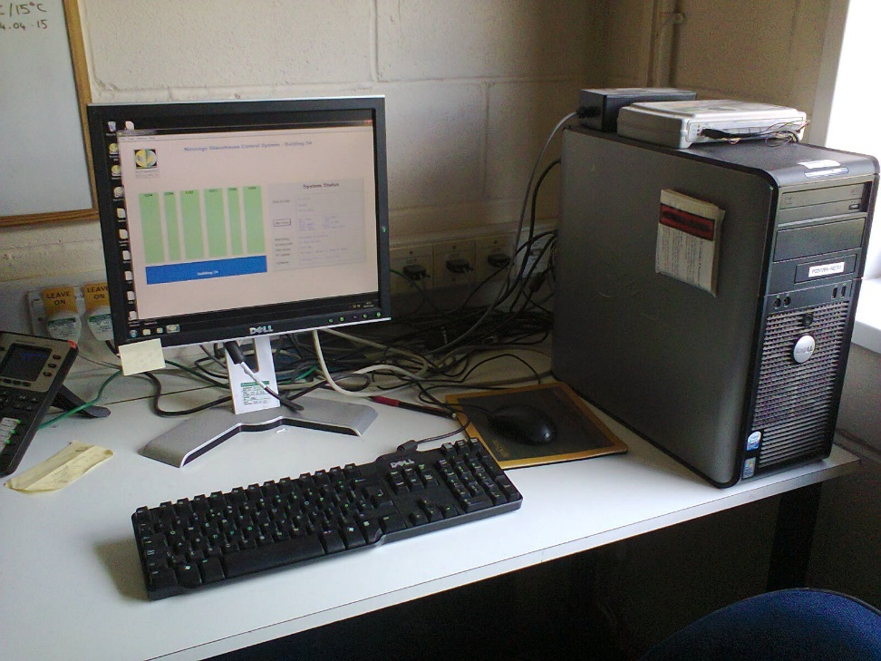
This PC can display the temperature status of a whole block or the detailed status of any one compartment.
The next figures show successive layers down from top to bottom of the PC mimic.
View of mimic for Building 54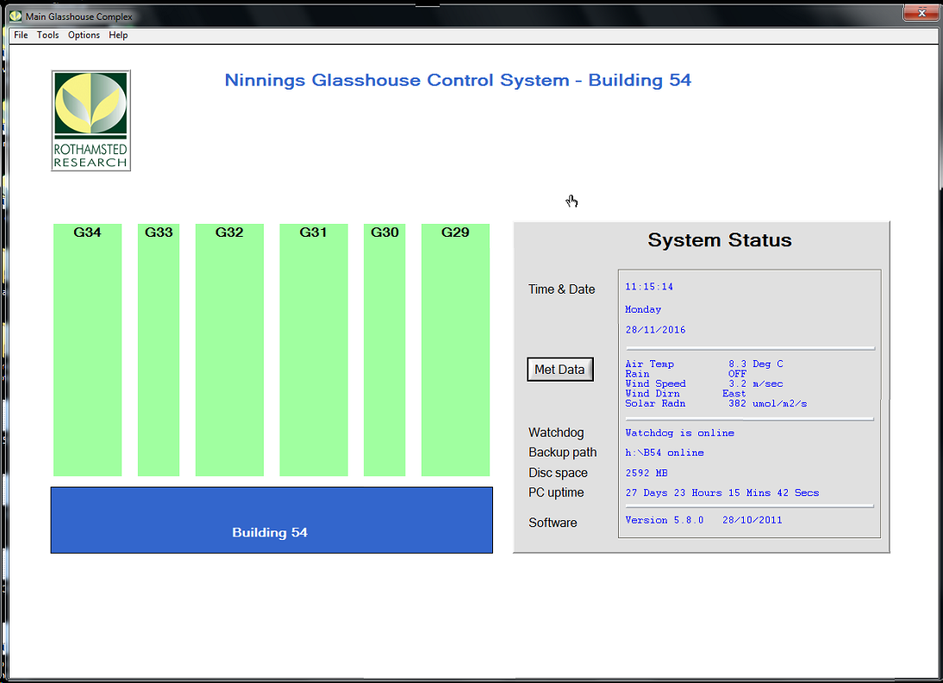

View of mimic for Glasshouse 33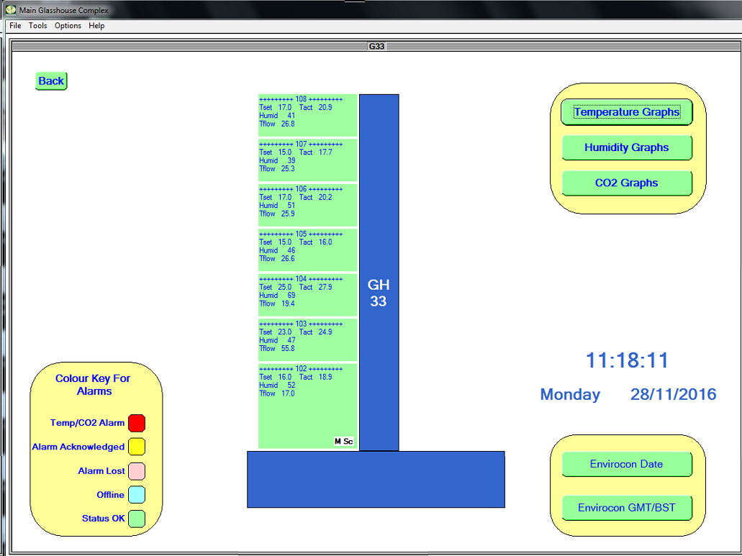

View of Mimic for 1 compartment which has no vents
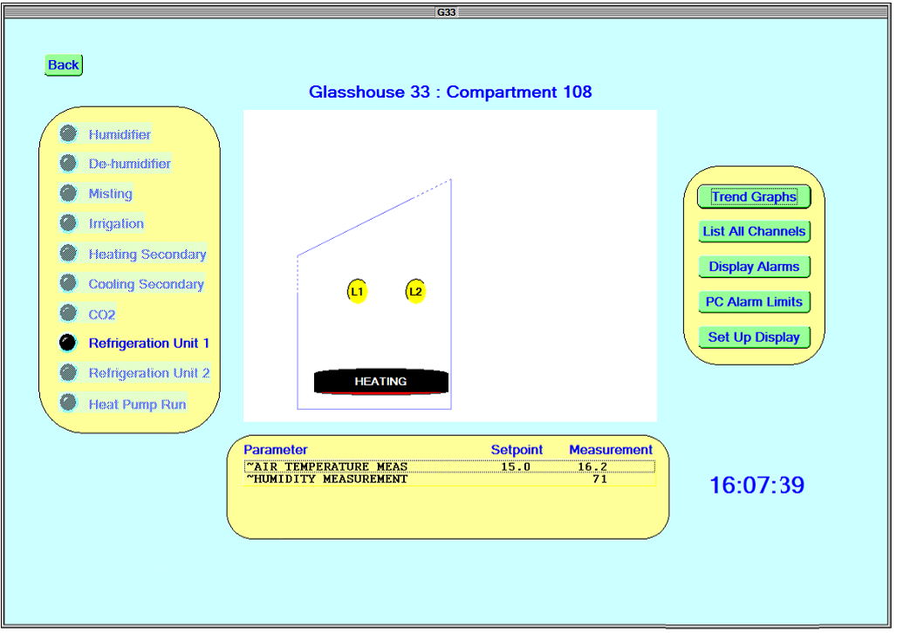

View of Mimic for 1 compartment which has screen open (grey)
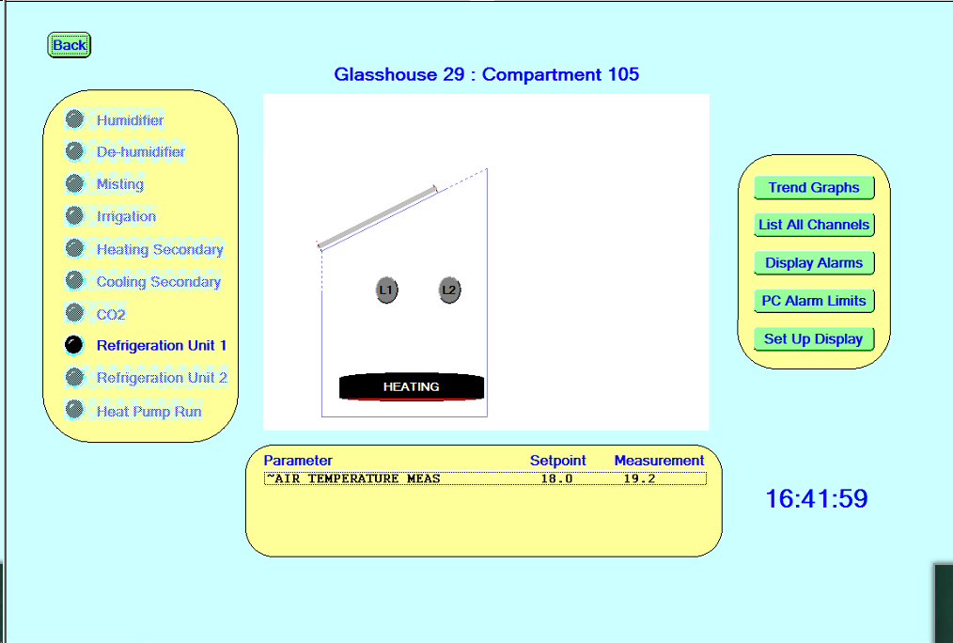

It also allows operator to view time plots of various parameters over a period of hours up the whole previous week. The data is also stored on file to give a record for previous years.
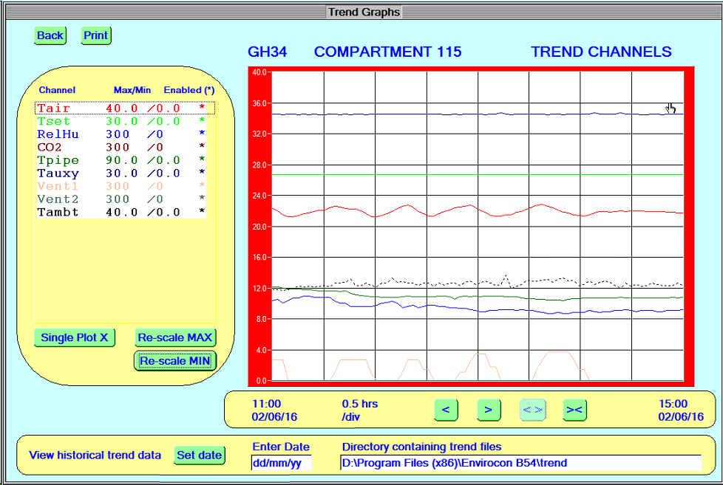
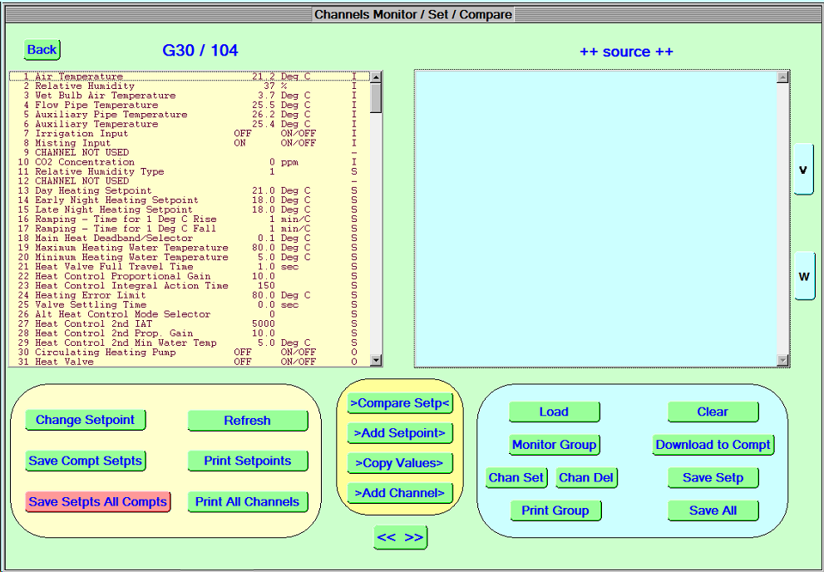
The mimic allows access to all Setpoints, Input variables, Output variables, Statistical variables and Control loop variables. These can be sent to a printer as a long list. It can print just the setpoints or just the channels.
It also allows the current setup to be stored in the PC for future reference or the stored setup for that compartment or a different compartment to be downloaded into a particular controller.
The current setup of a compartment can be compared with the stored setup to see what changes have been made since the last store command.
Each compartment is represented by a diagram specific to that compartment.
Mimic for compartment showing vent positions.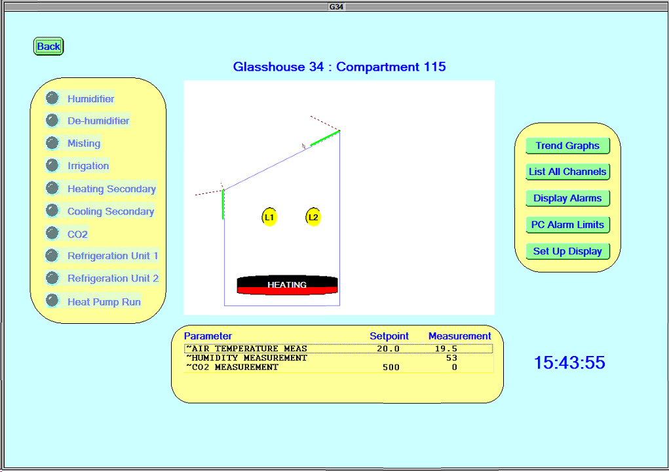

View of hot water control valves
Typical hot water control valve arrangement using timed 3 way mixing valve. This has occasional close events to reset position accuracy.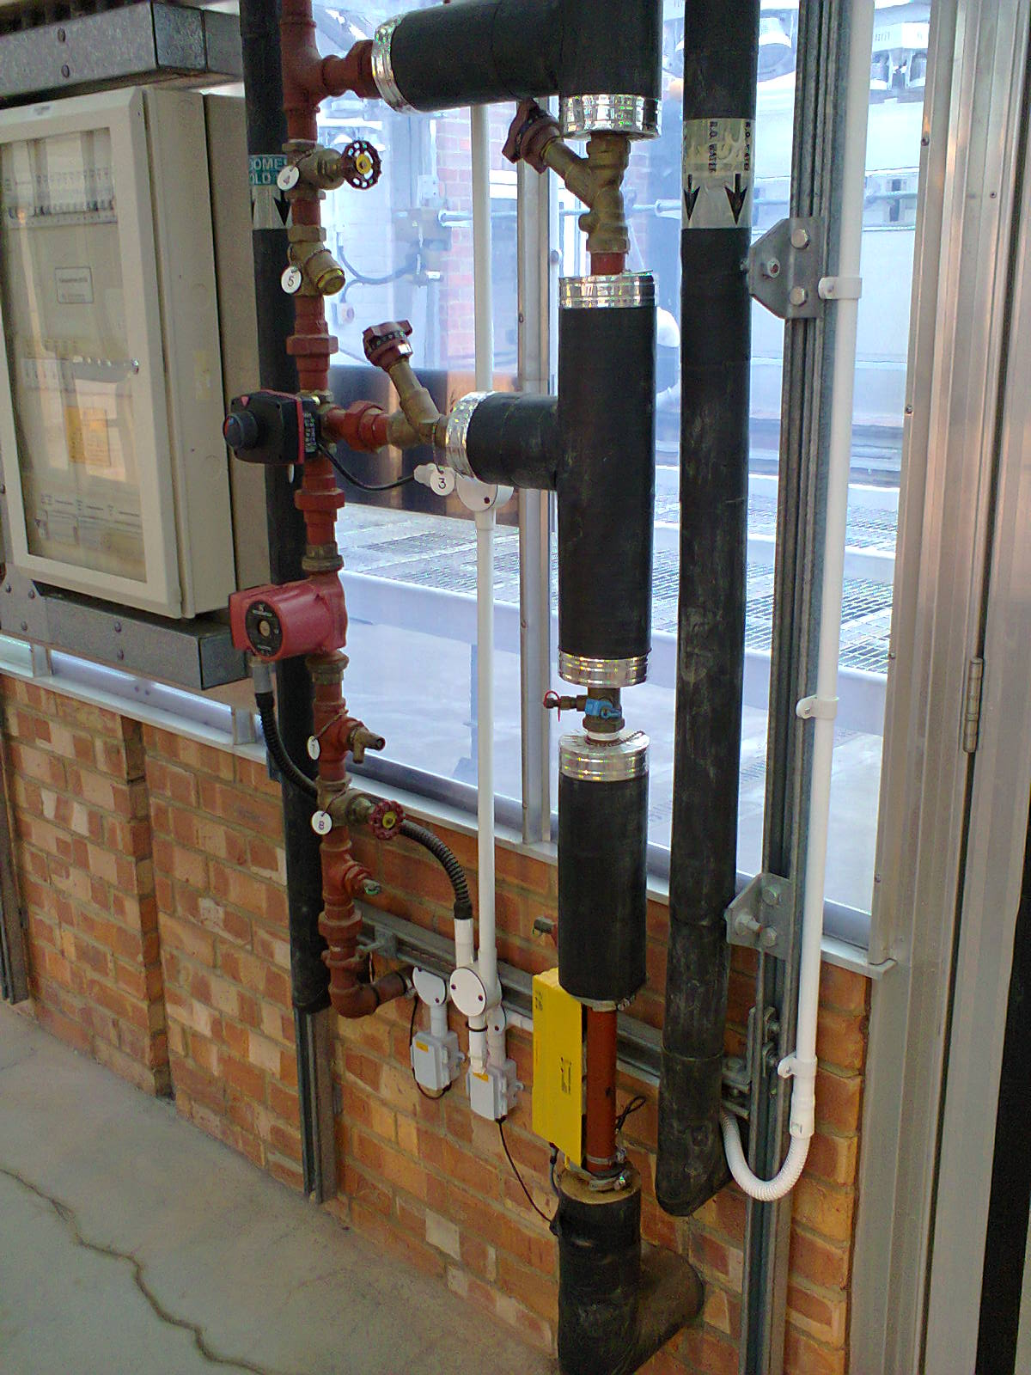
Each heat valve has 2 control signals for, open and close. The computer is programmed with the time it takes to fully open (or close) the valve. The computer turns on the open or close relays for some calculated value of seconds to adjust the valve setting between 0 and 100%. The computer keeps a running total of how many seconds of opening and closing have occurred since the valve was last “zeroed” or “slammed” which happens once a day to eliminate accumulated errors.

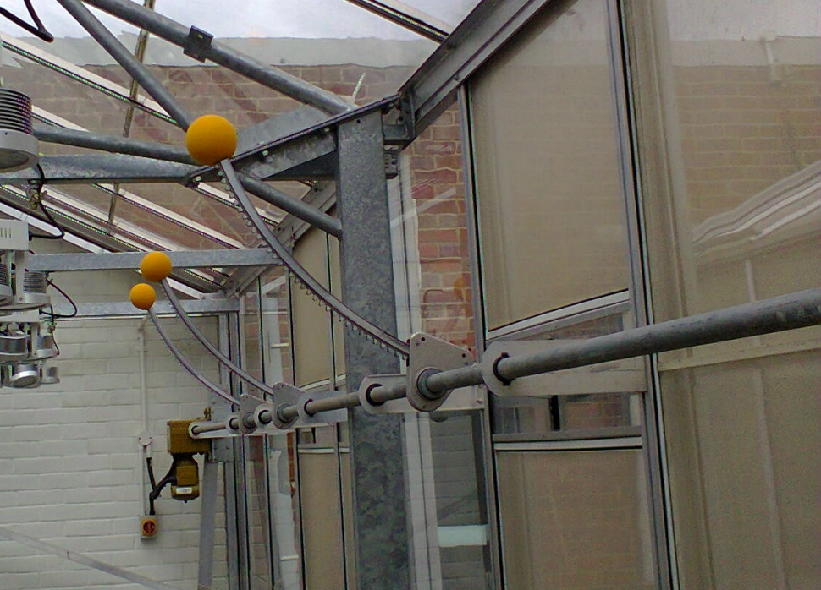
View of vents. The vents are controlled by timed opening or closing with the full opening time programmed into the controller. Once a day a slam event is used to remove accumulated errors in position.
Some glasshouses are symmetrical and use windward and leeward algorithm coupled with wind direction sensing from the Met station. Other single sided glasshouses use top and side algorithm.
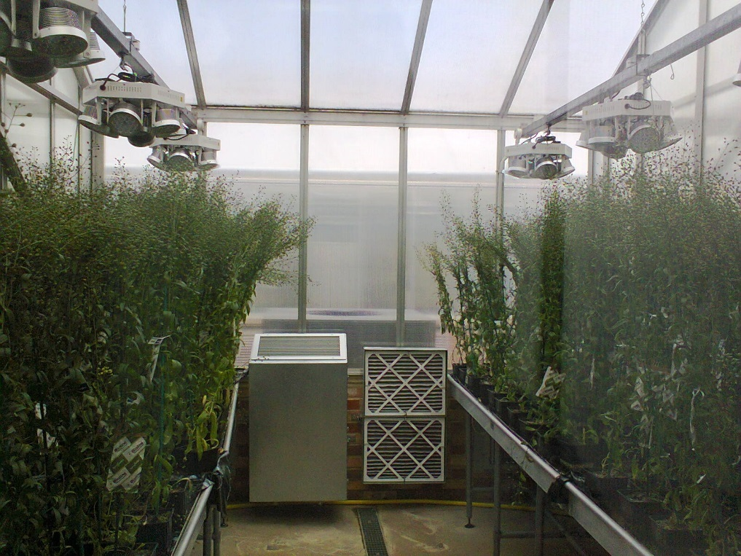

Some of the compartments have air-conditioning using heat pumps.
This is controlled by separate heat demand and coolth demand relays. These are operated at 8 minute intervals, set by the AC interface specification, to reduce wear on the AC equipment.

View of mimics for compartments in building 54 and 56
Building 56
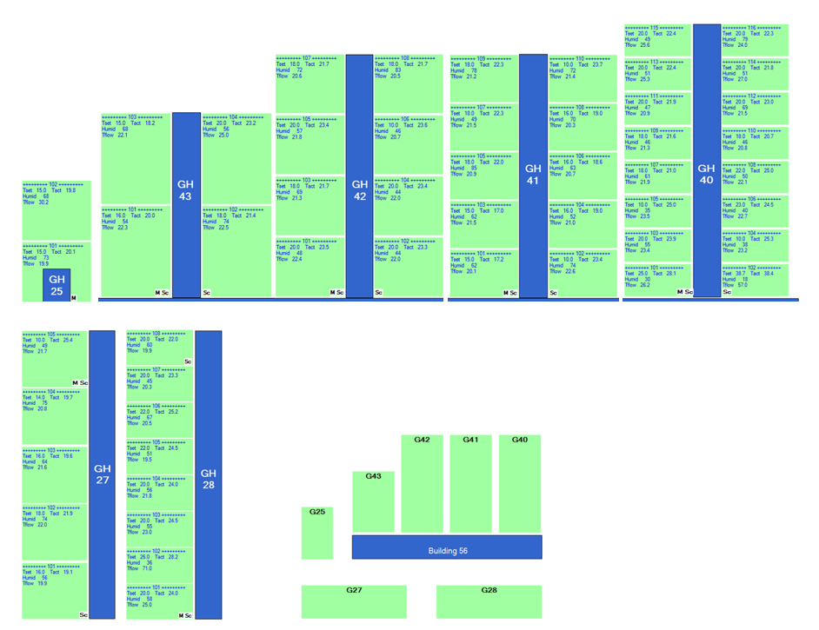
Building 54
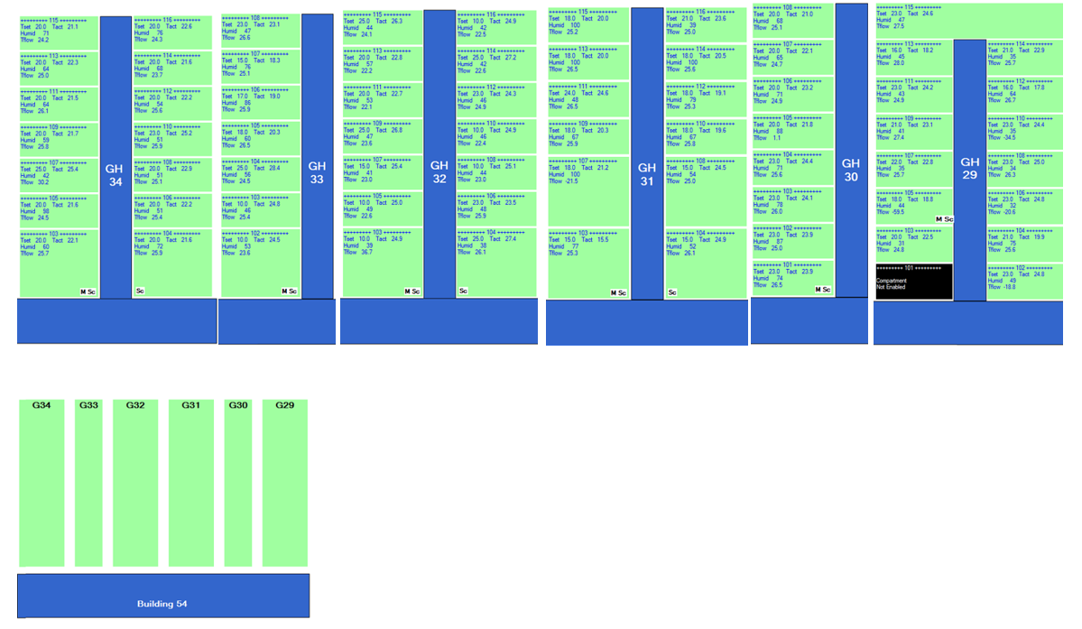

Architecture of Environmental Control Systems in B54
The following 2 diagrams show the architecture of the present system. Each compartment has its’ own controller. Each glasshouse has a master controller which controls one of the compartments but also relays information from the meteorological station and to and from the compartments to the logging PC.
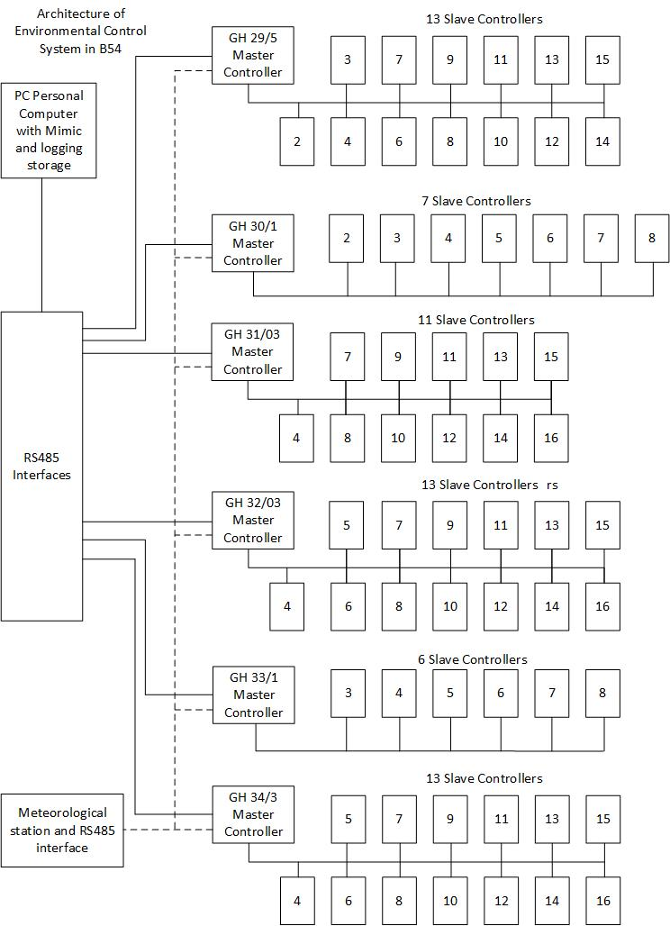

Architecture of Environmental Control Systems in B56
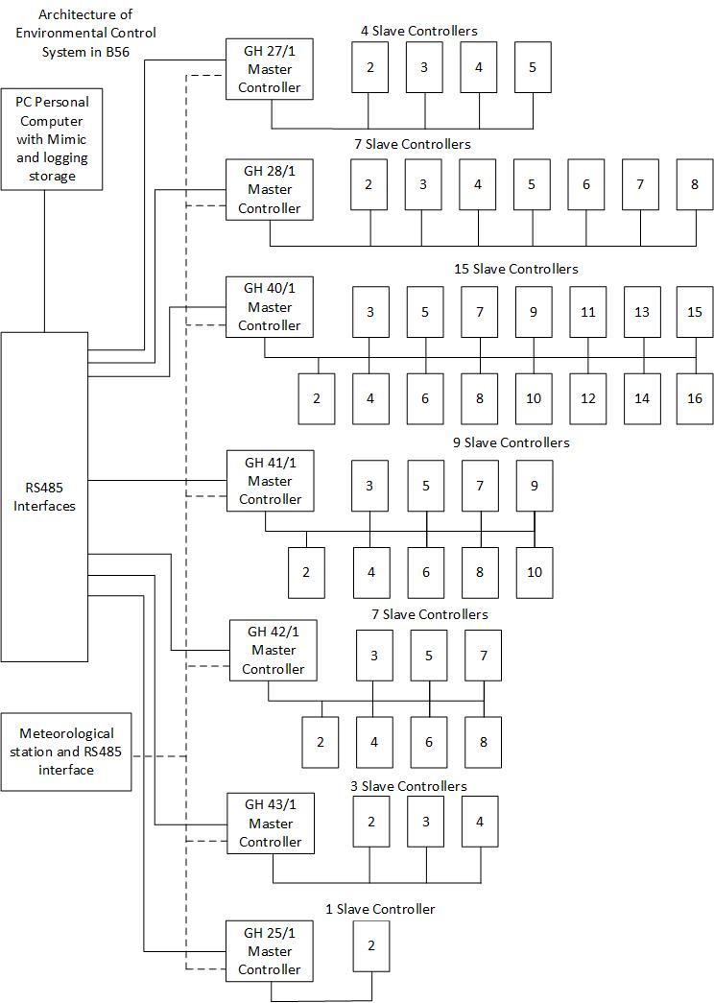
Each Master controller serves a compartment and also controls the slaves which serve neighbouring compartments via RS485. Generally, the Master also controls the screen for that side of a group of compartments. The slave on opposite side controls the screen for the other side.

Alternative architecture
Modern controllers are so powerful that some can serve multiple compartments each with their separate settings and parameters.
An alternative design could have one controller at the end of each glasshouse and a series of relay/analog interface units, one per compartment, each next to its’ compartment.
These would use a bus, RS485/RS422/Ethernet, to take the sensor measurements and control the relays for each compartment.
This would allow short connections between the 24V relay outputs and the electrical contactors which operate the vents and valves and lights etc. Several of the glasshouses have many small compartments with a narrow corridor so it is preferable to not have large numbers of relay cables and sensor cables running up to a central point. The contactors, motors and lights create a lot of electrical noise which can interfere with sensor signals and controller stability. However, there is limited room by the doors of some compartments so it may be necessary to use that arrangement for larger controllers which cannot fit by the door of those compartments.
The following 2 diagrams represent the architecture of such a system.
Each glasshouse would have a portable tablet or terminal to allow viewing of system parameters or changing controls while in a compartment.
Variants of this arrangement with similar functionality would be considered.
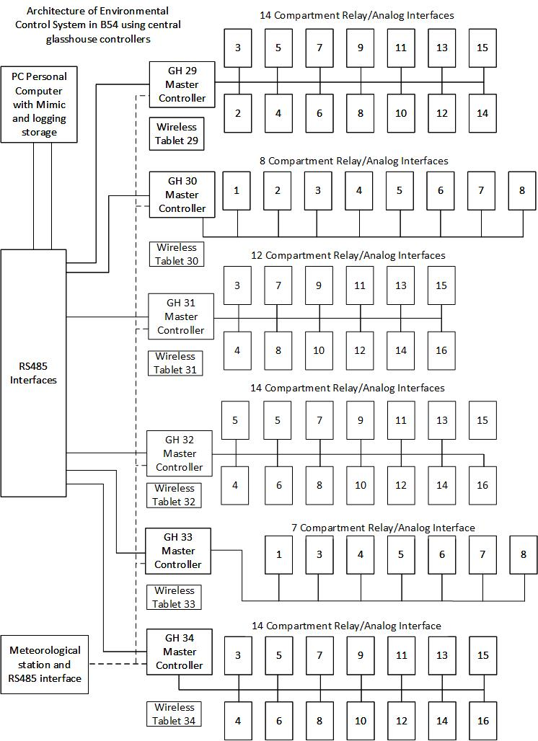
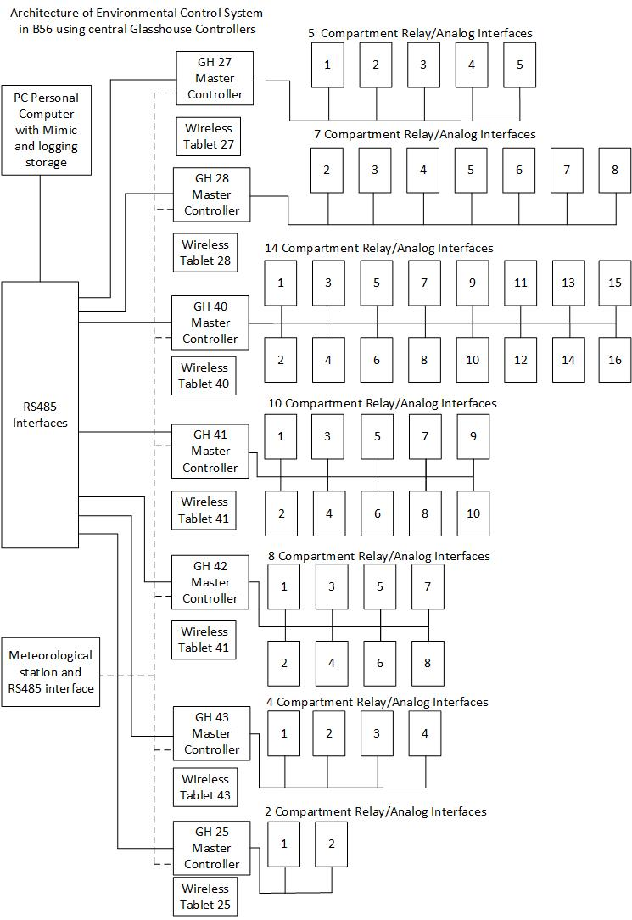

Option using present relay board and low voltage interface.
A further option would be to retain the enclosure, relay boards and contactor wiring of the present Envirocon systems. Each of these has a standard IDC ribbon cable connector with the following pin out which gives access to all the control relays. A breakout pcb might be made to interface relay contact pairs to this ribbon cable. The greenhouse controller would need to be located in the main corridor for some glasshouses since there is insufficient space in the internal corridor for the relay box and the controller.
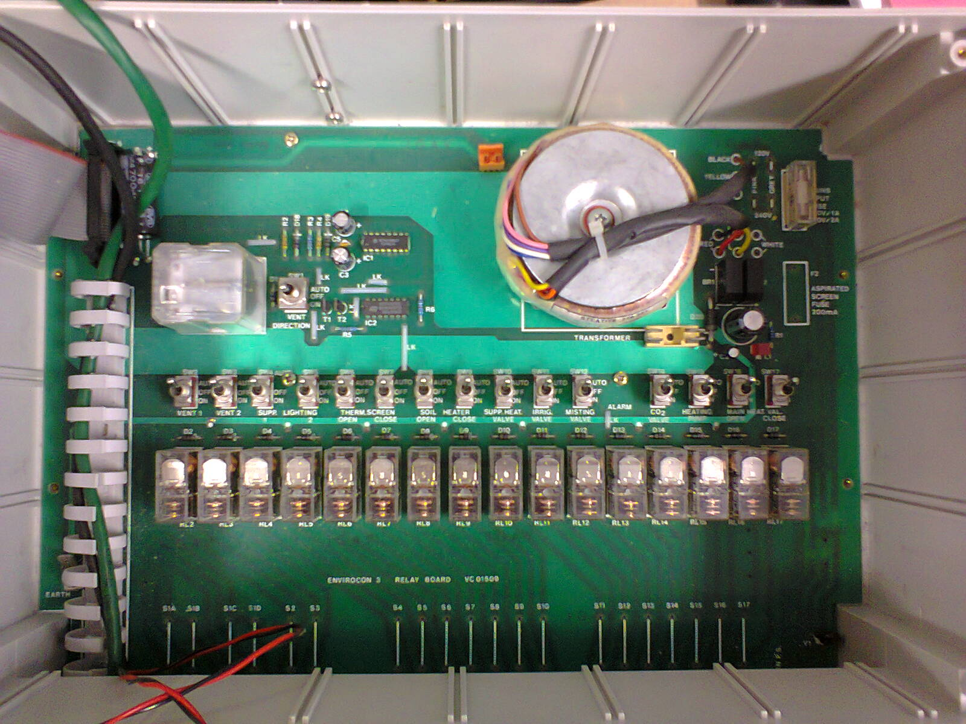

View of Relay board and ribbon cable top left.

Ribbon cable pin out for control relays
Pin number | Function
1 | Supply Voltage sense
2 | Heating Valve Close
3 | Heating Valve Open/Heat pump heat demand
4 | Heating Pump
5 | CO2 Valve
6 | Alarm
7 | Misting Valve
8 | Irrigation Valve
9 | Supplementary Heating Valve
10 | Soil Heater Close
11 | Soil Heater Open
12 | Thermal Screen Close
13 | Thermal screen Open
14 | Supplementary Lighting string 2
15 | Supplementary Lighting string 1
16 | Vent 2
17 | Vent 1/Heat pump cool demand
18 | Vents Direction open/close
19 | 9.8V
20 | 13 V Supply Common for all relays
21 | 9.8V
22 | 9.8V
23 | 0V
24 | 0V
25 | 0V
26 | 0V
Each relay is type G2R-1-A 12V 16A 250VAC SPDT contacts.

For the vents, the direction is set by pin 8, open or close.
The relays for vent1 or vent2 or both are energised to go in that direction.
There is a timer chip in the direction circuit to prevent instantaneous changes in direction. Otherwise the motor may not actually change direction. The limit switches may fail to operate correctly which could cause serious damage to the vents.
There are connections for the two vent motors for direction and on/off control separately.

List of Required features and Desired features
This list informs the supplier of required specification.
The supplier should enter Y or N to the fourth column as appropriate to ensure each feature has been considered and to facilitate evaluation by tender committee of degree of match of candidate system to required specification.
It is anticipated that there may be some exceptions and these will be considered on a case by case basis.
A “Y” in the tick boxes indicates that the recommended System supports that feature as a standard feature. We wish to avoid bespoke features which are not standard, tried and tested and documented.
If clarification is required, please email john.elliott@rothamsted.ac.uk

Supplier Details
Name of Supplier

Name of model of controller

Contact name & email

Feature List
Item No | Feature description | Required or Desirable | Place Y or N as applicable, Comments
 | Backwards compatibility
1 | Maximum dimensions of controller or relay/analog interface, (390 mm x 320 mm x 150 mm),  14.5 inch wide x 12.5 inch high x 6 or more inch deep. However, sizes up to 450mm x 400mm x 200 mm would be considered. The nearer to the ideal, the better. | D

Overall System Architecture
See diagrams on page 23
2 | Front panel keypad/touch screen and LCD on each controller | R
3 | Central meteorological station communicating to all of up to 69 controllers in a building/glasshouse complex, may need distribution boxes. | R
4 | Central computer with mimic of all of up to at least 69 glasshouse controllers in a building | R
5 | Separate controller for each compartment | R
6 | The same model of controller will be used throughout, whether controlling hot water heating or heat pumps, for consistency of human interface and hardware. | R
 | Environmental Specification
7 | Operating temperature range - -10 deg. C to 45 deg. C (shielded from direct sunlight) | R
8 | Storage temperature range - 20 deg. C to +40 deg. C | R
9 | Relative humidity - 10% to 90% non-condensing | R
10 | Dust and water - Enclosure to IP64 rating (Dust and splash proof). | R
11 | The equipment will be compatible with the UK electricity supply being 230 V +10% -6% | R
12 | Sulphur fumigation is used in the glasshouses from time to time. The aspirated temperature and humidity sensor should be tolerant this sulphur or have clear practical procedures to avoid degradation of performance. | R
13 | All components and the overall system must be compliant with EMC and CE regulations | R
14 | Test certificates for controllers should be supplied. | R
15 | The installation will be electrically and EMC compatible with the operation of lighting including SON T lamps in the compartment and actuators. | R
 | Controller Details
16 | User logon authentication level 1 for setpoints | R
17 | User logon authentication level 2 for loop parameters and system variables | R
18 | Separate log-ons for each compartment | R
19 | Log of recent users logged on | D
20 | Log of changes made and by who. | D
21 | If there is an interruption of power or an internal reset, the controller will automatically resume operation, continuing from previous operation without manual intervention. | R
 | Inputs to controller from compartment Aspirated screen
22 | Temperature, RH and CO2 inputs will be obtained from an aspirated screened enclosure. | R
23 | Minimum air velocity of aspiration 1 m/s | R
24 | Adjustable suspension height | R
25 | Air temperature | R
26 | Air Humidity | R
27 | All compartments should be capable of CO2 measurement but only fitted in a minority of compartments due to cost. | D
 | Other Inputs to controller from compartment without aspiration
28 | Heating water flow out temperature | R
 | Heating water flow temperature | D
29 | Electronic leaf | D
30 | Soil Moisture | D
 | Meteorological Station | R
31 | Wind speed 0 – 40 m/s | R
32 | accuracy and resolution better than 0.1 m/s | R
33 | Wind direction, at least 8 points of compass resolution | R
34 | Ambient temperature resolution 0.1C, accuracy 0.2C | R
35 | PAR 0-2000 umol/m2/s | Very D
36 | Rain detection (preferably heated) | R
37 | At least 69 compartments can receive met data from 1 station | R
 | Relay Control of Valves, screens, lighting etc.
38 | Each of the control relays will have a manual over-ride switch with 3 positions, Auto, On, Off. This allows manual control of a compartment even if the control board is malfunctioning and facilitates testing of actuators in a compartment | Very desirable
39 | 1) Vents Open/Close | R
40 | 2) Vent 1 motor ON/OFF | R
41 | 3) Vent 2 motor ON/OFF | R
42 | 4) Supplementary Lighting 1 ON/OFF | R
43 | 5) Supplementary Lighting 2 ON/OFF | R
44 | 6) Thermal Screens Open | R
45 | 7) Thermal Screens Close | R
46 | 8) Soil Heater Open | D
47 | 9) Soil Heater Close | D
48 | 10) Supplementary Heating Valve | D
49 | 11) Irrigation Valve ON/OFF | R
50 | 12) Misting Valve ON/OFF | R
51 | 13) Alarm ON/OFF - disable | R
52 | 14) CO2 Valve ON/OFF | R
53 | 15) Heating Pump | R
54 | 16) Main Heat Valve Open | R
55 | 17) Main Heat Valve Close | R
 | Parameters stored in Controller
56 | All user setpoints are stored in non-volatile memory (EEPROM) or equivalent and are therefore maintained indefinitely after power down. | R
57 | Time clock and calculated, averages, maximum/minimum readings etc. are stored in `battery' backed up memory and are maintained for several hours after power down. | R
58 | All setpoints and control settings can be saved to a specific file on the PC and downloaded if the controller is reset or replaced. | R
59 | Simple single function change from GMT to BST | R
60 | Low voltage Power output to Aspirated Screen Fan Motor – protected by a fuse | R
61 | Secure key-switch access to keypad. | R
62 | Key switch access to manual over-ride controls which are easily opened for access. | R
 | Alarms
63 | High Temperature Alarm | R
64 | Low Temperature Alarm | R
65 | RH High Alarm | R
66 | RH low Alarm | D
68 | Flow Pipe Temp High Alarm | R
69 | Flow Pipe Temp Low Alarm | R
70 | Each controller outputs a “watchdog” pulse or responds to a regular polling of data to the Mimic program on the PC. If any controller fails to respond or the PC crashes, a volt free relay contact goes open circuit which signals an alarm to the site Trend BMS system. This is separate from the alarm relay. It alerts the site support staff if any controller has crashed or stopped functioning correctly. | R
71 | Adjustable delay before alarm to Trend BMS so that short lived over-temperatures etc do not cause unnecessary alarms and call-outs. | R
 | CO2 Control
72 | Concentration level control, adjustable setpoint or purely enrichment for 3 periods during 24 hours, user selectable | D
73 | Wind speed interlock to avoid uneconomic use of CO2 | D
74 | Light level interlock to maximise use of CO2 | D
75 | Ventilation opening for CO2 setpoint or enrichment interlock, user selectable | D
76 | Allows repeating timed CO2 enrichment within a specified time interval | D
 | Vent cooling
77 | Glasshouse orientation user setpoint | R
78 | 2 Vent cooling, either 2 top vents or 1 top and 1 side vent. | R
79 | Leeward or windward vent opening control | R
80 | Vents Open/Close (Changeover) | R
81 | Vent 1 ON/OFF  Single or double sided floating control with user definable slam periods, avoids maintenance of vent feedback potentiometers. | R
82 | Vent 2 ON/OFF | R
83 | ON/OFF control for fan type ventilation.  Deadband interlocked to heating setpoint to avoid vents being open when heating is on unless humidity has priority. | R
84 | 3 Periods of control - Day, Early Night and Late Night | R
85 | Maximum and minimum Vent openings | R
86 | End of day venting setpoint to trap heat and save energy | R
 | Extreme weather features
87 | Maximum vent opening at very low temperatures to protect plants being chilled.  Opening and temperature parameters | R
88 | Storm protection, close vents for selectable period after wind gust intensity detected | R
89 | Snow detection to protect external screens | D
90 | Hail detection to protect external screens | D
91 | No movement of external screen below freezing temperatures | R

Clock Type Selection:
Up to 3 clock types can be selected for timing of heating and ventilation i.e.
92 | Fixed dawn and dusk | R
93 | Dawn and dusk calculated from internal calendar clock | R
94 | Dawn and dusk advanced or delayed dependent upon light levels | R
95 | Secondary Heating or Secondary Cooling (common output)  Can be user selected as:  1. A separate ON/OFF control facility to supplement main control system for those applications where primary circuit under extreme conditions requires additional or alternative energy source.  3 periods control, Day, E. Night, L. Night | R
96 | 2. A separate ON/OFF control facility to supplement normal vent control/cooling  3 periods, Day, E. Night and L. Night | R
 | Hot Water Heating
98 | 3-way proportional mixer valve hot water heating: | R
99 | Opening/closing time for mixer valve 0-200 seconds | R
100 | Main Heating Valve Open relay contact | R
101 | Main Heating Valve Close relay contact | R
102 | Circulating Pump ON/OFF Circulating Pump Control (Pump switches off after 30 minutes when no demand for heat to save energy). | R
 | Heat demand and cool demand on AC, | R
103 | These use vent1 open and Heat valve open relays on the present system since we do not need those vents for an AC compartment. | R
104 | The minimum period between each heat or cool demand is 8 minutes to reduce wear on heat pump components | R
105 | Mode using vent 2 to cool up to a certain temperature but closes vents and transfers to AC beyond that temperature. Energy saving feature. | R
106 | Supplementary Heating/Cooling:  Auxiliary Heating Valve Open for soil heating | D
107 | Soil temperature sensor input | D
108 | Auxiliary Heating Valve Close | D
109 | Heating Control for heat pumps  Modulating (proportional) or ON/OFF selectable by user | R
110 | 3 Stages, Day, Early Night, Late Night operator setpoint | R
111 | Ramping control - rising and falling 0 – 99 minutes per degree Celsius | R
112 | Max/Min pipe temperature limits | R
113 | Proportional plus integral control | R
114 | Wind-up maximum for integrator term | R
115 | Temperature Boost  A user definable period in any 24 hours in which the temperature can be brought up or down to the desired boost setpoint as quickly as possible. The start time, and duration can also be defined. Usually late afternoon to avoid condensation. | D
116 | Automatic adjustment of control parameters when operating with thermal screens | R
117 | When compartment temperatures, pipe temperatures, auxiliary temperature or CO2 concentration are in high or low alarm i.e. above or below user alarm setpoints by selectable margins, output status is shown on LCD display, on PC mimic display and potential free relay contact closure to BMS alarm.  Text to operator and night staff and email to list of staff. | R
 | Measured parameters/sensors Resolution and accuracy
118 | Internal and external temperature 0.1 Celsius resolution, accuracy +/- 0.2 Celsius at 20C | R
119 | Internal and external Humidity, resolution 1% RH, accuracy +/- 2% RH.  Tolerant of condensation, accuracy retained the day afterwards. | R
120 | Relative Humidity Control  Two independent control algorithms acting on both heating and ventilation control setpoints to control RH. Can be used independently or both together. | R
121 | Solar micromole/m2/sec  PAR 0-2000 umol/m2/s  Angular response Cosine corrected  PAR Spectral sensitivity | R
122 | Wind speed 0 – 40 m/s, resolution 0.1m/s | R
123 | Minimum wind speed measured 0.4 m/s | D
124 | Wind direction, used to compute vent opening, 8 points of compass minimum resolution | R
 | Software specification
125 | Set point and parameter list accessible from controller keypad and LCD and from central PC, to view or change under username and password control | R
126 | Logging frequency, 10 seconds – 1 minute | R
127 | Email and text alarms | R
128 | History, all logged data is stored on a specified hard drive on the network. | R
129 | Graphing display on PC, 1 Hr per division to 1 day per division for preceding 8 days | R
130 | Group of temperatures scaled in Celsius, min/max range selectable by user | R
131 | Group mimic displays up to 16 compartments | R
132 | Measure of mains current via current transformer with daily and weekly total amp-hours, dc voltage proportional to input. Integral measurement for each day. This is to help monitor power consumption | R
 | When a personal computer system is connected to the Controller, any measurement, or setpoint on the system, or a selection of the same may be displayed or saved to file in the form of a log either on demand or at pre-selected intervals. | R
133 | All data available on network with password protection | R
 | Statistics of measured Variables
134 | Instantaneous Readings:  All measurements such as temperature, RH, CO2 concentration levels, pipe temperature, solar radiation etc, can be viewed on demand via the keyboard and LCD display on the controller. | R
135 | 24 Hour Averages value available from controller or PC including day, night and 24-hour period for temperatures, RH and CO2 levels. | R
136 | 24 Hour total measurement for current measurement of mains supply via current transformer and voltage output 0 – 5V
137 | Maximum/Minimum Values  Temperature and RH in each 24-hour period (from dawn to dawn). | R
138 | Weekly Averages  Of day, night and 24-hour period for temperatures, RH and CO2 levels. | R
139 | Air Temp Day - Weekly Average | D
140 | Air Temp Night - Weekly Average | D
141 | Air Temp 24 Hr - Weekly Average | D
142 | RH Day - Weekly Average | D
143 | RH Night - Weekly Average | D
144 | RH 24 Hr - Weekly Average | D
145 | Auxiliary Temp Day - Weekly Average | D
146 | Auxiliary Temp Night - Weekly Average | D
147 | Auxiliary Temp 24 Hr - Weekly Average | D
148 | Day Start Offset | D
149 | E Night Start Offset | D
150 | Air Temperature - Day Average | R
151 | Air Temperature - Night Average | R
152 | Air Temperature - 24 Hr Average | R
153 | RH - Day Average | R
154 | RH - Night Average | R
155 | RH - 24 Hr Average | R
156 | Auxiliary Temperature - Day Average | D
157 | Auxiliary Temperature - Night Average | D
158 | Auxiliary Temperature - 24 Hr Average | D
159 | CO2 Conc. - Day Average | R
160 | CO2 Conc. - Night Average | R
161 | CO2 Conc. - 24 Hr Average | R
162 | Air Temperature - 24 Hr Minimum | R
163 | RH - Minimum | R
164 | Auxiliary Temperature - 24 Hr Minimum | R
165 | CO2 Conc. - 24 Hr Minimum | R
166 | Air Temperature - 24 Hr Maximum | R
167 | RH - Maximum | R
168 | Auxiliary Temperature - 24 Hr maximum | R
169 | CO2 Conc. -24 Hr Maximum | R
170 | Daily and weekly total PAR solar radiation | R
171 | Day maximum PAR level | D
172 | Details of PAR sensor provided | R
173 | Day accumulated rain total | D
 | Thermal Screen Control:
174 | An advanced control algorithm that modulates the gap left in the screen at night to prevent excessive temperature/humidity build up.  Staggered opening to avoid thermal shock to plants when screens are opened in the morning. | R
175 | Shading Screen Control  Will operate external screens automatically in a shading mode during the day.  Screens operated on ambient light levels | R
176 | External temperature interlock to prevent external screen deployment when frozen, snow, hail, selectable temperature threshold | D
 | Misting Control
177 | ON/OFF control of a misting solenoid using a sequence time initiated by one of the following: - | R
178 | Time | R
179 | RH | R
180 | Solar radiation level | R
181 | Radiation Integral | R
182 | External condition e.g. electronic leaf | R
183 | Sequence enables the ON period and number of repeats to be selected when misting is called for, determined by operator setpoints. | R
 | Supplementary Lighting
184 | Two separate user definable outputs for control of supplementary lighting  Control is based on light level, radiation level or time, to either supplement the ambient light levels during the selected day period, or to extend the day period as a function of the integrated radiation level during the day. | R
185 | Settable day length | R
186 | Clock type selectable, single function change from GMT to BST | R
 | Heating control parameters
187 | Setpoints for day, early night and late night | R
188 | Ramping - Time for 1 Deg C Rise, 1-99 min | R
189 | Ramping - Time for 1 Deg C Fall, 1-99 min | R
190 | Heat Control Proportional Gain factor | R
191 | Heat Control Integral factor | R
192 | Dead bands for above and below Setpoint. | R
193 | Heat Valve Full Travel Time (1 – 200 seconds) | R
194 | Valve Settling Time for water circulation, minimum time before next movement to prevent hunting, 999 seconds max. | R
195 | Thermostat style of control of Heat Pump where used | R
196 | Screen Clock Type | D
197 | Screen Night Covering Offset | D
198 | E Night Duration Time | D
199 | L Night Heating Setpoint | D
200 | Day Vent Deadband | D
201 | E Night Vent Deadband | D
202 | L Night Vent Deadband | R
203 | Vent Lee Max Opening (in rain) % gap for run off | R
204 | Vent Lee Day Min Opening | R
205 | Vent Lee Night Min Opening | R
206 | Vent Windward Max Opening (in rain) | D
207 | Vent Windward Day Min Opening | D
208 | Vent Windward Night Min Opening | D
209 | Storm Warning Wind Speed for vent shut | R
210 | Select how long to remain shut after last gust | R
211 | Vent Control Proportional Gain | R
212 | Vent Control Integral factor | R
213 | Vent Full Time Travel | R
214 | Vent Slam Interval Time | R
215 | Vent Double/Single Select | R
216 | End of Day Venting Temperature | D
217 | End of Day Venting Offset Time | D
218 | Glasshouse Orientation | R
219 | Screen Morning Covering Offset | D
220 | Screen Partial Opening Time | R
221 | Screen Full Travel Time | R
222 | Screen Overrun Time | R
223 | Screen Maximum Opening | R
224 | Screen Settling Time | R
225 | Max Heating Water Temp | R
226 | Min Heating Water Temp to prevent freezing | R
227 | Main Heat Deadband/Selector | R
 | Irrigation and Misting controlled by RH, temperature or time | R
228 | Sequence Time 1 Condition | R
229 | Sequence Time 1 Parameter | R
230 | Sequence Time 1 A Time | R
231 | Sequence Time 1 B Time | R
232 | Sequence Time 1 Repeats | R
233 | Sequence Time 2 Condition | R
234 | Sequence Time 2 Parameter | R
235 | Sequence Time 2 A Time | R
236 | Sequence Time 2 B Time | R
237 | Sequence Time 2 Repeats | R
238 | Max Light Dependent Lift | R
239 | Light Intensity Lift Level | R
240 | Boost Start | D
241 | Boost Duration | D
242 | Boost Temperature Setpoint | D
243 | Boost Type | D
244 | Max Total Radiation Lift | R
245 | Total Radiation Lift Level | R
246 | Screen RH Control Band | D
247 | Screen External Temp Low Level | D
248 | Screen External Temp Band | D
249 | Screen Temperature Diff Factor | D
250 | Radiation for no Light/Radn Dep Lift | R
 | Supplementary Lighting
251 | No 1 Supplementary Lighting Type | R
252 | No 1 Light Control Type | R
253 | No 1 Start/Offset Time | R
254 | No 1 End/Offset Time | R
255 | No 1 High Light Level | R
256 | No 1 Low Light Level | R
257 | No 1 Radiation Integral Level/Time Delay | R
258 | No 2 Supplementary Lighting Type | R
259 | No 2 Light Control Type | R
260 | No 2 Start/Offset Time | R
261 | No2 End/Offset Time | R
262 | No 2 High Light Level | R
263 | No 2 Low Light Level | R
264 | No 2 Rad Integral Level/Time Delay | R
265 | Screen Wind Low Level | D
266 | Screen Wind High Level | D
267 | Night time Heat Control 2nd Integral factor | D
268 | Night time Heat Control 2nd Proportional Gain | D
269 | Alt Heat Control Mode Selector for night mode | D
270 | Shading Screen Radiation for CLOSE | R
271 | Shading Screen Delay before CLOSE, up to 15 minutes | R
272 | Shading Screen Radiation for Open | R
273 | Shading Screen Delay before OPEN | R
274 | Shading Screen Travel Time | R
275 | Heat Control 2nd Minimum Water Temperature | D
276 | Minimum Storm Duration seconds | R
277 | Vent no Movement Deadband, reduce hunting wear | D
278 | Vent Max Opening Normal Conditions | R
 | Humidity Measurement and Control
279 | RH Clock Type | R
280 | RH Level 1 Start | R
281 | RH Level 1 Duration | R
282 | (deviation from temperature setpoint to avoid humidity extremes)  RH Heating Upper Limit Level 1 day | R
283 | RH Heating Lower Limit Level 1 day | R
284 | RH Heating Upper Limit Level 2 night | R
285 | RH Heating Lower Limit Level 2 night | R
286 | RH Heating Max T Lift for disease control | R
287 | RH Venting Upper Level 1 | R
288 | RH Venting Lower Level 1 | R
289 | RH Venting Upper Level 2 | R
290 | RH Venting Lower Level 2 | R
291 | RH Lee Vent Opening | R
292 | RH External T Vent Interlock | R
293 | RH Wind Speed Vent Interlock | R
294 | RH Interlock with external temperature, Deadband | R
295 | Pump delay time, 0-60 minutes | R
296 | Relative Humidity type RH | R
297 | VPD Vapour Pressure Deficit mode | D
298 | RH sensor Calibration Factors, offset and slope | R
 | CO2 Control
299 | CO2 Start Time Offset as crop grows | R
300 | CO2 Stop Time Offset | R
301 | CO2 Lee Vent Min Position | R
302 | CO2 Lee Vent Max Position | R
303 | CO2 Max Enrichment Period 1 | R
304 | CO2 Duration Period 1 | R
305 | CO2 Max Enrichment Period 2 | R
306 | CO2 Duration Period 2 | R
307 | CO2 Max Enrichment Period 3 | R
308 | CO2 Minimum Enrichment | R
309 | CO2 Wind Speed Interlock | R
310 | CO2 Light Level Interlock | R
311 | CO2 Light Level Int Selector | R
 | Secondary Heating and Cooling
312 | Secondary Heating Day Temp | R
313 | Secondary Heating E Night Temp | R
314 | Secondary Heating L Night Temp | R
315 | Secondary Heating Deadband | R
316 | Secondary Cooling Day Temp | R
317 | Secondary Cooling E Night Temp | R
318 | Secondary Cooling L Night Temp | R
319 | Secondary Cooling Deadband | R
320 | Auxiliary Day Heating Setpoint | D
321 | Auxiliary E Night Heating Setpoint | D
322 | Auxiliary L Night Heating Setpoint | D
323 | Vent Lee Max in High Winds | R
324 | Auxiliary Heat/Deadband Selector | D
325 | Auxiliary Max Heating Water Temp. | D
326 | Auxiliary Min Heating Water Temp. | D
327 | Auxiliary Heat Valve Full Travel Time | D
328 | Auxiliary Heat Valve Settling Time | D
329 | Auxiliary Pump Delay Time | D
330 | Screen Max Rad for RH Interlock | D
331 | Period of Day | R
332 | Desired Heating Water Temp | R
333 | Dynamic Vent Deadband | R
334 | Vent 1 Position | R
335 | Vent 2 Position | R
336 | Screen Position | R
337 | Dynamic Control Temperature | R
338 | Auxiliary Desired Heating Water Temp | D
339 | Auxiliary Dynamic Control Temp | D
340 | Days from Reset | R
341 | Day of Week | R
342 | DALI digital control of lights | D
 | Mimic Features
343 | The mimic allows access to the following information for any particular compartment.
344 | Setpoints | R
345 | Input variables | R
346 | Output variables | R
347 | Statistical variables | R
348 | Control loop variables | R
349 | These can be all sent to a printer as a long list | R
350 | It can print just the setpoints | R
351 | It can print just the input and output channels. | R
352 | It allows the current setup to be stored in the PC for future reference. | R
353 | It allows the stored setup for that compartment or a different compartment to be downloaded into a particular controller. | R
354 | The current setup of a compartment can be compared with the stored setup to see what changes have been made since the last store command. | R
355 | Each compartment is represented by a diagram specific to that compartment. | R
356 | The Glasshouse mimic should show current temperature, set point and humidity for each compartment | R
357 | The Glasshouse mimic should be able to show a time graph of temperatures of all compartments in that glasshouse | R
358 | The compartment mimic should show current temperature, set point and humidity | R
359 | The compartment mimic should be able show temperature, dynamic temperature setpoint, humidity, external air temperature, vent position, heating water temperature on a time graph. | R
360 | The scale of the vertical axis must be selectable for any of the displayed variables | R
361 | The scale of the horizontal axis must be selectable from ½ hr per major division to 1 day per major division | R
362 | There should be at least 8 major divisions along the time axis | R
363 | The compartment mimic should show status of controls, e.g., lights, vents, fans, pumps, heat and cold demand | R
364 | The Mimic should allow all analog and digital inputs to be listed for fault finding and checking setup. | R
365 | The Mimic should show which glasshouse and which compartment in that glasshouse is generating an alarm by changing the background colour. | R
366 | The Mimic will allow the operator to acknowledge an alarm to let others know that it is being attended to, the background changes to an intermediate colour. The alarm is silenced and cleared from the BMS | R
367 | The Mimic will allow the alarm to be disabled during maintenance or testing. A clear message appears on the mimic and remains until the alarm is enabled.  The alarm colour reverts to normal when the alarm condition is no longer present. | R
 | Health & Safety
368 | The contractor shall comply fully with all legislation in respect of Health &  Safety and good site practice, together with the requirements of the  Construction (Design & Management) Regulations 2015 | R
369 | All wiring shall be of Low smoke zero halogen or low smoke free of halogen (LSZH or LSOH or LS0H or LSFH or OHLS) material classification used for cable jacketing in the wire and cables supplied | R
370 | All wiring from sensors to controller shall be flexible multi strand wire which can tolerate a reasonable amount of flexing. | R
371 | Connection of mains or low voltage wiring to the relay board will be via connectors rather than hard wired. This is to facilitate replacement of a relay or CPU board in case of malfunction. | R
372 | Connection of low voltage signal from sensors, met station etc will be via connectors rather than hard wired. This is to facilitate replacement of a control board in case of malfunction. | D
373 | The LCD display will automatically compensate for variations in ambient temperature so that it is always legible throughout the ambient temperature range. | R
374 | The controllers must be compatible with permanent operation from a UPS such as APC SmartUPS RT 10000 or PowerWave 9 120 supplying 240Vac | R

End of document.

