ANNEX 7 — CHANGE CONTROL FORMS

CHANGE CONTROL NOTICE (CCN)

Contract for the Provision of Security Personnel Services

CZI20Al 1 1

1/04/2022

Between: The Cabinet Office (The Customer) and Ten Acres Security Consulting LTD (The Supplier)

- The Contract is varied as follows:

The Call-Off Contract with reference CCZI20A11 is extended for 10 hearing weeks from 01/04/2022. This extension is time and value and therefore has an attendant cost of REDACTED TEXT under FOIA Section 43 Commercial Interests, meaning the original Call-Off Contract value REDACTED TEXT under FOIA Section 43 Commercial Interests. No further Variations will be permissible once this Extension has expired.

- Words and expressions in this Change Control Notice shall have the meanings given to them in the Contract.

- The Contract, including any previous Contract changes, authorised in writing by both Parties, shall remain effective and unaltered except as amended by this Change Control Notice.

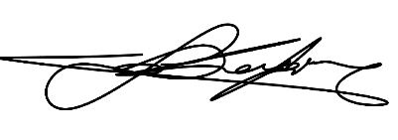
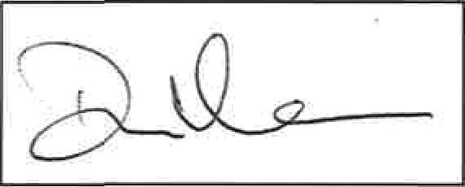
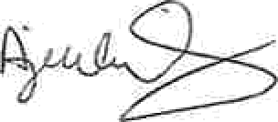
Change authorized to Proceed by: (Customer’s Representative): | REDACTED TEXT under FOIA Section 40, Personal Information  Signature | REDACTED TEXT under FOIA Section 40, Personal Information  Print Name and Job Title | 14/3/22  Date
Authorised for and on behalf of the Supplier: | REDACTED TEXT under FOIA Section 40, Personal Information  REDACTED TEXT under FOIA Section 40, Personal Information  Signature | REDACTED TEXT under FOIA Section 40, Personal Information  Print Name and Job Title  REDACTED TEXT under FOIA Section 40, Personal Information | Date
Authorised for and on  behalf of the Customer: | Signature | Signature | 15/03/2022  Date

