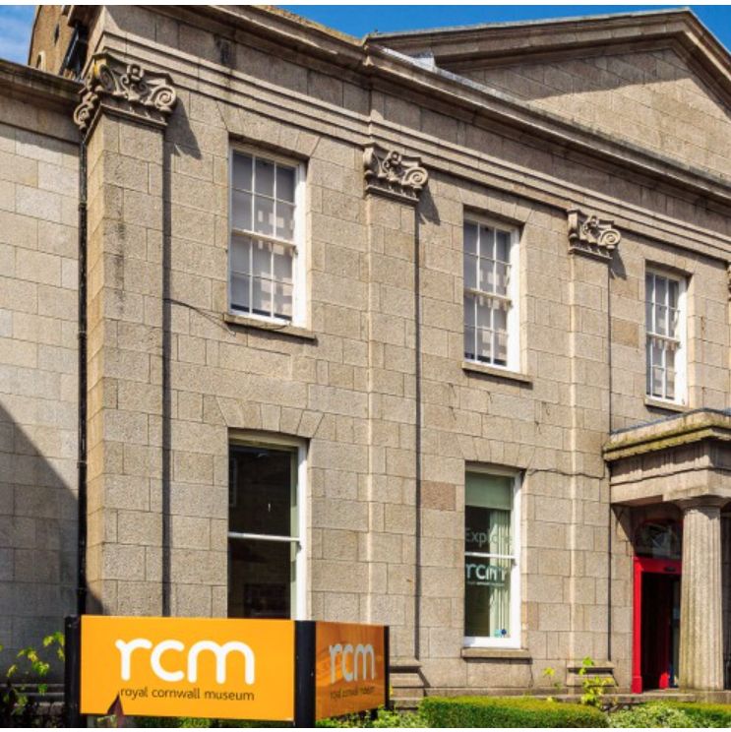
Design and Build Tender
Heart of Cornwall & Nature Gallery - Royal Institution of Cornwall
Volume 2 (Part B) – Applicants Offer
This document must be completed and returned in the published format. Failure to comply with this instruction may result in your Submission being discounted.
October 2024
Closing time/date for return of submission: 12:00 (Noon) 08/03/2024
Name of Applicant:
Please return electronically to: jackie@jackiegeorge.co.uk
Contents

Section 1 – General Notes 3
Section 2 Applicants Response to Tender 4

Section 1 – General Notes
- This document should be read in conjunction with the supporting information contained within Volume 1 “Invitation to Tender - Background Information, Instructions and Conditions of Tender” and associated documents also referenced.
- This document and associated documents will form the basis of the Applicants formal tender response. Care should be taken to ensure that it is completed accurately, and all information required to submit a compliant tender is done ahead of submitting any final response.
- There is a word count for the responses – Please ensure that for each method statement that the response is no more than 750 words on 2 A4 pages at a font no smaller than Aerial 11.
- Appendices are only permitted to illustrate detail as set out in the method statement, not to add in more detail. Where appendices are used to avoid word count or are not succinct then they will not be evaluated.

Section 2 Applicants Response to Tender
- Section 3 to be completed by all Applicants looking to submit a formal response to this Tender.
- Please note, in completion of the bid submission around quality questions, we would be expecting to see the tenderer bring out the detail of the whole core team (irrespective of level of input anticipated and their roles, experiences and capabilities, and what they would bring to support in the delivery of this project – but with a clear focus on the key members of the proposed team that would be engaged.
- The below are pass fail questions, and in the event that you answer “no” to any of the questions then we will not evaluate your tender any further and will not be able to contract with you.
Ref | PASS / FAIL QUESTIONS – Confirmation that Tender is submitted on the following understanding: | Please delete as appropriate
1 | For the design element of the work you will have (and will maintain for the duration of the Contract) suitable trading / accredited body status (or equivalent)  Please state below which apply: | Yes / No
2 | You will be contracting under the stated terms of Contract. | Yes / No
3 | You will act as Principal Designer and Principal Contractor as defined under the Construction Design Management (CDM) Regulations for the duration of the works. | Yes / No

Method Statement Topic Areas - Understanding the brief, including methodology and approach
Requirements for the Applicant’s response to this Method Statement:
The Invitation to Tender documents provides details of the services required. Importantly the context and setting in which those services are to be provided and the support which is required to be provided by the Royal Institution of Cornwall.
As part of the Supplier’s response the Royal Institution of Cornwall would be seeking a submission that outlines the method and approach to be adopted in response to the accompanying brief and how this would contribute to successfully meeting the objective and required outcomes as set out.
Please provide in your response your understanding of the aims of the project set out in the statement of requirements and the role that you would be expected to perform.
We would be looking for you to highlight procedures, major issues, constraints, risks etc., and demonstrate your approach to achieving the objectives and importantly your understanding of the key principles to support a successful outcome.
This should be in the form of a method statement for each phase that includes the approach and methodology to be applied in that phase and including the tools, techniques and processes you intend to follow.
Please include an outline programme plan setting out your indicative support over the various stages.
To meet the agreed timetable of progress reporting and other activity to be confirmed but as a minimum, a monthly written progress report to be provided to the Royal Institution of Cornwall for presentation to the monthly project meetings. In addition, Programme Managers will be expected to provide verbal updates on significant developments or issues.
Please include a succinct methodology and outline plan /programme.
WHAT DOES A STRONG RESPONSE LOOK LIKE?
A strong response would clearly evidence you understand the role and support which the appointed a core team would be expected to undertake, the scope and complexity of the overall scheme, the engagement with other partners as required outcomes.
A strong response would include the submission of a methodology for undertaking the work which should include the following elements;
- How individual consultants will work efficiently together with their team and others, identifying who is the lead consultant managing the day to day work;
- What you see as the main risks to the project success and how you will contribute to mitigate and manage them;
- What are the key objectives and elements of work and expertise you bring to them;
- Clear details on the methods and approach which you would undertake and confidence that the method and approach would be able to deliver quality outcomes to the satisfaction of the Royal Institution of Cornwall within the timeframe required.
- The tools, techniques and processes to be undertaken must be appropriately applied, proportional for the required delivery of the Contract and proven in delivering the outcomes required in this tender.
A strong response would also indicate an understanding of the proportional nature of the support required and how resources would be flexed appropriately to manage periods of more intense support versus other periods during the scheme duration where little or no active resource input would be needed. In short, a strong response would demonstrate you fully understand what is required and know how you would go about your role in this project.
A strong response would clearly indicate an understanding of the requirements as set out within the Brief and what is necessary to deliver high quality outcomes. It will clearly set out how each of the identified themes will be approached and met by the bidder.
A strong response would clearly set out a structured approach to ensure that the Contract is delivered in a timely, orderly and professional manner, with particular emphasis around the design element and the build elements.
It would also clearly outline through the delivery of the contract how the objectives of the Brief would be achieved and provide a high degree of confidence that the core team would be able to perform the Contract in line with the expectations set out by the Royal Institution of Cornwall.
A strong response would clearly indicate an understanding of the requirements as set out and what is necessary at the respective stages of the overall programme. It will clearly set out the approach to be taken in the respective stages including both sign off from the Royal Institution of Cornwall at key stages and wider effective engagement with key stakeholders.
A strong response would include an indicative programme and timeline which is credible in relation to the wider expectations of the different phased of activity from design to the build. In addition, the response would provide clarity on expectations around response and delivery timescales for the services provided, as well as details on how issues would be escalated and resolved. It would set out key milestones with anticipated dates. Any variations with the submitted programme should be explained.
A strong response would include details and examples of how you propose to show you will complete the project to all deadlines as set in the agreed timetable.as well as how you would provide verbal updates on significant developments or issues between formal reports.
A succinct methodology and outline plan / programme would be integral to this response, coupled with concept sketch designs or interpretations on the proposed options which the interior / exhibition design would look to explore further with the client.
PLEASE ADD RESPONSE BELOW:

Method Statement Topic Areas - Quality and Past Experience and how this would be used:
Requirements for the Applicant’s response to this Method Statement:
As noted in the accompanying documents, this tender is seeking a partner to undertake a comprehensive design and build project to overhaul the museum’s Heart of Cornwall and Nature Galleries.
It is important to highlight the Grade 2 Listed Building status of the Royal Cornwall Museum and as part of this response would provide details of your experience in similar settings and how this would be beneficial to the works required in this tender.
To deliver the outcomes of this tender, it will require a range of different, but core experience, skills and capabilities as a core team, to include (but not limited to):
- Interior / exhibition Design within a public setting
- Contract / Project Administration
- Project Management
- Quantity surveyors / cost controller
- Creating improved interpretation including physical and digital interactives
- Responsible removal of unwanted fixtures and furniture, including radiant panels, temporary dividing screens and obsolete interactives
- Digital interpretation and content development
- Exhibition cases and exhibition furniture,
- Decoration and floor treatment
- Exhibition and flexible event lighting
- Acoustic treatment for the main gallery
- Fitting out
- Any related M&E work
The above would also be complimented by excellent communication and stakeholder engagement skills.
By very nature of the work required, it will be assembling a competent, diverse and talented core team and as such that will need to be drawn out in the response. Importantly, the project leans towards tradespersons who truly get the importance of the uniqueness of the building, setting and local heritage.
The Supplier would be able to provide core team who have proven capability in delivery of support and advice on similar projects ideally in similar settings or contexts.
Your response should provide strong evidence that you are able to assemble and bring the key experience, skills and capabilities to deliver the high-end quality outcomes required by the museum.
To support the work, it would be highly desirable for the consultant(s) to have knowledge, experience and skills in respect of working with the public sector, ideally local government, along with a strong understanding of engagement within and across diverse communities.
Please provide details around all key members of your core team, either individuals or companies and the role which they would play in the delivery of the project. Where roles are not yet determined at time of tender then details should be provided around how you would select and appoint, to take into account assurances on high end quality outcomes, detail how you propose to meet that condition e.g. appoint another individual or organisation under your supervision with the specific experience, skill or knowledge required to meet the condition.
Provide the name and contact details of sub-contractors.
To support your response, we would be seeking suitable case studies and references sites which Royal Institution of Cornwall may seek to contact as part of due diligence around evaluation. Your proposals should provide clear reference on how the experience you have would be utilised on this project to deliver meaningful quality outcomes.
WHAT DOES A STRONG RESPONSE LOOK LIKE?
A strong response would show that the Supplier would be able to demonstrate they can provide the necessary core skills across a diverse team.
A strong response would provide clear assurance that the Supplier would be delivering the Contract with resources with relevant core experience, skills and capabilities required to deliver the outcomes set out in the Tender Brief in a manner that provides confidence and assurance around capacity and continuity of the team.
A strong response would have set out the core team and the necessary supporting evidence that the team has all of the required core experience, skills and capabilities to ensure a high-end quality outcome.
A strong response would clearly indicate that the proposed team has the right blend of core experience, skills and capabilities required to work on such a high profile, complex project. The response would clearly indicate the roles which the individual team members would bring to the project and how this project would benefit from their experience, knowledge and expertise.
This experience, knowledge and expertise would also look to demonstrate a clear connection to work on similar projects of similar scale and profile, ideally within a Grade 2 Listed Building settings.
This could also include details on how staff are inducted and how they are trained and supported to be effective within all they do, and the assurance that they have the right and relevant skills and experience to undertake the roles required.
Where roles are not yet determined at time of tender then the response should provide details around how you would select and appoint partner organisations or resources, to take into account assurances on high end quality outcomes.
Where relevant, details of trade bodies, accreditation bodies and / or professional organisations would also be included in the response to this requirement.

PLEASE ADD RESPONSE BELOW:

METHOD STATEMENT - Social Value Considerations
The Applicant shall provide a Method Statement in accordance with the information provided.
For the purposes of the consideration and application of this Tender, Social Value is defined as the additional added value or extra benefits able to be attributed to Social Value outcomes beyond the core requirements related to the spend. More details on the Social Value Act itself can be found here:
https://www.gov.uk/government/publications/social-value-act-information-and-resources/socialvalue-act-information-and-resources
Royal Institute of Cornwall requirements for the Applicant’s response to this Method Statement: is for the Applicant to provide a detailed method statement that focuses on how they would approach supporting Social Value considerations as part of the delivery of the Contract. In relation to this contract the Royal Institute of Cornwall sees the following as being areas where through the delivery of the Services positive outcomes to Social, Economic and / Environmental outcomes could be achieved, in particular:
- Within the workforce this could be supporting apprenticeships, local employment, or contribution to the Local economy as a direct result of this Contract.
- Supporting environmental outcomes (including reduction of use of products / material that are harmful to the environment or working practices that minimise environmental damage), as well as making a positive contribution to the Royal Institute of Cornwall’s pledge around removing use of “single use plastics”. The initiative aims to reduce the use of single use plastics wherever reasonably practicable. Details should be given in the tender response which highlight the measures which the tenderer will be taking to reduce its use of single use plastics wherever possible. More information can be found at: https://www.sas.org.uk/about-the-movement/
Social outcomes may also include details on how the Supplier would look to support community initiatives and / or work to make a positive outcome within the wider community. The above list is not exclusive or exhaustive but an indication on what are deemed to be relevant and proportional areas for Social Value consideration to this contract.
The Royal Institute of Cornwall is looking to work with like-minded organisation – those which share the same values.
WHAT DOES A STRONG RESPONSE LOOK LIKE?
A strong response would outline clearly what would be done to contribute towards added Social Value if awarded the Contract, actually how the Supplier would go about doing this, and what tangible outcomes the Royal Institute of Cornwall could expect as a result. It would detail how your organisation aligns with the values of The Royal Institute of Cornwall.
Linkages to how this would also support the Royal Institute of Cornwall’s wider aspirations would also be made clear.
A strong response would demonstrate commitment to deliver on the stated outcomes not simply be aspirational.
PLEASE ADD RESPONSE HERE:

