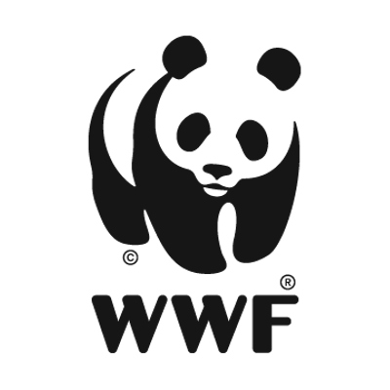

**WWF UK Grant System:**

**Review, Comparison & Recommendations**

**Record of Questions and Answers relating to this contract opportunity.**

WWF-UK is sharing the following list of questions received and the answers provided which may be of interest to parties who are submitting proposals in response to this contract opportunity:

Q: Are you happy to receive appendices beyond the 5 page limit?

A: Yes that’s fine.

Q: Is your stated budget range inclusive or exclusive of VAT?

A: We expect that VAT would be applicable to this contract and therefore it would be beneficial to include pricing showing net of VAT costs and inclusive of VAT costs, or to explicitly state whether the costs exclude or include VAT.

Q: What is the size of the WWF-UK grants programme (e.g. # of grants, size of grants)?

A: Around 100+ grants per annum, currently, with grants varying from £50k to a few million per annum.

Q: Who are the grant partners? How many sit within the WWF Network, and how many are external conservation organisations?

A: Almost all grant partners are WWF partner offices in the Network. The WWF partner office will then have sub-grantees and in Asia alone, there could be 600 sub-grantees (we also provide grants to Africa and Latin America)

Q: What does the WWF-UK grant department look like in terms of size of team and position within the wider WWF organisation?

A: Central position within WWF UK. In the Conservation Programmes team who deal directly with grants, there’s c. 16 people, then additional another 4 grant specialists, then the Design & Impact and the Finance departments are also key to grant management, as well as our Public Sector Partnership team. So in total, up to 30 people.

Q: Are there any other departments within the WWF organisation that make grants? Would this project look to cover these grantmakers?

A: Yes there are other departments that provide grants, but not to the same extent as Conservation Programmes. But this review is dealing with conservation grants, albeit what is proposed by the contractor may impact or be considered by other departments.

Q: How do you envision the role of the business analyst/secondment position during project delivery?

A: Working alongside the contractor, understanding the WWF UK and acting as a liaison for the contractor, as well as providing insight and intel, as to how WWF UK works and the intricacies of the current grant system. As well, managing the contractor as and when delegated by the Director.

Q: Would you be willing to share any anecdotal feedback from users or stakeholders on the effectiveness of the existing user journey / business processes?

A: Anecdotally, the existing processes can be clunky, cumbersome and time consuming.  We have a completely manual system composed of a high number of individual steps in the process, which has organically evolved over time and not user friendly.

Q: What do we know about the organisations we wish to provide referrals to; what requirements are unmet by today’s solution?

A: During the course of the review one of the outputs is to identify what capacity transfer would make sense, from WWF UK to our partner offices. There are various challenges, so it’s about teasing these out and identifying which ones would be best served by capacity transfer and where it makes more sense to maintain capacity in the UK office.

Q: Can you provide us a summary of the tech stack / tools that support the online aspects of the user journey.

A: Our existing online user journey is limited, currently our grants system works through emails between respective parties and online documents being shared.

Q: Are there any architectural principles or blueprints that we can look at, ahead of time? Are these likely to change as a result of the analysis?

A: We do not have architectural principles nor blueprints as we are at the review stage, they could be developed during the review as deemed relevant.

Q: Does WWF currently have one system to administer grants or a combination of different systems and processes developed over time?

A: The system it uses for conservation grants (the focus of this assignment), is a system that has evolved organically over time, based upon multi-party emails and online documents, with a scheme of delegation. The system has been mapped and there are a lot of individual steps, hence the need for a lean process and service design approach, required.

Q: There is an aspiration to distribute £40m through the improved system - how much is currently allocated to grants by WWF?

A: £25 million for the current financial year.

Q: A Business Analyst has been allocated to support the project - how much additional in-house BA and process engineering expertise does WWF have?

A: In relation to the conservation programme grants, there is no other process engineering expertise, hence the need to bring in an external party, to step in to do the review and recommendations.

Q: What pain points in the user journey / business processes have been detected so far

The process has been mapped and it is long, there is a lack of clarity around roles and responsibilities at various points, plus a number of pain points both within and across departments engaged in the grant process.

**Reminder - Submission deadline: Monday 22nd November 2021**

**Commissioned by:**WWF-UK, Living Planet Centre, Brewery Road, Woking, GU21 4LL

**Contact person:** Helen Gibbons, via [Procurement@wwf.org.uk](mailto:Procurement@wwf.org.uk), Director of Conservation, WWF-UK