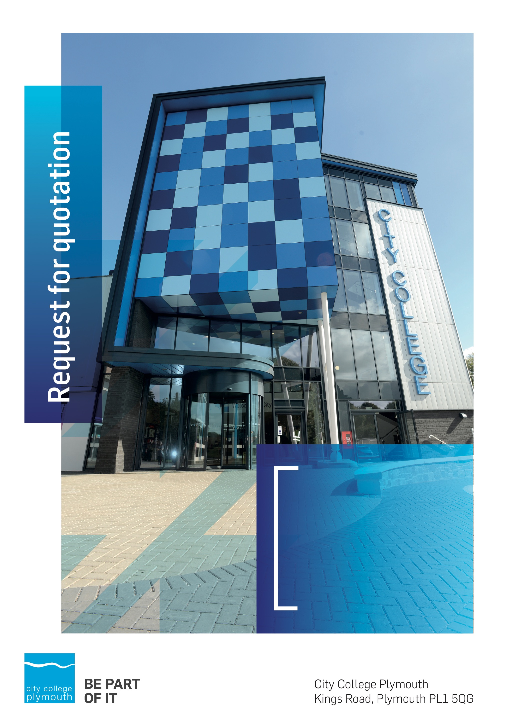

**Request for Quotation**

**RFQ103**

**Outsourcing Firewall Management**

**Issued xxxxxxxxx**

# Table of Contents

Table of Contents……………………………………………………………………………2

Table of Contents 2

Confidentiality Statement 3

Open Procedure 4

Submission Details 4

Submission Deadlines 4

Submission Delivery Address 4

Submission Questions and Clarifications 4

Electronic Submissions 5

Introduction and Executive Summary 5

Business Overview & Background 6

Our Vision … is where our future lies 6

Our Mission … is what we focus on each and every day 6

Background 6

DETAILED Requirement 7

EqUipment 7

Core Service 7

Required Affiliations 9

Timescales 9

Written Submission 10

Pricing 10

Terms and Conditions 10

Validity 10

Selection Criteria 11

Award Price 11

Written submission 11

Assessment of Quotations 12

Freedom of Information Act 2000 12

general data protection Regulation (GDPR) 2018 12

Agreement Conditions Acceptance and Declaration 13

Supporting Documentation 13

# Confidentiality Statement

This document, and any attachments thereto, regardless of form or medium, is intended only for use by the addressee(s) and may contain legally privileged and/or confidential, copyrighted, trademarked, patented or otherwise restricted information viewable by the intended recipient only. If you are not the intended recipient of this document (or the person responsible for delivering this document to the intended recipient), you are hereby notified that any dissemination, distribution, printing or copying of this document, and any attachment thereto, is strictly prohibited and violation of this condition may infringe upon copyright, trademark, patent, or other laws protecting proprietary and, or, intellectual property. In no event shall this document be delivered to anyone other than the intended recipient or original sender and violation may be considered a breach of law fully punishable by various domestic and international courts. If you have received this document in error, please respond to the originator of this message or email him/her at the address below and permanently delete and/or shred the original and any copies and any electronic form this document, and any attachments thereto and do not disseminate further.

Thank you for your consideration, City College Plymouth.

Where no notice is given, all information contained herein is Copyright 2018 City College Plymouth.

# Open Procedure

The College fully adheres to the requirements of the Public Contracts Regulations 2015, including for opportunities which are under threshold amounts.

Any Contractor who directly or indirectly canvasses any Member or Officer of the Institution, or advisor concerning the award of the contract for the provision of the services, or who directly or indirectly obtains or attempts to obtain information from any such member or Officer concerning any Tender or proposed Tender for the service will be disqualified from having his/her Tender considered.

# Submission Details

## Submission Deadlines

All submissions for responding to this Request for Quote must be submitted via email as stated below, no later than:

**Friday 9th November 2018**

**12:00 Noon**

Any submissions received after this date will not be considered.

## Submission Delivery Address

All submissions should be submitted electronically as below

## Submission Questions and Clarifications

You may contact the following person if you have any questions or require clarification on any topics covered in this Request for Quotation: Friday 2nd November 2018

**Carol Williams**

Procurement Officer

Phone: 01752 856 809

Email: tenders@cityplym.ac.uk

All correspondence during the Tender should be channeled via the Procurement Officer using the above details only. Bidders found to have gained an unfair advantage shall be disqualified from the current opportunity and future opportunities with the College for a minimum of four (4) years.

## Electronic Submissions

Electronic submissions in response to this Request for Quotation are required as follows:

Sent via email to: [tenders@cityplym.ac.uk](mailto:tenders@cityplym.ac.uk)

Document standards:

* Text must be in Microsoft Word format;
* Price tables must be in Microsoft Excel format (using pricing schedule in Appendix A);
* Supportive evidence may additionally be submitted in PDF format;
* Images, Designs, and other supporting evidence may be in either JPEG or PDF format
* Completed Appendix C Suitability Assessment & Selection Questionnaire (Including Mandatory & Discretionary Exclusions) Parts 1, 2 and 3. - *Please note this suitability assessment will not be viewed unless you are the winning tenderer. Failure at this stage may prevent the contract from being awarded.*
* Signed Agreement Acceptance and Declaration.

*Please note that the College is able to accept submissions sent in a compressed or “.zip” file format, so long as the files contained meet the standards described above.*

**WARRANTY**:

By submitting your tender bid, you are warrantying to the College that you have not breached our canvassing or soliciting clause.

If any successful tenderer awarded a contract is found to have provided an inaccurate warranty, then the College reserves the right to terminate the awarded contract with immediate effect and re-tender the contract from which the successful tenderer will be excluded from re-bidding and shall be disqualified from any future opportunities for a period of four years.

# Introduction and Executive Summary

The College is looking to outsource its Firewall Management. The College is looking at a one or three year contract.

As the total value of the contract over the three years is likely to exceed £25,000, the opportunity will be advertised on the government portal ‘Contracts Finder’.

# Business Overview & Background

The College operates on two sites within the city, serving 12,897 students and employing 622 staff. The College operates year round, with opening times from 0800-2100 on some days.

## Our Vision … is where our future lies

We are a College with a national reputation for promoting enterprise, employability and science, technology, engineering and mathematics (STEM).

## Our Mission … is what we focus on each and every day

To be the South West’s leading provider of innovative, technical, professional education and training by supporting partnerships for growth, raising aspirations and fostering wealth creation

## Background

City College Plymouth is one of the largest providers of innovative, technical and professional, education in the South West with a national reputation for promoting enterprise, employability and science, technology, engineering and mathematics (STEM). The College plays a central role in the educational, cultural and economic life of the region and works with strategic partners to facilitate growth, raise aspirations and foster wealth creation.

The College was awarded the Teaching Excellence Framework Gold award for its university-level provision and its most recent Ofsted inspection confirmed that the College continues to be ‘Good’ with outstanding features. The College was rated first in the South West and second nationally for student satisfaction in the latest FE Choices student satisfaction survey.

City College supports the region’s employers with their award-winning Apprenticeship provision, as well as providing a range of courses and bespoke training programmes which enable employees to upskill or retrain to better support their business’ requirements. Their successful partnership working with the local business community resulted in a 99.5% satisfaction rate in the Government’s national ‘FE Choices employer satisfaction survey 2016 to 2017’ - placing them first in the country for general further education Colleges.

City College Plymouth offers a wide range of academic and vocational courses in a variety of subjects. The total number of students supported by the College in 2016/17 was 12,533 - which comprised: 3,569 full-time students, including 765 higher education students and 179 non EU students; 8,964 part-time students; and 1,599 apprentices. The College also employs over 500 staff.

# DETAILED Requirement

The College has recently replaced its firewalls with two new Fortinet 500E devices along with the Fortinet Log Analyser. The firewalls are obviously key to the safe running of the College and provides connectivity onto the Ja.net network, currently through a POP located at the College. (Note: this is subject to review by JISC). The College phone system is provided by SIP across this link.

The College is looking at ways to reduce the workload for the onsite team. Due to recent staff changes, there is only one Senior Network Manager capable of supporting the system. The College is therefore looking to outsource the day to day activities of looking after the firewall such that the firmware is kept up to date, the logs are monitored and firewall rules modified where appropriate, and that standard changes are undertaken as requested by the College.

It is expected that the successful company will drive forward managed change by continuous improvement covering but not limited to security gap analysis, system performance, overlapping rules and current best practice.

Remote access to the firewalls and analyser will be enabled to the successful company.

The approximate spend will be £10k-£12k per annum for a three year period.

It is expected that the contract would commence on 2 January 2019.

This will be a two stage process. Stage one will be the initial analysis and scoring of responses. Up to three companies will then be invited to present their solution to a panel made up of senior staff and IT Professionals.

## EqUipment

**Equipment Definition:**

2 x Fortinet 500E in High Availability set-up is Active-Passive

1 x Log Analyser FAZVM64 6Gb/Day license

The FortiGate is licensed for IPS, Antivirus and WebFiltering

## Core Service

**Monitoring:**

* + 24 x 7 x 365 monitoring of the firewall
  + Healthcheck - threshold for excessive CPU and memory usage
  + Arrange swap-out of hardware should one device fail and reconfiguration after replacement (Note: Actual hardware swap-out will be undertaken by CCP staff)
  + Device backup
  + Alert College via phone/mobile phone of issues (eg DDoS) and outages within SLA hours
  + Proactive Log review to detect attacks, DDoS etc and take appropriate action such as add preventative rules

**Reporting:**

* + Monthly exception-based reporting, derived from the analyser eg:
  + Bandwidth usage, inc maximum average usage, peak single usage etc
  + popular web destinations
  + traffic type
  + Outages
  + Serious attacks

This list is not exhaustive and to be agreed in advance of contract.

The purpose of the reporting is to present a high level management overview but the expectation is that the company will address any issues presenting a significant threat. “Significant” needs to be defined within the contract.

**Change Control**

* + Website rating changes to be submitted via ticket from ITS service desk with 24 hrs turnaround. In some circumstances, Head of IT or the Senior Network engineer will request an immediate change to block sites. These are likely to be when student safety is deemed compromised eg. terrorism etc.
  + Firewall configuration change eg. ports opening/closing, new services etc. to be submitted via ticket followed by a formal change board. Timescale normally 10 working days to complete after approval
  + Firmware updates - out of hours except in discussion with the College; service affecting changes must be agreed via change control. Note - the College does not wish to implement the latest changes immediately. A point release will be typically installed 2 weeks after issue, and a major release will be installed a minimum of 3 months after issue.
  + The College needs to allow external companies to have remote access on demand. This should be classed as a Standard Change. This will usually involve enabling/disabling a rule but sometimes this will involve creating a rule.
  + In exceptional circumstances, the College will retain the ability to make limited changes and to upload the changes to the company

**SLA:**

* + College can be contacted Mon - Fri, 0800 to 1700hrs, business days via the IT Service Desk ([ITServices@cityplym.ac.uk](mailto:ITServices@cityplym.ac.uk)) or 01752-305355 or via mobile.
  + Outages to be reported within 5 minutes to the service desk via mobile (as the VOIP service is likely to be down)
  + Resolution target:
    - Service failure - whole site affected - 1 hour
    - Major problems - up to 100 affected - 4 hours
    - Other - 8 hours
  + Firewall Rule review - with Senior Network Engineer - once every 6 month
  + Service Review - quarterly with a summary report provided by the company. This should be face-to-face at least once during a 12 month period

Direct mobile contact will be provided on contract acceptance.

## Required Affiliations

The successful company must be a Fortinet Silver partner as a minimum. Companies who do not meet this requirement will not be assessed.

# Timescales

|  |  |
| --- | --- |
| Evaluation of responses | 30th November 2018 |
| Shortlisted companies invited to present solutions | 4th or 6th December 2018 |

# Written Submission

You are required to submit a written document which details your company offer outlining how you will meet our requirements outlined above, with particular interest to the following:

* Your service offering,
* Innovative suggestions with regard a mutually beneficial arrangement following the initial period,
* Your contribution to Sustainability, the Environment and Corporate Social Responsibility including Modern Slavery

The submitted document will be scored as per the table on page 11.

# Pricing

Pricing should be specified using Appendix A.

The College is looking for prices for a one year or a three year period, with preference for an annual invoice payable in monthly instalments. Payment by standing order can be discussed.

Prices should be firm and valid for the contract period (36 months) and not subject to increase or escalation of any kind throughout the contract.

The data provided in Appendix A **should not** be considered a commitment to purchase, services will only be ordered on award of contract.

# Terms and Conditions

This Request for Quotation and any resulting purchase order will be subject to the College’s General Terms and Conditions of Purchase of Goods/Services – see Appendix B. The College reserves the right to request a formal contract for all contracts over 1 year duration in supplement to the terms and conditions and contract acceptance documents.

The College’s normal business terms are 1-2 months from the date of invoice. For larger invoices, the College would prefer monthly payments where possible. Payment will become due subject to the above upon the College’s full acceptance of the goods/services.

# Validity

Bidder’s offers should be open and valid for acceptance for a period of no less than ninety [90] days from the date of submission.

# Selection Criteria

The successful supplier will have provided the Most Economically Advantageous Tender (MEAT) to the College. It should be noted that the bidder with the lowest submitted prices will not necessarily be down-selected. All bidders will be notified via email of the results of the outcome no later than 90 days from the date of submission. The date of contract award will be provided within that email.

The marking criteria follows:

|  |  |
| --- | --- |
| Category | Weight |
| Price | 60% |
| Service offering | 35% |
| Contribution to Sustainability, the Environment and Social Responsibility | 5% |
| Pass / Fail Criteria |  |
| Fortinet Silver partner | Pass/ Fail |

Please see table below for more details on the scoring method.

## Award Price

Lowest quote price divided by quote price multiplied by 100

## Written submission

|  |  |  |
| --- | --- | --- |
| **Assessment** | **Score** | **Interpretation** |
| **Excellent** | 4 | *Comprehensive response supported by examples*  *Description fully supported by details that demonstrate the applicant’s ability to provide the required services.* |
| **Good** | 3 | *Broad response supported by relevant examples.*  *Description well supported by details that demonstrate the applicant’s ability to provide the required services.* |
| **Satisfactory** | 2 | *Reasonable response supported by some evidence.*  *Description adequately supported by details that demonstrate the applicant’s ability to provide the required services.* |
| **Poor** | 1 | *Limited response not well supported by evidence.*  *Description inadequately supported by details that demonstrate the applicant’s ability to provide the required services.* |
| **Unacceptable** | 0 | *No response or insufficient information provided.* |

# Assessment of Quotations

Bidders must ensure that their quotation fully addresses all information requested within this RFQ document. Bidders must ensure that any quotation fully meets the specification required. The College reserves the right to discount any quotation which does not fully meet the specification.

The College reserves the right to seek clarification with bidders upon receipt of quotations.

# Freedom of Information Act 2000

Under the Freedom of Information Act 2000 the College cannot guarantee that information provided by bidders during the course of this RFQ procedure or any resulting contract will be held a confidential. The College will not routinely release information to interested parties unless required to do so in order to meet our statutory obligations.

# general data protection Regulation (GDPR) 2018

All bidders must comply with the General Data Protection Regulation (GDPR) 2018 in respect of using and processing personal information. Bidders must have in place technical and organisational safeguards to protect personal data from unauthorised use, disclosure or loss.

The College reserves the right to request a copy of your privacy statement if you are the successful bidder.

# Agreement Conditions Acceptance and Declaration

Bidders are required to sign and return the attached Agreement Conditions Acceptance and Declaration. Appendix D

# Supporting Documentation

Appendix A: Pricing Schedule

Appendix B: City College Plymouth Standard Terms & Conditions

Appendix C: Suitability Assessment & Selection Questionnaire

Appendix D: Agreement Conditions Acceptance and Declaration