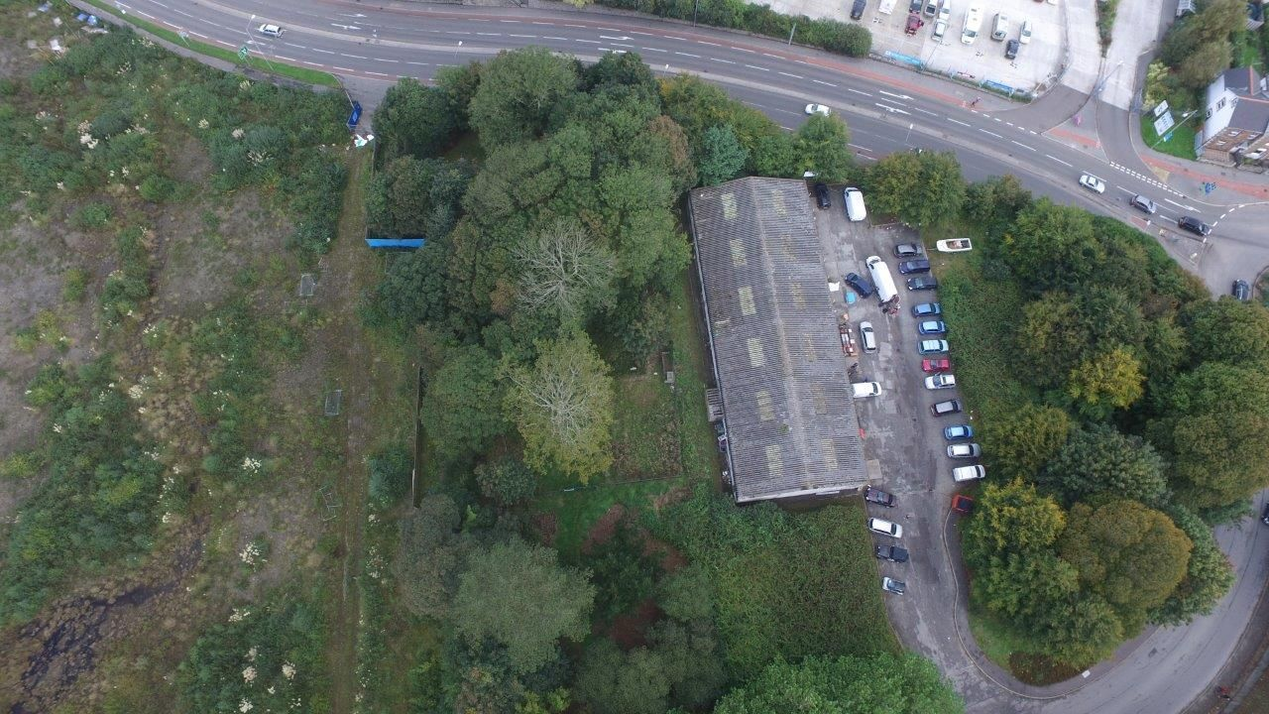
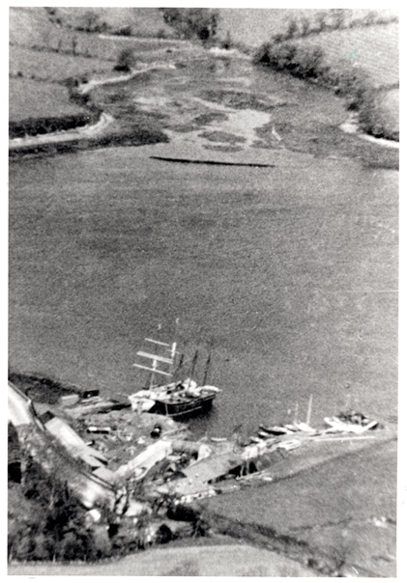
Drone image of The Ponsharden Cemeteries (centre) sitting south of Falmouth Road between a vacant site to the left and an industrial estate to the right both proposed for development
Above rare aerial photo c1930s ?. The cemeteries are just showing in the bottom left. A white tented structure appears in the location of The Ohel at the entrance to the Jewish cemetery
The Congregationalist Cemetery before and after initial clearance by Tom Weller and Rob Nunn in 2014

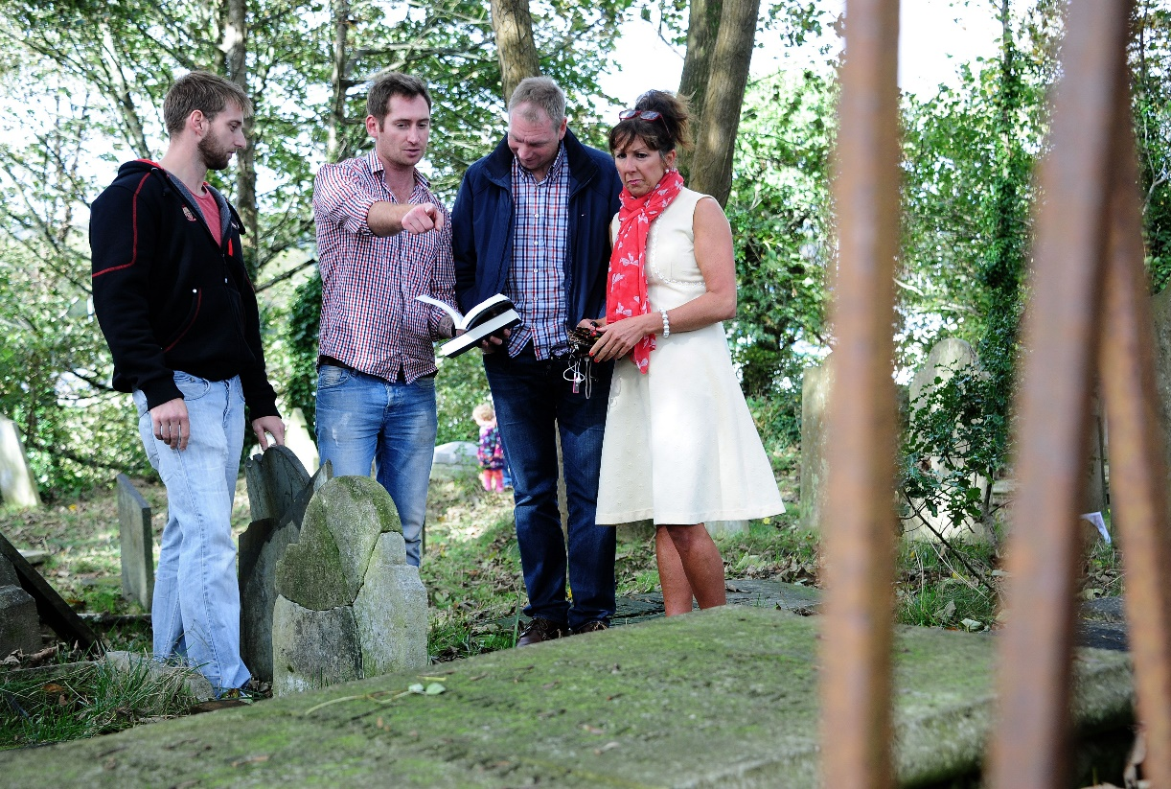
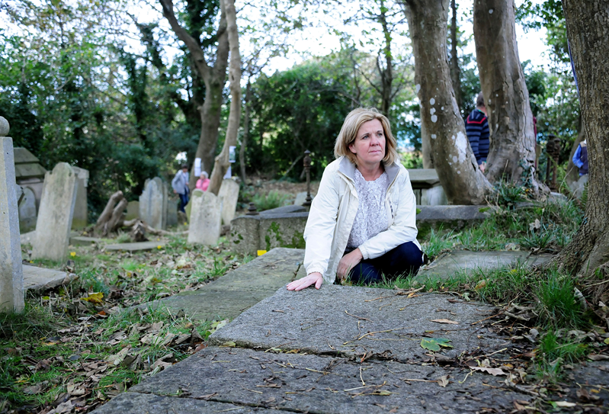
A visitor at the open day in the Congregationalist cemetery
Key volunteers, Tom Weller and Rob Nunn (left) show their published research to visitors at an open day

