Contents
Glossary of terms 1
Request for Information – timeline and process 2
Context 3
Questions 9

Vacant & Derelict Land – Delivery Partner

Glossary of terms
Consortia/ consortium | An association, usually made up of a group of organisations.
BCR | Benefit Cost Ratio
Bravo | The e-procurement portal used by Defra
GIS | Geographic Information System mapping
NCF | Defra’s Nature for Climate Fund
ROI | Return on Investment
Turnkey solution | A pre designed solution that can easily be implemented based on the resources already at the disposal of a company or individual. It is often an end-to-end solution resulting in minimal input from the customer
VDL | Vacant and Derelict Land

Request for Information – timeline and process

- Defra is developing plans for a Vacant and Derelict Land contract by initiating a Request for Information (RFI) on 25 November 2021. Dependent on feedback to the Request for Information, Defra may then issue an Invitation to Tender.

- Interested parties are encouraged to submit structured word-limited written submissions to this RFI via Bravo. Interested parties should clarify where information is commercially sensitive. Written submissions should be provided by no later than midday (12:00) 14 December 2021. Parties should not expect individual responses to written submissions.

- This is an urgent call for information, with a short timeframe.

- In combination with this RFI, Defra are also inviting interested parties to have individual meetings with the Defra VDL team to talk through the proposal. Interested parties can book a meeting in addition to submitting a written response to the RFI, or the meeting can be taken up as a separate offer of market engagement on this proposal. 1 hour appointments are available on the 14th December. Please use Bravo to message the team to arrange a mutually convenient time. Questions asked of Defra, and their responses, will be shared publicly as part of this market engagement (excluding any information deemed commercially confident) during 20-24 December.

- Clarifications from the RFI will also be publicly broadcast unless interested parties can provide a commercial in confidence qualification (these submissions will be evaluated on a case-by-case basis with Defra’s decision on what constitutes ‘commercially sensitive’ as final). Defra cannot commit to answering all questions but will use best endeavours.

- Information gathered through written submissions will be reviewed by the project team, who will use this to inform an Outline Business Case, and to shape the commercial approach to developing the contract.

- Thank you in anticipation of your engagement.

Context

What is the Nature for Climate Fund (NCF) Vacant & Derelict Land project?

- Defra is proposing to develop a tree planting on Vacant and Derelict Land offer through the appointment of a Delivery Partner, which will be charged with the responsibility of creating a minimum of 6,000 hectares of woodland on Vacant & Derelict Land. Defra will invest capital funds into a ‘turnkey solution’ (the offer) made to landowners by the Delivery Partner. Through this proposed contract, the Delivery Partner will be tasked with expanding an existing pipeline of VDL sites with new potential sites; sifting sites for suitability; liaising with landowners to accept the offer; leveraging contribution and/or external private finance; supplying the services and support to remediate land; and ultimately planting trees. There will also be a focus on supporting landowners through the relevant regulatory landscapes to enable woodland to be well designed and subsequently created.

- Developing a consensus in favour of tree planting at scale is challenging, even in those places where the opportunity appears greatest. The VDL project seeks to target damaged land that is not suitable for any kind of development and has no other environmental value. In this way, tree planting on VDL offers an opportunity to bring otherwise unusable land into productive and beneficial use, creating social, environmental and economic value. The project will seek to combine the “pull” of existing regulatory and economic incentives with the “push” of targeted public funding in order to “tip the balance” in VDL landowners’ decision-making away from lowest-cost options towards woodland creation.

Why is government taking this approach?

- The Nature for Climate Fund (NCF) is worth more than £750m and was set up to support increased tree planting and peat restoration in England over this parliament.

- Achieving the required level of woodland creation in England as outlined in the government’s election manifesto represents at least a fivefold increase in just over four years on hectarage planted in 2019. This will exceed the highest annual planting rates ever known to have been achieved in England, of 6,800ha in 1971. In addition, most planting schemes have a two-year lead-in time.

- Achieving this level of planting will require unlocking land for woodland creation both within the timeframe of the NCF and thereafter, through novel, innovative methods. Central to this VDL project is the concept of ‘enabling land’: transforming damaged, unproductive land into productive, beneficial spaces for communities. The project aims to achieve this by using targeted public funding to ‘tip the balance’ in landowners’ decision making towards woodland creation, while also leveraging private finance wherever possible.

What are the requirements of the Contract with the Delivery Partner?
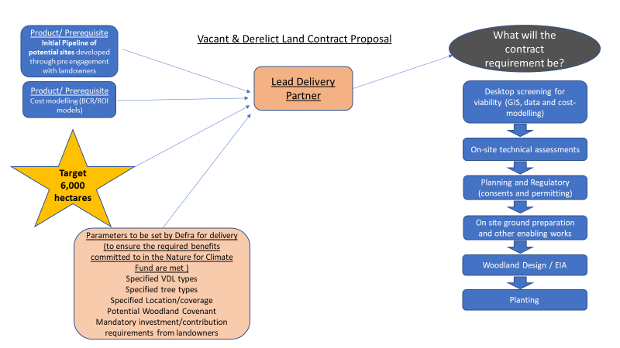

What is the proposed delivery model?

Defra are very keen to understand how the Lead Delivery Partner could deliver the contract. A potential delivery model is below, however, discussions regarding this would be welcome. We also welcome suggestions of consortia models to achieve the contract requirement.
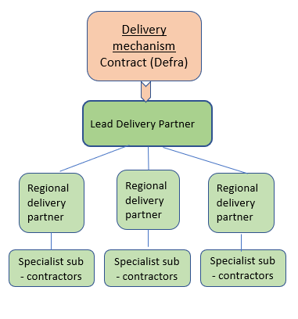

What types of land will be considered for scope of the VDL project?

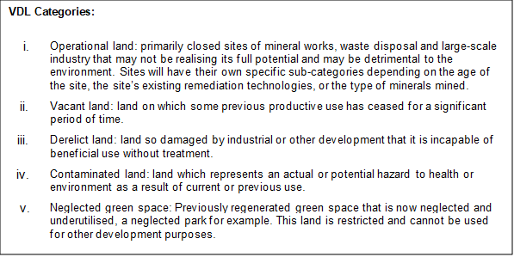

- Initial estimates of total VDL in the UK suggest that there around 280,000 hectares of landfill, mineral and mining sites that fall within our scope. This figure does not include land held by infrastructure companies, local authorities, and private landowners. The table below sets this out in more detail. These estimates suggest that identifying a minimum 6,000 hectares of VDL via this contract for planting is achievable by 2025.

Table 1: Initial estimates of VDL land
 | Landfill industry |  |  | Mineral working companies and Coal Mining Organisations
TOTAL | Operational land (permitted) | Vacant land (Closed Permitted) | Derelict land (Closed non-permitted) | Operational land | Vacant land | Derelict land | Contaminated land
280,886 | 10,640 | 18,499 | 46,496 | 1595 | 36,266 + 167390 = 203,656

- The potential vacant and derelict land sites will be owned by a wide range of landowners. We would anticipate that the delivery partner would need to engage with the following type of landowners and stakeholders in order to create a sufficient pipeline of sites to deliver the required planting:
  - Private landowners
  - Local authorities
  - Infrastructure operators – e.g. transport, energy
  - Landfill operators
  - Developers
  - Investors

- We propose that the pipeline should initially be prioritised, in partnership with Defra, by affordable sites in England with the greatest potential to achieve the highest environmental and social benefits, which will focus the pipeline towards the more challenging VDL that aren't eligible for other tree planting funding initiatives. We expect that this will be achieved by cross-referencing sites against Forestry Commission’s Priority places dataset, as well as other datasets which will be specified by Defra. Projects that are more suitable for other grant schemes (such as England Woodland Creation Offer) should be signposted towards these. all projects funded through this scheme would need to meet UK Forestry Standards.

What is the expected funding mechanism and payment schedule?

- It is expected that the Lead Delivery Partner will use the capital funds from Defra to ‘pitch’ an offer to landowners for a ‘turnkey solution’ to transform VDL sites into woodland. Defra funds will not represent 100% of the funds required for an end–to-end land-change solution, therefore, the Delivery Partner will be required to negotiate and secure the additional contribution from landowners, or others willing to co-finance. This could either be in the form of a direct contribution from the landowners towards the offer, or the landowners themselves, or the Lead Delivery Partner securing private investment from another source to supply the additional capital.

- Defra is anticipating in the region of £120,000,000 capital funding which we estimate will deliver at least 6,000 hectares. Defra is proposes to invest these funds into the turnkey solution delivered through this contract value (e.g. to contribute towards the activities required to prepare the land and plant trees). This funding will be available over a 3-year period according to the pipeline.

- The variation of land types and sites will create different costs depending on the activities needed to prepare the land for planting. As part of the desktop screening, the Lead Delivery Partner will work with Defra to assess the appropriate level of public funding per site which can be included as part of the turnkey solution on offer. It is at this point that the ‘shortfall’ for each site will be identified, and the contribution required from the landowner, or through private investment, will be agreed. Initial thinking regarding the cost of transforming VDL into woodland suggests that the contribution required from landowners or other investors will need to be at least 30%.

- The ‘service charge’ for this contract (services delivered to Defra rather than directly to the landowner), is an area that Defra is keen to discuss with the market. This ‘service charge’ would represent the following activities (list not exhaustive)
  - development and analysis of the pipeline,
  - liaising/selling the offer to landowners,
  - Agreeing the contribution rates with landowners,
  - Facilitating and supporting landowners to secure private investment.
  - being the single point of accountability and support for the landowners
  - administration
  - performance reporting

What are the intended outcomes and benefits of the Project?

- Minimum 6,000 hectares of new woodland.

- The demonstration of the viability of land change use from VDL to woodland, creating a legacy of confidence for this to be delivered without government funding in the future.

- The sequestration of carbon dioxide from the atmosphere to support our Net Zero target by 2050.

- The project will position the UK as a global leader on Nature Based Solutions to climate change, maximizing ecosystem services from trees. It will also improve the future financial sustainability of VDL tree planting by supporting the development of green finance and markets to increase private investment.

- The project will deliver a variety of other benefits in support of the 25 Year Plan objectives (e.g. flood alleviation, improvements to water quality, improvements to air quality).

- Where planting is near urban areas, additional benefits may include the provision of new opportunities for community access to nature, with the economic, social and health benefits that come with it.

What is the Project scope of outputs?

- A pipeline of potential sites (limited to England only) that meet Defra’s required benefits, are affordable, and well exceeds the 6,000 hectares (to represent contingency planning)

- Agreements made with landowners to initiate the turnkey solution, to meet the 6,000 hectare target.

- To encourage further private investment in ecosystem services markets.

- To generate shareable intellectual property (IP) and know-how so that ‘blueprints’ demonstrating the efficacy of VDL land change models that can be shared publicly, to aid development of a thriving pipeline of nature-based projects.

When will the Contract be published? And how long is the term?

- We intend to publish the Invitation to Tender in Spring 2022, with a contract start date in Autumn 2022, for a minimum of three years.

HOW TO RESPOND:
- You are not required to answer every question – any information will be gratefully received.
- Responses to each question (1-7) must be a maximum of the stated word limit of A4, font Arial, size 12
- Clarification period will be 12:00 (noon) 25 November 2021 – 12:00 (noon) 13 December 2021
- Clarification questions must be submitted via Bravo
- Clarification questions will not be accepted after the clarification period
- The authority will endeavour to respond to all clarifications raised through the RFI & individual meetings.
- Lobbying of Defra officials may lead to exclusion from any future competition
THE OPPORTUNITY TO SUBMIT WRITTEN RESPONSES TO THE RFI WILL CLOSE AT 12:00 (NOON) 14 DECEMBER 2021
INDIVIDUAL MEETINGS ARE AVAILBLE ON 14 DECEMBER 2021 AS AN ADDITIONAL OPPORTUNITY FOR MARKET ENGAGEMENT.

Questions

Delivery
Question 1
Delivery Model - Based on your knowledge of the VDL landscape in England, can you indicate:
- The most appropriate delivery model to achieve at least 6,000 hectares of planting for (i.e. to be able to offer a turnkey solution to landowners)? A suggested model of regional partners and sub-contractors has been considered, and therefore, thoughts on the viability of this, alongside other delivery models (such as consortia approach) would be welcome?

- The mechanism/approach required to secure commitment from landowners to create woodland (utilising a turnkey solution)?

- For the planting stage and/or the maintenance thereafter, what are your thoughts about ensuring woodland is long lasting and looked after?

Your response should be a maximum three (3) sides of A4, font Arial, size 12

Contract expectations

Question 2

Contract Expectations – To ensure Defra design a contract offer which will attract a high-quality Delivery Partner, what are your thoughts on the following:
- What is a reasonable ‘service charge’ for the contract (activities delivered for Defra rather than services included in the turnkey solution)? Alternatively, what are your ideas around an attractive payment model for this contract? Examples include flat fee, fee per hectare, incentive based etc.?
- Do you believe the scope described can achieve its aims? Are there any issues we should be aware of when setting the scope, which could dramatically affect the projects capacity to achieve commercial and policy outcomes?

- Is it possible to offer a turnkey solution INCLUDING support for landowners to secure private investment via one Lead Delivery Partner? Please indicate how or discuss why this is not possible.

Your response should be a maximum Three (3) sides of A4, font Arial, size 12

Question 3

Timing – The timescales for delivery of the Vacant & Derelict Land project within the Nature for Climate Fund are ambitious as they relate to government manifesto commitments. Please share your observations on the following sub- questions. How long (in months and years) do you believe it would take a Delivery Partner to:
- Create a pipeline of suitable sites;
- Garner commitment from landowners;
- Prepare land for planting.
- Support sites through regulation challenges;
- Plant saplings
- Create viable woodland habitats

It would be helpful to understand how different types of VDL will vary in timescales to get to the planting stage.

Your response should be a maximum Two (2) sides of A4, font Arial, size 12

The market landscape

Question 4
Landowner Appetite - Based on your experience, what are your observations on the following:
- Do you think this could be an attractive proposition for landowners? How could the offer be adapted to maximise the attractiveness to landowners?

- How much private investment do you think could be raised by the landowners? How could landowners seek and secure private investment?

Your response should be a maximum Two (2) sides of A4, font Arial, size 12

General Questions

Question 5
Do you have any further comments/suggestions/concerns about the proposed scheme?

Your response should be a maximum Two (2) sides of A4, font Arial, size 12

Question 6
Would your organisation consider competing for the role of Delivery Partner?
Please specify if your organisation would consider competing as part of a consortium.

