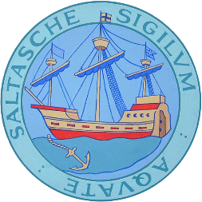 **

**Delivery of Professional Youth Work in Saltash**

Applications are invited to tender for the Delivery of Youth Work in

Saltash 2021/2022

Tender specification available from:

<https://www.saltash.gov.uk/tenders.php>

OR

Saltash Town Council

The Guildhall

12 Lower Fore Street

Saltash

PL12 6JX

Tel: 01752 844846

Email: [tenders@saltash.gov.uk](mailto:enquiries@saltash.gov.uk)

**Closing date: Monday 16th August at 5pm**

Please refer to Saltash Town Council’s privacy notice regarding how the Council retains your information <http://www.saltash.gov.uk/edit/stuploads/3760.pdf>