WWF-UK
Phase 2: Mid Term Evaluation of
HSBC funded Climate Solutions Partnership:
ASIA Energy Transition pillar
Nature Based Solutions Pillar
Global Knowledge Partnership Pillar

Jan 2020 – December 2024
TERMS OF REFERENCE
24/10/2022

Program Name | Climate Solutions Partnership
Pillar Name(s) | Energy Pillar  Nature Based Solutions Pillar  Global Knowledge Partnership Pillar
Programme Location(s) | Energy - China, Indonesia, Vietnam, India  NbS pillar – multiple countries inc Mexico, India, France, USA, Australia, UK  Global Knowledge Partnership - Global
Names of Programme Executants | Commissioned by WWF-UK as office with main accountability to the donor for M&E  Lesley King (Design & Impact Advisor); Sonia Sezille (Climate Solutions Partnership Programme Manager)
Period to Be Evaluated | Jan 2020-now
Potential Sites to Visit | TBC
Programme Budget Sources and Amounts (for period to be evaluated) | $26,165,098 USD over 4.5 years  ASIA Energy Transition: $4,278,898 USD  Nature-based Solutions: $4,250,000 USD  Global Knowledge Partnership: $4,300,000 USD  ASIA Palm Oil: $10,000,000 USD  Business Innovation: $2,496,200 USD
Names of Implementing Partners | WWF UK subcontracting  - WWF Singapore (not part of this review)  - WWF Malaysia (not part of this review)  - WWF Australia (not part of this review)  - WWF China  - WWF Indonesia  - WWF Vietnam  - WWF India  - WWF Hong Kong

Programme Overview: Climate Solutions Partnership
The Climate Solutions Partnership is a pairing of HSBC, WWF and World Resources Institute (WRI). This 5 year philanthropic relationship is intended to help climate solutions become a commercial reality and have real-world impact.
This MTR is only for the WWF delivered work under the Climate Solutions Partnership.
The Climate Solutions Partnership is powered by USD100 million of philanthropic funding from HSBC and, with a network of local partners, aims to scale up climate innovation ventures, nature-based solutions and help to transition the energy sector towards renewables in Asia, by combining our resources, knowledge and insight.
The Climate Solutions Partnership seeks to influence governments, business, and finance sectors to set natural capital at the heart of decision making and to contribute to bending the curve on biodiversity loss and reducing the impacts of climate change on the world, by encouraging these sectors to align to a 1.5˚ future in their decision making.
Outcome statement: The partnership aims to demonstrate scale in climate innovation, renewables, and Nature Based Solutions by unblocking barriers to accessing commercial financing. These solutions will help mitigate climate change, while also delivering gains for people and nature.

The Climate Solutions Partnership will work to remove barriers and create incentives in four Pillars:
- Energy transition: The partnership includes renewables and/or energy efficiency programs in China, India, Indonesia, and Vietnam – who combined account for more than 35% of the world’s power consumption. These aim to support Asia’s energy sector to shift towards renewables, and scale efficiency initiatives in key sectors - such as healthcare, textiles, and apparel.
- Nature-based solutions and NbS Accelerator: Supporting more than 25 projects globally to protect and revitalise wetlands, mangroves, and forests, and to promote sustainable agriculture. Working with a network of local partners, these projects will contribute to net zero goals by better enabling natural CO2 capture, while increasing social and environmental resilience in markets most at risk from climate change. The NBS Accelerator is a joint initiative by HSBC, WRI and WWF that provides technical and financial expertise to a global network of organisations to help scale nature-based solutions.
- Business Innovation: Start-up firms and next-generation technologies offer the potential to develop new approaches to cutting carbon emissions, but often face challenges to access the finance and business mentoring needed to scale. Utilising WWF’s Impactio collaboration platform, the partnership will help support business innovations to scale, in collaboration with leading universities, research institutes, incubators and accelerators. The first pilot challenge, involving 18 start-ups from 5 markets, was completed in 2021, and the first live challenge commenced in 2021 and is expected to complete in May 2022. This pillar is due to close in Spring 2023 and will not be part of this MTR.
- Sustainable palm oil: The goal of the Asia Sustainable Palm Oil Programme (ASPOP) is by 2030 to halt deforestation from oil palm supply chains to protect and restore forest landscapes in Asia, benefiting people and nature. By 2025, we aim to realise three transformational outcomes: 1) sustainable production of palm oil achieved in six living landscapes covering 12m hectares through integration of protection of forests and wildlife, production of RSPO CSPO and restoration of habitats; 2) palm oil from traders representing > 75% of global trade is responsibly sourced and sold, and 100% of RSPO CSPO from the living landscapes is traded as RSPO CSPO; and 3) market uptake of RSPO CSPO volume increases by 50% year-on-year in India and China. ASPOL was designed and agreed before the Climate Solutions Partnership and has subsequently been brought under the umbrella of the partnership. As such, the Program objectives do not fully align with the ASPOL objectives - there is a gap in terms of climate mitigation and shifting sources of finance for this type of work from philanthropic and donors to private investment. The MTR for ASPOL is already underway and will not form part of this contract.
- Global Knowledge Partnership: The Global Knowledge Partnership is the 5th element of the partnership. It will play a leading and critical role in ensuring the Climate Solutions Partnership delivers on its ambition, is driven by the latest insights and science and has real world impact, driving change in financial institutions and businesses. This is where the efforts of the individual pillars can be amplified using the partners combined platform.
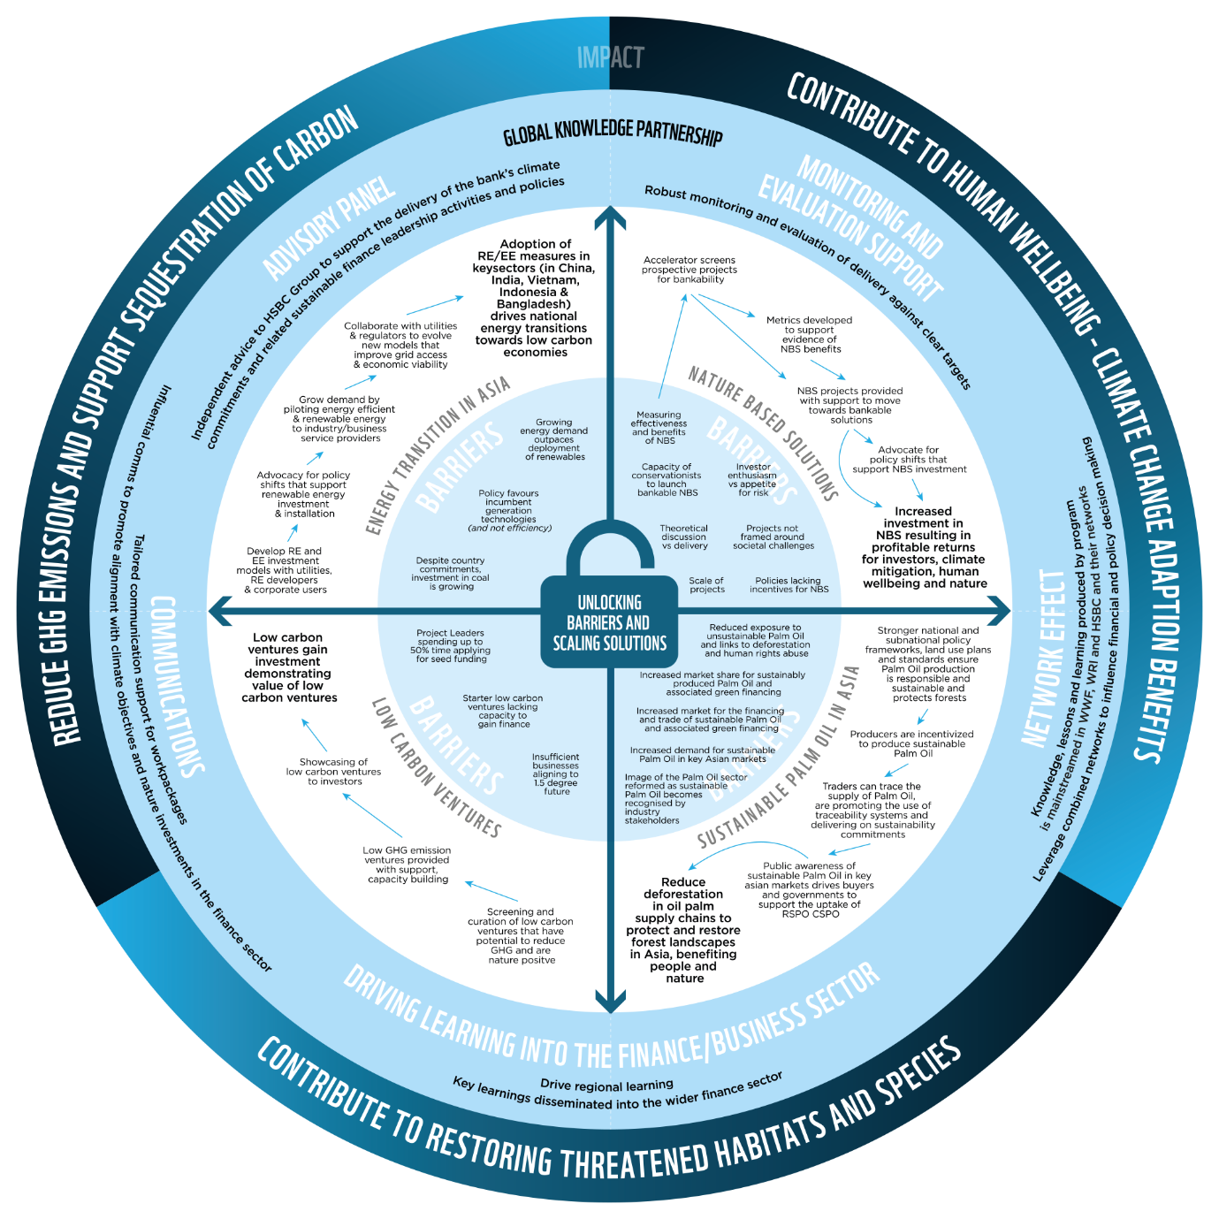

Figure 1: Theory of change for the CSP programme

Pillar Overview

ASIA Energy Transition
The single biggest 5-year challenge in climate change mitigation is transitioning Asia’s power generation towards renewable energy and limiting the region’s need for coal-fired power. The Energy Transition in Asia pillar will work to remove barriers and create incentives for renewables and/or energy efficiency programs in China, India, Indonesia and Vietnam – who combined account for more than 35% of the world’s power consumption. Through our work the progress of energy efficiency and renewable energy solutions in the region will be accelerated towards commercial viability.

On the demand side, partnerships with fast-growing industries will demonstrate and implement technical solutions and pool demand via procurement alliances.
On the supply side, the programme will collaborate with utilities and regulators to evolve new models that improve grid access and economic viability and shift investment from fossil to renewable energy (RE), energy efficiency (EE) and demand management.

Cross-cutting policy analysis and capacity-building efforts will promote an improved enabling environment to remove barriers to RE and EE uptake at scale, and help to mobilise finance.

Pillar goal: By 2025, adoption of RE/EE measures in key sectors (in China, India, Vietnam and Indonesia) drives national energy transitions towards low carbon economies.
Pillar outputs:
- Pooled demand from commercial/ industrial users supports deployment of affordable RE
- Pilots demonstrate business case and benefits of RE/EE measures
- Greater awareness among commercial/industrial users of appropriate green technologies available
- New models adopted which improve profitability of RE/EE solutions, respond to market demand and reduce costs to consumers

China Energy: Key sectors such as apparel and ICT set science-based emission reduction targets, pilot/procure RE/EE solutions, are better equipped to do so, and power sector reform is accelerated by advocating for favourable RE policies.
China Textiles: Textiles companies reduce the amount of GHG emissions through adopting energy efficiency technologies.
India: RE solutions benefitting rural communities and dairy cold chain sector
Vietnam: Target sectors and industrial parks procure/pilot RE/EE solutions, are better equipped to do so, and reform is accelerated by advocating for favourable RE/EE policies.
Indonesia: Companies, industrial estates and SEZs procure/pilot RE/EE solutions, are better equipped to do so, and reform is accelerated by advocating for favourable RE/EE policies.

Nature Based Solutions
NbS are interventions that use a shift in the management, protection, or restoration of ecosystems in order to solve a societal challenge. After energy transition, the greatest potential source of emission savings and removals is the suite of nature-based solutions for climate change. There is also tremendous potential to use NbS to boost climate resilience and to deliver biodiversity benefits while meeting social needs.

Pillar outcome statement: Transform investment into nature-based solutions by providing targeted support to high-quality NbS projects that are bankable, scalable and replicable, and sharing knowledge and learning from these examples.

The NBS Accelerator will pursue these objectives through four pillars
- Catalysing Bankable Investments - Assess projects for scalability, based on a tested model, and support those with the greatest potential to develop full-scale investment proposals and access investors.
- Shifting Incentives – Identify and shift barriers to NBS implementation, creating new incentives for investment and their commercial expansion. WRI led and not part of this MTR.
- Metrics and Accountability - Better aligned standards and field-tested, user-friendly online tools improve NBS monitoring, reporting and verification, and accelerate the flow of performance-based finance. WRI led and not part of this MTR.
- Collaboration and Learning - Connect, complement, interact with existing initiatives, building on existing work and strengths. Collect lessons learnt from the landscape work to feed into the incentives and tools work and to attract more investors and donors

Business Innovation
This pillar is closing in Spring 2023 and is not included under this MTR.

Sustainable Palm Oil
The MTR for this pillar was completed earlier in 2022. This is not an expected focus of this assignment.

Global Knowledge Partnership
As long-standing partners, HSBC and WWF will use our combined networks, expertise and influence to demonstrate that natural capital must sit at the heart of decision-making if we are to unlock opportunities, lower risk and be resilient in the face of climate change and the global loss of nature.

We will work together to catalyse investment in vital nature-based solutions, real world case studies in how to future-proof our economies, businesses and communities. We will show it is possible to embed sustainable production and consumption practices at the core of business models and complex supply chains, and demonstrate sustainable growth is possible, without increasing emissions or using more land.

Crucially, we will help to develop a new generation of leaders who have the skills, knowledge and support to transform our economies and drive finance to the future-ready businesses and innovators that are vital to creating a world where business, society and the natural resources upon which we depend, thrive.

As Global Knowledge Partner (GKP), WWF will contribute a wealth of experience, expertise, thought leadership, resources, communication channels and networks throughout the 5-year programme period.

Specifically, our role can be broken down into the 4 key components:
- Overall Advisory Support (including a Climate Advisory Panel)
- Monitoring & Evaluation
- Central Communications
- Driving Learning into Finance Sector

Climate Solutions Partnership in 2022
Covid has undoubtedly caused difficulties for the delivery of this program and resulted in significant delays. Also, during this time period new opportunities have appeared that we could take advantage of. It is right therefore that we take a good look at what is possible in the time remaining, and what is still necessary to achieve our program ambitions.

EVALUATION PURPOSE AND USE, OBJECTIVES, AND SCOPE
Phase 2 Purpose:
To validate the progress we’ve made under each Pillar, to surface learning from the current work within the Pillars, to consider the cumulative effect of all this work and how it contributes to the overarching Program Objectives, to support adaptive management decision making.

Evaluation Objectives:
- To provide an external validation of progress towards the stated objectives and outcomes and assess whether the programme is on course to achieve its targets;
- To enable each Pillar, and where applicable, country programme to surface lessons and plan improvements;
- To review the Pillar Theory of Change and the Program Theory of Change reflecting on the assumptions and test whether it still holds true. Make recommendations on how the program should adapt based on changes since the programme was designed;
- To consider the Governance structures and consider the suitability of this set up and provide recommendations on how to improve it;
- To evaluate the role of the Pillars in the wider Climate Solutions Partnership and to recommend ways in which they can be better integrated to the Partnership objectives, including the achievement of its KPIs;
- Assess whether we are set up for success: this includes analysis of strategies adopted, teams and resources deployed, internal ways of working;
- Based on the analysis above, support Pillar teams to provide solutions and clear ways forward (or provide recommendations directly);
- To run a Program workshop to validate the rearticulation of the Theories of Change, and discuss the recommendations from the evaluation outputs;
- To deliver an MTR report clearly documenting findings and recommendations on an agreed set of items, with an executive summary for sharing with the CSP governance body.

EVALUATION AND GUIDING QUESTIONS
The consultant will be asked to make use of the following questions as a way to frame the Mid Term Evaluation; in your response to this RFP, outline how you will use these questions:

1. Relevance & Quality of Design
- Is there a clear and relevant definition of ultimate programme success in terms of the stated goal, outcomes and objectives?
- Is the theory of change clear? Has the programme taken the best, most efficient strategic approach? Do the underlying assumptions still hold true? What needs to be improved or strengthened?
- Has the programme focused on and does it remain relevant to issues of highest priority given changes in the political and economic environment?
- Has the (late) application of WWF’s Environmental and Social Safeguards Framework enabled due adherence to WWF’s social policies on human rights, gender and IP?
- How does the project portfolio ‘add up’ to a necessary and sufficient approach to achieving programmatic success?
- How relevant is the programme to national sector development priorities and WWF strategic priorities? What changes would be proposed to create greater alignment and synergies?

2. Coherence.
- Does this programme have internal coherence, such that the respective project interventions create synergies and interlinkages with other interventions in country/landscape by the same sector or institution? Have the policy and trade linkages between countries been maximised?
- Does this programme have external coherence, such that the interventions of this programme and respective projects are consistent and provide complementarity, harmonisation and coordination with other sectors within the same context?

3. Efficiency.
- Are the financial and technical work plans consistent with one another (i.e. sufficient financial resources to support planned activities; priorities have been developed against different funding scenarios)? Are there improvements to be made in financial planning and resourcing across the programme and within implementing countries? In what ways can processes be improved to support informed budget revision decisions?
- Are human resources (i.e. WWF programme, WWF Network, and via partnerships) appropriate, adequate, efficiently organized and operating effectively within and across the region to deliver and monitor the programmes outcomes? (e.g. include considerations of capacity needs and gaps, communications, division and clarity of roles and responsibilities, processes for evaluation and improvement)?
- Is the programme and respective projects delivering value for money in that costs are reasonable given the outputs and outcomes generated? How can value for money be maximised?

4. Effectiveness.
- Focusing on stated objectives, desired outcomes, and intermediate results (as opposed to delivery of activities and outputs), validate what has and has not been achieved (both intended and unintended)?
- To what extent have changes in the external context influenced the results – consider drivers, opportunities, threats at a national, regional and global level?
- Which strategies are proving to be effective, and which are not? What anticipated and unanticipated factors have promoted or impeded the programme’s progress? What supporting or impeding factors might affect successful implementation in the next planning period?
- To what extent has coordination/communication been effective within and between the implementation team, stakeholders, partners and participants, as well as donor offices in the Network and external donors?
- Are the stakeholder engagement processes inclusive, gender-sensitive and accessible for all smallholders and community members? Have stakeholders been engaged at the right level for each of them throughout the programme cycle? Is there an effective complaint mechanism in place (usage of entry points, follow-up process, documentation etc.)?

5. Impact.
- To what extent is the programme progressing towards its stated vision and goals? Discuss observed impacts at all appropriate scales—local, landscape, national, regional, global, and present evidence
- How might the programme increase its impact and what would be the associated human and financial capacity needs? How was the process of increasing impact understood at the design stage (e.g. project replication, good practice guidelines through policy change, multi-stakeholder processes) and is there evidence that this has happened or is likely to happen?

6. Sustainability.
- Does the programme and Pillars have a clear exit strategy, including how to ensure continuity of programme activities and conservation gains, with particular reference to ensuring ongoing financial and technical capacity?
- How likely is it the benefits will last?

Key outputs expected
- Inception report to outline methodology to follow for KII etc.
- Draft Key Findings and recommendations
- Pillar level Workshops to discuss key findings and recommendations
- Draft report for discussion and input by steering group
- Finalise report

Expected Methods to be used
We expect prospective evaluation teams to set out their methodology in their proposal. However, we expect the following methods are likely to be useful in undertaking this review: Desk based document review; Questionnaires; Interviews with key stakeholders – remote and in-person; field visits to at least 2 energy project sites; Pillar level workshops (online or in-person to be proposed by evaluation team); Program level workshops (online or in-person to be proposed by evaluation team).
You may wish to consider each pillar as a phase of the work.

PROFILE OF EVALUATOR(S) AND WWF SUPPORTING RESPONSIBILITIES
At a minimum, the evaluator or evaluation team collectively should possess the following characteristics:

Essential
- Well qualified with demonstrated experience conducting evaluations similar to the one being commissioned.
- Proven ability to both assess past effectiveness and provide strong strategic thinking on future direction and adaptive management.
- Technical knowledge of, and familiarity of the Pillars focus including energy, , nature-based solutions and advocacy.
- Sensitivity to local beliefs, manners, and customs and ability to act with integrity and honesty in interactions with stakeholders: demonstrating understanding of safeguarding approaches at community level especially – labour rights and human rights-based approaches.
- Excellent written and oral communication skills in English.
- Demonstrated ability to generate high quality, rich, readable products on time and in line with expected deliverables.
- Orientation and approach is collegial and facilitates learning and analysis by project/programme teams themselves.
- Cross cultural professional experience and strong active listening skills

Desirable
- Knowledge of influencing the private sector to change their business practices.
- Knowledge and understanding of corporate engagement.

WWF Support. Will be provided by an Evaluation Steering Group, led by Lesley King.

TIMELINE
This review is expected to be completed over a period of 12 weeks (Nov-Feb 2022)
An initial report of findings and recommendations should be delivered by COB 30th January.

BUDGET, FUNDING, AND PAYMENT TERMS
The consultants are invited to submit a budget based on a clear workplan for performing this evaluation. It is estimated that, for documentation review, follow up, KII with WWF teams including WWF-UK, China, India, Vietnam, Indonesia and workshops at least 120 days over 12 weeks will probably be needed. We anticipate field visits to at least 2 countries per pillar though these may well be the same countries for each pillar. Note: travel in and out of China is still very challenging due to covid.
Present a work plan (and deliverables from each phase) that is fully budgeted for analysis of this Request for Proposals. Note that payments will be staggered over 3 or 4 stages to be proposed by consultants.
Budget to be submitted in GBP inclusive of VAT. Maximum budget including VAT cannot exceed £99k.

HOW TO APPLY
Submit to Lesley King by 5pm GMT 15th November 6 page response to the above ITT, indicating:
- Your understanding of the challenge & proposed method;
- Your evaluation experience and examples of at least 3 similar assignments;
- Your proposed team
- an outline workplan with expected deliverables and budget (including time allocation if more than one person is involved)
- Submit 2 page CVs for the lead evaluators (in addition to 6 page limit above)

Shortlisted firms may be invited to an interview with the Evaluation Steering Group in November.

Annex 1: Evaluation report structure
To support more systematic recording of evaluation findings to advance WWF’s broader organisational learning, all evaluators should follow, to the extent possible, the evaluation report structure below (Part A) and complete the summary table (Part B), to be attached to the evaluation report. These provide standardised frameworks for summarising evaluation findings and support sharing results internally and externally.

Part A - Report Table of Contents
The following provides a basic outline for an evaluation report. While this should be easily applied to evaluations of simpler projects or programmes, adaptation will be needed to ensure reports of more complex programmes (e.g. Country Offices, multi-country regions, landscapes and seascapes, Network Initiatives) are well organised, easy to read and navigate, and not too lengthy.

Title Page
Report title, project or programme title, and contract number (if appropriate), Date of report, Authors and their affiliation, Locator map (if appropriate)

Executive Summary (between 2 to 4 pages)
Principal findings and recommendations, organised by the core evaluation criteria from the TOR.

Table of Contents
List of Acronyms and Abbreviations

Body of the report (perhaps no more than 25 pages)
- Introduction (max 3 pages)
- Concise presentation of the project/programme characteristics
- Purpose, objectives, and intended use of the evaluation (reference and attach the ToR as an annex)
- Evaluation methodology and rationale for approach (reference and attach as annexes the mission itinerary; names of key informants; a list of consulted documents; and any synthesis tables containing project/programme information used in the exercise; limitations of the methodology/evaluation.)
- Composition of the evaluation team, including any specific roles of team members

- Project/Programme Overview (max 5 pages)
- Concise summary of the project or programme’s history, evolution, purpose, objectives, and strategies to achieve conservation goals (attach theory of change including conceptual model, results chain or logical framework and project monitoring system as annexes)
- Essential characteristics: context, underlying rationale, stakeholders and beneficiaries
- Summarise WWF’s main interest in this project or programme

- Evaluation Findings (3-5 pages)
- Findings and lessons learned organised by each of the selected core evaluation criteria, including sufficient but concise rationale.
- Tables, graphics, and other figures to help convey key findings

- Recommendations for this project (3-5pages)
- Recommendation organised each of the core evaluation criteria and the findings, including sufficient but concise rationale – recommendations should be specific, actionable and numbered.
- Suggestions for any modifications to the project theory of change.
- Project/programme performance rating tables to provide a quick summary of performance and to facilitate comparison with other projects/programmes (see the Summary Table Part B, below).

Annexes
- Terms of Reference
- Evaluation methodology detail
- Itinerary with key informants
- Documents consulted
- Project/programme theory of change/ logical framework/ conceptual model/ list of primary goals and objectives
- Specific project/programme and monitoring data, as appropriate
- Summary tables of progress towards outputs, objectives, and goals
- Maps
- Recommendations summary table
Part B. (Recommended) Evaluation Summary Table
Evaluators are to assign the project/programme a score assessing the extent to which the project/programme embodies the description of strong performance as described in the table below:

5: Excellent; 4: Very Good; 3: Good; 2: Fair; 1: Poor; N/A: Not Applicable; D/I: The criterion was considered but data were insufficient to assign a rating or score

Evaluators are also to provide a brief justification for the rating and score assigned. Identify most notable strengths to build upon as well as highest priority issues or obstacles to overcome. Note that this table should not be a comprehensive summary of findings and recommendations, but an overview only. A more comprehensive presentation should be captured in the evaluation report and the management response document. Even if the report itself contains sensitive information, the table should be completed in a manner that can be readily shared with any internal WWF audience.

Criteria | Description of Strong Performance | Evaluator Score | Evaluator Brief Justification
Relevance and Quality of Design | 1. The project/programme addresses the necessary factors in the specific programme context to bring about positive changes in conservation elements – biodiversity and/or footprint issues (i.e. species, ecosystems, ecological processes, including associated ecosystem services) and human wellbeing.
 | 2. The project/programme has rigorously applied key design tools including involvement of partners and community members, as appropriate, in the design
 | 3. The project/programme has identified the right opportunities or strategies to respond to key threats
Coherence | The project/programme interventions are synergistic with, and provide value to other interventions by the same actor in-country. They also are harmonized and consistent with other actors’ interventions in the same context.
Efficiency | 1. Most/all programme activities have been delivered with efficient use of human & financial resources and with strong value for money.
 | 2. Governance and management systems are appropriate, sufficient, and operate efficiently.
Effectiveness | 1. Most/all intended outcomes were attained.
 | 2. There is strong evidence indicating that changes can be attributed wholly or largely to the WWF project or programme
Impact | 1. Most/all goals—stated desired changes in the status of species, ecosystems, ecological processes, human wellbeing—were realised.
 | 2. WWF actions have contributed to the perceived changes
Sustainability | 1. Most or all factors for ensuring sustainability of results/impacts are being or have been established.
 | 2. Scaling up mechanisms have been put in place with risks and assumptions re-assessed and addressed - as relevant.
Adaptive Management | 1. Project/programme results (outputs, outcomes, impacts) are qualitatively and quantitatively demonstrated through regular collection and analysis of monitoring data.
 | 2. The project/programme team, involving key stakeholders, uses these findings, as well as those from related projects/ efforts, to strengthen its work and performance
 | 3. Learning is documented and shared for project/programme and wider learning

