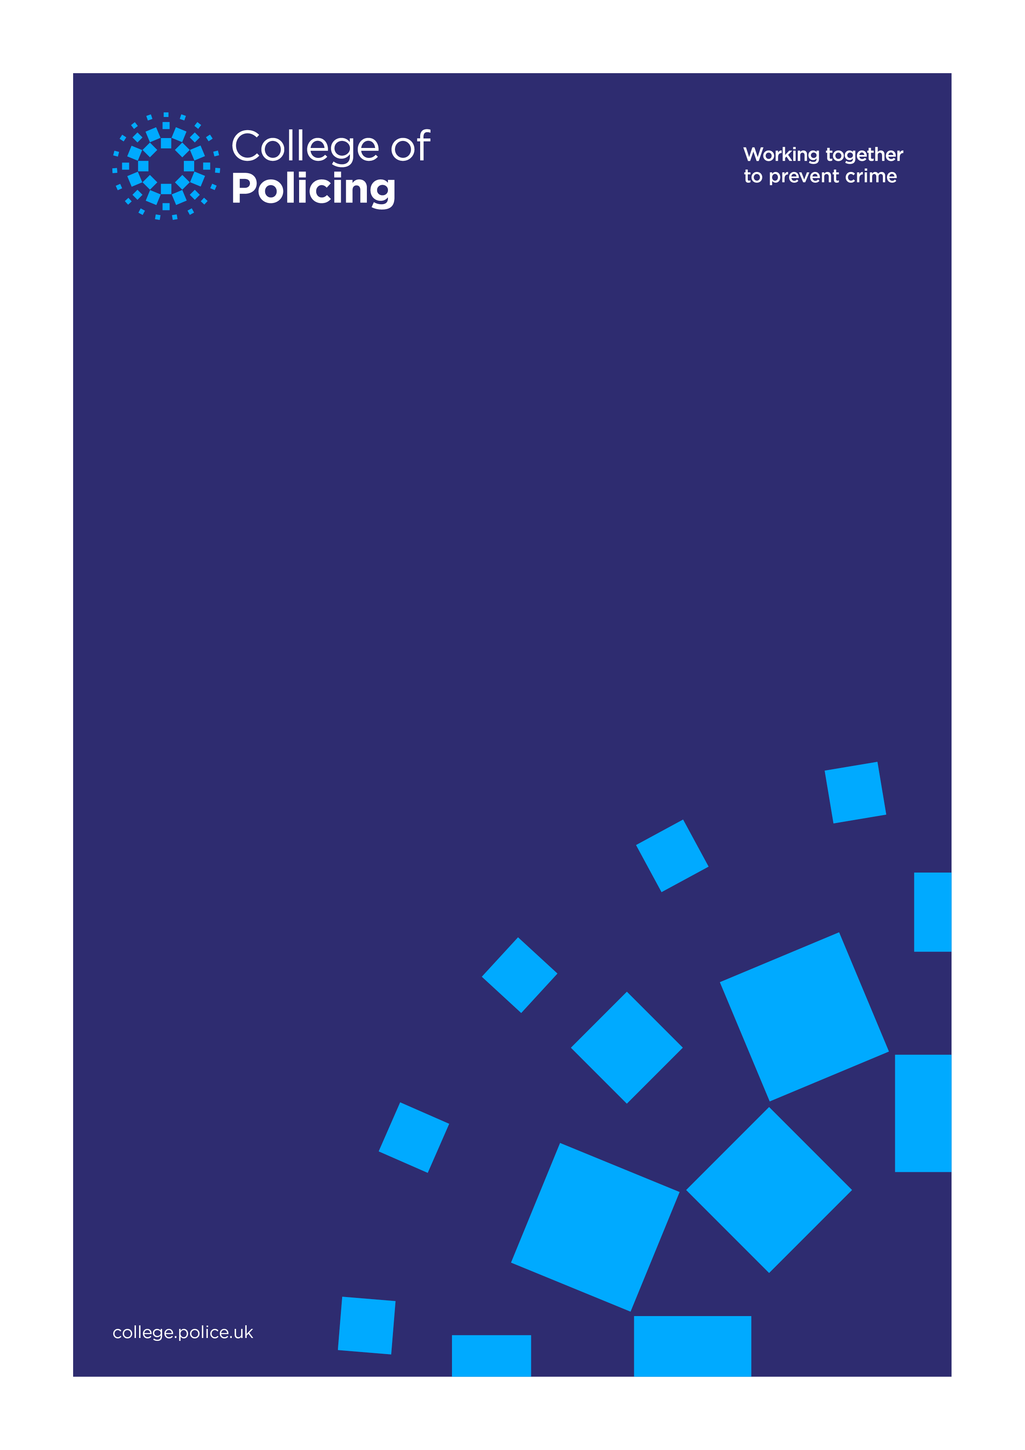
Driver Fatigue Immersive VR Training
Request for Information
Version number 1.0 or date August 2020 (optional)

Introduction
The National Police Wellbeing Service (NPWS) supported by the College of Policing (CoP) is seeking a partner to work collaboratively with to design, develop and support an immersive (VR and physical movement) driving and fatigue experience that will be installed into an NPWS mobile outreach service vehicle.
The NPWS was established in 2017 and consists of a series of planned measures, related events and coordinated activities in pursuit of delivering the “Common Goal for Police Wellbeing”.
This programme has been set up to deliver change across national policing through each of the 43 England and Wales, Home Office funded Forces. It also delivers change to discrete units within each Force, specifically the Occupational Health Units through the NPWS Capability Model. The Model delivers the two NPWS strategic themes:
- Psychological Health & Wellbeing;
- Specialist Support.
There are three capability pillars to the model:
- Develop – increase activities relating to Wellbeing Theme 2 initiatives to transition Specialist Support capability to the Capability Delivery live service function.
- Deliver – existing operational capability and new services as they develop and transition into the live service;
- Assure - activities to support the programme and specifically the benefits realisation work;
The change this programme is aiming to make is focused on how people work within those organisations. The NPWS Vision, which underpins the Strategic Roadmap, is:
“The National Police Wellbeing Service develops, delivers and assures wellbeing capability that individuals and organisations can access, making the police a high performance employer of choice with strong retention of officers and staff.
Transformational change will be enabled by a holistic approach and delivered through promotion, prevention, detection & support and treatment & recovery wellbeing initiatives in order to support the work force elements of Policing Vision 2025”

Specification
As part of this project we are seeking a supplier to work with the NPWS project team on the development of a driver fatigue awareness scenario, as well as providing the physical hardware that will be installed into one of our NPWS mobile outreach service vehicles. At present, we are looking for the installation to be carried out through our own arrangement but this can be discussed if required.
The chosen supplier will work with the NPWS project team on the development of a driver fatigue awareness scenario in order to develop an immersive VR and physical experience for officers and police staff. The experience itself should center around a policing scenario to provide individuals with a high-impact experience that reinforces the dangers of driving whilst fatigued. Ideally, the duration of the VR experience will be up to a maximum of four minutes and the supplier will lead on the technical design and delivery components of the service. There is no requirement for non-participants to view a “running/live” scenario.
In order to help suppliers understand the physical design requirements we have attached a specification for the Wellbeing Vehicles. This document is titled “Wellbeing Van Operational guide”. In coming up with a design for the physical solution suppliers should consider how the system will be secured within the vehicle so that it can be driven from site to site without being damaged in transit. Consideration should also be given to how the system will run using the power generated from the vehicle. The system should also be designed in such a way to make it easy to install and uninstall and ensure that there is suitable access required to essential parts that may need repairs or maintenance from time to time.
VR Experience
While it is expected that a Supplier will lead on the development of the VR experience and bring their knowledge and skill to this project we have provided below a basic outline of a scenario envisaged as part of the conceptualizing work our team has carried out in discussing this driver fatigue VR simulation. This has been included to give you an idea as to some of our thinking around what a scenario could look like.
Motion seat VR experience
- Black scene, words appear on screen setting the scene. “You have just finished a long shift, this is his journey home…”
- Scene opens from a first-person perspective. The Character is sitting in a stationary car at night. He sighs and says “What a day” he starts the car and drives off.
- Visual dips through black to next scene (Note each scene dips through black in a way like eyes closing and opening. At first the dip is fast as our character is awake, but as the story progresses it becomes slower to simulate the character getting more and more tired)
- Driving on town street large buildings, streetlights flashing by. The phone rings (phone is on the passenger seat – encouraging viewers to look left) the character answers the call using hands free. It’s his wife, a conversation follows where we understand explains our characters frustration, stress, length of shift etc. (Narrative needed – this conversation essentially highlights all the courses of fatigue and its build up} Conversation ends.
- Regular driving, visually different outside scene this time suburban, we hear a radio on with late night chatter; we have the drone of the car wheels.
- Transition to new road, different radio audio, by going to a new road it starts to show length of journey.
- New road now on dual carriageway with other cars around. We pass a “Tiredness take a break” sign.
- Transition again this time during the black dip we feel rumble stripes in the road and a horn sound before revealing a near miss with another car. Character opens his window to compensate.
- More motorway and audio drone
- Now motorway with no overhead lights, vision goes in and out of focus, then on final dip the scene stays black, we hear a crashing sound, motion chair moves abruptly.
- Silence, and then awake with blue flashing lights and noise of an accident scene.
- Closing statement

Request for Information
At this stage, before going out to formal tender, the College of Policing and NPWS are seeking to identify suppliers in the market who may be able to meet this requirement and enter into discussion with them to further develop the vision and specification for this requirement.
While we would be happy to discuss his project in a more open way it would be useful if you could provide us a response to the questions below. Please note if you need to have a conversation with us to better understand these questions, we would be happy to facilitate to aid your response.
- How confident would you be in providing a fully costed proposal with the information we have provided in this document? If there is information we could provide to increase that confidence, what is it?
- With consideration to you response to question one. While budget is still being assessed, we could have up to £80k for this project including the installation. Is this a reasonable budget and how would envisage such a budget being split between the Software and hardware. This could be presented as a percentage if it would be easier to do so.
- What would be a realistic timetable for you to develop the VR Simulation and provide the physical hardware? If possible, please set out what this timetable would look like detailing any assumptions you are making along with any perceived risks.
- While we have specified the development of a new VR experience, are you aware of any products on the market that would meet this requirement without the need to develop a new experience?
- As an Arms Length Body of the Home Office we are directed by them to use Crown Commercial Service Frameworks or other suitable Frameworks when every possible. Is your organisation on any Frameworks that you believe the College of Policing may be able to run a Procurement exercise through?

