PROSPECTIVE SUPPLIER LINK AND SETUP GUIDANCE
Dear Supplier,
In order to quote or tender for contracts with Thurrock Council, you need to register with Thurrock’s Oracle Cloud. Once registered you can view and respond to relevant active competitions.
Click on the following link Oracle Prospective Supplier Link which will take you to the front page registration screen and follow the directions below:

Section one - Company Details Section


Enter your full company name in the company field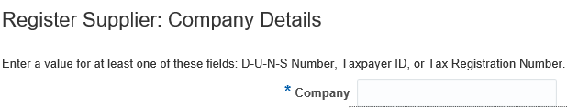
Tax Organisation Type – Select ‘Corporation’ from the drop down menu

Supplier Type – Select ‘Supplier’ from the drop down menu

Corporate Web Site – if you have web site for your company please provide the link

D-U-N-S Number – All registered businesses in the UK and Ireland are automatically issued with a D-U-N-S Number, this is a Dun & Bradsheet unique nine-digit code assigned by D & B to identify your business, please provide this if you have available, and however this is not mandatory

Tax Country – if you are a business in the UK please select United Kingdom


Taxpayer ID - if you are a Limited company please enter your company registration number in this field.
If you are a sole trader or self-employed please enter your national Insurance number
Tax Registration Number – in this field please enter your company’s VAT Registration number. This will need to be entered in a certain way with GB at the beginning and no spaces, for example if your VAT registration is 123 4567 12, you would enter in the field as below

Failure to enter in the above format will mean your registration request will generate an error.
Additional Information
This section only applies to companies that are registered on the ‘Construction Industry Scheme’ – which is a tax deduction scheme which involves tax being deducted at source from payments which relate to construction work.
If you are not on the CIS scheme you can move onto the next section
For those that are please provide your UTR number – a Unique Taxpayer Reference number (UTR) for your business is a 10 digit number assigned to you from HMRC
Once you have completed the fields as in the example below you can move on
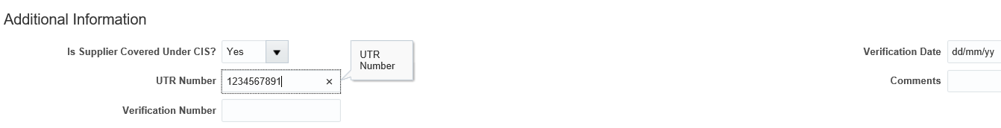
Contact information
This will be your details to which the system will create your Oracle Fusion Supplier Portal account against.
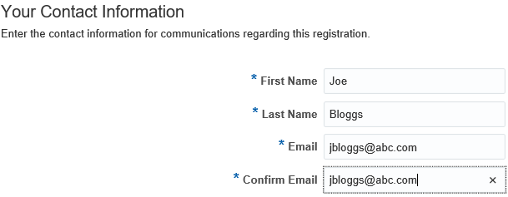

Section 2 – Contacts
The system will automatically create a contact account from the details placed in the previous screen above. You can optionally create further contacts to give them access to register on the Supplier Portal.
To do this – click the +Create icon
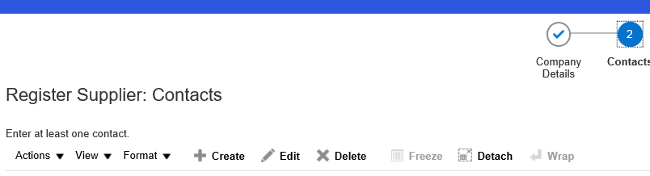
This will open the screen below, enter the details of the additional contact, First Name, Last name, email and phone number – then tick “Administrative contact” and “Request User Account” and then press ok
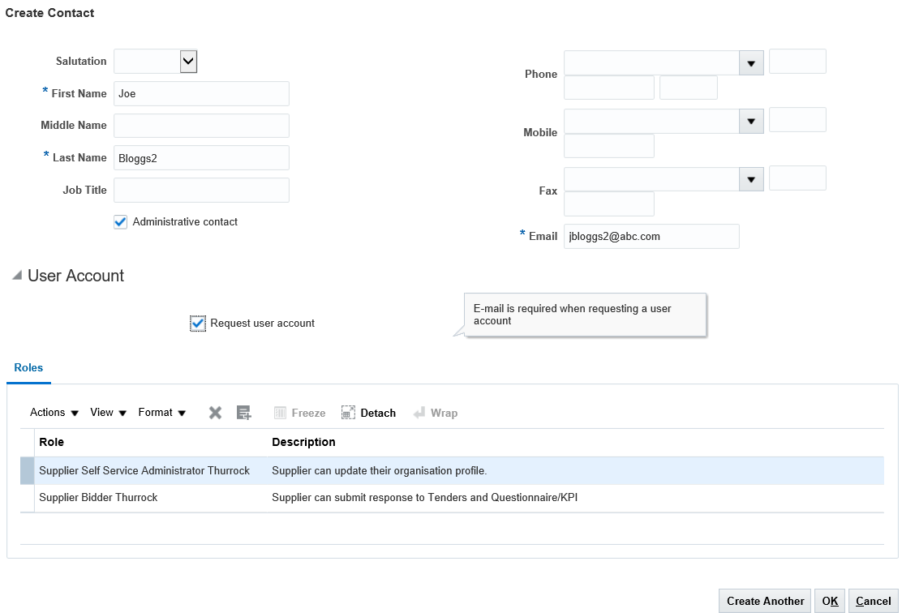
Section 3 – Addresses
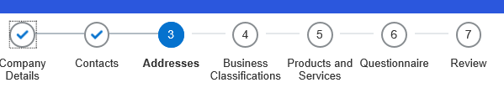

In this section you will provide your business address, to create the address please click the +create and then complete the relevant fields in the next screen, the example is shown below
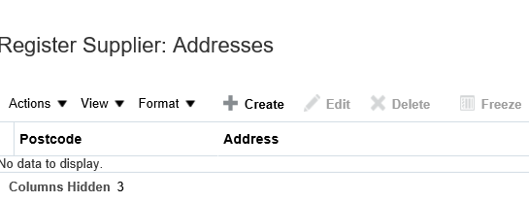
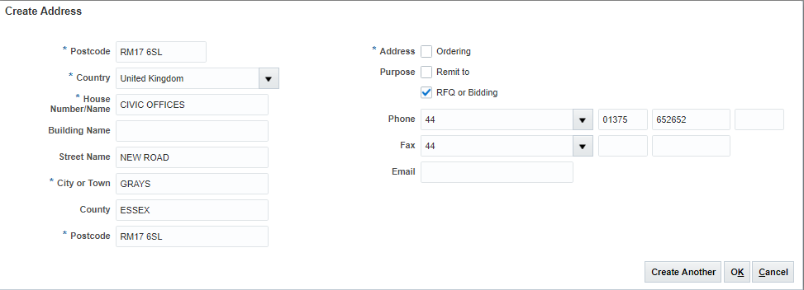
Then press ok to add the address
Section 4 – Business Classifications
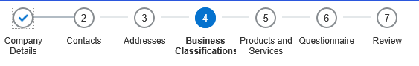
Currently there are 2 business classifications that you can select which relate to your business, these are DPIA Assessment and Local Thurrock Supplier, the definitions of each are provided below. If neither apply just select the option ‘None of the classifications are applicable’. This element is optional at the prospective supplier stage and you can fill it in or change it if you are awarded a contract with Thurrock.
DPIA Assessment – if the below applies to you please add this as a business classification

What is a Data Protection Impact Assessment (DPIA)
A DPIA is an assessment of a project that identifies the impact that the project might have on the privacy of individuals, and sets out recommendations for managing, minimising or eliminating that impact.

Is a DPIA necessary?
For any project that will involve the handling of personal information, the council must consider undertaking a DPIA. This will be achieved with service areas consulting with the Information Management Team.

Threshold assessment
The first step in undertaking a DPIA is assessing whether a DPIA is necessary for the project. Not every project will need a DPIA. The council have developed a DPIA form to help with this assessment and this form asks a number of initial assessment questions which will then allow for an informed decision to be reached (as to whether a DPIA is required).
The first question to ask when assessing whether a DPIA is needed is, ‘Will any personal information be collected, stored, used or disclosed in the project?’ Generally, if personal information is involved in the project, some form of DPIA will be necessary. If personal information is not involved in the project, the project is unlikely to impact on information privacy and a DPIA will not be necessary.
A DPIA may not be necessary if the project does not propose any changes to existing information handling practices.
Local Thurrock Supplier
This applies to suppliers which are based in the Thurrock Vicinity, please add this business classification if this applies.

Section 5 – Products & Services
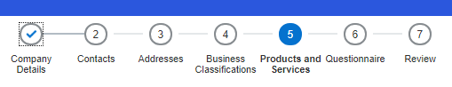
This section relates to the types of goods or services or both that you as a business can provide to Thurrock Council
To search the range of products & services, click the ‘Select and Add’ option


You will now be presented with a range of different categories, within each category there are sub-categories which are more specific to the goods or services you propose to provide Thurrock Council. This is very useful as we will use this to help search for companies providing specific products or services when we are looking for quotes or tenders.

You can find the subcategories by clicking on the arrow as below
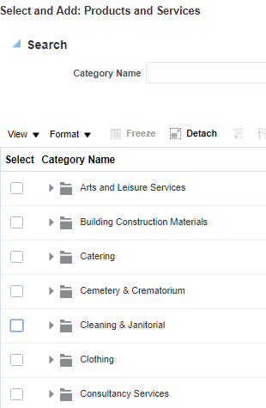

Now you can view all the subcategories within that category
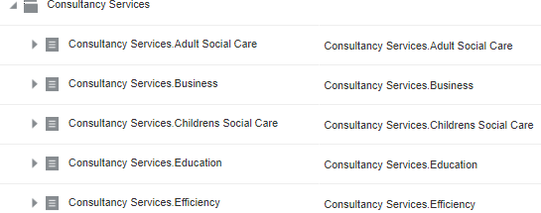

You have the option of selecting the sub-category as below or multiple sub-categories.

Alternatively you can cover all the sub-categories within that category by clicking here
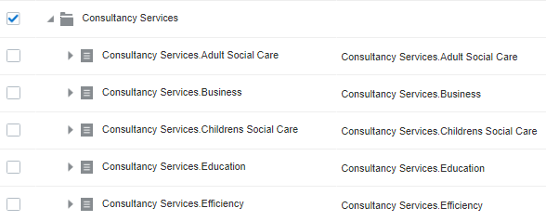
Once you have selected all the categories/sub-categories that you can provide as a business, just click the Ok button

Section 6 – Questionnaire



This section is compulsory, please answer each question accordingly the system will then determine whether you as a supplier pass or fail under the grounds for mandatory and discretionary exclusion. These are legal requirements normally applied to larger contracts and asked at the point of tender opportunity. However, answering this question now means you will not be asked again regardless of how many tenders you apply for during the next 12 months.
The questionnaire is tick box only, so click in the appropriate box and move on. At the bottom right hand side of the screen, click “Next Section” and one further page of questions will appear.
Section 7 – Review
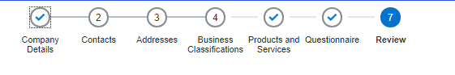
This section gives you the opportunity to check and validate that all the information you have entered is correct before you submit your prospective supplier request
Once you are happy that all the information is correct, please click the ‘Register’ button
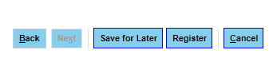
The Oracle System then will send you an email to confirm you’ve been registered with a link to log in and reset your password.
Once complete, you’re good to go.

