Invitation to Tender Christmas Lighting electrical supply – Lymington and Pennington Town Council
- Introduction
Lymington and Pennington Town Council invites tenders from suitably qualified electrical contractors to replace the current lighting connection for Christmas lights with an alternative long term, safe and discreet electrical solution with minimal disruption to the public highway, the business community and local residents as much as possible.
Scottish & Southern Electricity (SSE) are changing the way in which local authorities can use street lighting infrastructure under their control for Christmas displays as of 01 September 2020. This is endorsed by Hampshire County Council who have transferred responsibility for their street lighting service to SSE under a Public Finance Initiative (PFI). Any work will need to be carried out in accordance with the Professional Lighting Guide 06 (Guidance on Installation and Maintenance of Seasonal Decorations and Lighting Attachments 2014) as known as PLG06.
- Existing situation
Lymington High Street currently has a cross street display of LED icicles and bulbs that currently takes it power from the top of 25 lighting columns throughout Queen St, St. Thomas Street and High Street which are evenly spaced throughout, thereby creating a flowing effect through the town & down the hill. The Town Council is keen to carry on with this cross street lighting display for 2020 and subsequent years. See images below from the 2019 display.
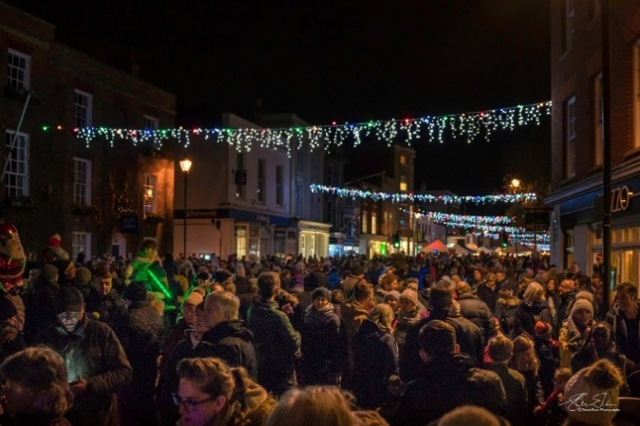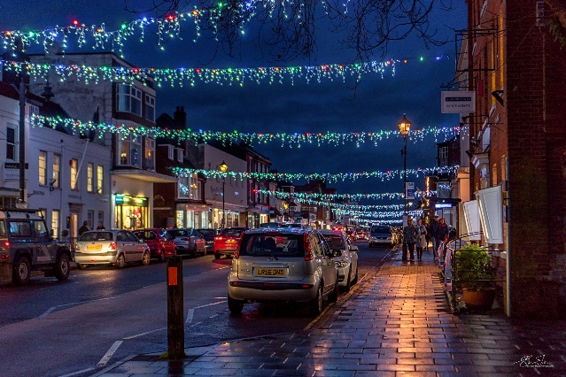
- Project Requirements
In order to continue with this type of display we are now seeking suitable tenders from qualified electrical contractors to connect up the display without utilising the existing lighting columns in the High Street.
The strings of icicle and coloured bulb lights currently used by L&PTC are not fixed to the actual lighting columns, but to the buildings themselves, via catenary wires with carabiners attached at either end, which are then clipped to eyebolts which are securely attached to the buildings. These eyebolts are annually tested to ensure they can withstand the weight of the annual bunting and the Christmas lights. This pulling testing does not form part of this tender, as carried out by our existing bunting supplier who tests up to 3KN.
The Council has looked at and considered other options to light the town during the festive period, but concluded not to pursue:
- Mofits onto the lighting columns, as the cast iron columns are not authorised to be used for this type of lights
- running lights cross and along the buildings with the installation of a feeder pillar at either end and then extensive use of loose 240v cable extension leads with fitted plug & socket across the buildings.

The advice given by SSE is that in order to install the same display and utilise the bulb and icicle lighting purchased by the Town Council, there is a need for feeder pillars to be installed at suitable locations on the High Street, taking an unmetered supply from the Low Voltage network. This supply is believed to run either side of the road nearest the pavement edge.
From these feeder pillars (to be positioned in a discreet location against the building) there would be a need for armoured cabling to be taken up the nearest appropriate building to a new socket attached to the building. Therefore, the work will involve excavation of the pavement. From here cabling (painted to match the building’s colour where necessary) would run across the necessary buildings’ frontages to the next light position. It has been estimated that approximately 16 new feeder pillars could be required throughout the High Street, Queen Street & St Thomas Street for an efficient display. However, this may vary and hopefully be considerably less, depending on the solution offered by your tender and the permissions given by the building owners.
It is anticipated in some instances, one feeder pillar may be able to support 3-4 string lights on the same side and run either way horizontally across several buildings to minimise the costs to be incurred. This depends on the gaps between buildings.
- Additional Information
Lymington High Street is within a conservation area and many buildings are listed. Therefore works to install sockets will be subject to the required Listed Building Consents and freeholder/leaseholder approval. This will be obtained from LPTC before works can commence on the relevant buildings.
Close collaboration and rapport will be required in working with the Town Council to ensure a cohesive joined up partnership is created with the successful contractor, as it is anticipated that the project will need to be managed carefully due to the necessary permissions and need to change the chosen building if permission cannot be obtained.
If there is the possibility of replacing the existing sockets on the current buildings, then this option would be encouraged and permission requested from the building owners.
The lanterns attached to the buildings at Gosport Street, Gosport Street and Quay Hill and Quay Street do not form part of this remit, as they are attached to a building and SSE have confirmed that these lanterns can be used for cross street lighting.
Any supplier will need to be registered with NERS (The National Electricity Registration Scheme) and HERS (Highway Electrical Registration Scheme) while also be familiar and compliant with PLG06.
Additionally, the successful contractor will be required to remove any existing cross pavement cabling from the buildings to the existing lighting column (where relevant) to ensure that there is no connection between the two, plus the now defunct sockets on the columns. Your tender should clearly and separately identify the costs of these remedial works.
Lymington does have a weekly Saturday market and an annual Christmas market and therefore should the contractor feel economies of scale can be achieved by installing feeder pillars that can serve the purposes of cooking, lighting and refrigeration etc please include as a separate option.

