**Invitation to Tender**

**Tarmacking Services**

**Ref: RUR722**

# 1. About Newlyn School of Art

We are an art school which provides skills training and business mentoring, both in-person and online, for creative people based in Cornwall, around the UK and abroad*.*

# 2. Background and Context

Newlyn School of Art (NSoA) has begun a rapid period of growth since diversifying some of our skills training and business mentoring courses into an online format during the Covid pandemic. Alongside this, our ‘in person’ skills training courses and our Business Mentoring Year-long courses held within the Art School building also continue to grow in popularity, and we are a ‘340 days of the year’ business – often with multiple courses running at once. This success has meant that, due to our current facilities, office size and building access, we have not been able to effectively service this new growth. We simply do not have appropriate office space for additional staff nor suitable capacity and facilties for increased customer numbers. In particular, our current facilities limit our ability to include customers (and potential staff) from the whole community as we do not have disabled access to the building.

This project focuses on resolving immediate issues which we urgently need – as well as building-in resilience for our future. The car park resurfacing and professional design of lined space allocation to maximise parking spaces, enabling additional visitors to site as well as new staff to be taken on by the business. Plus dedicated disabled parking, to improve customer/student access and allow us to potentially recruit from the full breadth of our local community including those with accessibility limitations. We will bring electricity to the car park to provide safe passage between the car parks and the school building with outside lights for staff and customers.

We will assess tenders received on lowest compliant Tender.

# 3. Tender requirements

The successful tenderer will be expected to undertake the following activities with regard to the following plan:

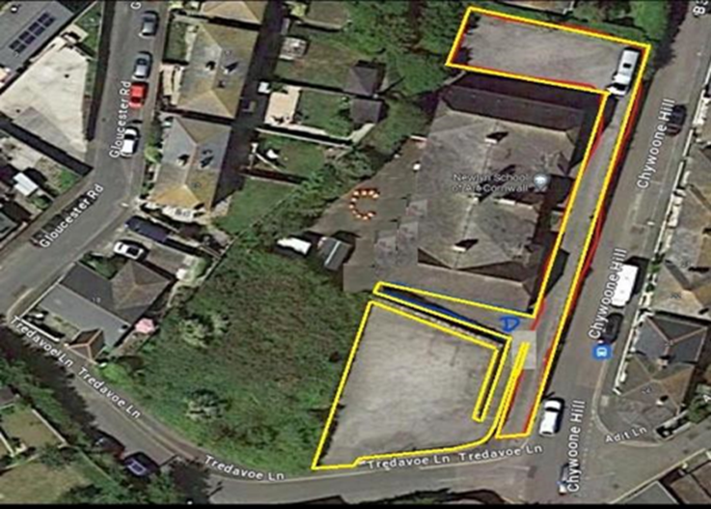

1. Patching works @ 60mm only within the YELLOW area
   1. To patch/Void areas of up to 245m2
   2. Cut joints to allow a flush finish to adjacent surfaces (where required)
   3. Plane out/ Excavate to a depth of up to 60mm
   4. Remove arisings from site to a licensed tip
   5. Supply, hand lay and consolidate
   6. 60mm of 20mm dense binder course
2. Lining
   1. To install lining as listed below using thermoplastic
   2. 11 standard parking bay lines
3. Surface course - YELLOW area
4. To a combined surface area of up to and including 1079m2
5. The client will prepare the surface; to include adjusting /replacing gulleys and covers - installing ramping/ kerbing
6. Cut joints to allow a flush finish to adjacent surfaces (where required)
7. Remove arisings from site to a licensed tip
8. Sweep clean and apply a tack coat of cold bitumen emulsion to aid adhesion of new surface
9. Supply, machine/hand lay and consolidate
10. 40mm of 10mm stone mastic asphalt surface course

4**. Budget**

The total maximum budget available for this commission is £40,000.00 (exc VAT) but inclusive of all expenses.

**Tenders that exceed the total budget will not be considered.**

The budget will be reviewed as part of the tender evaluation detailed in Section 10 and will reflect the degree to which there is a saving on the maximum budget

# 5. Tender and commission timetable

The timescale of the programme is from the date of signing the contract until acceptance by the client. The timetable for submission of the Tender, completion of the programme are set out below.

|  |  |
| --- | --- |
| **Milestone** | **Date** |
| Date ITT available on Contracts Finder | 31 October 2024 |
| Last date for raising queries | 1700: 7 November 2024 |
| Last date for clarifications to queries | 1700: 8 November 2024 |
| Deadline to return ITT | 1700: 18 November 204 |
| Evaluation of ITT | 19 November 2024 |
| Award of Contract | 20 November 2024 |
| Completion of the work | 31 December 2024 |

# 6. Tender submission requirements

Please include the following information in your Tender submission.

6.1 Please provide your proposal and any necessary technical or specification sheets.

6.2 Provision of a Conflict of Interest statement as per Section 8.

6.3 Budget

**7. Sub-contracting**

Tenderers should note that a consortia can submit a tender but the sub-contracting of aspects of this commission after appointment will only be allowed by prior agreement with Newlyn School of Art.

**8. Conflicts of Interest**

Tenderers must provide a clear statement with regard to potential conflicts of interests. Therefore, **please confirm within your tender submission** whether, to the best of your knowledge, there is any conflict of interest between your organisation and Newlyn School of Art or its programme team that is likely to influence the outcome of this procurement either directly or indirectly through financial, economic or other personal interest which might be perceived to compromise the impartiality and independence of any party in the context of this procurement procedure.

Receipt of this statement will permit Newlyn School of Art to ensure that, in the event of a conflict of interest being notified or noticed, appropriate steps are taken to ensure that the evaluation of any submission will be undertaken by an independent and impartial panel.

# 9. Tender clarifications

Any clarification queries arising from this Invitation to Tender which may have a bearing on the offer should be raised by email to:

[henry@newlynartschool.co.uk](mailto:henry@newlynartschool.co.uk)

in accordance with the Tender and Commission Timetable in section 5.

Responses to clarifications will be anonymised and uploaded by Newlyn School of Art to Contracts Finder and will be viewable to all tenderers.

No representation by way of explanation or otherwise to persons or corporations tendering or desirous of tendering as to the meaning of the tender, contract or other tender documents or as to any other matter or thing to be done under the proposed contract shall bind Newlyn School of Art unless such representation is in writing and duly signed by a Director/Partner of the tenderer. All such correspondence shall be returned with the Tender Documents and shall form part of the contract.

# 10. Tender evaluation methodology

Each Tender will be checked for completeness and compliance with all requirements of the ITT. The award of the contract will be to the LOWEST COMPLIANT BID.

11**. Tender Award**

Any contract awarded as a result of this tender process will be in accordance with this ITT and the tenderer’s response.

# 12. Tender returns

Tenders are to be returned by email.

Tenders are to be returned in accordance with Section 5

Latest date to be returned: As per Section 5

Latest time to be returned: 17:00

Emailed tenders should be sent electronically to

[henry@newlynartschool.co.uk](mailto:henry@newlynartschool.co.uk)

with the following message clearly noted in the Subject box;

‘Tender response to RUR722’

**Tenderers are advised to request an acknowledgement of receipt of their email.**

**13.** **Disclaimer**

The issue of this documentation does not commit Newlyn School of Art to award any contract pursuant to the tender process or enter into a contractual relationship with any provider of the service. Nothing in the documentation or in any other communications made between Newlyn School of Art or its agents and any other party, or any part thereof, shall be taken as constituting a contract, agreement or representation between Newlyn School of Art and any other party (save for a formal award of contract made in writing by Newlyn School of Art or on behalf of Newlyn School of Art).

Tenderers must obtain for themselves, at their own responsibility and expense, all information necessary for the preparation of their tender responses. Information supplied to the tenderers by Newlyn School of Art or any information contained in Newlyn School of Art’s publications is supplied only for general guidance in the preparation of the tender response. Tenderers must satisfy themselves by their own investigations as to the accuracy of any such information and no responsibility is accepted by Newlyn School of Art for any loss or damage of whatever kind and howsoever caused arising from the use by tenderers of such information.

Newlyn School of Art reserves the right to vary or change all or any part of the basis of the procedures for the procurement process at any time or not to proceed with the proposed procurement at all.

Cancellation of the procurement process (at any time) under any circumstances will not render Newlyn School of Art liable for any costs or expenses incurred by tenderers during the procurement process.