Including Missing Voices

A new project about disabled people.

What your organisation must do if you want to do this project.

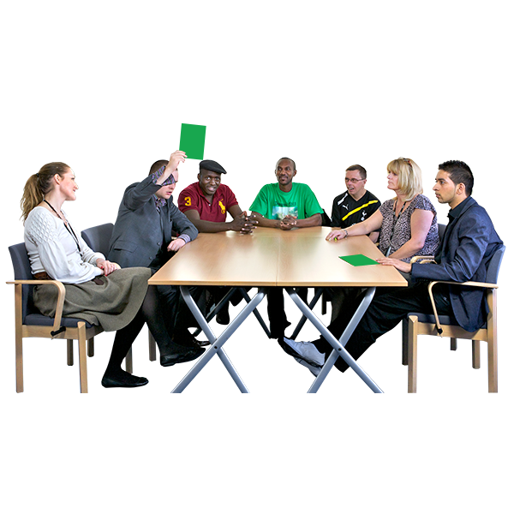

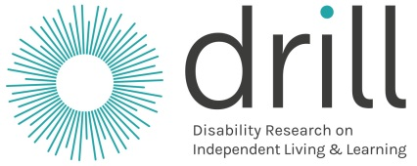

What is in this booklet

 | Page
About this booklet | 3
About DRILL | 4
About Including Missing Voices | 6  27  27  27  27
The work you would need to do | 7
What DRILL wants to happen | 120
Other things to know | 14
How you will work with DRILL | 150
What will happen when | 16
How to say you want to do the project | 17

About this booklet

We are DRILL.

DRILL is short for Disability Research on Independent Living and Learning.

We have a new project called
Including Missing Voices.

A project is a piece of work.

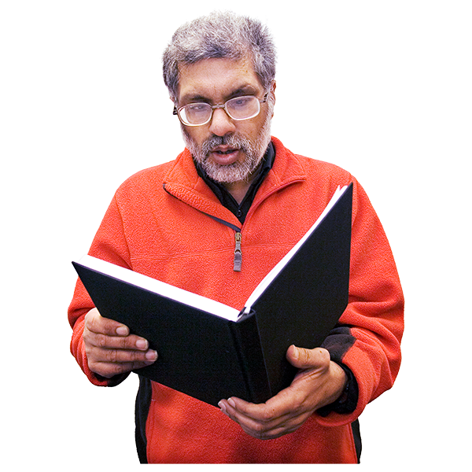
This booklet tells you about:

- The project

- What your organisation must do if you want to do the project

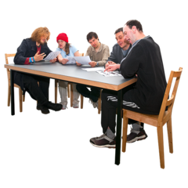
We will look at all organisations that want to do the project.

We will choose one organisation to do the project.

About DRILL

DRILL gives money for important projects to make life better for disabled people in the UK.

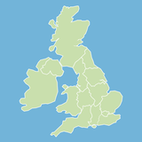

The UK is Northern Ireland, Scotland, Wales and England.

The projects will help disabled people to:

- Live how they want to

- Make their own choices

- Have the best life they can

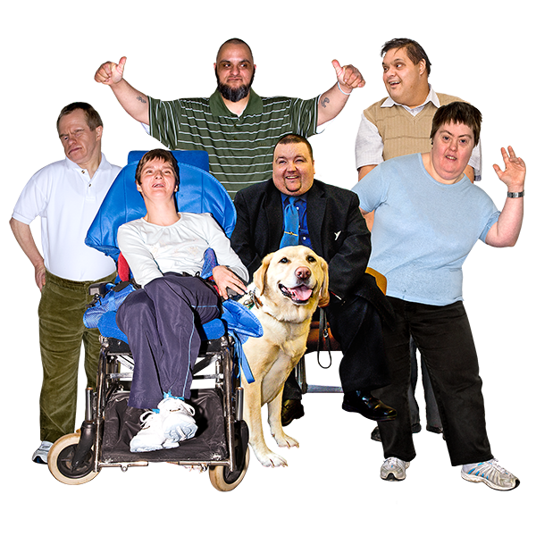
This is called independent living.

DRILL wants all disabled people to have a good life like this.

DRILL wants better information about how to make sure all disabled people have a good life.

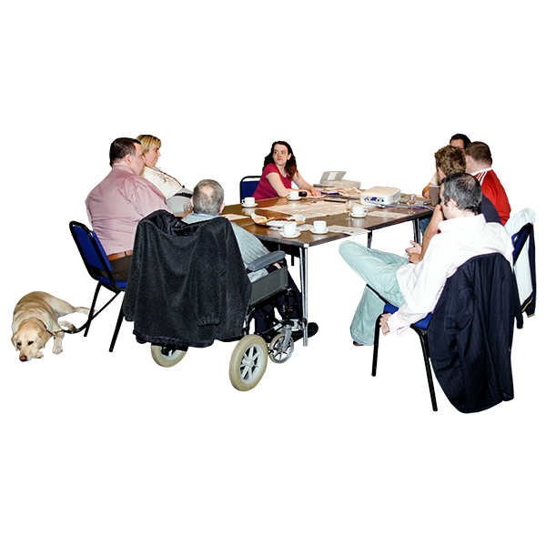

The information DRILL finds out will help:

- Disabled people and other people work together to make good plans
and services

- Disabled people to have a big say
in what happens to them

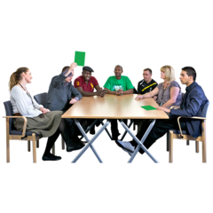

DRILL is different because disabled people have a big say
in everything that DRILL does.

About Including Missing Voices

Including Missing Voices is a new project.

It is about how to make sure all disabled people can have a say in what happens to them.

For example, disabled people should be able to have a say about new laws, rules, plans and services.

At the moment, some groups of disabled people do not have much say.

We want to know:
- Why that is

- What can be done to make sure these groups of disabled people can have a say

The work you would need to do

There are 3 main parts of the project.

Your organisation must work with disabled people on all parts of the project.

1
Stage 1

Your organisation must do the following things:

- Look at one group of disabled people that find it hard to have a say.

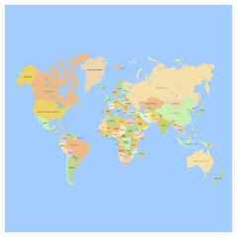
We want to know more about disabled people from the following groups:

- Roma or Traveller groups

- People who come to the UK from other countries to be safe from danger or to work

They are called migrants or refugees
- People with learning disabilities

But we may look at other groups of disabled people if you can show us why it is a good idea.

You must show us how you have worked with that group of disabled people in all parts of your project.

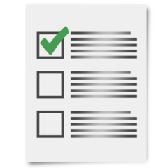

- Look at how to make sure that group of disabled people can have a say in what happens.

- Look at what is happening for that group of disabled people across the UK.

Is it the same in every country? Are there good ideas from one country that can be used in other countries?
- Look at how organisations of disabled people have already worked with the group of disabled people you are looking at.

Your organisation must write a report about:

- What you find out

- What you think should happen

- How to move to the next part of the project

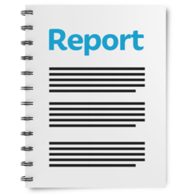

Stage 2
2

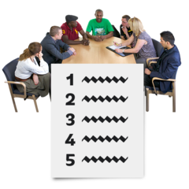
Your organisation should work with some organisations of disabled people across the UK.

You should look at how to make sure more disabled people can have a say in what the organisations do.

This includes the group of disabled people your project is about.
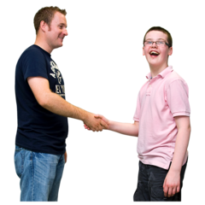
It may help that group of disabled people to join an organisation of disabled people to have their say.

Or there may be other ways.

Your organisation must:

- Write another report about what you have found out and what you think should happen

- Make a plan about how to make sure the group of disabled people your project is about can have more say

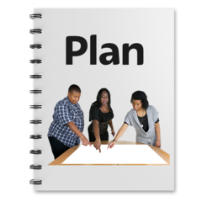

Stage 3
3
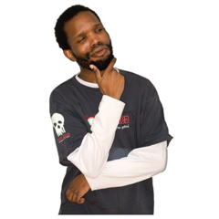

Your organisation will need to:

- Help check how your work with DRILL has gone

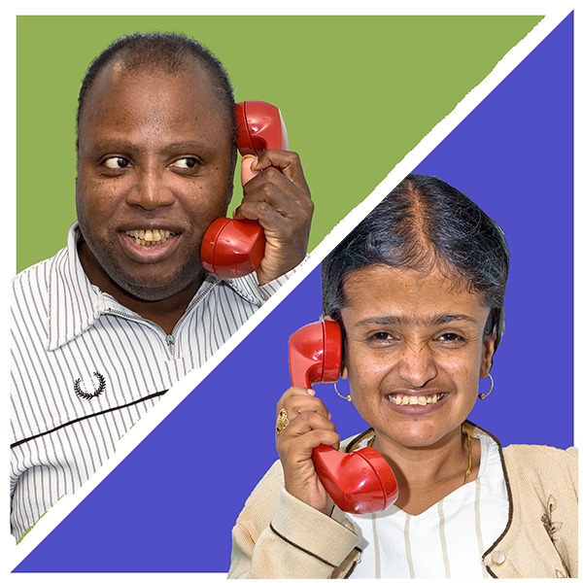

- Get in touch with another DRILL project called Getting Our Voices Heard.

See what you have both learned that can help DRILL

Your organisation must write:

- A plan about how to share what you have learned with other people in the UK

- A final report about what you have done, what you found out and how the project is going

What DRILL wants to happen

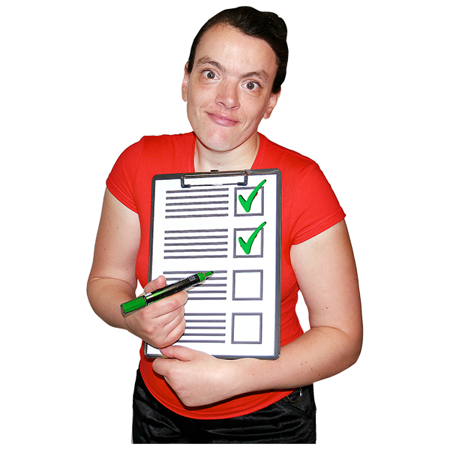
There are 4 things that DRILL wants to happen.

They are called outcomes.

The Including Missing Voices project
will help with all 4 things.

Here are the DRILL outcomes:

- Your project will help people learn about what is important to disabled people.

You will find out new information about how to make life better for disabled people.

- Your project will help disabled people have a better life by taking part in your project.

- Your project will help people in charge make good decisions about things like plans and services for disabled people.

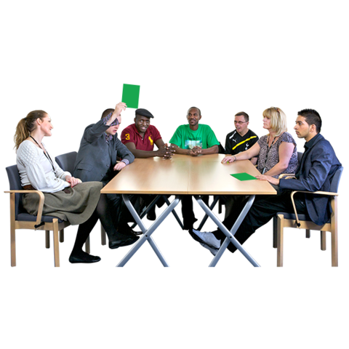
- Your project will help disabled people have a big say in laws, plans, services and other decisions.

Your organisation must say how your project will help with all the outcomes and how you will check this.

Other things to know

Working with other organisations

Your organisation will work with other organisations on the project.

Please tell us how you will do this.

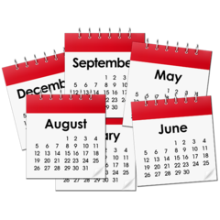
How much money and how long

DRILL and your organisation would agree to work together for 1 year.

This is called a contract.

The most money you can ask for is £100,000.

You must tell DRILL how much all the work will cost.

This includes support for disabled people to take part.

How you will work with DRILL

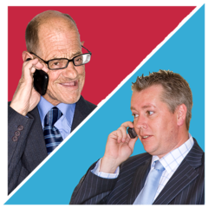

There will be one main person from your organisation that DRILL will speak to about the project.

Your organisation would need to:

- Make sure the project runs well

- Make sure DRILL gets all the information it needs

- Go to meetings with DRILL about the project

- Write reports about how the project is going

What will happen when

This may change once the project starts.

What | When
Your organisation would come to a meeting with DRILL.  This is to talk about how we will work together. | In 10 working days or less after the contract starts.  The contract is the agreement we make together.
Your organisation would send us the information we need about how we will work together.  DRILL will write up notes from the meeting. | In 10 working days or less after the meeting.
Your organisation would do the work for Stage 1 (see page 7 for more information) | In 32 weeks or less after the contract starts.
Your organisation would do the work for Stage 2 (see page 9 for more information) | In 50 weeks or less after the contact starts.
Your organisation would do the work for Stage 3 (see page 11 for more information) | By the date that the contract ends.
Your organisation would write a final report and come to a meeting about the project. | Report in 1 month or less after the contract ends.  Meeting in 1 month or less after you send us the final report.

How to say you want to do the project

You need to give us all the information we ask for.

Email your information to:
sylviagordon@disabilityaction.org

You must send us the information by
27 November 2018 at 12pm.

Our website is www.drilluk.org/tenders
Pictures by Photosymbols

