

Regeneration
Project Management
Construction and Property Services
Energy Carbon Sustainability

Create and Deliver

Devonshire Park Redevelopment

Wayfinding and Signage Consultant

Appointment Brief

September 2017



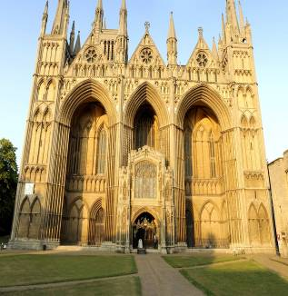

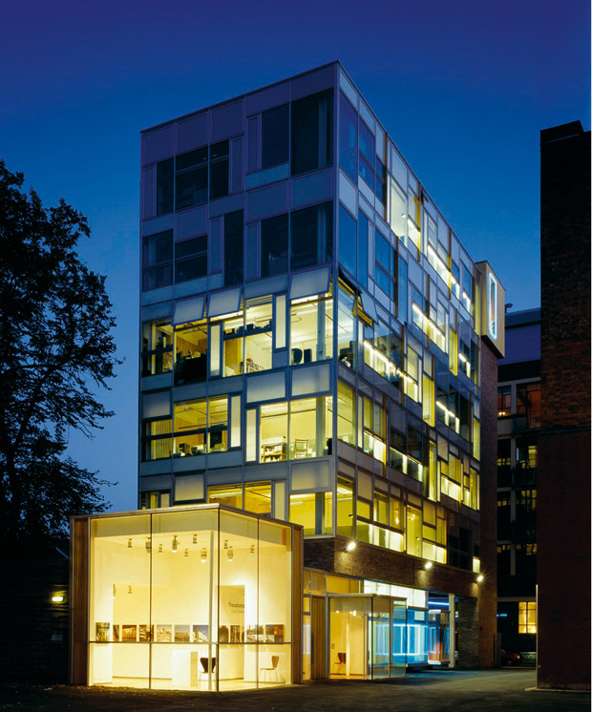
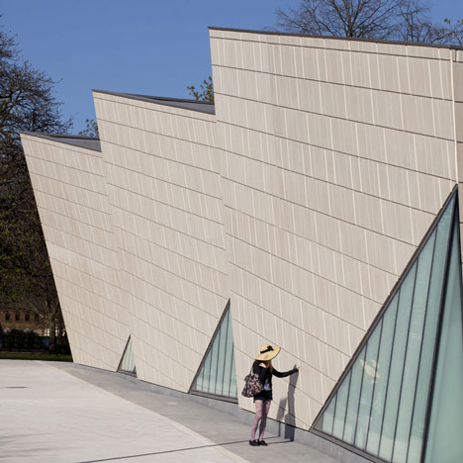

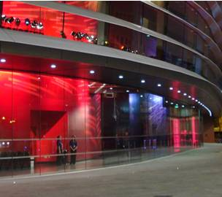

www.focus-consultants.co.uk

Focus Offices

Nottingham
Focus House
Millennium Way West
Phoenix Park
Nottingham
NG8 6AS
Tel: 0115 976 5050
E-mail: enquiries@focus-consultants.com
Website: www.focus-consultants.co.uk

Leicester
4 Merus Court
Meridian Business Park
Leicester
LE19 1RJ
E-mail: leicesterenquiries@focus-consultants.com
Website: www.focus-consultants.co.uk

Lincolnshire
Focus House
Resolution Close
Endeavour Park
Boston
Lincolnshire
PE21 7TT
Tel: 01205 355 207
E-mail: bostonenquiries@focus-consultants.com
Website: www.focus-consultants.co.uk

London
605 Elizabeth House
39 York Road
London
SE1 7NQ
Tel: 0203 0969717
E-mail: londonenquiries@focus-consultants.com
Website: www.focus-consultants.co.uk
© Focus Consultants 2010 LLP

Client:
Eastbourne Borough Council
1 Grove Road
Eastbourne
East Sussex
BN21 4TW

Client Lead: Paul Quanstrom, Corporate Support Officer
Tel: 01323 415375
Email: paul.quanstrom@eastbourne.gov.uk

Prepared By:
Focus Consultants
605 Elizabeth House
39 York Road
London
SE1 7NQ

Focus Contact: Eleanor Clarke, Partner
Tel: 0203 0969717
Email: eleanor.clarke@focus-consultants.com

Project: Devonshire Park Redevelopment, Eastbourne

Document Title: Wayfinding and Signage Consultant

Date: September 2017

Authorised By: Eleanor Clarke, Partner

Signature:
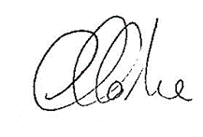

CONTENTS
 | Page Nr
- Introduction to the Project | 2
2.0 Consultant Appointment | 10

APPENDICES

Appendix A - Schedule of Service
Appendix B - Form of Agreement

1.0 Introduction to the Project

1.1 Subject of Appointment

This Appointment Brief is for the appointment of the Wayfinding and Signage Consultant (herein known as ‘the Consultant’) for the purposes of developing the statutory permissions for the Devonshire Park Redevelopment project in Eastbourne (herein known as ‘the Project’).

The scope of the Project includes all areas within the Devonshire Park Redevelopment as described below and specifically the Devonshire Park Theatre, the Winter Gardens, the Congress Theatre, the Tennis Facilities, new build Conference Centre, and landscaping/public realm. The Consultant will be required to give consideration to the wider setting and context of Devonshire Park and provide proposals for ensuring the integration and raising the profile of Devonshire Park locally, regionally, and nationally.

1.2 Project Summary/Overview

Vision Statement:

‘The transformed Devonshire Park will be one of the UK’s most distinctive and talked-about cultural places. It will celebrate and care for its unique heritage. Through its relationships with diverse performing and visual arts audiences and its partnerships with artists and fellow-producers it will enrich lives. Through its mission to entertain through everything from theatre to tennis, it will welcome hundreds of thousands of people every year. This cultural vitality and visibility will make Devonshire Park a natural place for people to gather and to meet – whether for a major conference or for exceptional hospitality – bringing new people to Eastbourne, to culture and to support the sustainability of the Park for future generations.’

‘To transform Devonshire Park into a distinctive, thriving, diverse cultural and tennis destination and amenity with an economically and environmentally sustainable long term future that can be enjoyed by the local community and international visitors alike.’

Objectives:

- To celebrate its past and embrace its future.
- To sensitively transform and renew its key heritage buildings to create a quality experience.
- To make efficient use of these existing buildings ensuring that they are flexible for traditional and new uses.
- To create carefully judged new facilities that make a dramatic statement of confidence in the future.
- To ensure that new and existing facilities work together as an efficient and coherent whole.
- The creation of a new public realm that improves the setting of the listed buildings and opens the Park to a wider audience for enjoyment throughout the year.
- To improve the connection and visibility between the Town Centre, Park and the Seafront.

Overview

Devonshire Park consists of a number of theatres, arts and cultural venues; including theatres, galleries, several buildings providing offices for external professionals, staffing and storage, several car parks, conference facilities and the International Lawn Tennis Centre, which hosts six major tennis tournaments each year, from the AEGON International ladies and men’s tennis, to junior and veteran events.

The site also accommodates many of the Tourism and Leisure Staff at various locations throughout the site who, in addition to the services above, also deliver major events and conferencing services.

It is a key development site in Eastbourne Borough Council’s ambitious renewal strategy for the Town. Consequently, the project has cross party support with both parties having membership on the Project Board that steers the development. The Park was a key element of the town planning of Eastbourne, undertaken by the Duke of Devonshire and his architect Henry Currey, as a public amenity combining sports and arts, starting with the Winter Garden in 1875 and followed by the Devonshire Park Theatre. Since then buildings have been added, haphazardly, over time, with no overall master plan, and existing listed buildings have become tired and altered, sometimes unsympathetically, without any co-ordination.

The existing buildings all have their own separate and different orientations. The Park contains a number of buildings which are of historical, heritage and architectural significance including the Devonshire Park Theatre and the Winter Garden which are Grade II and the Congress Theatre which is Grade II*.

The original catalyst for the Project was dilapidations affecting the façade of the Congress Theatre which suffers from significant concrete corrosion issues; the careful replacement of the facade of this II* listed facility was completed in summer 2015. Since then, repair works and heating plant upgrade works have taken place at the Devonshire Park Theatre, a new showcourt has been built within the tennis field, a new international tennis players facility has been built and had its first use at the Aegon 2017 tournament and works are under way to the Congress Theatre and construction of the Welcome Building. Works to the Winter Garden are due to commence in early 2018.

The scope of the wayfinding and signage design is for the whole of the site and in particular the Southern Buildings which comprises the restoration and repair works to the 20th Century Grade II* listed Congress Theatre, the 19th Century Grade II listed Winter Garden and the construction of a new build 4 storey Welcome Building connecting the two and including conference facilities, plus the associated landscaping and public realm works. The works are to be completed January 2017 – April 2019. The design must also tie in with the wider town signage and wayfinding initiative and with East Sussex County Council requirements, details of both of these schemes will be provided to the successful consultant.

1.3 Funding

At the Cabinet Meeting on 9th December 2015 approval was given to the full £44m required to deliver the Devonshire Park Redevelopment project. £5m has been secured from the South East LEP towards the project.

1.4 Planning

At the Planning Committee Meeting on 17th November 2015 conditioned planning permission and listed building consent was granted for the full project and all pre-commencement conditions have been discharged with other conditions in due process.

It is expected that a separate planning application and advertisement application will be required for the external wayfinding and signage.

In addition, the Congress Theatre, Winter Garden, and Devonshire Park Theatre are all listed and therefore consultation on the wayfinding and signage strategy with Historic England will be required and Listed Building Consent may be needed.

1.5 Site Description and Location

The site lies between the railway station, retail centre, seafront and residential/hotel district. The Project seeks to reinforce connections between the Park, its public buildings and the town. The site is bounded by Blackwater Road to the north, Hardwick Road to the east, Compton Street/Wilmington Gardens to the south and College Road to the west. It is a self-contained, walled site that the Project seeks to open up providing stronger links to the seafront and a sense of arrival – a true destination.
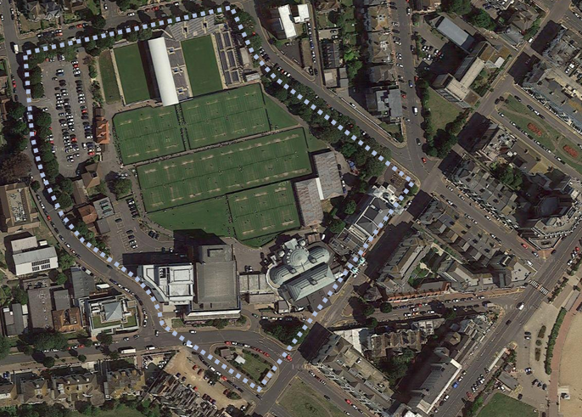

The site is wholly owned by Eastbourne Borough Council. The Towner Gallery is on a lease to a Trust. Neither the Buccaneer nor Towner Gallery form part of the project but both are key neighbours and therefore stakeholders in the project.

The site is generally operated, managed and maintained by Eastbourne Borough Council.

Key uses of the site run by Eastbourne Borough Council are as follows:

Conferences
- The Congress Theatre is the primary conference venue and the Winter Garden serves as exhibition space and break out facilities. The new Welcome Building once constructed will provide state of the art purpose built conference halls with adjacent break out facilities/meeting rooms. It has a prime spot in the Park with front and back terraces overlooking the Park and out to the coast.

Catering
- Devonshire Park Catering based in Devonshire Park; offices in the Winter Garden and a commercial kitchen attached to the Congress Suite. In the new arrangement the kitchen is sited in the Racquet Court and the offices for the staff are elsewhere on the site.
- Deliver catering services for Council facilities and additionally a commercial arm for outside catering, functions etc. This will be contracted out once the full site re-opens.
- The new facilities provide a new café in the Welcome Building and in the Foyer of the Congress Theatre.

Theatres
- Congress Theatre; Capacity 1690; Grade II* listed venue for larger shows/musicals etc and also the primary venue for conference business which was part of its original purpose. The replacement of the façade has been completed as part of an early works package.
- Winter Garden; two rooms, the Floral Hall and the Gold Room; Grade II listed large and versatile Victorian pavilion for functions, exhibitions, festivals, shows etc with 2 rooms. The ground floor Floral Hall will be linked to the Welcome Building and through to the Congress Theatre.
- Devonshire Park Theatre; capacity 600; Grade II listed Victorian theatre used for plays, musicals etc.

Public Realm
- Site visits are destination or event driven.
- Site comes alive when tennis events are on.
- The new scheme will help to ensure the site is engaging and welcoming to the local community and the wider visitors to make it a destination in its own right.

T&L Offices, Events
- The Tourism and Leisure services (theatres, Conferencing etc) are based on the site in the Point building,
- The Events team are based in the Pavilion building adjacent to College Road Car Park.

Tennis
- Devonshire Park hosts a major pre-Wimbledon Tennis Tournament in June each year attracting players from across the world including several of the world’s top twenty players. The tournament is currently sponsored by AEGON.
- In addition, the Devonshire Park site also hosts a number of regional and international tennis tournaments due to the high standard of its grass courts.

Note that the Tennis is run in partnership with the Lawn Tennis Association and therefore they are a key stakeholder in the Project. The AEGON International Tennis Tournament must continue throughout the course of the project.

The following is run independently:

Towner
- Recently constructed (2010) contemporary Art Gallery with exhibition and collection galleries.
- Managed by an independent Trust.

1.6 Project Governance

See Governance Diagram below.

Core Team
Partnership
Group
PM
Client
Sponsor
Project
Board

Project Board Remit
- Champions of project
- Take decisions within delegated governance arrangements
- Endorse the PID
- Control dissemination of information
- Stakeholder management
- Resolution of conflicts between time, cost and performance
- Awareness of risks
- Agree the benefits.

Project Board Members
- Cllr David Tutt
- Cllr Margaret Bannister
- Cllr Gordon Jenkins
- Robert Cottrill
- Alan Osborne

Partnership Group Remit
- Authority to be the voice of their organisation
- Understand the wider implications of the project
- Challenge the project to maximise its success
- Sense check for wider consultation
- Promote the project positively.

Partnership Group Members
- Arts Council England
- Theatres Trust
- Historic England
- Lawn Tennis Assoc
- EB Hospitality Association
- Chamber of Commerce
- East Sussex County Council
- Eastbourne Conference Partnership
- Victorian Society
- Twentieth Century Society
- Eastbourne Society
- EBC Tourism & Leisure service managers for Theatres; Towner; Conferences; catering.

Project Sponsor
Nazeya Hussain; Director of Regeneration and Planning
Remit:
- Delivery of the project for the client
- Manage the interface between the parties

Nazeya is supported by a Programme Director, Graham Cook.

Client
Phil Evans; Director of Tourism & Enterprise
Remit: Controls the specification of the project

The Core Team includes the Project Sponsor, the Client and Charlotte Coe – Regeneration & Corporate Projects LawyerCelia Cullen – Lawyer, Graham Cook the Programme Director, and Paul Quanstrom – Client Project Manager

The Core Team meets weekly and the Project Board and Partnership Group meet bi-monthly.

1.7 Project Programme

The proposed programme for the Project is outlined below.

Milestones | Date
RIBA Stage 4 – Technical Design | January 2016 – February 2017
Production/ Tender Documentation / Tender Action | July 2016 – February 2017
RIBA Stages 5-6 – Construction & Handover | January 2017 – June 2019
Defects Liability period | June 2019 – June 2020
RIBA Stage 7 – In Use survey and evaluation | June 2019 – June 2020
Project Performance review | Feb 2020 – March 2020
Project Complete | End March 2020

1.8 Wayfinding and Signage Programme

Milestones | Date
Deadline for Quotation Response | 6th October 2017
Interview | w/c 9th October 2017
Appointment of Wayfinding and Signage Consultant | 13th October 2017
RIBA 1 – Development of Wayfinding and Signage Strategy | October – November 2017
RIBA 2 - Concept Design | December – February 2018
RIBA 3 – Developed Design | March – April 2018
Submission of Planning Application | April 2018
Planning Approval Granted | June 2018
RIBA Stage 4 – Technical Design | May 2018 – July 2018
Production / Art working | August – September 2018
Procure Signage Contractor | August – September 2018
Fabrication and Installation | October 2018 – March 2019
Defects Liability period | March 2019 – March 2020
Project Complete | End March 2020

1.9 Project Team

Client Eastbourne Borough Council
Project Manager Focus Consultants LLP
Conservation Architect Levitt Bernstein, Lead of MDDT
New Build Architect Levitt Bernstein, Part of MDDT
Tennis Facilities Architect TrioPlus, Part of MDDT
Landscape Architect Levitt Bernstein, Part of MDDT
Principal Designer Levitt Bernstein, Part of MDDT
Structural Engineer Edge Structures, Part of MDDT
M&E Engineer Max Fordham, Part of MDDT
Fire Engineer Exova Warrington, Part of MDDT
Transport Planner Project Centre, Part of MDDT
Access Consultant All Clear Design, Part of MDDT
Quantity Surveyor Huntley Cartwright
Theatre Consultant Neill Woodger Associates
Business Planner David Clarke Associates
Conference Consultant Venues Advisor
Catering Consultant Kendrick Hobbs
Retail Consultant Quince Retail
Building Control Wealdon
Planning Consultant Parker Dann
Legal Dentons UKMEA LLP
Branding Consultant Someone
Wayfinding and Signage Consultant TBC
Others As required

1.10 Meeting and Reporting Structure

The Wayfinding and Signage Consultant will be expected to attend meetings as needed to progress the works. These will be held in Eastbourne. It may also be necessary for the Wayfinding and Signage Consultant to meet with the Design Team at the Architect's office in London on an ad hoc basis.

2.0 Consultant Appointment

2.1 Introduction

The Consultant shall provide the Services described with an excellence of service as expected of a competent, professional person of the relevant discipline in the performance of their services who is experienced in carrying out such services in relation to works of similar size, scope and nature to the proposed works.

2.2 Brief

To develop a way finding strategy, guidelines and designs for visitor information, orientation (new Devonshire Park plan, orientation leaflet and signage) and site signage across the site. Note that statutory signage is in the remit of the architects. The budget for the wayfinding and signage across the project is £250,000.

This strategy must have applicability to the various uses of the site including but not limited to:

- Theatre goers to Devonshire Park Theatre, Winter Gardens and Congress Theatre
- Conference organisers and delegates to Winter Gardens, Welcome Building, and Congress Theatre and International Tennis Centre
- Exhibition organisers and attendees to the same as above.
- Aegon Tennis Tournament across the whole site. Note that this tournament has its own brand and signage that is brought in and therefore the new strategy must be able to work in tandem with this.
- Cafe visitors
- General public

The Consultant will be required to:

Act as the lead consultant within a wider project design team on matters relating to signage and way finding at and around the site including the access consultant.

Produce a way finding and signage strategy and guidelines for the re-developed site which implements visual language across all signage and way finding tools – signage, leaflets, maps, etc. To include approach on naming of break out/meeting rooms across the site.

Produce a fully costed list of signage requirements across the site.

Undertake, as necessary, prototyping of signage to test and prove design solutions.

Create a signage hierachy and guidelines to guide any future signage requirements.

Produce artwork for all signage and wayfinding elements across the site

Assist with the procurement of the signage and wayfinding supplier through production of tender information, responding to tender queries and assisting with evaluation of tenders

Work to an agreed timetable of design development with the Council, factoring in a 3-stage incremental sign-off creative process, from initial ideas concepts working towards a final design sign-off. The final sign-off will come with the culmination of the project and the delivery of all assets, to factor in a range of testing and consultation into the process to support the proposed approach.

Familiarise and be fully acquainted with the site and its users, its vision, mission and values.

Carry out an audit of current street signage to the site from town centre/railway station and seafront (see below about new town centre signage).

Provide tests and samples of any materials and finishes in time for client approval and testing.

Work with the Council to develop a meeting schedule and be in attendance for meeting where required.

Seek and provide estimates and competitive quotes for any attributable costs prior to procurement as requested by the Council. Maintain up-to-date records of costs at all times. It should be noted that the Council operates an “open book” policy with regard to contracts and finances and may require to see any sub-contractors estimates, discounts etc.

Provide comprehensive instruction via models, details, visuals and technical specifications for final client approval.

Liaise and work in collaboration with the Council's team, and to work with staff from across the organisation to understand and respond to their requirements and feedback.

Work alongside teams from the project consultants to ensure that all work is integrated with the broader project scheme, to identify timescales and deadline for delivery in feeding into that process.

Allow for alternatives in the event of value engineering.

Present proposals to the Project Team, the Project Steering Group, the Project Board, the Partnership Group and a wider staff briefing if requested.

Adhere to the Council's internal policies and procedures, including compliance in the areas of Equality Access & Diversity and Health & Safety and Ethics. Copies of all the Council's policies can be found on the website.

All elements in the proposed project are to be:

Compliant with current Equality Act legislation.

In line with EBC's corporate ethos and strategic objectives. The council does not have an overarching Streetscene Strategy and makes decisions on a project by project basis. A strategy for the current town centre redevelopment is being finalised now and will be provided to the consultant. This will indicate form, content and location of signage to allow the consultant to identify where it will be necessary to “join up” the two schemes to ensure clearly marked routes from the town centre to the Devonshire Quarter.

In line with the site development aspirations as outlined in this document.

Where materials are recommended, these should be subject to Health and Safety, sustainability, and durability testing.

Where materials are recommended these should be open to value engineering

Where elements are to be delivered digitally that shall be designed to be read on PC, tablets and mobile phones

Developed in harmony with the broader architectural design approaches

Branding Guidelines have been developed for the site and the Consultant will be required to work within the parameters of the requirements set out therein. The Branding Guidelines will be shared with the successful bidder but the key outputs can be seen here:

http://devonshirequarter.co.uk/

2.3 Basis of Appointment

The Consultant's appointment will be by formal Agreement as detailed at Appendix B of this appointment brief. The employer will be Eastbourne Borough Council. No material amendments will be accepted to this Agreement unless they have implications on the ability of the Consultant to maintain insurance. Any amendments required must be submitted with your quotation response.

2.4 Services

The Consultant will be required to provide all services identified within the Schedule of Professional Services included at Appendix A.

2.5 Fee

Please complete the Form of Quotation and return it as part of your response. The Form of Quotation included with the Request for Quotation

The fee proposal to provide the services indicated in the Schedule of Professional Services is to include all reasonable expenses and disbursements.

The fee proposal is to be presented in a clear manner, supported by a stage by stage breakdown, presented in sufficient detail and a style that enables a clear understanding of the fee, services, programme and deliverables for each stage, with any specific exclusions stated.

2.6 Timetable and Appointment Commencement

The appointment will commence from 13th October 2017. Consultants should ensure adequate resource provision to deliver the requirements of this appointment, within the timescale stipulated at 1.7 above.

APPENDIX A

Schedule of Service

Signage Consultant - Schedule of Service

For ease of reference the Services have been divided into two categories; pre-contract and post-contract. The pre-contract element has been sub-divided further in to the following categories; General, Outline Design, Detailed Design and Tender Action.

In carrying out the Services, the Consultant shall address all communications, including advice, to the Employer through the Project Manager (save where the Consultant considers it necessary or appropriate to direct communications or advice direct to the Employer) who is to be responsible, to the Employer, for matters of co-ordination of the design and specification. The Consultant shall liaise with the Project Team throughout the carrying out of the Services.

Pre-Contract Services

1.0 General Requirements

  - Agree operational procedures with the Project Manager, the Employer and the Professional Team to include communication channels, authority structure, reporting and meeting procedures between the Employer, the Project Manager, the Consultant, the Professional Team any Funding Body, any Tenant and any Tenant’s Designer including in relation but not limited to;

- Design, specification and quality of the Works.
- Programme and progress.
- Budget and financial effects.
- Compliance with any contractual obligations.
- Monitoring the Works on the Project Site in compliance with the Building Contract.
- The requirements of the Employer, any Funding Body and any Tenant.
- The convening, chairing, attendance, purpose, frequency of meetings, and the responsibility for recording of meetings and circulation of information.

1.2 Comply with the procedures for co-ordinating the design and specification of the Works prepared by the Project Manager including procedures for the issue of all drawings, specifications and other documents and the maintenance of full and proper records by the Design Team.

1.3 In conjunction with the Professional Team review the Signage Design Brief and report to the Employer on any matters contained within the Signage Design Brief which in the opinion of the Consultant should be reviewed further and/or amended having regard to the requirements of the Employer in relation to the Project. The obligation upon the Consultant to review the Design Brief and advise the Employer thereon shall continue during the initial Design Phase.

1.4 Establish at the outset with the Employer an agreed cost limit for the Signage Proposals and from time to time review and maintain the agreed cost limit. With the Professional Team, provide the Employer with all such budget estimates (including breaking these down into sections where appropriate), cost analyses, cost reports, and cost advice generally as the Employer may require. Advise the Employer on steps the Employer may take where the estimated costs exceed the agreed costs limit.

1.5 Assist the Project Manager as required to prepare, maintain and review not less than monthly the Project Master Programme indicating periods and critical dates for the design, contract negotiation, construction and other principal activities. Report to the Employer on progress against the Project Master Programme and advise on and recommend to the Employer action to be taken to mitigate delays which have occurred or which the Consultant may occur.

1.6 Liaise with the Employer to ascertain the requirements of any Funding Body, any Tenant and any Tenant’s Designers or other person with whom the Employer may be negotiating in relation to the Project Site and advise the Employer of any further information which, in the opinion of the Consultant, should be obtained in respect of any matter which might affect the designs or specifications to be prepared by the Professional Team and representatives of the end user (Haymarket Theatre).

1.7 Advise the Employer in relation to the design and positioning of the signage proposals having regard to the nature of the Project proposed by the Employer.

1.8 In conjunction with the Professional Team review with the Employer alternative design and construction approaches and cost implications having regard to commissioning, capital and life cycle costs.

1.9 With the Professional Team advise the Employer on reasonable risk analysis and prepare risk assessments and recommend actions to avoid/minimise the effects of risk on the signage element of the Project, and carry out any such further analysis and assessment as the Employer may reasonably require.

1.10 Make and monitor as appropriate applications for all permissions, approvals, consents and the like required by any statute, regulation of the like relating to the discipline of the Consultant and advise the Employer accordingly.

1.11 With the Professional Team review, comment upon and approve any plans, specifications and details relating to the fitting-out works of any Tenant and advise the Employer if the integrity of the project signage might be compromised or otherwise adversely affected by the carrying out of the proposed fitting-out works of any Tenant.

  - In conjunction with the Professional Team, prepare an all necessary specifications and schedules for the core design and construction elements.

1.13 Monitor the production of design information prepared by the Consultant against the design programme and if delayed use reasonable endeavours to expedite the production of the information.

1.14 With the Design Team review the practical buildability and technical design of proposals including durability and maintenance of materials and report to the Employer.
1.15 Not do or fail to do any act or thing which may cause or contribute to a breach by the Employer of the Agreement for Headlease, any Agreement for Lease, the Building Contract or any Funding Agreement.

2.0 Appraisal and Outline Design

2.1 Obtain from the Employer details of the Signage Design Brief, Survey Information, the Employer’s brief, budget and timetable in relation to the project, and specifically the signage element. Confirm the Employer’s requirements, establish designs standards, investigate alternative solutions and identify the preferred concepts.

2.2 Advise the Employer on matters or obligations arising under the Part M of the Building Regulations, and the Equality Act 2010. (It should be noted that a separate Access Consultant has been appointed to assist in this regard).

2.3 Discuss with the Client and the Project Manager the role of the Consultant and his relationship with the Lead Consultant and any Other Consultants, the various Contractors and Sub-Contractors and any planning supervisor appointed in accordance with the Construction (Design and Management) Regulations.

2.4 Collaborate with any other Consultants in seeking from the Client any further information needed so that they can perform their services under their various agreements with the Client.

2.5 Collaborate any Other Consultants in making initial recommendations to the Client on the technical viability of the Works.

2. 6 Visit the site as necessary and study data and information relating to the Project and relevant to the Works which are reasonably accessible to the Consultant, and consider reports relating to the Works which have either been prepared by the Consultant or have been prepared by others and made available to the Consultant by the Client.

2.7 Consult any local or other authorities about matters of principle in connection with the design of the Works, in particular any issues including relating to utility service providers and the like.

2.8 Consider alternative outline solutions for the Works.

    - Provide sufficient preliminary information in relation to the Works in the form of advice, sketches, reports or outline specifications to enable the Lead Consultant to prepare his outline proposals and assist any other Consultant to prepare the outline Cost Plan.
  - In conjunction with the lead designer and other design consultants establish an outline signage strategy for approval by the Employer. The strategy must cover the following elements:

- Statutory signage requirements
- Way finding signage requirements
- Concept design for signage, including primary palette of materials and colours (including samples and ‘mock-ups’)
- Services infrastructure to accommodate signage
- Structural infrastructure to accommodate signage
- A cost plan for the manufacture and installation of the signage.

  - Undertake Consultations with key Eastbourne Borough Council Departments, including, but not limited to:

- Planning
- Building Control
- Corporate Access
- Highways
- Public Art
- Environment/Energy Team.

Sponsorship & Fundraising

  - Attend all such meetings with external stakeholders/users in order to present design ideas, and generate feedback. (Minimum of 2 meetings in Eastbourne to be allowed for).

3.0 Detailed Design

3.1 Liaise as may be necessary with the Project Manager and any other Consultants to agree a programme for the whole of the design and construction of the Works.

3.2 Develop the design of the detailed proposals for the Works in collaboration with the Lead Consultant and any other Consultants.

3.3 Prepare such representative sketches, drawings, specifications, and/or calculations in respect of the Works as are necessary to enable the Lead Consultant or any other Consultant to prepare a more detailed Cost Plan.

3.4 Provide by way of Sketch Drawings or schedules information to assist the structural planning requirements showing locations and approximate sizes and provide the approximate weight of any item affecting the structural design.

3.5 Seek through the Project Manager the Client's approval of the detailed proposals and consent to proceed to the Final Proposals Stage.

3.6 Develop the design of the Works in collaboration any other Consultants and prepare sufficient calculations, Schematic Drawings, schedules and specifications to enable the Consultant, Lead Consultant or any Other Consultant to prepare the final proposals.

3.7 Assist in the provision of Builders Work Information sufficient to allow development of the structural design and mechanical and electrical service installations to enable the Construction Contractor to sufficiently interpret, and price it at tender stage.

3.8 Collaborate with the Lead Consultant and any other Consultants to prepare the final proposals for presentation to the Client, drawing attention to any significant differences from the previously agreed requirements for the Works.

    - Prepare Detailed Design Drawings for the Works.

  - Prepare detailed room data sheets in respect of the final design proposals, and manage the co-ordination of these with those for other disciplines.

  - Prepare a detailed specification for the proposed signage installation in sufficient detail to enable specialist contractors to submit bona fide tenders for the works.

4.0 Tender Action and Appraisal

4.1 After receiving the Client’s consent to proceed to the Tender Documentation and Tender Action Stage, with the Professional Team prepare a full package of tender documents to enable the prices for the signage element to be invited.

Outline Schedule of Tender Stage Deliverables required by the Consultant

Drawings
- Typical standard architectural details in relation to the core construction elements, and the like, i.e fixing methods.
- Core Location Plans, including but not limited to:
  - Site Plan
  - Floor Plans
  - Elevations
  - Detailed design drawings for each specific signage type and function.

Specifications
- NBS Specification or equal and approved for the signage manufacture and installation elements.
- Detailed room data sheets for the core signage elements.

4.2 Tenders will be invited on a package basis by the appointed Contractor in collaboration with the remainder of the Client Team.

4.3 Assist the Client as required to:
- Assess responses and advise on and obtain the Employer’s approval to a list of tenderers for the signage package.
- Insofar as may be necessary, liaise with and/or provide information to tenderers, including any specialist sub-contractors or suppliers, to enable them to prepare and submit tenders to the Employer, and report to the Employer upon any matters arising.
- Assist in any mid-tender meetings as may be required with any tenderer and ensure the circulation of questions, responses and information to all tenderers.
- Assist the Employer on procedures for appraising and evaluating tenders including procedures for post tender interviews.
- Appraise and evaluate the tenders with the Professional Team and report to and advise the Employer upon the tenders received.

- Post-Contract Services

  - Develop the design information submitted at tender stage for Construction issue, including preparation of all detailed working drawings including artwork and the like to enable the Signage Contractor to complete the works in accordance with the Employers Requirements.

  - Comply fully with all duties as defined under the Construction (Design and Management) Regulations 2015.

5.3 Make all necessary inspections during the manufacture and installation of the signage works, both on and off site, to maintain quality standards and compliance with the specification.

APPENDIX B

Form of Agreement

APPENDIX C

Brand Guidelines

