

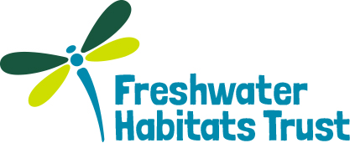

**Living Waters: Brief for Rainwater harvesting at Leygreen Farm (NFNPA – 0026)**

## Summary

The New Forest National Park Authority and partners are leading a Landscape Partnership Scheme funded by the Heritage Lottery Fund: **Our Past, Our Future** (OPOF). This 5 year partnership project will deliver some 20 projects under three main themes (see Section 2 below).

The Freshwater Habitats Trust (FHT) is leading on the delivery of the **Living Waters** Project, which is focused on the Beaulieu Stream catchment area. The project aims to reduce diffuse nutrient and sediment pollution and improve freshwater biodiversity through a range of actions, working in close collaboration with landowners.

**FHT and the New Forest National Park Authority are looking to commission a rainwater harvesting system at Leygreen Farm, which needs to be installed by 31st March 2016**.

Further information about the project and detailed specifications are included the Sections below.

## Our Past, our Future overview

The OPOF’s vision is to ensure the New Forest’s distinctive landscape survives through future change and modern-day pressures. A range of projects to **restore habitats, discover forest heritage and develop forest skills** alongside volunteering and measures to connect people to the landscape, will aim to provide a step-change towards this goal.

This will be achieved through the delivery of 20 projects under the following themes.

**Restoring Lost Landscapes**

This theme focuses on practical work and management of the lands surrounding the Open Forest in order to improve and protect the natural environment. The projects are aimed at restoring habitats and decreasing fragmentation, increasing responsible access, sustaining historic land management practices and discovering and restoring archaeology and built heritage.

**Developing Forest Skills**

This theme focuses on the people and communities living and working in the New Forest. The projects will aim to retain, develop and share knowledge and skills required for sustainable management of the New Forest habitats and built heritage.

**Discovering Forest Heritage & Inspiring a New Generation**

This theme focuses on encouraging, enthusing and inspiring a new generation of people to be more involved in learning about, championing and caring for the New Forest. The projects will promote an understanding of the New Forest’s unique heritage and its common story amongst residents, communities and visitors through a range of interpretation projects, educational campaigns, and engagement of volunteers.

## Living Waters overview

The Living Waters Project will help to restore one of the New Forest’s most important freshwater landscapes. These landscapes include numerous ponds, rivers, lakes and streams which together support some of the UK’s rarest plants and animals. However, due to historic modification some elements of these landscapes have become disconnected or put under stress due to changes in land management and anthropogenic pressure.

The New Forest Catchment Partnership have been working with local landowners, stakeholders and communities on **the Beaulieu River** to identify issues which may be impacting on the water environment and find solutions which will bring significant benefits for freshwater wildlife, and put people in touch with their freshwater heritage.

**Specific issues on the Beaulieu River include:**

* Lack of connection between communities and their freshwater environment – there is little information available in a publically accessible format about the heritage, quality and importance of New Forest freshwaters
* In-stream structures – creating restrictions on eel passage, erosion due to obstructions in the river channel and lack of connectivity from source to sea
* Sudden runoff following rainfall – large areas of hard standing and agricultural farm buildings and drainage straight to the river
* Diffuse agricultural runoff – nutrient runoff to naturally low nutrient freshwater habitats from livestock and cultivation of crops
* Lack of suitable habitat for key freshwater species within agricultural areas surrounding the New Forest (i.e. amphibians and dragonflies), limiting dispersal beyond the boundary of the protected area
* Recreational pressure – runoff from small horse pasture paddocks and increasing pressure from recreational vehicles in car parks (i.e. disposal of grey water)

**The objectives of the Project are to:**

1. move towards Water Framework Directive targets through reducing diffuse pollution in order to improve water quality and in-stream biodiversity in the lower Beaulieu catchment and the Beaulieu estuary, including the Shellfish Protected Area;
2. restore connectivity for priority species;
3. monitor the effectiveness of these measures through their contribution to better water quality, and potential to extend the high quality freshwater environment beyond the protected area of the New Forest;
4. raise awareness of the importance of the freshwater landscape; and
5. deliver messages about individual measures that can be taken to help protected good water quality (e.g. through clean water camping campaign, developing a schools education pack and running training events for water quality volunteers).

A programme of work will be implemented over the next three years (2016-2018) by the Living Waters Project Team to address these issues in the Beaulieu Stream catchment.

The work programme has already been agreed by landowners and is ready to be delivered. This tender is for one of the work items.

## Tender specification

This brief is for the installation of a **rainwater harvesting system** at Leygreen Farm, Lyndhurst Rd, Brockenhurst SO42 7YP (Ordnance Survey grid reference: SU 37879 03636).The contractor will work closely with the tenant farmer, Mr Martin Dolbear, and the Living Waters project team. The financial aspects of the contract will be managed by the New Forest National Park.

**Due to funding restrictions, the work is due to be completed by 18th March 2016 and invoiced for by 31st March 2016.** Site visits can be arranged by appointment week commencing 8th February 2016.

Water will be collected from at least 3 roofs (shown in dark blue in Figure 1 below), which each will have a raised storage tank located nearby, so that gravity can be used to access the water stored, although a pump may be needed at location (1).

The ditch (blue arrow, see Figure 1 below) running along the southern side of the farm is currently the main recipient of water from the farm yard, and the overflow from the storage tanks will need to run into this ditch.

The main drain which currently takes yard water to the southern ditch is shown in dashed yellow (see Figure 1 below).

1. **How to tender**

Contractors should provide:

* a *breakdown* of cost for the main elements of the water harvesting system including storage tanks, pipes and guttering (assume the existing infrastructure needs replacing), pumps and fixings
* evidence of experience of installing water harvesting systems
* evidence of ability to deliver within the timescale

1. **Selection Criteria**

Selection will be based on experience, cost and the ability to deliver within the given timescale (i.e. by 18th March 2016).

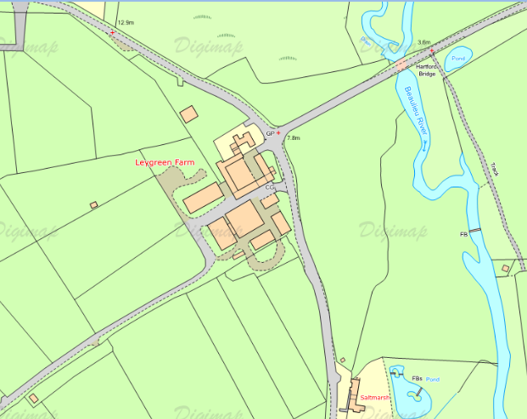

Roof (18 x 9 m) and storage tank 3

Roof (25 x 25 m) and storage tank 2 (in gap between barns)

Roof (13 x 32 m) and storage tank 1

**Figure 1 Overview map of Leygreen Farm, showing the location of water storage tanks and the water collection area.**

1. **Timescale for Tender**

The outline timescale is:

* Deadline for submissions on: Noon Wednesday 17th February
* Final selection by: Friday 19th February

All submissions are required to comply with the New Forest National Park Authority ‘Standard Conditions of Contract for Services’ (copy below) which will be used to draw up the contract with the winning contractor.



The Authority reserves the right to withdraw this contract opportunity without notice and will not be liable for any costs incurred by suppliers during any stage of the process.

All submissions must be made via our e-Procurement portal [In-tend](https://in-tendhost.co.uk/newforestnpa/aspx/Home) and must be submitted by **12noon Wednesday 17 February 2016.**

1. **Contact Details**

Any queries relating to this brief should be addressed to: Dr Pascale Nicolet, Director of Policy and Implementation, Freshwater Habitats Trust, [pnicolet@freshwaterhabitats.org.uk](mailto:pnicolet@freshwaterhabitats.org.uk), 07773731564.

Please note that to ensure fair and open competition, all substantive responses to any questions raised by interested suppliers will be made available to all other suppliers where appropriate. Any such clarifications will be posted on our In-tend portal and you will receive email notification to make you aware of this (you must be registered on the site in order to receive these).