Crown Commercial Service

**___________________________________________________________________________**

CONSTRUCTION PROFESSIONAL services framework schedule 5

template call off agreement (INCORPORATING THE nec4 professional services SHORT contract JUNE 2017 (including amendments issued january 2019 and october 2020) AND contract data

**___________________________________________________________________________**

**Date 27th September 2023**

**FORM OF AGREEMENT**

**Incorporating the NEC4 Professional Services Short Contract June 2017 incorporating amendments January 2019 and October 2020**

**Between**

**The Ministry of Defence (MOD), Defence Infrastructure Organisation (DIO)**

**And**

**Mott MacDonald Limited**

**For the provision of**

**DST FCM L2 Assets for Reassessment**

**THIS AGREEMENT is made the 27th day of September 2023**

**PARTIES:**

1. **The Ministry of Defence (MOD), Defence Infrastructure Organisation (DIO)** acting as part of the Crown (the "***Client***"); and

2. **Mott MacDonald Limited** which is a company incorporated in and in accordance with the laws of **England and Wales** Company No. **01243967** whose registered office address is at **8-10 Sydenham Road, Croydon, CR20 2EE** (the "***Consultant***").

**BACKGROUND**

1. The Minister for the Cabinet Office (the "**Cabinet Office**") as represented by Crown Commercial Service, a trading fund of the Cabinet Office, without separate legal personality (the "**Authority**"), established a framework for construction professional services for the benefit of public sector bodies.
2. The *Consultant* was appointed to the framework and executed the framework agreement (with reference number RM6165) which is dated [ ] (the “**Framework Agreement**”). In the Framework Agreement, the Consultant is identified as the “Supplier”.
3. On the 14th August 2023 the *Client*, acting as part of the Crown, and in the Framework Agreement is identified as a “Contracting Authority” invited the *Consultant* along with other framework suppliers to tender for the *Client’s* construction professional services requirements in accordance with the Call Off Procedure (as defined in the Framework Agreement).
4. On the *28th August* the *Consultant* submitted a tender response and was subsequently selected by the *Client* to provide the *service*.
5. The *Consultant* has agreed to Provide the Services in accordance with this agreement and the Framework Agreement.

**IT IS AGREED AS FOLLOWS:**

The *Client* will pay the *Consultant* the amount due and carry out his duties in accordance with the *conditions of contract* identified in the Contract Data and the Contract Schedules.

The *Consultant* will Provide the Service in accordance with the *conditions of contract* identified in the Contract Data and the Contract Schedules.

This contract incorporates the conditions of contract in the form of the NEC4 Professional Services Short Contract June 2017 Edition incorporating amendments January 2019 and October 2020 and incorporating the additional conditions specified in the Client’s Contract Data, which form this contract together with the documents referred to in it. References in the NEC4 Professional Services Short Contract June 2017 Edition incorporating amendments January 2019 and October 2020 to "the contract" are references to this contract.

This contract and the Framework Agreement, is the entire agreement between the parties in relation to the *service* and supersedes and extinguishes all prior arrangements, understandings, agreements, statements, representations or warranties (whether written or oral) relating thereto.

Neither party has been given, nor entered into this contract in reliance on any arrangements, understandings, agreements, statements, representations or warranties other than those expressly set out in this agreement.

Nothing in clauses 4 or 5 shall exclude liability in respect of misrepresentations made fraudulently.

**Executed Under Hand**

|  |  |  |
| --- | --- | --- |
| **Signed** | Supplier | Buyer |
| **Name** | ***Redacted*** | ***Redacted*** |
| **Title** | ***Redacted*** | ***Redacted*** |
| **Signature** | ***Redacted*** | ***Redacted*** |
| **Date** | 29th September 2023 | 29th September 2023 |

|  |
| --- |
| nec4 Professional Service |

Short Contract

|  |  |
| --- | --- |
| **A contract between** | **The Ministry of Defence (MOD), Defence Infrastructure Organisation (DIO)** |
|  |  |
| **and** | **Mott MacDonald Limited** |
|  |  |
| **for** | **Facilities Condition Management (FCM) L2 Assets for Re-Assessment** |

Contract Forms

Contract Data

The *Consultant’s* Offer

Price List

Scope

**Notes about the contract are printed in boxes like this one. They are not part of the contract**

|  |
| --- |
| Contract Data |
| The *Client’s* Contract Data |

The *Client* is

|  |  |  |
| --- | --- | --- |
| Name | The Ministry of Defence (MOD), Defence Infrastructure Organisation (DIO) | |
|  |  | |
| Address for communications | St George’s House| Defence Infrastructure Organisation Head Office |  DMS Whittington | Lichfield | Staffordshire | WS14 9PY | |
|  |  | |
| Address for electronic communications | ***Redacted*** | |
|  |  | |
| The service is | The Ministry of Defence (MOD), Defence Infrastructure Organisation (DIO) | |
| q |  | |
| The starting date is | 29th September 2023 | |
|  |  | |
| The completion date is | 31st March 2026 | |
|  |  | |
| The delay damages are | N/A | per day |
|  |  | |
| The *law of the contract* is | England & Wales | |
|  |  |  |
| The *period for reply* is | 2 | weeks |
|  |  |  |
| The *defects date* is | N/A | weeks after Completion |
|  |  |  |
| The *assessment date* is the | N/A | of each month |
|  |  |  |
|  | | |
|  | | |
| The United Kingdom Housing Grants, Construction and Regeneration Act (1996) **does not** **apply** | | |
|  | | |
|  | The *Adjudicator* is: | |
|  |  | |
| Name | *Institution of Civil Engineers* | |
|  |  | |
| Address for communications | Defence Infrastructure Organisation Head Office,  DMS Whittington,  Lichfield,  Staffordshire,  WS14 9PY | |
|  |  | |
| Address for electronic communications | ***Redacted*** | |

|  |
| --- |
| Contract Data |
| The *Client’s* Contract Data |

|  |  |  |  |  |
| --- | --- | --- | --- | --- |
| The interest rate on late payments is | | N/A | % per complete week of delay | |
| **Insert a rate only if a rate less than 0.5% per week of delay has been agreed.** | | | | |
|  |  | | | |
| The *Client* provides this insurance | N/A | | | |
|  |  | | | |
| **Only enter details here if the *Client* is to provide insurance.** | | | | |
|  |  | | | |
| The *Consultant* provides the following insurance cover | | | | |
| q |  | | | |
| **INSURANCE AGAINST** | **MINIMUM AMOUNT OF COVER** | | | **PERIOD FOLLOWING COMPLETION OR EARLIER TERMINATION** |
| Liability of the *Consultant* for claims made against it arising out of the *Consultant's* failure to use the skill and care normally used by professionals providing services similar to the service. | £5,000,000 in the aggregate | | | From the starting date until Contract end date |
| Loss of or damage to property and liability for bodily injury to or death of a person (not an employee of the *Consultant)* arising from or in connection with the *Consultant* Providing the Service | £5,000,000 in the aggregate | | | From the starting date until Contract end date |
| Liability for death of or bodily injury to employees of the *Consultant* arising out of and in the course of their employment in connection with the contract | £5,000,000 in the aggregate | | | From the starting date until Contract end date |
|  | | | | |

|  |  |
| --- | --- |
| The *Consultant’s* total liability to the *Client* which arises under or in connection with the contract is limited to | £5,000,000 |
|  |  |
| The *Adjudicator nominating body* is: | *Institution of Civil Engineers* |
|  |  |
| The *tribunal* is: | Arbitration |

|  |  |
| --- | --- |
|  |  |
| If the *tribunal* is arbitration, the arbitration procedure is | The *arbitration procedure* is the London Court of International Arbitration Rules |

**Social Value:**

Mott MacDonald’s performance will be assessed against the tender commitments made under the following Model Award Criteria (MAC):

* **MAC 7.1 Improve health and well being** in order to demonstrate action to support health and wellbeing, including physical and mental health, in the contract workforce.

KPI’s to be measured are as follows:

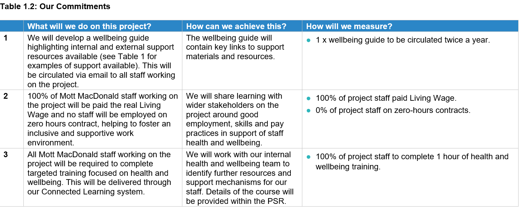

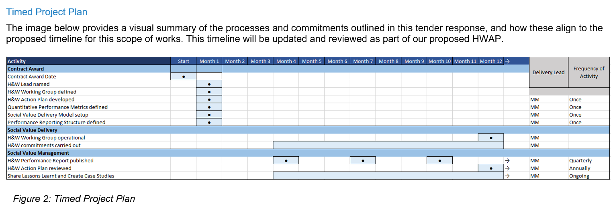

|  |
| --- |
| Contract Data |
| The *Client’s* Contract Data |

The *conditions of contract* are the NEC4 Professional Service Short Contract June 2017 incorporating amendments January 2019 and October 2020 and the following additional conditions

|  |
| --- |
| **Only enter details here if additional conditions are required** |
|  |
| **Option Z2 Identified and defined terms**  applies  **Option Z4 Admittance to Client’s Premises**  applies  **Option Z5 Prevention of fraud and bribery**  applies  **Option Z6 Equality and Diversity**  applies  **Option Z7 Legislation and Official Secrets**  applies  **Option Z8 Conflict of Interest**  applies  **Option Z9 Publicity and Branding**  does not apply  **Option Z10 Freedom of information**  applies  **Option Z13 Confidentiality and Information Sharing**  applies  **Option Z14 Security Requirements**  applies  **Option Z16 Tax Compliance**  applies  **Option Z22 Fair payment**  applies  **Option Z26 Building Information Modelling**  does not apply  the information execution plan is ……………………  **Option Z42 The Housing Grants, Construction and Regeneration Act 1996**  does not apply  **Option Z44 Intellectual Property Rights**  applies  **Option Z45 HMRC Requirements**  applies  **Option Z46 MoD DEFCON Requirements**  applies  **Option Z47 Small and Medium Sized Enterprises (SMEs)**  does not apply  The percentage of the *Consultant’s* subcontractors required to be SMEs is …………. %  **Option Z48 Apprenticeships**  applies  **Option Z49** **Change of Control**  applies  **Option Z50 Financial Standing**  applies  **Option Z51 Financial Distress**  applies  **Option Z52** **Records, audit access and open book data**  applies  **Option Z100 Data Protection**  applies  **Option Z101 Cyber Essentials**  applies  **Other additional conditions**  1. DEFCON 5J (Edn 18/11/16) - Unique Identifiers  2. DEFCON 76 (Edn 06/21) - Contractor's Personnel at Government Establishments  3. DEFCON 129J (Edn 18/11/16) - Use of Electronic Business Delivery Form  4. DEFCON 501 (Edn 11/17) - Definitions & Interpretations  5. DEFCON 502 (Edn 05/17) - Specifications Changes  6. DEFCON 503 (Edn 12/14) - Formal Amendments to Contract  7. DEFCON 507 (Edn 10/18) - Delivery  8. DEFCON 513 (Edn 11/16) - Value Added Tax  9. DEFCON 514 (Edn 08/15) - Material Breach  10. DEFCON 515 (Edn 06/21) - Bankruptcy and Insolvency  11. DEFCON 516 (Edn 04/12) - Equality  12. DEFCON 518 (Edn 02/17) - Transfer  13. DEFCON 520 (Edn 05/18) - Corrupt Gifts and Payments of Commission  14. DEFCON 522 (Edn 11/17) - Payment and Recovery of Sums Dues  15. DEFCON 526 (Edn 08/02) - Notices  16. DEFCON 527 (Edn 09/97) - Waiver DEFCON  17. DEFCON 529 (Edn 09/97) - Law (English)  18. DEFCON 531 (Edn 11/14) - Disclosure of Information  19. DEFCON 532A (Edn 04/20) - Protection of Personal Data  20. DEFCON 534 (Edn 06/21) - Sub Contracting and Prompt Payment  21. DEFCON 537 (Edn 06/02) - Rights of Third Parties  22. DEFCON 538 (Edn 06/02) - Severability  23. DEFCON 539 (Edn 08/13) - Transparency  24. DEFCON 550 (Edn 02/14) - Child Labour and Employment Law  25. DEFCON 566 (Edn 110/21) - Change of Control of Contractor  26. DEFCON 602B (Edn 12/06) - Quality Assurance (without Deliverable Quality Plan)  27. DEFCON 604 (Edn 06/14) - Progress Reports  28. DEFCON 605 (Edn 06/14) - Financial Reports  29. DEFCON 609 (Edn 08/18) - Contractor’s Records  30. DEFCON 620 (Edn 05/17) - Contract Change Control Procedure  31. DEFCON 632 (Edn 06/21) - Third Party Intellectual Property – Rights & Restrictions  32. DEFCON 642 (Edn 06/14) - Progress Meetings  33. DEFCON 658 (Edn 10/17) - Cyber  34. DEFCON 656A (Edn 08/16) - Termination for Convenience – Under £5M  35. DEFCON 656B (Edn 08/16) - Termination for Convenience – £5m and Over  36. DEFCON 660 (Edn 12/15) - Official-Sensitive Security Requirements  37. DEFCON 670 (Edn 02/17) - Tax Compliance  38. DEFCON 694 (Edn 07/18 - Accounting For Property of the Authority  39. DEFCON 703 (Edn 06/21) - Intellectual Property Rights – Vesting in the Authority |

|  |
| --- |
| Contract Data |
| The *Consultant’s* Contract Data |

The *Consultant* is

|  |  |  |  |
| --- | --- | --- | --- |
| Name | ***Redacted***, Mott MacDonald Limited | | |
|  |  | | |
| Address for communications | St Vincent Plaza  319 St Vincent Street  Glasgow  G2 5LD | | |
|  |  | | |
| Address for electronic communications | ***Redacted*** | | |
|  |  | | |
| The service is | To carry out reassessment of Level 2 assets | | |
| q |  | | |
| The starting date is | 29th September 2023 | | |
|  |  | | |
| The completion date is | 31st March 2026 | | |
|  |  | | |
| The delay damages are |  | | per day |
|  |  | | |
| The *fee percentage is* |  | % | |
| The *people rates* are |  | |  |
| category of person | unit | | rate |
|  |  | |  |
|  |  | |  |
|  |  | |  |
|  |  | |  |
|  |  | |  |
|  |  | |  |
|  |  | |  |
|  |  | |  |
|  |  | |  |
|  |  | |  |

I**f the work is to be carried out on a time change basis the *Consultant* includes *people rates* for its own people as well as people provided by a subcontractor**

The *key persons* are

|  |  |
| --- | --- |
| Name |  |
| Job |  |
| Responsibilities |  |
| Qualifications |  |
| Experience |  |

|  |  |
| --- | --- |
| Name |  |
| Job |  |
| Responsibilities |  |
| Qualifications |  |
| Experience |  |

|  |
| --- |
| The *Consultant’s* Offer |

The *Consultant* offers to Provide the Service in accordance with these *conditions of contract* for an amount to be determined in accordance with these *conditions of contract*.

|  |  |  |  |
| --- | --- | --- | --- |
| The offered total of the prices is | |  | £734,602.64 (excl. VAT) |
|  | |  | |
|  | **Enter the total of the Prices from the Price List. If all work is to be carried out on a time charge basis, enter ‘Not Applicable’** | | |

|  |
| --- |
| Price List |

|  |  |
| --- | --- |
| |  | | --- | | 1. **“The contract does not provide for the *Consultant* to be paid on a mixture of time charge and Prices and one or the other must be selected. If the work is to be paid on a time charge basis, only expenses should be included. No other entries should be made in the Price List. If the *Consultant* is to be paid on a priced basis the entries in the first four columns are made by either the *Client* of the tenderer.** |  1. **For each row:**  * **If the *Consultant* is to be paid an amount for the item which is not adjusted if the quantity of work in the item changes, the tenderer enters the amount in the Price column only.** * **If the *Consultant* is to be paid an amount for the item of work and which is the rate for the work multiplied by the quantity completed, the tenderer enters the rate which is then multiplied by the expected quantity to produce the Price, which is also entered.**  1. **Costs incurred by the *Consultant* other than the listed expenses are included in the Rates and** 2. **Prices and the People Rates. If expenses are paid at cost, then 'at cost' should be entered into** 3. **the Rate column.**   **Delete or strike through unused rows.** |

|  |  |  |  |  |  |
| --- | --- | --- | --- | --- | --- |
| **ITEM NUMBER** | **DESCRIPTION** | **UNIT** | **EXPECTED QUANTITY** | **RATE** | **PRICE** |
| ***Redacted*** | ***Redacted*** |  |  |  | ***Redacted*** |
| ***Redacted*** | ***Redacted*** |  |  |  | ***Redacted*** |
| ***Redacted*** | ***Redacted*** |  |  |  | ***Redacted*** |
|  |  |  |  |  |  |
|  |  |  |  |  |  |
|  |  |  |  |  |  |
|  |  |  |  |  |  |
|  | | | **The total of the Prices** | **£734,602.64 (excl. VAT)** | |
|  | | | | | |
| **EXPENSES (included in the above)** | | | | | |
|  |  |  |  |  |  |
|  |  |  |  |  |  |
|  |  |  |  |  |  |
|  | | | |  | |

The method and rules used to compile the Price List are

|  |
| --- |
|  |

|  |
| --- |
| Scope |

|  |
| --- |
| 1. **The Scope should be a complete and precise statement of the *Client's* requirements. If it is incomplete or imprecise, there is a risk that the *Consultant*** **will interpret it differently from the*****Client's*** **intention. Information provided by the*****Consultant* should be listed in the Scope only if the*****Client* is satisfied that it is required, is part of a complete statement of the*****Client's* requirements and is consistent with other parts of the Scope.** |

|  |
| --- |
| 1. **Purpose of the *Service*** |
|  |
| **Provide a brief summary of why the *service*  is being commissioned and what it will be used for.** |
|  |
| Please refer to the following documents:   * 20230425 FBC 23 24 SOR.docx * 20230426 FBC 23 24 Master Asset List v1.ods |
|  |
| 1. **Description of the *service*** |
| **Give a complete and precise description of what the *Consultant* is required to do.** |
|  |
| Please refer to the following documents:   * 20230425 FBC 23 24 SOR.docx * 20230426 FBC 23 24 Master Asset List v1.ods |

|  |
| --- |
| Scope |

|  |
| --- |
| 1. **Existing information** |
|  |
| **List existing information which is relevant to the *service*. This can include documents which the *Consultant* is to further develop** |
|  |
| Please refer to the following documents:   * 20230425 FBC 23 24 SOR.docx * 20230426 FBC 23 24 Master Asset List v1.ods |
|  |
| 1. **Specifications and standards** |
| **List the specifications and standards that apply to the contract.** |
|  |
| Please refer to the following documents:   * 20230425 FBC 23 24 SOR.docx * 20230426 FBC 23 24 Master Asset List v1.ods |

|  |
| --- |
| Scope |

|  |
| --- |
| 1. **Constraints** **on how the *Consultant* provides the Service** |
|  |
| **State any constraints on sequence and timing of work and on method and conduct of work including the requirements for any work by the *Client.*** |
|  |
| Please refer to the following documents:   * 20230425 FBC 23 24 SOR.docx * 20230426 FBC 23 24 Master Asset List v1.ods |

|  |
| --- |
| Scope |

|  |
| --- |
| 1. **Requirements for the programme** |
| **State whether a programme is required and, if it is, what form it is to be in, what information is to be shown on it, when it is to be submitted and when it is to be updated** |
|  |
| Please refer to the following documents:   * 20230425 FBC 23 24 SOR.docx * 20230426 FBC 23 24 Master Asset List v1.ods |

|  |
| --- |
| Scope |

|  |
| --- |
| 1. **Information and other things provided by the *Client*** |
| **Describe what information and other things the** *Client* **is to provide and by when. Information is that which is not currently available, but will become available during the contract. Other things could include access to a person, place (such as office space or a site) or the** *Client's* **information technology systems.** |

|  |  |
| --- | --- |
| **ITEM** | **DATE BY WHICH IT WILL BE PROVIED** |
| **Site points of contact (POC)** | **Within 30 days of contract start.** |
| **List of assets to be reviewed in each Financial Year** | **Within 30 days of contract start date for FY 23/24 and by 30th April for FY 24/25 and FY 25/26.** |
| **Account set up for company login for DIO FCM App** | **Within 30 days of contract start date.** |
|  |  |
|  |  |