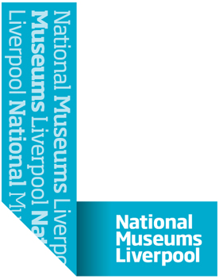

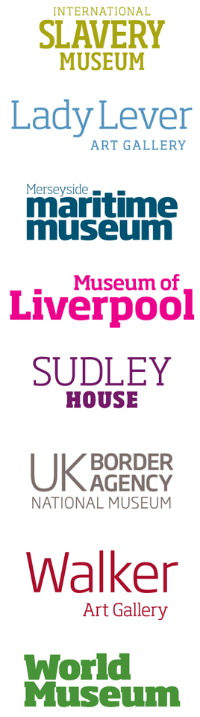

NATIONAL MUSEUMS LIVERPOOL

Waterfront Masterplan Project Tender Document

Author: Sadie Graham
Date: 28/02/2019

Tender Submission Return Date:
12 noon 1st April 2019

Contents
- Introduction 5
1.1 Company Background 5-6
1.2 Project Background 6
1.3 High Level Overview of Requirements 6
1.4 Existing Solution 6

- Tender Instructions 7
2.1 Introduction 7
2.2 General 7-8
2.3 Confidentiality and Non-Disclosure 8
2.4 Accuracy of Information and Liability of NML 8
2.5 Cost of Preparation 8
2.6 Oral Agreement or Arrangements 9
2.7 Independent Price Determinations 9
2.8 Payments Against a Contract Award 9
2.9 Bidder Misrepresentation or Default 9
2.10 Amendments to the Tender 9
2.11 Responding to the Tender 9-10

- Tender Timing, Scoring and Process 12
3.1 Questions and Additional Information 12
3.2 Site Visits 12
3.3 Target Timetable and Project Programme 12
3.4 Timing and Delivery 12
3.5 Compliance 12
3.6 Evaluation 13
3.7 Bidder Interviews 14

- Bid Requirements 15
4.1 Introduction 15
4.2 Management Summary 15
4.3 Company Background 15-16
4.3.1 Company Details 16
4.3.2 Financial Information 16
4.3.3 Third Party Services 16
4.3.4 Relevant Experience and Performance 16
4.4 NML Security and Health & Safety Requirements 16
4.5 NML Procurement Protocol 17
4.6 Timetable 17
4.7 Contractual Considerations 17
4.8 Costs 17
4.9 Summary of Documents for Submission 18

- Requirements Specification - Project Brief
5.1 Current Context 19
An NML Year 2017-18 20
5.2 The Waterfront Site 21-22
5.3 The Waterfront Project 23-24
5.4 Mission, Aims and Objectives 25
5.5 Our Current Audiences 26
5.6 Project Priorities 27-28
5.7 Key Requirements 29
5.7.1 Study Area 1 – External Spaces 29
5.7.2 Study Area 2 – Pilotage, GWR, Canning Docks 30
5.7.3 Study Area 3 – Piermaster’s Group 31
5.7.4 Study Area 4 – Merseyside Maritime Museum 32
5.7.5 Study Area 5 – Museum of Liverpool 33
5.8 Project Address 34

Appendices
Appendix A – Form of Tender
Appendix B – NML Supplemental conditions
Appendix C – NML Safety Guidelines for Contractors
Appendix D – NML H&S Questionnaire
Appendix E – NML Procurement Protocol
Appendix F – Contract (To be issued under a separate cover)

Introduction

Company Background
National Museums Liverpool (NML) is one of the world’s leading museum organisations. NML currently comprises eight museums in and around Merseyside. Entry to all our venues is free, with circa 3 million visitors per year. We hold in trust and safeguard some of the world’s greatest museum collections, which are universal in their range – everything from archaeology and ethnology, natural and physical sciences, fine and decorative arts, maritime, social and industrial history. We are core-funded by central UK government, and we are the only national museum service in England based wholly outside London, so we have a unique fourfold role – we are the main museum service for Liverpool and Merseyside; the largest cultural organisation in the North West of England; and we operate at both national and international levels.

Having played a pivotal role in the cultural, educational and economic life of Liverpool and the North West for more than 150 years, our success can be measured in terms of how well we combine this local and regional role with our national and international responsibilities.

Our mission is to provide memorable experiences, for everyone, challenging expectations. We believe in the concept of social justice; we are funded by the public and in return we strive to provide an excellent service to the whole of the public. We believe in the power of museums to change people’s lives. We work hard to be a free museum service and focus our venues, exhibitions and education resources to reach out, and to represent the diverse needs of our local communities.
National Museums and Galleries on Merseyside was established as a national museum as an incorporated Trustee Body by the Merseyside Museums and Galleries Order 1986, because of the outstanding quality of its collections. In 2003 the name was changed to National Museums Liverpool. Our origins go back to 1851 and the founding of Liverpool Museum. NML is an exempt charity by virtue of Schedule 3 to the Charities Act 2011.

NML has status as a Non Departmental Public Body (NDPB) sponsored by the Department for Culture, Media and Sport (DCMS). The DCMS became the principal regulator of NML on 1 June 2010 and provides the majority of its revenue funding.

Project Background
(Full project brief Section 5)
The project focuses upon NML waterfront museums and property, which include: The Merseyside Maritime Museum, The International Slavery Museum, Border Force's national museum: Seized! The Border and Customs uncovered, Piermaster’s House, Piermaster’s Office, Cooperage, Dock Master’s House (Mermaid House), Canning Graving Docks, Great Western Railway Building, Pilotage and The Museum of Liverpool.

Our site is situated within the heart of Liverpool’s maritime World Heritage Site, the starting point to understanding Liverpool and its global connections. This location is an unrealised focal point for sharing the narrative of Liverpool’s past, present and future.

We wish to create an outstanding visitor destination that connects Liverpool’s stunning waterfront with the city, the River Mersey and the significant buildings that together all create such a strong visual identity.

To do this we will commission a team of multi-disciplinary consultants to assist in creating a masterplan for the site and surrounding buildings. This will enable NML to undertake a number of interventions within the site that will create opportunities for visitors to linger within the unique setting and to engage with the spirit of the place through a range of activities – viewing items from NML’s collections, enjoying art installations and participating in major cultural events.

The aim of the project is to analyse what makes a successful visitor attraction, the opportunities offered by the site and existing venues, and to use the conclusions to drive development. As such, the consultancy team may not necessarily be architect led however, they must posses the broad range of skills to address the brief. Expertise is required in the design of hospitality, retail, exhibition, events, work and play spaces.

The programme for the tender process and the award selection criteria are shown in Section 3 of this tender pack.

High Level Overview of Requirements
Bidders are asked to submit a formal tender for the “Waterfront Masterplan Project”.

This tender pack has been produced as a means of selecting and appointing a multi-disciplinary team to work with NML on the Waterfront Master Planning project. The masterplan must be costed and sustainable, with a focus on visitor experience/ public offer and commercial opportunities within NML waterfront buildings and public spaces.

Looking at five study areas within the waterfront site, the consultancy team are required to produce design briefs to RIBA stage 1 for the development of the external public realm; Pilotage, Great Western Railway Building, Canning Graving Docks and Quaysides; Piermaster’s group of buildings, and minor alterations to the Museum of Liverpool. Outline design to RIBA stage 2 also required for refurbishment of the Merseyside Maritime Museum.

Existing Solution
The waterfront museums and land are currently under utilised assets with great potential. We need to examine the site to devise the best plan for developments to improve visitor experience and engagement; sustainability; display of collections; wayfinding and public realm; educational and curatorial requirements; and commercial activities. The masterplanning project will steer developments and aid us in delivering our strategic aims over the next ten years.

Tender Instructions

Introduction

Tendering is required by NML’s procurement processes that ensure that NML is adhering to Managing Public Money guidelines. The Bidder is requested to propose a solution that will meet the current and future requirements of NML, as detailed within this tender pack.

NML anticipates that one company will be the lead consultant of a consortium of partners who provide the range of expertise needed for the project. The lead consultant is referred to as “the bidder” throughout this document.

2.2 General
NML reserves the right, without prior notice, to change, modify, or withdraw the basis of its request and/or to reject all proposals and terminate negotiations at any time. In no circumstance will NML incur any liability in respect of time, effort or costs incurred in regard to either discussions, meetings or time spent in respect of reviewing and/or responding to this document or any subsequent material.

This tender is not a purchase order or an offer to contract and does not constitute an offer capable of acceptance. This tender does not commit NML or any official of it to any specific course of action. The issue of this tender does not bind NML or any official of it to accept any proposal, in whole, or in part, whether it includes the lowest priced proposal, nor does it bind any officials of NML to provide any explanation or reason for its’ decision to accept or reject any proposal. Moreover, while it is the intention of NML to enter contract negotiations with the selected bidder, the fact that NML has given acceptance to a specific Bidder does not bind it or any official of it in any manner to the bidder. Acceptance of a proposal neither commits NML to award a contract to any bidder, even if all requirements stated in this tender are satisfied, nor does it limit NML’s right to negotiate in their best interest. NML reserves the right to contract with a bidder for reasons other than the lowest price. Contract award will be post the tender process and may be awarded without discussions or negotiations

The bidder shall be deemed to have examined before the submission of their bid submission, all the provisions in this tender as well as regulations and other information relevant to your bid submission, and to have fully considered the risks, contingencies, and other circumstances, which could affect the bid submission. The bidder shall be responsible for obtaining all information by the making of reasonable and prudent inquiries and, by prior arrangement.

By submitting a bid submission the bidder represents that it has read and understood the tender. The bidder will consider the contents of any submitted bid submission as an offer to contract.

Any attempt by bidders or their advisors to influence the contract award process in any way may result in the bidder being disqualified. Specifically, bidders shall not directly or indirectly, at any time:

- Revise or amend the content of their tender in accordance with any agreement or arrangement with any other person, other than in good faith with a person who is a proposed partner or bidder;
- Enter into any agreement or arrangement with any other person as to the form or content of any other tender, or offer to pay any sum of money or valuable consideration to any person to effect changes to the form or content of any other tender;
- Enter into any agreement or arrangement with any other person that has the effect of prohibiting or excluding that person from submitting a tender;
- Canvass NML or any employees or agents of NML in relation to this procurement; or
- Attempt to obtain information from any of the employees or agents of NML or its advisors concerning another bidder or tender; or
- Offer, pay, promise to pay, or authorize the giving of any financial or other benefit to any person for the purpose of obtaining an improper advantage, or otherwise conduct themselves in a manner contrary to any anti-bribery or anti-money laundering legislation and/or regulations in the broadest sense (whether issued by the EU, the US, the UN or any other body) or any other such rule or legislation that may apply from time to time.

Bidders are responsible for ensuring that no conflicts of interest exist between the bidder and its advisors, and NML and its advisors and Partners.

NML also reserves the right to cease discussions with any bidder from the date of submission of bidder tender.

Failure to meet a qualification or requirement in this tender will not necessarily subject a proposal to disqualification but may do so.

2.3 Confidentiality and Non-Disclosure
The information contained in this tender (or accumulated through other written or verbal communication) is confidential. It is for proposal purposes only and is not to be disclosed or used for any other purpose.

Information received by NML in this tender will be held in strict confidence and will not be disclosed to any party, other than within NML and their engaged consultants if appropriate, without the express written consent of the bidder.

NML undertakes not to publicise any information obtained during this tender process, either generally or to any other bidders involved in the tender. Additionally, there will be no obligation on the part of NML to share any of the results or conclusions of the tender process with any bidder.

As a responder to this tender, you are reminded of the need for confidentiality and the need not to divulge your actual or intended tender price or an approximation of that price to any other person or body until we notify you that the contract has been awarded.

2.4 Accuracy of information and liability of NML
The information contained in this tender has been prepared by NML in good faith but does not purport to be comprehensive or to have been independently verified. NML does not accept any liability or responsibility for the adequacy, accuracy, or completeness of, or make any representation or warranty (express or implied) with respect to the information contained in the tender, or with respect to any written or oral information made or to be made available to any bidder or its professional advisors and any liability therefore is hereby expressly disclaimed.

Bidders considering entering into a contractual relationship with NML should make their own enquiries and investigations of NML's requirements. The subject matter of this tender shall only have contractual effect when it is contained in the express terms of an executed agreement.

Nothing in this tender is, or should be, relied upon as a promise or representation as to the future, and NML does not undertake to provide bidders with access to any additional information, or to update the information in this tender, or to correct any inaccuracies that may become apparent. NML reserves the right, without prior notice, to change the procedures outlined in this tender or to terminate discussions and the delivery of information at any time before entering into an agreement.

Should there be any obvious typographical errors or misunderstandings in the tender documentation then clarification should be sought. However, if the response is found to misrepresent facts, the documents will be deemed void. In the case where the error or misrepresentation is not discovered until after the contract is awarded, we reserve the right to determine the contract and costs incurred by us as a result of the determination shall be recoverable from the bidder under the contract.

2.5 Cost of Preparation
NML will not accept any liability or responsibility for any costs incurred by the bidder in preparing this tender document or any associated work effort.

2.6 Oral Agreement or Arrangements
Any alleged oral agreements or arrangements made by the bidder with any NML agent or employee will be disregarded in any proposal evaluation or associated award.

2.7 Independent Price Determinations
The bidder shall warrant, represent, and certify that the following requirements have been met in connection with their proposal for this tender:

- The costs proposed have been arrived at independently, without consultation, communication, or agreement for the purpose of restricting competition as to any matter relating to such process with any other organisation or with any competitor;

- Unless otherwise required by law, the pricing proposed has not been knowingly disclosed by the bidder on a prior basis directly or indirectly to any other organisation or to any competitor; and no attempt has been made, or will be made, by the proposed to induce any other person or firm to submit or not to submit a proposal for the purpose of restricting competition.

2.8 Payments Against a Contract Award
Under no circumstances shall the successful bidder begin to perform under the contract prior to the effective date of the contract. NML shall assume no liability for payment of services under the terms of the contract until the successful bidder is notified that the contract has been agreed by both parties.

2.9 Bidder Misrepresentation or Default
NML may reject the proposal and void any award resulting from this tender to a bidder who makes any material misrepresentation in their proposal or other submittal in connection with this tender.

2.10 Amendments to the Tender
NML reserves the right to issue amendments or modifications to this tender during the tender stage. These will be amended on the procurement portal where the tender was originally advertised and bids will be assumed to take account of any such modifications and amendments.

2.11 Responding to the Tender
In responding to this tender, the bidder you specifically agrees to the following:

Having examined all parts of the tender that the supply of the Goods and/or Services to NML will be at the rates/prices as provided. All prices must be quoted on the basis indicated in the accompanying documents, except where the bidder proposes alternative priced procedures, and should exclude VAT. Discounts for prompt payment should be stated. The basis of the price shall be inclusive of all costs and delivery to NML.

That any contract whatsoever that may result from this tender shall be subject to the laws of England and Wales as interpreted in an English Court.

The prices quoted and all other information supplied in this tender are valid and open to acceptance by NML for a period three calendar months from the tender return date specified in the tender

The essence of competitive tendering is that NML shall receive bona fide competitive tenders from all companies tendering. In recognition of this principle, any response is declared to be a bona fide tender, intended to be competitive and that the bidder (or representatives) have not fixed or adjusted the amount of the tender by or under or in accordance with any agreement or arrangement with any other person.

The bidder declares that you have not done and undertake that you will not do any of the following acts:-
- communicate with a person, other than the person calling for this tender, the amount or approximate amount of the proposed tender.

- enter into any agreement or arrangement with any other person that he shall refrain from tendering or as to the amount of any tender to be submitted.

- offer to pay or give, or agree to pay or give, any sum of money or valuable consideration directly or indirectly to any person for doing or having done or causing or having caused to be done in relation to any other tender or proposed tender for the requirement any act or thing of the sort described above.

Tender Timing, Scoring and Process

3.1 Questions and Additional Information
Formal queries concerning the content of this tender and the bidder’s submission should be submitted in writing by e-mail to Ian Lindsay (Ian.Lindsay@liverpoolmuseums.org.uk) with the subject title “Waterfront Project Tender”.

Where questions are raised by bidders and answers given clarify NMLs requirements for the tender, then these questions and answers may be shared with other bidders responding to this tender.

Queries must not be directed through any other employee, contractor or consultant who is engaged as part of the tender working party.

3.2 Site Visits
It is advised that bidders visit the site, we would designate a day for all selected tender applicants to visit if required. This will ensure that all parties get the same information and opportunity. This would be arranged as per the dates in section 3.3 below. Please contact sadie.graham@liverpoolmuseums.org.uk

3.3 Target Timetable and Project Programme
The target timetable for this project is shown in the table below but bidders must be aware that whilst every effort will be made to meet these dates, the timetable may change for operational reasons.

Step | Task | Date
1. | Tender issued | 1st March 2019
2. | Site visit | 20th March
3. | Deadline for clarification questions | 20th March
4. | Responses to clarification questions issued | 25th March
5. | Deadline for Tender Return | 1st April 2019
6. | Evaluation of the Tender Responses | 1st – 5th April 2019
7. | Interviews | 9th April 2019
8. | Notification to Bidders | 12th April 2019
9. | Confirmation of Successful Bidder | 23rd April
10. | Contracts signed, set-up meeting | 30th April
11. | Project commences
Project Stage 1 | Baseline information review, site visits, initial consultation with internal and external parties. Agree detailed scope, outputs, objectives, and production schedules. | End of April 2019
Project  Stage 2 | Develop initial assessment through detailed consultation, analysis of current condition and use of NML waterfront buildings (MMM, MoL, Pilotage, Piermaster’s Group, GWR group), public realm and location of utilities.  Ascertain planning and heritage considerations.  Confirm condition and capacity of existing engineering systems, future viability of current installation and recommendations for replacement or upgrades.  Feasibility work to ascertain potential uses of existing buildings and public spaces, and how greater footfall could be encouraged around the site.  Produce outline costs for proposed refurbishments and renewal works.  Expertise required in the design of hospitality, retail, exhibition, events, work and play spaces to inform options long list, considering the concept, cost and deliverability. | May 2019
Project  Stage 3 | Develop and appraise options short list according to objectives and agree preferred options.  Produce visualisation of what site could look like.  Key internal and external stakeholder consultation.  Outline costs, implementation programme, risks, financial options, impact assessment, begin robustness testing and visitor research. | Mid- June 2019
Project  Stage 4 | Complete design briefs and outline design, covering all aspects of the project brief, along with a costed and phased implementation plan.  Document the findings from all stages.  Develop the business plan and financial models. | End of July 2019

Note – all deadlines are at Noon on that business day.

3.4 Timing and Delivery
The bidder must provide a full submission by email. Bids should be in Microsoft Word, Excel or PDF format. The submission must include a copy of “Appendix A - Form of Tender”.
The submission must be made to Tenders@liverpoolmuseums.org.uk. To ensure that your submission is successful you should ensure that each email is less than 8Mb. Emails should be titled “Waterfront Masterplan Project Tender”. If multiple emails are sent the header should indicate they are “Part x of xx”.

Bid submissions must be received no later the date as specified in section 3.3 above. Any response received after this date and time may be discounted from further consideration. Any requirement that the bidder might have for proof of delivery is at the bidder’s discretion and cost.

No bid submission will be opened until the deadline as specified in section 3.3 above.

To enable an efficient and fair evaluation process this process must be strictly adhered to. If a bidder does not comply with the requirements contained in this Section, NML may (in its sole discretion) disqualify the bidder from the competition.

3.5 Compliance
The bid submissions will be checked initially for compliance with this tender and for completeness. Responses that are not substantially complete and/or compliant will be rejected.

The compliance criteria are as follows:
Tender documentation received by specified deadline
All relevant questions answered
All relevant information provided
Compliance with any specified timescales
Signed Form of Tender
Signed Acknowledgement of NML Procurement Protocol form
Signed completion of Health & Safety forms (if applicable)

3.6 Evaluation
Bid submissions that pass the compliance checks will then be evaluated against the criteria specified below. During the evaluation period, NML reserves the right to call for further information from

The bid submissions will be evaluated according to the following criteria, to determine the highest scoring responses. :

Criteria | Element of Evaluation | Max Score Available
Skill | Mix of skills you will bring to the project | 30%
Experience | Relevant experience evidenced by past projects | 30%
Team | Proposed team, resource schedule and structure | 15%
Cost  (Max. fee £80k) | What you will provide for the fee to address the requirements of the brief | 25%
 | Total | 100
 | Minimum Quality Score threshold (60%) | 45

Only information provided as a direct response to this tender will be evaluated. Information and detail which forms part of general company literature or promotional brochures etc. will not form part of the evaluation process. Supplementary documentation may be attached where you have been directed to do so. All sections must be answered unless advised otherwise.

In order to protect the quality of any procurement, any tender response that scores below the minimum quality score threshold will not be considered.

3.7 Bidder Interviews
Following the deadline for bid submission, NML will evaluate and score each bidder’s submission against the evaluation criteria. Bidders may be invited to attend an interview to discuss the content of their written bid. A maximum of 6 bidders will be invited to interviews. Any bidder with a submission score greater than 20% behind the highest score will not be interviewed.

The post tender interviews will be held on the date as specified in section 3.3 above. Notification will be sent to those bidders invited to interview.

Bid Requirements

Introduction
This section provides bidders with details of the form and content of bids that are invited and sets out the procedural requirements with which bidders must comply when submitting bids in order for their bids to be considered by NML. The process is intended to:

• assist NML in choosing the most economically advantageous bid;
• make clear the requirements with which bidders must comply and the basis on which the bids will be evaluated; and
• maintain competition throughout.

If a bidder does not comply with the requirements contained in this Section, NML may (in its sole discretion) disqualify the Bidder from the competition. Bids should be as concise as possible, whilst providing sufficient information to enable NML to evaluate bids in accordance with this tender.

The bidder is required to prepare the proposal and pricing based on the requirements specification detailed in section 5 and 6 of this document. Any assumptions that the bidder makes must be clearly stated in the appropriate section.

The costs must be fully itemised and transparent.

If the bidder has additional information that is directly relevant to the stated requirements but not explicitly requested, this may be added to the end of the most appropriate section under the heading “Additional Information” or referenced out to appendices.

Failure to return all of the requested documentation may result in your tender not being considered further.

This document details baseline requirements for the solution. This is not meant to be an exhaustive list of requirements but it will however serve to identify suitable solutions and bidders. NML reserves the right to modify its requirements at any time.

4.2 Management Summary
The bidder must provide a concise management summary of their offering, including the following:

- A brief overview of the proposed solution including reference to any partners and third parties.

- Reasons why NML should choose the proposed bidder and solution.

- Summary of the bidder’s commercial offer.

4.3 Company Background

4.3.1 Company Details
The bidder must provide the following information:

- The registered name and address of the company
- Details of any holding companies
- The date the company was established
- The main activities of the company
- The proportion of the total business accounted for by the proposed services
- The number and location of offices, identifying the main functions of each
- Insurance details (Professional Indemnity cover, Employers Liability cover, IPR cover)
- Company accreditations (professional body accreditations and trade body accreditations but excluding awards)
- Certifications and last audit dates, e.g. ISO9000 / 9001
- An organisation chart that highlights those functions that would be involved in the delivery and subsequent support of the proposed services
- The quality assurance mechanisms employed by the bidder
- Describe any recent mergers or acquisitions
- Detail any significant partnerships that will be used to deliver the proposed services. Detail the specific nature of each partnership and describe the commercial and contractual implications

4.3.2 Financial Information
The bidder must provide audited accounts for the last three financial years. If the organisation has not been in existence for three years then supply all available accounts.

4.3.3 Third Party Services
The bidder must provide the following information for each of the proposed third parties / sub-contractors that may form part of the proposed solution to this tender:

- Service
- Supplying bidder name
- Product name / version
- List of relevant clients where the bidder has provided that service

4.3.4 Relevant Experience & Performance
The bidder must provide evidence of previous experience in relation to expertise required and performance in completing past projects to the required standards.

As part of the selection process NML will require to contact existing customers of the bidder for similar solutions. The bidder must select 2 reference clients and provide the following contact information:

- Client name and address
- Description of solution provided
- Key contact name, title, and contact information
- Length of the supply relationship
- Relevance to this tender
- Size and duration of project
- Role of the tenderer
- Performance, in relation to time, budget, claims, project management and value of the solution.

NML undertakes not to contact any reference company without arranging such contact via the bidder’s Account Manager first.

4.4 NML Security and Health & Safety requirements
As part of the selection process NML will require potential bidders to agree to NML’s security and Health and Safety requirements. Please review the enclosed documents:

i) Appendix B – NML Supplemental conditions
ii) Appendix C – NML Safety Guidelines for Contractors
iii)Appendix D – NML H&S Questionnaire

Please complete and return the NML H& S Questionnaire with your submission.

4.5 NML Procurement Protocol
As part of the NML Procurement protocol and procedures, NML expect suppliers to uphold similar business standards, particularly in relation to sustainability, ethics and the Modern Slavery Act. NML will require potential bidders to agree to NML’s Procurement Protocol and their agreement to uphold those values. Please review the enclosed document:

i) Appendix E – NML Procurement Protocol

Please complete and return the NML Procurement Protocol Supplier Agreement.

4.6 Timetable
Please note that the project is expected to be completed by 1st August 2019.

Bidders should present a detailed timetable for planning and completion for the project as a whole, indicating how this date will be achieved.

4.7 Contractual Considerations
The bidder must provide a copy of their standard Terms and Conditions for the proposed services.

4.7.1 Insurances
Professional Indemnity insurance is to be maintained by the appointed Lead Consultant in an amount of not less than £1m for any one occurrence or series of occurrences arising out of any one event.
Public Liability Insurance is to be maintained by the appointed Lead Consultant in an amount of no less than £5m.
Employers Liability Insurance is to be maintained by the appointed Lead Consultant in an amount of no less than £5m.
The Lead Consultant will be required to ensure that insurance certification is maintained for the duration of the Project and to provide updated certificates upon request.

4.7.2 Form of Agreement
The winning bidder shall be appointed using the NML Contract. Copy of this form of contract is to be issued under a separate cover.

4.8 Costs
A full breakdown of all costs is to be provided. Cost breakdown should include the following as a minimum:

As an exempt charity and an educational institution funded by government (DCMS). NML generally qualifies for academia, educational or charity pricing schemes offered by many bidders and manufacturers and this must be taken into account when tendering.
We would look for a phased payment schedule across the lifetime of the schedule, with minimal upfront payment. We would expect each phased payment to be invoiced with accompanying evidence of work completed and time spent.

4.9 Summary of Documents to be returned as part of Submission
Bidders are required to provide the following completed documents as part of their tender return, if a bidder fails to return the below items the tender submission will be considered invalid:

    - Form of Tender
    - Pricing document - Cost breakdown
    - Management summary answers (section 4.2)
    - All requirements referenced in point 4.3
    - Confirmation of Delivery dates/Programme
    - Detailed specification of proposed solution
    - Acknowledgement of NML Procurement Protocol form
    - Standard Terms & Conditions

The Tender response must include the following:

• Your approach to the project, how you will work with us to create the Master Plan

• Your experience of Master Planning, ideally with similar organisations to ourselves

• Your proposed team, including sub-consultants (the team that comes to interview must be the
team that will work on the project throughout), Lead Consultant and team structure

• An indicative resource schedule

• Your fee breakdown and fee structure

• Three relevant references that we could contact

Requirements Specification

Current context
NML Director Laura Pye joined the organisation in August 2018, and together with staff has been reviewing NML vision and mission. Laura Pye describes her vision as: “by 2030 we want to be the best museum ‘league’ in the world… In our buildings and online we will have world class displays and engagement programmes that make everyone feel welcome.”
National Museums Liverpool: creating memorable experiences – for everyone – challenging expectations
In delivering this vision we will focus on five strategic aims:
- Be more representative
- Be more self-sufficient
- Provide memorable experiences
- Partner and influence
- Engage and empower our staff

In order to deliver the objectives, we will extend our current programming activities of exhibitions, events, activities and outreach. We will also seek to undertake a series of capital projects designed both to achieve the objectives, and to address various issues around improving visitor experience and capitalising on commercial activities.
The decision was made to appoint a multidisciplinary consultancy team to assist in the Master-Planning exercise to support the delivery of these change objectives by 2030.

The Waterfront Site
Our waterfront museums and property comprise: The Merseyside Maritime Museum, The International Slavery Museum, the Border Force's national museum: Seized! The Border and Customs uncovered, Martin Luther King Jr Building, Piermaster’s House, Piermaster’s Office, Cooperage, Dock Master’s House (Mermaid House), Canning Graving Docks, Great Western Railway Building, Pilotage and The Museum of Liverpool.
Our site is situated within the heart of Liverpool’s maritime World Heritage Site, the starting point to understanding Liverpool and its global connections. This location is an unrealised focal point for sharing the narrative of Liverpool’s past, present and future. It is a special place - to the south is the Albert Dock which is on a journey to celebrate its 175th birthday in 2021, to the north is the Pier Head, to the west the River Mersey stretching out to the Irish Sea and Atlantic Ocean and, to the east the changing Liverpool cityscape.
Merseyside Maritime Museum is part of the Royal Albert Dock, Liverpool. It contains a variety of objects associated with the social and commercial history of the port of Liverpool. Highlights include ship models, maritime paintings, colourful posters from the golden age of liners and even some full sized vessels. There is also the major exhibition Titanic and Liverpool: the untold story, which tells the story of Liverpool's links to the ill-fated liner. The Museum also houses the International Slavery Museum (on the third floor) as well as the Border Force's national museum: Seized! The Border and Customs uncovered (in the basement).
The International Slavery Museum opened on 23 August 2007. Not only was this the date of the annual Slavery Remembrance Day, but the year 2007 was particularly significant as it was the bicentenary of the abolition of the British slave trade. The International Slavery Museum highlights the international importance of slavery, both in a historic and contemporary context. Working in partnership with other museums with a focus on freedom and enslavement, the museum provides opportunities for greater awareness and understanding of the legacy of slavery today. Located in Liverpool's Albert Dock, at the centre of a World Heritage site and only yards away from the dry docks where 18th century slave trading ships were repaired and fitted out. The next stage in the development of the museum will see it expand into the adjacent Dr Martin Luther King Jr Building (The historic Dock Traffic Office). This will be the International Slavery Museum's new entrance, with spaces to engage in educational and community activity, including researching family history and viewing the museum’s newest collections. The refurbishment of this building is the focus of another project.
The Museum of Liverpool opened on 19 July 2011 in a purpose-built landmark building on Liverpool's famous waterfront. Since then it has won a number of awards, including the Council of Europe Museum Prize for 2013. The Museum of Liverpool reflects the city's global significance through its unique geography, history and culture. Visitors can explore how the port, its people, and how their creative and sporting history have shaped the city.
The Piermaster’s House, Piermaster’s Office, Cooperage and Mermaid House (Dock Master’s House) is situated on Albert Parade on the waterfront. The Piermaster’s House was originally built in 1852 for the Piermaster and his family. The Piermaster was responsible for ensuring the safe passage of ships entering and leaving the dock at high tide. The house was one of four built on this site, and was the only one left standing following the heavy bombings in the Second World War. In 2003 it was transformed back into a wartime house, dressed with original period furniture and everyday objects. The Cooperage is currently used as a lunch area for school groups. The Piermaster’s Office and Mermaid House are currently unused.
Canning Graving Docks are part of the internationally significant Liverpool dock system. Constructed between 1765-69, they are the oldest operating element of the dock system in the city. They linked to Canning Dock at the entrance of the original Old Dock (built between 1710-15), to provide space for the repair and cleaning (graving) of boats. Ships sailed in on a high tide. As the tide receded the boats were propped onto the staggered walls, known as alters, while strong lock gates kept the water out while the boats were serviced.
Canning Graving Docks add greatly to the Outstanding Universal Value (OUV) of the Liverpool dock system, which forms the centrepiece of the Liverpool Maritime Mercantile City World Heritage site (WHS). They illustrate the development of the docks from its earliest origins, as well as the practicalities of continually maintaining ocean-going vessels to a sea-worthy standard. Their historical significance is further recognised in their designation as Grade II listed buildings.

The Waterfront Project
The Waterfront master planning project presents an extraordinarily absorbing challenge and an opportunity with international significance. The design and civic qualities will shape both local and international perceptions of the Liverpool Waterfront, and capture the transforming identity of Liverpool and the wider City Region.
Master-planning advice is required to help us meet our change objectives and:
• Increase the quantity and diversity of visitors
• Improve the quality of visitor experience
• Enhance the interpretation of the docks and NML collection to better present Liverpool’s global story
• Conservation of the historic World Heritage Site
• Commercialise assets for income generation
• Strengthen relationships with external partners for mutual benefit.
Our vision is to use this wonderful eighteenth century dockland to create an outstanding visitor destination that connects Liverpool’s stunning waterfront with the city, the River Mersey and the significant buildings that together all create such a strong visual identity.
To do this we will commission a team of consultants to assist in creating a masterplan for the Canning Graving Docks and surrounding buildings. This will enable National Museums Liverpool to undertake a number of interventions within the site that will create opportunities for visitors to linger within the unique setting and to engage with the spirit of the place through a range of activities – viewing items from NML’s collections, enjoying art installations and participating in major cultural events.
A visitor destination using the architecturally-important Canning Graving Docks as the setting for a modern intervention would draw on the stories, collections and history which are part of the NML group. There are already assets on the site including vessels on the National Register of Historic Ships, which alongside a rich variety of other heritage assets, would form part of the narrative.
The location has emotional resonance as a place of arrival and departure. In common with other port cities across the world, we will be seeking to bring out the unique personality of Liverpool in this development. Liverpool is a place that is open, brave, entrepreneurial, resilient and creative.
The scale and uniqueness of the Graving Docks’ architecture, surrounded by water and public realm, means that the site has the ability to become a linking destination within the context of Liverpool’s waterfront.
At the heart of the integrated development will be world-class institutions sharing animated public spaces, with opportunities for complementary programmed uses in the spaces around and between: National Museums Liverpool, Tate, Royal Albert Dock Liverpool Ltd, Canal & River Trust.
Some developments are currently planned within and surrounding the site, that will need to be incorporated into the new interventions. Liverpool City Council plan to build a continuous pedestrian bridge across the eastern tips of the graving docks connecting Mann Island to the Pump House quay. The bridge will provide access onto the quays at their eastern ends and enable pedestrian circulation around the entire site. Considering the nature of access to the bridges is within the scope of the project. A new Albert Dock Welcome Centre has received planning permission and is expected to start on site in 2019. It is situated adjacent to The Strand by Salthouse Dock and will act as a gateway to the waterfront for visitors arriving through Liverpool One.
The Consultancy Team will need to consider the site’s highly distinctive context, its listed and World Heritage Status and create a public realm design brief that seamlessly connects the site to the rest of the South Docks. They will need skills in the design and delivery of civic and attractive visitor destination projects.
It is very important to NML to generate income from our estate. Consultants will need to consider opportunities for new paid for experiences and exhibitions as well as augmenting existing retail, catering, events and educational facilities.
The masterplan also needs to be flexible to allow it to adapt and change over 10 years. There is a requirement to raise external funds for nearly all of the elements of the plan, and there are constraints on our own capacity to do this. As a result, the developments may need to be phased over the period.

5.4 Mission, aims and objectives
‘National Museums Liverpool: creating memorable experiences – for everyone – challenging expectations’
In focusing on five strategic objectives, NML will pursue a strategy of combining audience growth and diversity, whilst striving for self-sufficiency by commercialising our activities wherever possible.
In undertaking the master-planning process we seek to:
• Create a strong, connected vision for the waterfront site as a whole
• Animate the central public space at the heart of the waterfront
• Explore viable options for interventions, alternative uses and physical improvements
• Devise a plan for determining the preferred options for enriching the site and obtaining commercial benefit from our assets.
We anticipate that this exercise will result in a Master Plan of a series of phased interventions that could be delivered over a period of 10+ years, in order to help us achieve the mission and strategic objectives.

Our current audiences
Overall visitor figures for NML 2017-18:
Merseyside Maritime Museum visitor figures 2017-18:
906,000 visits
57.1% Female | 42.9% Male
6.7% of visitors have a disability
5.7% of visitors from a BAME background
23.4% of visitors from the Liverpool City Region
16% under the age of 16
49.9% from NS-SEC 1-4 Social economic background
37.7% from NS-SEC 5-8 Social economic background
12.3% from unclassified Social economic background
International Slavery Museum visitor figures 2017-18:
391,000 visits
59.9% Female | 40% Male
9.5% of visitors have a disability
7.7% of visitors from a BAME background
23.6% of visitors from the Liverpool City Region
18% under the age of 16
48.1% from NS-SEC 1-4 Social economic background
36.6% from NS-SEC 5-8 Social economic background
15.4% unclassified Social economic background
Museum of Liverpool visitor figures 2017-18:
829,000 visits
58.2% Female | 41.8% Male
9.8% of visitors have a disability
4% of visitors from a BAME background
33% of visitors from the Liverpool City Region
15% under the age of 16
48.7% from NS-SEC 1-4 Social economic background
40.6% from NS-SEC 5-8 Social economic background
10.7% unclassified Social economic background

Project priorities that have been identified:

There are five study areas to examine within the waterfront site:
1) Public realm, connections, wayfinding, street furniture
2) Pilotage, Great Western Railway Building and Canning Graving Docks
3) Piermaster’s Group
4) Martin Luther King Jr Building and Merseyside Maritime Museum
5) Museum of Liverpool

We wish to have four sets of conversations with stakeholders inside NML and beyond.
- Operational factors, connectivity, accessibility and visibility
- Curatorial, exhibition and educational requirements
- Commercial functions, retail, catering, and events
- Visitor and audience development.

NML has had initial contact with external stakeholders which we expect to continue in partnership with the consultancy team. Initial conversations have been held with Liverpool City Council Planning and Regeneration teams, Liverpool City Region Combined Authority, Historic England, Royal Albert Dock Ltd, Canal & River Trust, Tate Liverpool.

Waterfront Masterplan Project to define:
• NML vision for the site
• Options for interventions, alternative uses and physical improvements
• Plan for determining the preferred options
• Design brief for the development of external spaces
• Design brief for the reuse and redevelopment of the Pilotage, Great Western Railway Building, Canning Graving Docks and quays
• Design brief for reuse and development of the Piermaster’s Group (Piermaster’s House, Piermaster’s Office, The Cooperage, Mermaid House)
• Merseyside Maritime Museum outline design for refurbishing the building
• Museum of Liverpool design brief for minor alterations
• Implementation programme with indicative costs and phasing
• Visualisations of how the site and venues could be in future (which may be used for fundraising purposes).

5.7 Key Requirements
5.7.1 Study area 1 – External spaces & Public Realm
Output: RIBA stage 1 Design brief for the development of external spaces
• Viable uses for specific areas, maximising income generation and providing great visitor experience
• Accessibility improvements to public realm -including lighting, way finding, street furniture, bridge ramps (LCC Canning Dock bridge scheme)
• Proposals for infrastructure to support events, educational & commercial activities (power, drainage, storage)
• Curatorial suggestions involving internal and external exhibition area
• Indicative costs.

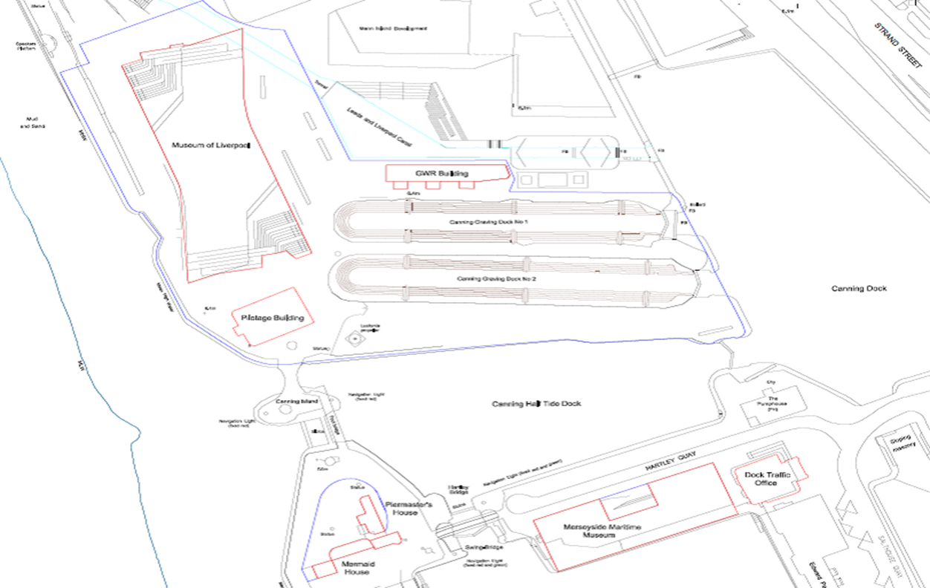

5.7.2 Study area 2 - The Pilotage, Great Western Railway Building, Canning Graving Docks and quays
Output: RIBA stage 1 Design brief for the reuse and redevelopment of the Pilotage, GWR, Canning Graving Docks and quays informed by:
• Review of existing building fabric
• Analysis of options for commercial activity
• Exploration of curatorial opportunity for improved visitor experience and display of collections
• Discussions with external partners
• Indicative costs

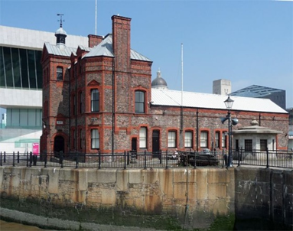  The Pilotage | 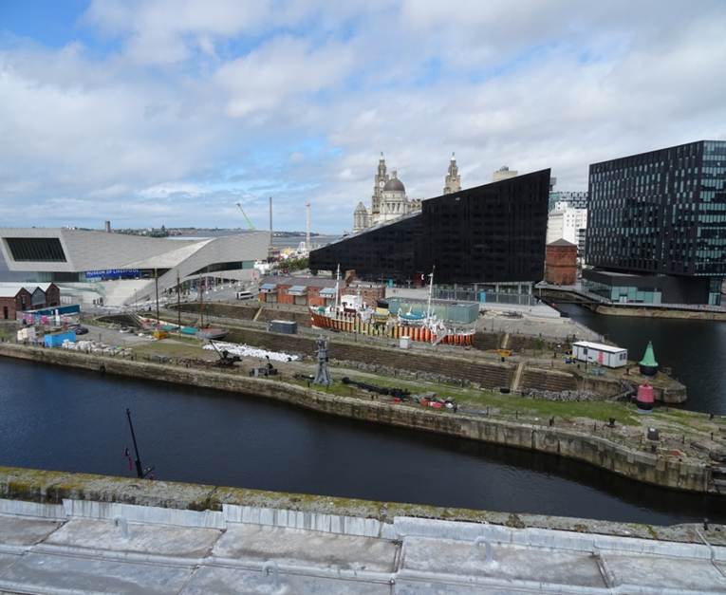  Canning Graving Docks
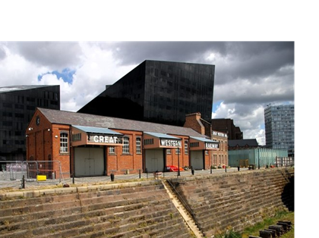

Great Western Railway Building

5.7.3 Study area 3 - Piermaster’s Group
Output: RIBA stage 1 Design brief for reuse and development of the Piermaster’s Group informed by:
• Review of existing building fabric
• Analysis of options for commercial activity
• Exploration of curatorial opportunity
• Discussions with external partners
• Indicative costs

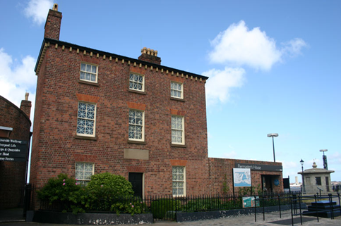  Piermaster’s House | 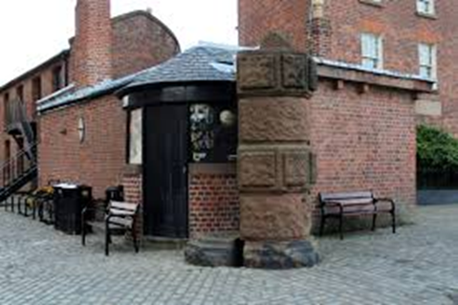  Piermaster’s Office
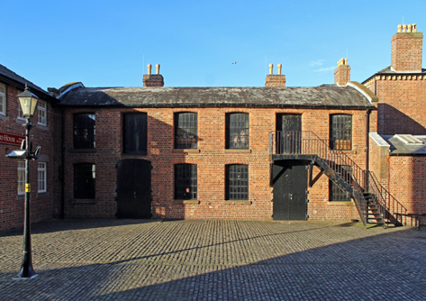  The Cooperage | 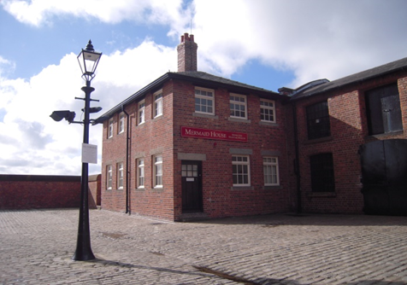  Mermaid House

5.7.4 Study area 4 – Merseyside Maritime Museum
Output: RIBA stage 2 Outline design for refurbishing the MMM building, informed by:
• Review of mechanical and electrical infrastructure
• Review of building fabric
• Design of catering, retail and events offer
• Response to ISM/ MLK project
• Proposals for re-stacking MMM addressing the welcome, education and exhibition needs
• Indicative costs.

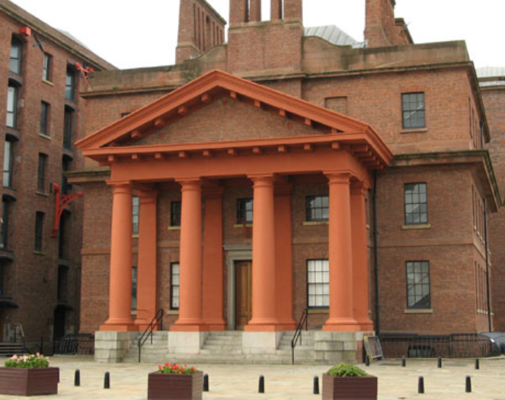  Martin Luther King Jr Building | 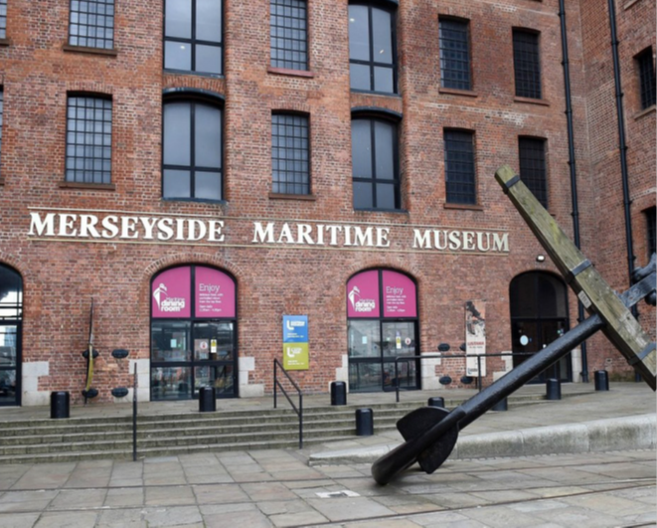  Merseyside Maritime Museum

5.7.5 Study area 5 – Museum of Liverpool
Output: RIBA stage 1 Design Brief for MoL minor alterations informed by:
• Examine building layout and review how spaces are currently used
• Suggestions for increasing the intensity and quality of use of public spaces
• Commercial use of café, external area, lecture theatre
• Development of exhibition space
• Discussions about the future development of House of Memories
• Indicative costs.

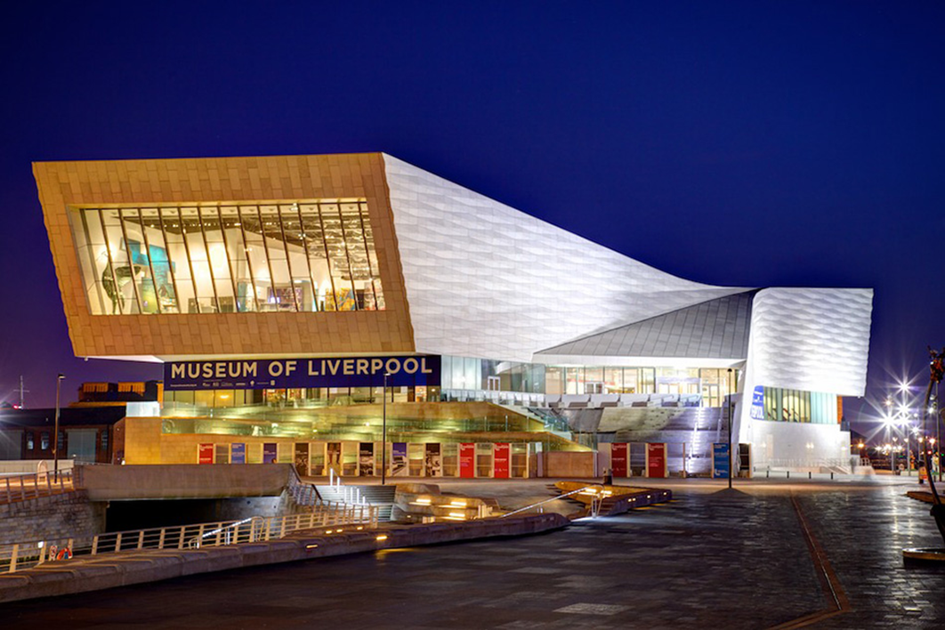

Museum of Liverpool

5.8 Project Address
The project is focused on NML waterfront sites:
Merseyside Maritime Museum, Royal Albert Dock, Liverpool Waterfront, Liverpool. L3 4AQ.
International Slavery Museum, Dr Martin Luther King Jr Building, Royal Albert Dock, Liverpool Waterfront, Liverpool, L3 4AX.
Museum of Liverpool, Pier Head, Liverpool Waterfront, Liverpool, L3 1DG.
Piermaster’s Group Albert Parade, Liverpool Waterfront.
The Pilotage, Liverpool Waterfront
The Great Western Railway Building, Canning Dock, Liverpool Waterfront
Canning Graving Docks, Liverpool and adjacent quays

